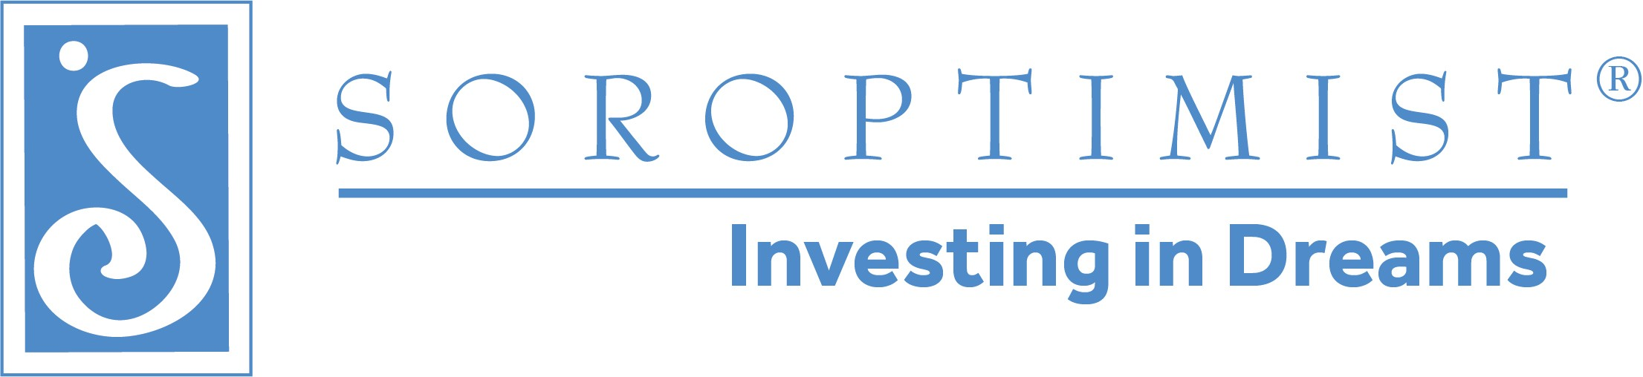

Founder Region Amended 2025 Calendar

Soroptimist International of the Americas Elise Balgley, Governor

|  |  |
| --- | --- |
| August 1-3, 2025 | Region Board Meeting * |
| August 8-10, 2025 | Fellowship Board Meeting ** |
| August 11- 24, 2025 | Presidents’ Roundtables Times and locations to be set by District Directors |
| October 3, 2025 | Districts I and II Meet and Greet with SIA ED/CEO Michelle Burnett |
| October 4, 2025 | Districts I and II District Meeting-Concord Host Clubs: SI/24-680 (Walnut Creek) and SI/American Canyon 2018 |
| October 10, 2025 | Districts III & IV Meet & Greet-Redwood Valley |
| October 11, 2025 | District III and IV District Meeting-Redwood Valley Host Clubs: SI/Novato & SI/Arcata |
| October 18, 2025 | District V Meeting: Maui  Host Clubs: SI/Maui |
| October 18, 2025 | District V Meet & Greet-Maui |
| October 19, 2025 | District V Leadership Training -Maui |
| November 7-9, 2025 | Region Board Meeting *  VIA ZOOM |
| November 15, 2025 | Fellowship Board Meeting Via Zoom |
| November 17-23, 2025 | Presidents’ Roundtables [Times and locations to set by District Directors] |
| December 1, 2025 | Nominations due for 2026-2028 Region and Fellowship Boards |
| **2026** |  |
| January 31-February 2, 2026 | Founder Region Board Meeting * |
| February 6-8, 2026 | Fellowship Board Meeting ** |
| February 16-28, 2026 | Presidents’ Roundtables [Times and locations to be determined by District Directors] |
| February 20-21, 2026 | Fellowship Interviews [Hawaii] |
| March 6, 7, and 8, 2026 | Fellowship Interviews [California] |
| March 24, 2026 | Caucus [To be confirmed] |
| April 30, 2026 | Region and Fellowship Conference Board Meetings-San Ramon Marriott |
| May 1-3, 2026 | Founder Region Conference-San Ramon Marriott  Host Clubs: SI/The Redwoods, SI/Eel River Valley, SI/Noyo Sunrise |
| June 5, 2026 | New Board Training |
| June 6, 2026 | Leadership Training-Eureka |
| June 7, 2026 | Memorial Grove |
| June 13, 2026 | Leadership Training-Bay Area |
| June 20 | Leadership Training via Zoom (District V) |

*Region Board meetings are planned to be held in Hopland, CA

**Fellowship Board meetings are also planned for Hopland, CA other than the November meetings

Please Note:

Region Board members are expected to attend the following:

1. Board training-June 7, 2024 in Eureka
2. As many leadership training meetings as possible
3. Memorial Grove
4. All Region Board meetings
5. All District meetings in their Districts (District Directors) and all District meetings (Officers)