Worship Service for January 4, 2026
Welcome and Announcements Lois Squires
*The Prayer Group and Book Discussion will begin again on January 13, 2026. We will be reading and sharing our thoughts on a book by Max Lucado titled “What Happens Next – A Traveler’s Guide Through the End of this Age”. Chapters 1 & 2. Let Pastor Theresa know if you would like to receive the link for this zoom discussion.
*Men’s breakfast will meet on the 17th. Come join us for a potluck breakfast and devotional. Contact Ken Taylor for more details.
*Church potluck and game night. Join us for a time of food, fellowship and fun. Sign up sheet will be in the fellowship room for the potluck. Bring a game to play or join in with group games.
*Its annual report time.. Please submit your report to Jeremy Crumb by January 12.
*Pastor Theresa will be resuming her regular office hours.

Upcoming Events
Tuesday 1:30 Deacon Meeting at church
7:00 CLC Meeting via zoom
Sunday 8:30 Mary & Martha breakfast & meeting

Celebrations

Happy Birthday to:
]Mark Squires Today; JR O’Brien Tomorrow.

Happy Anniversary to:
Jon & Rebecca Denofer Last Friday; Dave & Rosemary Hall Yesterday.]
Word of Preparation - Lois Squires
Prelude ~Salt & Light
Verse 1
Oh, the beauty of the King,
You make righteous those who seek.
You have written and redeemed my story.

Chorus
Let my eyes see Your kingdom shine all around.
Let my heart overflow with passion for Your name.
Let my life be a song revealing who You are.
For You are salt and light.

Verse 2
Oh, the love that set me free.
You bring hope to those in need.
You have written and redeemed my story.
Chorus
Bridge
You are love's great height.
You are deep and wide,
A consuming fire.
You are salt and light.
You are love's great height
You are deep and wide
A consuming fire
Chorus
Ending
You are salt and light.
For You are salt and light.
For You are salt and light.
Lauren Ashley Daigle, Leslie Jordan, Paul Mabury
CCLI Song #7023285
© 2014 CentricSongs; See You At The Pub; Oceans Away Music; So Essential Tunes; Integrity's Praise! Music; Little Way Creative
CCLI License #11289244

Call to Worship ~ Based on Hebrews 1:1-3 NRSV
Please join in reading the bold lines.

Long ago, God spoke to our ancestors through the prophets;
now God has spoken to us by a Son.
God made the world through the Son, who has been appointed heir of all things and the perfect reflection of God's glory.
The Son is the exact representation of God's being,
sustaining all things by his powerful word.
Praise God for the gift of the Son.
We welcome the Light of the world!

Song: Here I Am to Worship

Verse 1
Light of the world,
You stepped down into darkness.
Opened my eyes let me see,
Beauty that made this heart adore You,
Hope of a life spent with You.

Chorus
And here I am to worship.
Here I am to bow down.
Here I am to say, that You're my God.
You're altogether lovely, Altogether worthy,
Altogether wonderful to me.

Verse 2
King of all days,
Oh, so highly exalted,
Glorious in heaven above.
Humbly You came,
To the earth You created,
All for love's sake, became poor.
Chorus
Bridge
And I'll never know how much it cost,
To see my sin upon that cross. 3x
Chorus 2x
Tim Hughes
CCLI Song #3266032
© 2000 Thankyou Music Ltd
CCLI License #11289244
Praying Together ~

Our Father, Who Art in Heaven, Hallowed be Thy Name.
Thy Kingdom come. Thy will be done
on earth as it is in heaven
Give us this day our daily bread.
and forgive us our debts as we forgive our debtors
And lead us not into temptation, but deliver us from evil
For Thine is the Kingdom, and the power, and the glory forever, Amen
Hymn: 172 Blue Hymnal - We Three Kings (Kings
Verse 1
We three kings of Orient are,
Bearing gifts we traverse afar,
Field and fountain, moor and mountain,
Following yonder star.

Chorus
O star of wonder, star of light,
Star with royal beauty bright,
Westward leading, still proceeding,
Guide us to Thy perfect light.

Verse 2
Born a King on Bethlehem's plain,
Gold I bring to crown Him again,
King forever, ceasing never,
Over us all to reign.
Refrain
Verse 3
Frankincense to offer have I.
Incense owns a Deity nigh,
Prayer and praising, voices raising,
Worshiping God on high.
Refrain
Verse 4
Myrrh is mine, its bitter perfume,
Breathes a life of gathering gloom.
Sorrowing, sighing, bleeding, dying,
Sealed in the stone cold tomb.
Refrain
Verse 5
Glorious now, behold Him arise,
Christ and God and sacrifice,
Alleluia, alleluia,
Sounds through the earth and skies!
Refrain
John Henry Hopkins Jr.
CCLI Song #38002
© Words: Public Domain; Music: Public Domain
CCLI License #11289244
Intro to sermon - Rev Dr Theresa Taylor
Scripture text - Genesis 26:3-4a; Psalm 8:1-5; 136:3-7a; Matthew 2:2-12.
Gen 26:3-4a;
3Dwell in this land, and I will be with you and bless you; for to you and your descendants I give all these lands, and I will perform the oath which I swore to Abraham your father. 4And I will make your descendants multiply as the stars of heaven;
Ps 8:1-5
1O Lord, our Lord,
How excellent is Your name in all the earth,
Who have set Your glory above the heavens!
2Out of the mouth of babes and nursing infants
You have ordained strength, Because of Your enemies,
That You may silence the enemy and the avenger.
3When I consider Your heavens, the work of Your fingers,
The moon and the stars, which You have ordained,
4What is man that You are mindful of him,
And the son of man that You visit him?
5For You have made him a little lower than the angels,
And You have crowned him with glory and honor.

Ps 136:3-7a
3Oh, give thanks to the Lord of lords!
For His mercy endures forever:
4To Him who alone does great wonders,
For His mercy endures forever;
5To Him who by wisdom made the heavens,
For His mercy endures forever;
6To Him who laid out the earth above the waters,
For His mercy endures forever;
7To Him who made great lights,

Mt 2:2-12
2 Saying, “Where is He who has been born King of the Jews? For we have seen His star in the East and have come to worship Him.”
3When Herod the king heard this, he was troubled, and all Jerusalem with him. 4And when he had gathered all the chief priests and scribes of the people together, he inquired of them where the Christ was to be born. 5So they said to him, “In Bethlehem of Judea, for thus it is written by the prophet:6But you, Bethlehem, in the land of Judah, Are not the least among the rulers of Judah; For out of you shall come a Ruler
Who will shepherd My people Israel.7Then Herod, when he had secretly called the wise men, determined from them what time the star appeared. 8And he sent them to Bethlehem and said, “Go and search carefully for the young Child, and when you have found Him, bring back word to me, that I may come and worship Him also.” 9When they heard the king, they departed; and behold, the star which they had seen in the East went before them, till it came and stood over where the young Child was. 10When they saw the star, they rejoiced with exceedingly great joy. 11And when they had come into the house, they saw the young Child with Mary His mother, and fell down and worshiped Him. And when they had opened their treasures, they presented gifts to Him: gold, frankincense, and myrrh. 12Then, being divinely warned in a dream that they should not return to Herod, they departed for their own country another way.
Sermon - “Star of Wonder” Rev Dr Theresa Taylor
Hymn: 220 Red Hymnal -Turn Your Eyes Upon Jesus
Verse 1
O soul, are you weary and troubled?
No light in the darkness you see?
There's light for a look at the Savior,
And life more abundant and free!

Refrain
Turn your eyes upon Jesus,
Look full in His wonderful face;
And the things of earth
Will grow strangely dim,
In the light of His glory and grace.

Verse 2
Thro’ death into life everlasting,
He passed, and we follow Him there;
Over us sin no more hath dominion,
For more than conqu’rors we are!
Refrain
Verse 3
His Word shall not fail you He promised:
Believe Him, and all will be well;
Then go to a world that is dying,
His perfect salvation to tell!
Refrain
Helen H. Lemmel
CCLI Song #15960
© Words: Public Domain; Music: Public Domain
CCLI License #11289244
Communion
Doxology
Benediction -
The God of our salvation has called us from darkness into the eternal light of Christ. So, go from this place walking and
shining in that blessed light. May it brighten every room you walk in, every conversation you have, and every person you
encounter, now and forevermore. In the name of Jesus, the hope of our salvation. Amen.

For any pastoral needs contact Pastor Theresa at:
(802)535-7710 or revtheresa67@gmail.com

Purpose:
To share the love of Jesus
Vision:
Beacon of hope, welcoming all
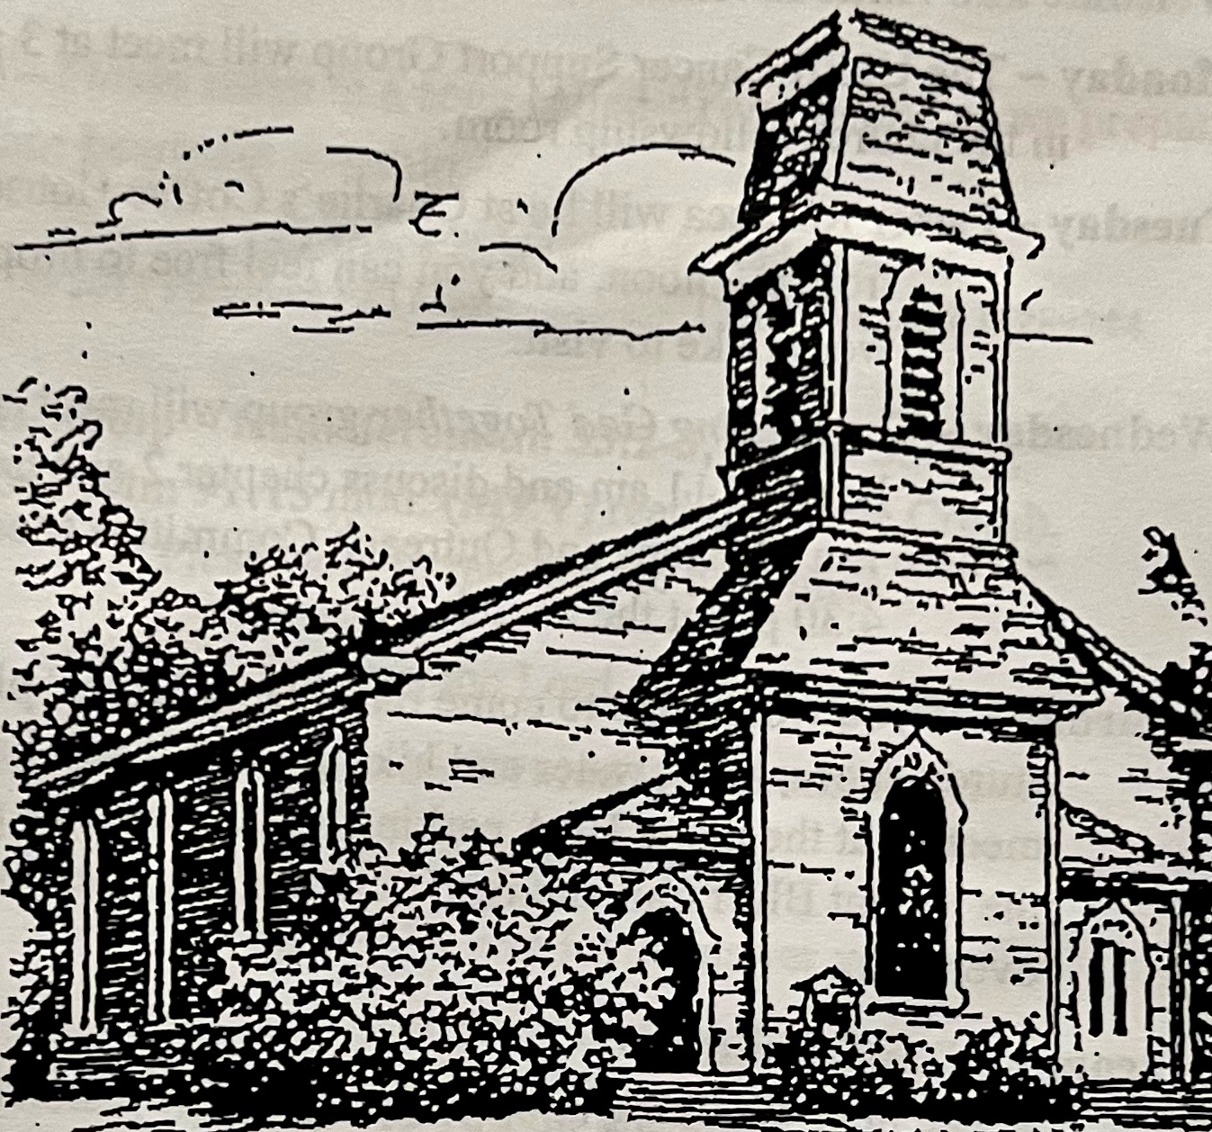
Mission:
Worship God, Follow Jesus, Rely on the Holy Spirit, and Love Everyone.

January 4, 2026
and behold, the star which they had seen in the East went before them, till it came and stood over where the young Child was.
Mt 2:9b

