CELEBRATE YOUR DANCER HOLIDAY SHOW 2025

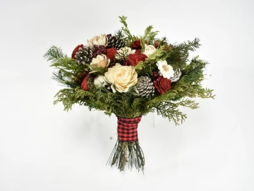 Flowers $ 30.00 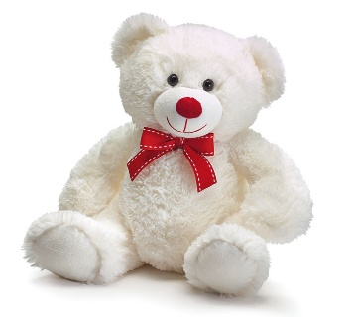 Stuffed Bear $ 30.00
Seasonal Bouquet of Flowers ready to give to your Dancer With Logo T-Shirt

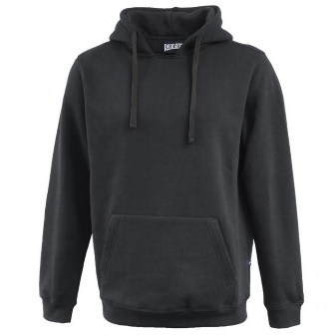 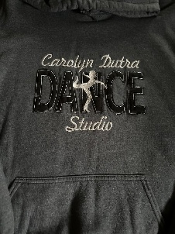 Hooded Sweatrshirt $ 60.00
Logo will be Tackel Twill and Embroidery
9.5 oz. premium cotton fleece
"rugger-cut" neck detail
60% cotton / 40% poly
Adult XS – 4XL (3XL & 4Xl add $8.00 to above price) Youth S – L

GARMENT MEASUREMENTS XS S M L XL 2XL 3XL 4XL
CHEST 21 22 23 24 25 26 27 28
BODY LENGTH 25 26 27 28 29 30 31 32
SLEEVE LENGTH 32 33 34 35 36 37 38 39
YS YM YL
CHEST 17 18 20
BODY LENGTH 20 22 24
SLEEVE LENGTH 24.5 27.5 30.5
CHEST - MEASURED ACROSS THE CHEST, 1" BELOW ARMHOLE BODY LENGTH - MEASURED FROM HIGH POINT SHOULDER TO BOTTOM SLEEVE LENGTH - MEASURED FROM CENTER BACK TO SLEEVE HEM
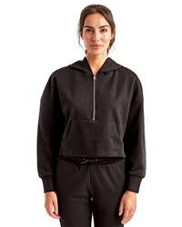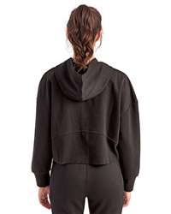 Scuba Hoodie $ 55.00
Logo will be embroidered on the left chest.
This is just like the popular LuLuLemon Scuba.
- 8 oz./yd²., 60/40 cotton/recycled polyester
- Cropped, oversized fit
- Half-zip fastening to front
- Pouch pocket
- Thumbhole on cuffs
- Paneling detail on back
Adult XS – 2XL
XS S/M L/XL 2XL
Body Length 19 3/5 20 1/5 21 1/5 22 4/5
Chest Width (Laid Flat) 23 3/5 25 2/5 28 1/3 29 1/9
Sleeve Length 18 4/5 19 3/5 20 2/5 21 1/5

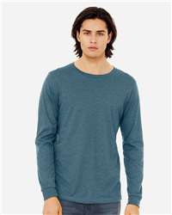 Long Sleeve Bella (Heathered Teal) T-Shirt $ 30.00
Screen Print Logo Adult & Youth
- 4.2 oz .Ring-spun cotton/polyester
- Pre-shrunk
- Retail fit
- Unisex sizing
- 2" ribbed cuffs
- Cover stitched collar
- Side seams
Adult XS S M L XL 2XL
Body Length 27 28 29 30 31 32
Chest Width 16 ½ 18 20 22 24 26
Sleeve Length 25 ½ 25 5/8 26 ¼ 26 7/8 27 1/2 28 1/8
Youth S M L
Body Length 21 1/8 22 1/4 23 3/8
Chest Width (Laid Flat) 15 1/4 16 1/4 17 1/4

We reserve the right to change the color / style of the item depending on the supplies available at the time the order is placed.
No exchanges or returns. Please be sure that you order the correct size.

Must have orders by November 22, 2025

