Vol. 48 #10 October 1, 2025
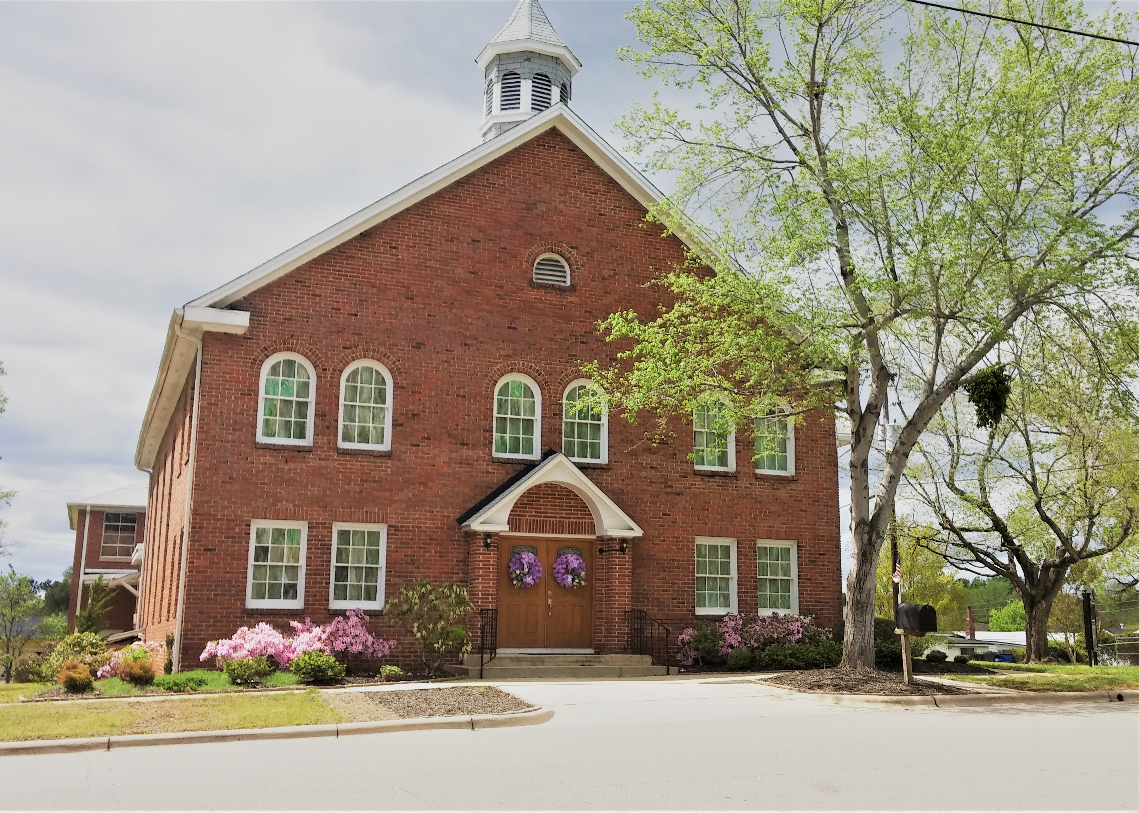

Caraleigh Baptist Church
October Newsletter
Established June 2, 1904

Desk of Pastor Michael Simmons
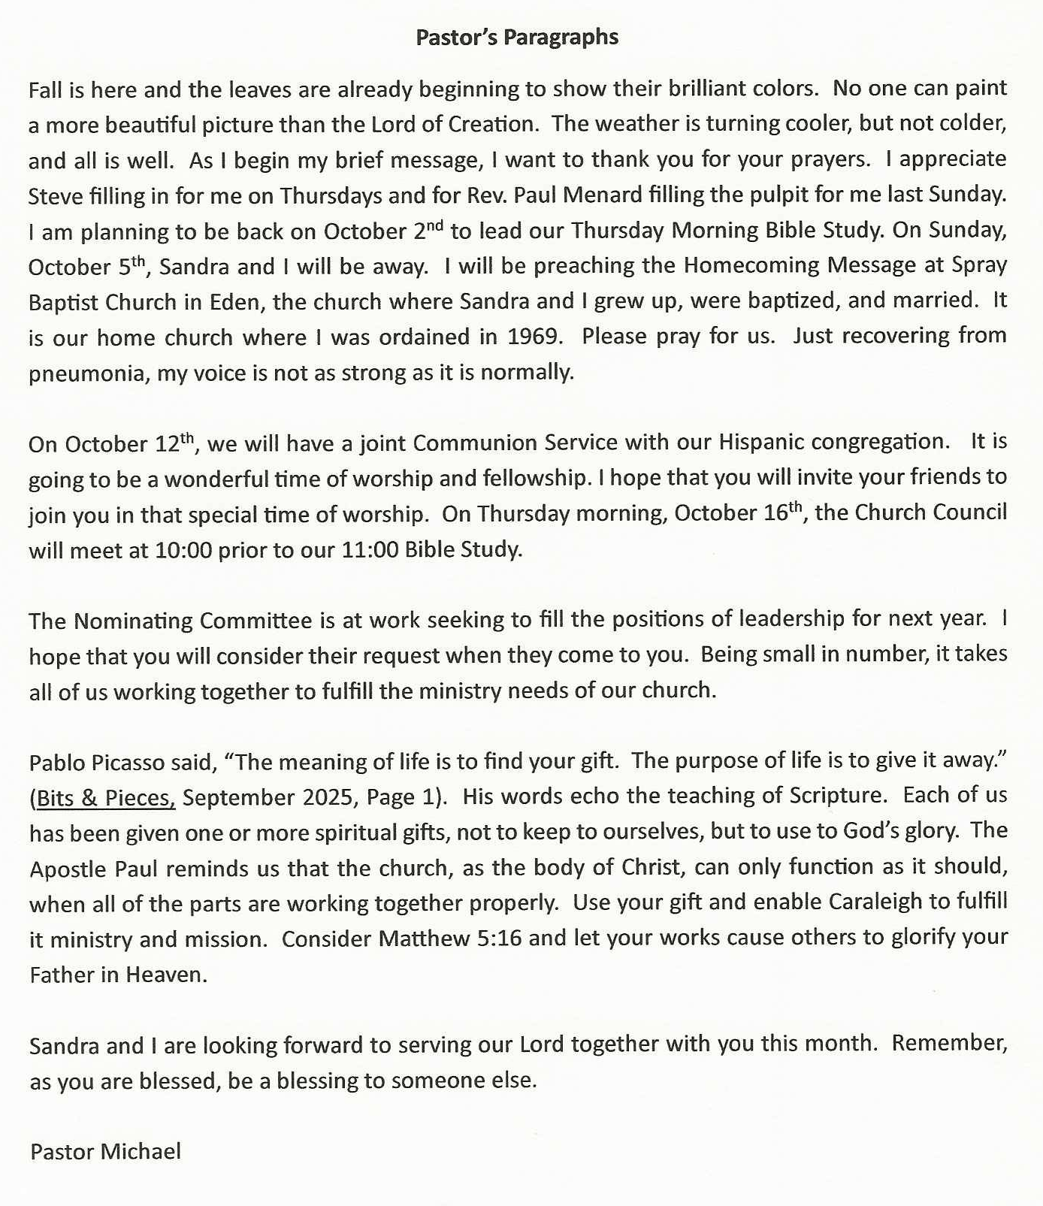

Looking Ahead
Church Service 11:00am Sunday School 9:45 am

Thursday - Bible Study 11:00am
October 12th Joint Communion Service with our Hispanic congregation.
16th Church Council Meeting @ 10:00am, prior to Bible Study @ 11:00am.

Birthdays & Anniversaries


Linda Suggs October 12
Sandra Simmons 27
Connie Crumpler 28

Edith Crumpler 30

Remember Pray for Our Shut – Ins

Rachel Council The Landing of Chestnut Grove, Phone# 919-247-0873
158 Chestnut Grove Church Rd. Sparta NC 28675

Edith Crumpler 54 Summit Ave. Raleigh NC 27603

Sue Denning Smithfield Manor Rm. 421 Phone# 919-616-9000
902 Berkshire Rd. Smithfield NC 27577

Clyde Hutton Raleigh Rehabilitation Center Rm. 426
116 Wade Ave. Raleigh NC 27605

Johnny Hutton Lawndale Manor Assisted Living Rm. 201
601 Lakeside Dr. Garner NC 27529

Linda Hutton Wedgwood Homes Apt. 15
740 Smallwood Dr. Raleigh NC 27605
Prayer Concerns

  Pastor & Deacons | Church Family | Caraleigh Comm. | United States
Leaders of the USA | World Leaders | Connie Crumpler | Jean Myers
Maria Walton | Angela Melton | Sue Denning | Sandra James
Carolyn Murphy | Windy Tedder | Clyde Hutton | Joyce Caudle
Linda&Karl Stephenson | Mike Coates | Eleanor Stokes | Sue Price
Cindy & Mike Poole | Rev. Simmons | Missionaries | MPLS Disaster
Linda & Glenn Suggs  items after the other gifts are taken out of it. The self-adhesive labels can help simplify the | CL O’ Neal

Music Notes: Desk of Margie Huggins

With October comes cooler weather and the trees will be adorned with the beauty of different colored leaves. God has given us such beauty decorating the world for us. Thank you Father, that with each season you give us such different kinds of beauty to look at.

Folliot Sandford Pierpoint, Born October 7,1835 in Bath England was an author, poet and hymn writer known for his religious and nature-inspired works. . He wrote “For the Beauty of the Earth”. Pierpoint composed this beloved Christian hymn in 1864, inspired by the natural beauty surrounding his hometown of Bath, England, it was originally written for a communion service. But when the song was sung on our shores it quickly became a song used for fall as well as Thanksgiving season. It is one of the very few songs that we have devoted solely to giving thanks to God.

“For the Beauty of the earth, for the glory of the skies, For the love which from our birth, over and around us lies. Lord of all to Thee we raise, this our hymn of grateful praise.
For Thyself, best gift divine, to our race so freely given. For that great, great love of Thine, Peace on earth and joy in heaven. Lord of all to Thee we raise, this our hymn of grateful praise.”

Pierpoint originally wrote the last line of each verse to read: “Christ our God to Thee we raise This our sacrifice of Praise.” It was later changed to what we know today. “Lord of all to Thee we raise, this our hymn of grateful praise.”

Inspiration & Humor: Desk of Teresa Moore

Son Bursts~ That if thou shalt confess with thy mouth the Lord Jesus, and shalt believe

Son light bursts, in thine heart that God hath raised him from the dead, thou shalt be saved.
through Autumn leaves For with the heart man believeth unto righteousness; and with the mouth
bringing rays of hope confession is made unto salvation.
to all who believe. For the scripture saith, Whosoever believeth on him shall not be ashamed.
Light glowing down, For there is no difference between the Jew and the Greek: for the same Lord
on the Truth and Way over all is rich unto all that call upon Him.
Autumn time blooms For whosoever shall call upon the name of the Lord shall be saved.
of a more restful day. Romans 10:9-13 KJV
Son beams bursts, “Who being the brightness of his glory, and the express image of his
into a golden hue person, and upholding all things by the word of his power, when he had by
flickers of God’s glory himself purged our sins, sat down on the right hand of the Majesty on high:”
come glistening through. Hebrews 1:3 KJV
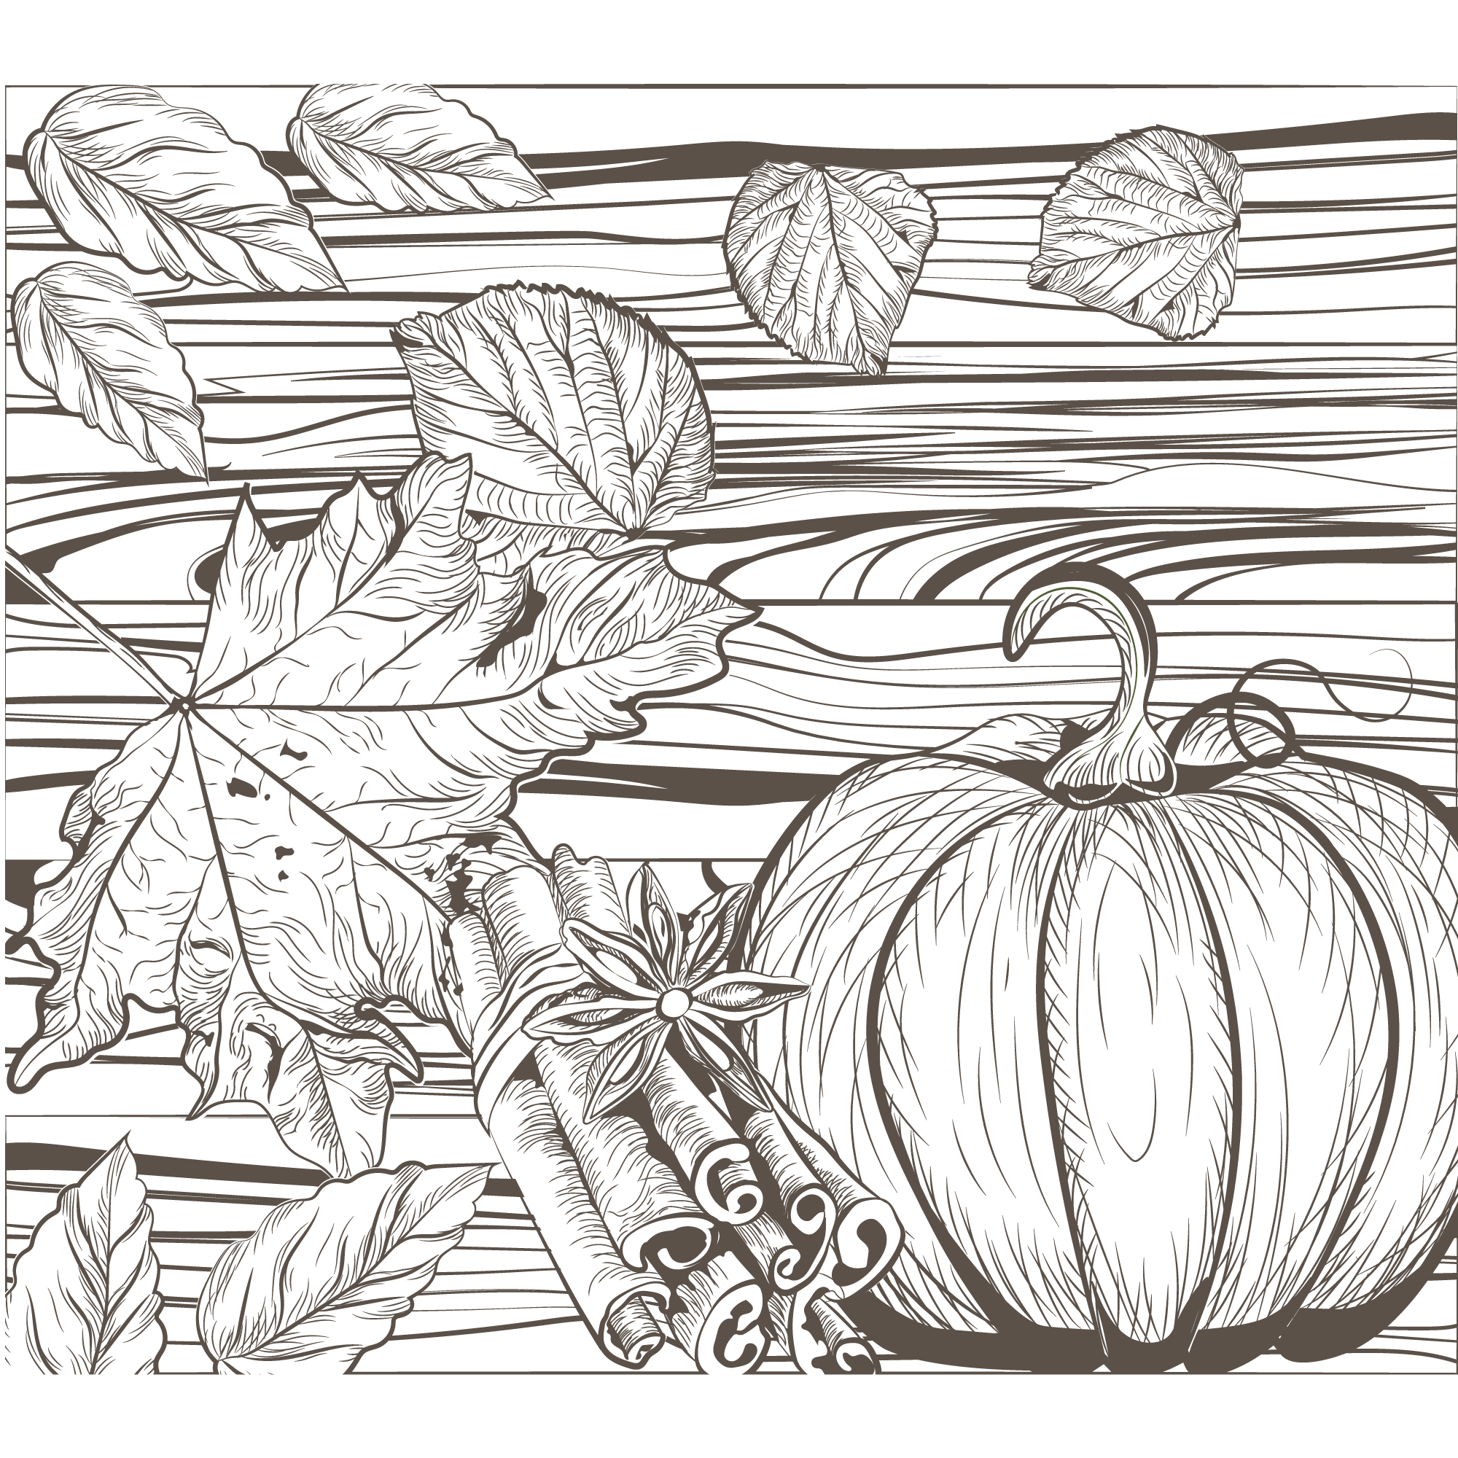
The radiance reveals,
the light of one Man
unveiling the way
to salvation’s plan.

Son rays bursts,
through Autumn trees
peaceful reminders
of things awaiting me!
~Deborah Ann Belka

Why do trees dislike test in the fall?
Because they get stumped by the questions
Why’s it so easy to trick a leaf in October?
They fall for anything.
What is worse than finding a worm in your apple?
Finding half a worm in your apple
Knock knock. Who's there? Orange. Orange who?
Orange you glad it is Fall!!


Have a wonderful October with all things color, pumpkins, apple picking, hikes, festivals, Music, State Fare, Food and football, ect,ect, ect. It’s a great time for Fall. Don't forget the spooks.
Thank our Heavenly Father for ALL.
Missions Report: Desk of Connie Crumpler







OPERATION CHRISTMAS CHILD – PRAY. GIVE. GET INVOLVED.

It’s that time again: Time to pack up a shoe box with items that will be sent to a child in this
country or in a foreign country where people are hungry for the saving grace of Christ. The
mission of Operation Christmas Child is to demonstrate God’s love in a tangible way to needy
children around the world, and together with the local church worldwide, to share the Good
News of Jesus Christ. “We want boys and girls around the world to know that God loves them
and has not forgotten them during this time of fear and uncertainty. Children need great joy now
more than ever. Most of all, they need the hope found only in the Gospel of Jesus Christ.” We
have participated in this ministry for several years and have blessed many families around the
world with our gifts.

We will place some cardboard shoeboxes in the church foyer for you to pick up along with self-
adhesive shoebox labels. There are a limited number of plastic containers available in the

church library in case you’d rather fill one of those instead of a cardboard box. The plastic
containers themselves are a gift because the child can use them to store personal and precious
items after the other gifts are taken out of it. The self-adhesive labels can help simplify the
packing process. There are instructions attached to the label telling you how you can follow
your box on its journey to its final destination. I will put out a few brochures in case you want
to use them to help in packing your shoebox, but I’m sure that y’all know how to do that by
now.
Samaritan’s Purse is also offering another way to fill a shoebox: building a shoebox online. You
will be able to pick the gender and age of the child for whom you want to fill a shoebox and
will be given a choice of items to go into the box. The cost of filling a box online, including
the $10 donation for shipping, is around $25. You will probably be spending less using this
method and will be assured of quality products in your shoebox. Build your box by going to
Samaritanspurse.org and Operation Christmas Child. I have set up a goal page under
Caraleigh Baptist Church through which you can build your shoebox and have it count
for us. By building your box online and using the goal page, you will have until December 31,
2025, to fill your shoebox.

REMEMBER: No toothpaste or candy will be allowed in the shoeboxes due to custom
regulations. The donation per shoebox is $10, which is needed to cover shipping and other
ministry expenses incurred by Samaritan’s purse. If you cannot give $10 and still want to fill a
shoebox, let me know. We have funds available to cover a portion of those expenses. Don’t be
embarrassed! We want as many people as possible to fill a shoebox if they want to! This is a
special ministry for our church and means a lot to many of our members who enjoy
participating!

THE SHOEBOXES WILL BE DUE BACK AT THE CHURCH BY SUNDAY,
NOVEMBER 16, 2025. We will have a short dedication service for the shoeboxes during the
service that morning.

If you have any questions or need help with this project, please contact me through my e-mail:
ccrumpler1947@gmail.com or by phone at 919-832-2408 or 919-210-8027.

This ministry is sponsored by the WMU of Caraleigh Baptist Church.

October is also Pastor Appreciation Month! Please be sure to let our pastor know how much
he means to you and to our church especially during this month!

I don’t have the final total on the donations for the North Carolina Missions Offering.
That total will be in the November newsletter. Remember that this offering is split between 3
groups: North Carolina Missions, WMU (The Heck Jones Offering) and the Baptist Children’s
Homes. Thank you for your generous donation to these missions!

We are all missionaries of the Gospel. Let’s live our lives as though we are the only Bible
someone will read. Let’s reflect Christ in all we say and do!

GIVE to missions (church offerings and organizations). Give sacrificially of
your money, time, and talents!

THANK God for your blessings.

PRAY for someone (and don’t forget the missionaries!)

BLESS someone you love (and those who may be a little more difficult to love)

TELL OR SHOW someone about Jesus. When you walk through your neighborhoods for
exercise or drive through them on your way somewhere, pray for each
resident and that God will fill their needs! When you’re at the grocery
store or pharmacy, smile and say “hello” to someone you see there. And
remember, to some people YOU may be the only Bible they read!

