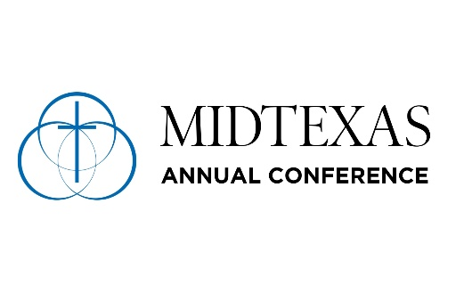
ANNUAL CONFERENCE CONNECTIONAL FUNDING PAYMENT FORM (3%)

Annual Conference: MIDTEXAS ANNUAL CONFERENCE

Church Name:
Church Address:
Church Preferred Phone Number:
Church Preferred Email Address:
Name of person completing form:

- Jan
- Feb
- Mar
- Apr
- May
- June
- July
- Aug
- Sept
- Oct
- Nov
- Dec
- Annual

- Other

If annual, which year? :

Total Payment (3%): $
Please make Connectional Funding checks payable to the
Mid-Texas GMC
Mail this form with check to:
Mid-Texas GMC
PO Box 5015, San Angelo, TX 76902

If you have questions, please contact Jim Noble at
jimnoble@midtexasgmc.org or (361)562-9147

