**NOTE: THERE IS NO VIDEO OR AUDIO ACCOMPANYING THIS CLASS. THE PRESENTATION SLIDES ARE INCLUDED TO AID YOU IN FOLLOWING ALONG AND COMPLETING THE HANDOUT REQUIREMENT.**

# How Depression Feels

* The images are dark and evocative. Desperately alone, doom, black holes, deep wells, emptiness.
* “I felt like I was walking through a field of dead flowers and found one beautiful rose, but when I bent down to smell it, I fell into an invisible hole.”
* “I heard my silent scream echo through and pierce my empty soul.”
* “There is nothing I hate more than nothing.”
* “My heart is empty. All the fountains that should run with longing, are in me dried up.”
* “It is entirely natural to think ceaselessly of oblivion.”
* “I feel as though I died a few weeks ago and my body hasn’t found out yet.”

# How Depression Feels

* C.S. Lewis:

“My heart is empty. All the fountains that should run with longing, are all dried up.”

* Charles Spurgeon:

“The iron bolt mysteriously fastens the door of hope and holds our spirits in gloomy prison.”

* Abraham Lincoln:

“I am now the most miserable man living. If what I feel were equally distributed to the whole human family, there would not be one cheerful face on earth. Whether I shall ever be better, I cannot tell; I awfully forbode I shall not. To remain as I am is impossible. I must die or be better, it appears to me.”

**What is Man?**

What is man, anthropology, forms the basis on how we view depression. In a *materialistic anthropology*, man is a being composed of material elements, his mental, emotional, and spiritual life being simply by-products of his ____________ structure. Human beings have not been created in the image of God—in fact, the very existence of the Creator is denied. Materialistic anthropology focuses on the physical side of man while denying the reality of what we might call his or her “mental” or “spiritual” side. This type of anthropology is guilty of idolatry: of worshiping an aspect of creation in the place of God.

“One of the basic presuppositions of the Christian view of man is belief in God as the Creator, which leads to the view that the human person does not exist _________________ or independently, but as a creature of God. “In the beginning God created the heavens and the earth.… So God created man” (Gen. 1:1, 27). ~ *Anthony Hoekema, Created In God’s Image*

# The Importance of the Doctrine of Man

Sorrow, hopelessness, and guilt are immaterial/ metaphysical/spiritual – that is, these features have no physical quality. The physical effects on the body can be observed but there is no scientific means to __________ or ___________ actual sorrow, hopelessness, or guilt.

* “Faith [*not material*] is the substance of things hoped for the evidence of things not seen.” (Hebrews 11:1)
* “Now hope that is seen is not hope. For who hopes for what he sees?” (Romans 8:24) Hopelessness is the metaphysical condition of the soul that longs for deliverance. The nature of both hope and hopelessness are related to a person’s faith.

# Defining Depression

* Many Bible translations do not have the word “depression.” The most common references to the feeling we often call depression is “despair”, “dejected”, “haggard,” (in appearance),

“heart weighted down,” “deeply grieved” or “sorrowful” and “hopelessness.”

* Depression is a persistent mood that is characterized by intense feelings of inadequacy, sadness, _____________________, pessimism, irritability, apprehension, and a decreased interest in or ability to enjoy normal activity.
* There is no evidence that depression has an ______________ base, though depression certainly has effects on the body. A person becomes depressed when he follows his feelings instead of his responsibilities.

# Defining Depression – Despair

Despair is the complete loss of hope. Circumstances can press in around us to the extent that we cannot see a way out. When fear grips us, hopelessness is right behind. The apostle Paul knew firsthand what that was like. Yet he wrote in 2 Corinthians 4:8, “We are hard pressed on every side, but not crushed; perplexed, but not in _____________.” Paul could suffer so many hardships yet not despair because his hope was not based on earthly circumstances. He held on to the knowledge that God was ultimately in control of it all (cf. Isaiah 55:8–9). He knew that, whether he lived or died (Philippians 1:23–24), whether he had plenty or had nothing (Philippians 4:12–13), God was in control and his sufferings would have meaning for all eternity (2 Corinthians 4:17).

**What is behind depression?**

Almost anything can be at the root of the counselee’s depression: a recent illness in which he gets behind in his work, hormonal changes, a reversal of his fortunes, the consequences of simple negligence, guilt over a particular sin, ____________ arising from jealousy or a disadvantageous turn of events, bad feeling resulting from resentment, worry, etc. The important fact to remember is that a depression does not result *______________* from any one of these factors, but rather comes from a cyclical process in which the initial problem is mishandled in such a way that it is enlarged in downward helical spirals that eventually plunge one into despair.

# Anger in depression

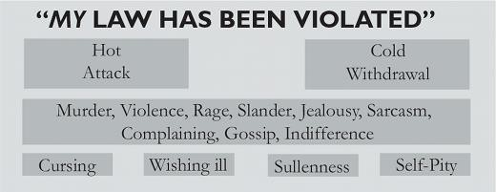

Note the various ways anger can be expressed.

# The Heart of Anger

* Anger says, “You have done wrong.” It is making some kind of judgment about a __________________ injustice.
* Grumbling is more about us than it is about other people or our circumstances. It is our hearts saying something against God.
* Do you see the role reversal in anger? God has a right to test our hearts. Who are we to test God and question him? It is the height of arrogance.

# What is Behind Depression? — “Too Much to Handle”

People who must make and keep their own schedules are the ones most ____________ to slide into depression. Those whose lives are structured by others (at work, etc.) less frequently become depressed. Counselors must teach counselees how to become selfstructured. A depressed person has given up because he thinks that things have become too much for him to handle. It will help to show him how to handle a bit each day until by structured living he has caught up. One need not slide into depression.

# Depression – Outside Events / Internal Beliefs

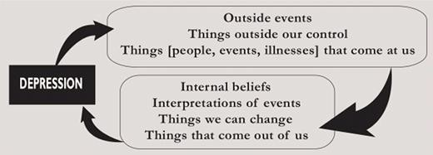

# The Downward Spiral of Depression

* Worrisome thoughts can lead to deeper despair and take one's eyes off God through a cycle of _______________ thinking and spiritual disconnection. When we allow our minds to dwell on anxious or sinful thoughts, it can create a downward spiral that pulls us away from faith.
* As these thoughts take root, they can erode our trust in God and make it difficult to focus on spiritual truths.
* “The downward cycle of sin moves from a problem to a faulty, _____________ response, thereby causing an additional complicating problem which is met by an additional sinful response, etc. That pattern needs to be reversed by beginning an upward cycle of righteousness resulting in further righteousness. Here the reverse pattern may be seen; a problem met by a biblical response leads to a solution which ___________________ one’s ability to solve new problems. The downward cycle enslaves one in hopelessness and guilt, thus bringing on a slowing down or cessation of activity, called depression.” ~Jay Adams*, The Christian Counselor’s Manual.*

See Diagram below on the downward and upward spiral of depression:

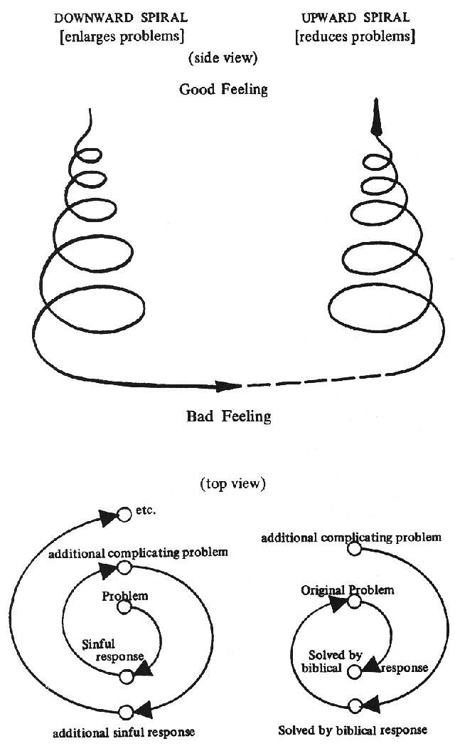

# Depression and Repentance

1. Sin will _____________ our thinking; we fail to see our own sin clearly. 1 Sam 15 (Saul), 2 Sam 11(David), Psalm 73 (Asaph).
2. Physical problems and sinful patterns increase (pride, blame shifting, etc.) Gen 3, Psalm 32.
3. Godly sorrow is needed, not worldly sorrow (repentance NOT remorse). 2 Sam 12 (Nathan to David), Psalm 51, 1 Cor 10.
4. True Repentance is confessing and receiving forgiveness AND it also includes _____________ from the sin and putting on the righteous opposite. Ephesians 4:22-24, Col 3:8-10.

# Finding Hope in Depression

Open the Bible and use the cause and effect that God gives us:

* Psalm 32
  1. Sin makes your life miserable (3-4)
  2. David’s depression ______________ when he repented of his sin (1,5)
  3. Our sin is covered, forgiven, and not imputed against us because of Christ (Isa 53:3ff)
* Psalm 73
  1. __________________ in the world can test your faith (1-14)
  2. You need a change in perspective - from the here and now to the eternal and heavenly (15-28)
  3. The world does not change, but the psalmist does, as he finds satisfaction in God alone (25-26)
  4. Christ endured injustice for us and makes us fit for God’s holy presence.

# Biblical Portraits of Depression

* Cain – Genesis 4

Fear is the most obvious co-conspirator with depression; anger is the most common. The formula is a simple one: Sadness + Anger = Depression

* Elijah – the events following Mount Carmel (1 Kings 18–19)
  1. See Elijah’s boldness – 1 Kings 18:21
  2. Elijah’s _____________________ not met – 1 Kings 19:2
  3. Overcome by Fear – 1 Kings 19:3
  4. Elijah overwhelmed by sadness and ready to die – 19:4

* Solomon – Ecclesiastes 2

Solomon’s description of his own mindsets, emotional responses, and failed efforts to remedy human nature mimics what psychology refers to as bipolar disorder.

* 1. ____________ self-confidence – Ecclesiastes 2:1-10, 12-14.
  2. Outcome was not what was expected – Ecclesiastes 2:11, 15-23.
  3. Acceptance – Ecclesiastes 2:24

* See Psalm 42 and 43 – Thirsting for God in Trouble and Exile / Prayer for Deliverance

* Psalm 88
  1. Depression can be very deep.
  2. Depression does not always go away ________________.
  3. Sometimes depressed people simply need to be encouraged to endure.

* 2 Corinthians 4
  1. Hard times abound; we feel bad; but we’re not destroyed or consumed (8-9)
  2. We have the life of Jesus in our bodies which is more powerful than the oppression of depression (10-12)
  3. Must not lose heart though outer body is decaying because our hearts are being renewed daily (16)
  4. This hard time now doesn't compare with eternity and glory!

* Peter the night before Jesus is on trial
  1. See Peter’s boldness – Matthew 26:33
  2. Ready to fight – Matthew 26:51
  3. Overcome by Fear and denies Christ – Matt 26:69-74
  4. Peter overwhelmed by sadness and guilt and weeps bitterly – Matthew 26:75

# Depression has a Redemptive Purpose

* Remember – Deep sorrow (depression) is not always sinful!
* Depression can reveal issues that may have been previously ignored which allows the individual to face their **_________________**. 1 Kings 19 (Elijah); 2 Cor 7:5-6, John 21 – Peter restored by the Lord Jesus.
* Difficult experiences are designed to lead to personal growth. This can be seen in the use of endurance. James 1:2-4, Rom 5:3-5; Heb 12:1-3.
* Depression should increase one’s capacity for empathy. Isa 53, 2 Cor 1:3-7, Heb 4:15; • Everything, including depression, points to the Lord’s larger divine purpose for our life. Rom 8:28-29; Gen 50:20.

**Finding Hope in Depression** – Ed Welch, *Depression: Looking Up from the Stubborn Darkness*.

* “You might be able to discern some obvious causes of suffering, and knowing those causes might help alleviate the pain. We are all for less pain. But all suffering is intended to ____________ us to fix our eyes on the true God. Therefore, depression, regardless of the causes, is a time to answer the deepest and most important of all questions:

Whom will I trust? Whom will I worship?”

# Finding Hope in Depression – Redirecting Your Focus

* 2 Chronicles 20:10–12 — Jehoshaphat’s Prayer
* Hebrews 12:1-3 — Fixing our eyes of Jesus

**How do we minister, shepherd and counsel suffering in depression?**

1. Listen sympathetically and patiently. “Help me understand your thoughts, feelings, your motivations. What do you think is causing you to think and feel the way you do?”
2. What is the cause of this depression?
3. What is the history/pattern of depression?
4. What lies is your depression telling you? (false hopes need to be identified) 1 Tim 6:17
5. Are the person’s physical needs being met?
6. Who else is being affected? Depression is contagious. Gal. 6:1
7. Offer encouragement and give hope. Romans 5:3-5, Romans 15:13
8. Pray with and for them.
9. Other homework includes Bible reading and study and Scripture _______________________ on the passages we just covered.
10. It should also include dealing biblically with depression.
    1. Confess and repent of sin. Ps 32:5, Psalm 51, 1 John 1:9.
    2. Submit to God’s sovereignty over your circumstances. Ps 73:15ff; Rom 8:28; Gen. 50:20.
    3. Stop listening to yourself and start talking to yourself. Phil 4:8 iv. Hope in God. Ps 42:5, 11; 43:5; Rom 8:29ff; Heb 13:5.
    4. Offer thanks and praise to God. Make a list of all you have been blessed with and have to be thankful to God for. Ps 43:4; 68.3; 32:11.
    5. Start to cycle out of depression by serving God and others. Romans 12:20-21.

**Depression Counseling Keys** - Ed Welch, *Depression: Looking Up from the Stubborn Darkness*.

* The successful end and goal to overcoming depression is hope and joy.
* Hope is a key issue in depression and the critical transition is from hopeless to hopeful, and every depressed person should set out to become an expert in joy. (Rom. 15:13)
* Hope is what one looks forward to as the beacon of light through the fog and the anchor for our soul. (Heb. 6:19)
* Changing from hopeless to hopeful is necessary and available on this side of life, not just reserved for glory. Hope is found in the Christian’s assurance of God’s promises and faithfulness to keep His promises.
* Hopelessness is in one who is unwilling to wait on the Lord, and is wanting something more than Jesus, and not really knowing Jesus. Heb. 6:15
* “Hopelessness is ultimately a denial of the resurrection.” 1 Cor. 15:13-19
* The everlasting, faithful promises of God, and true hope in God, must fill the sufferer and he must submit and open his eyes to see the goodness in the land of the living in moving from hopeless to hopeful.
* As hope is a process and skill one develops through submitting to the Lord, joy is the attitude and vehicle necessary to fuel and carry one along the path to deliverance.
* Joy takes our attention off ourselves and places it on God and all the things that have God as their source. (Neh. 8:10)
* As the depression sufferer seeks for and finds joy in the Lord and the
* things of the Lord, his mind is turned to the Lord (upward and outward) and away from just himself (inward).
* One begins to fully experience joy when he moves from the inward selfishness to the selflessness of outwardly loving God and others.
* Finally, true joy comes with practice and one must study, pray, fellowship with God’s people, and look for and appreciate the evidence of God’s joy.
* True joy comes when we learn to enjoy the things that God enjoys. Jude 24-25

# Do not get carried away by the error of unprincipled men – 2 Peter 3:14-18

Class Summary: __________________________________________________________________________________________________________________________________________________________________________________________________________________________________________________________________________________________________________________________________________________________________________________________________________________________________________________________________________________________________________________________________________________________________________________________________________________________________________________________________________________________________________________________________________________________________________________________________________________________________________________________________________________________________________________________________________________________________________________________________________________________________________________________________________________________________________________________________________________________________________________________________________________________________________________________________________________________________________________________________________________________________________________________________________________________________________________