**Biblical Marriage Part 2 - Genesis 2:18-24; Ephesians 5:22-33; 1 Cor. 11:3; 1 Peter 3:1-7**

**Basic Marriage Principles**

1. Both of You: Put Jesus First; Love Jesus Most: Matthew 22:35-38

2. Both of You: Be Empowered, Changed, and Comforted by the Trinity—Be Filled by the Spirit, Empowered by the Son, Comforted by the Father: Eph. 5:18; 6:10-18; 2 Cor. 1:3-8

3. Both of You: Remember Who Your Enemy Is—Satan! Eph. 6:11-12

4. Both of You: Take Personal Responsibility: Joshua 1:6-9; Philippians 4:9

5. Both of You: Take the Log Out of Your Own Eye, Confess, Repent: Matthew 7:3-5; James 4:1-4

6. Both of You: Forgive Each Other, Reaffirm Your Love, Comfort Each Other: 2 Corinthians 2:5-11

7. Both of You: Speak Life Words, Not Death Words to Your Spouse: Ephesians 4:29; Proverbs 18:21

8. Both of You: Put the Interests of Your Spouse First in the Power of Christ: Phil. 2:1-5

9. Husband: Lead, love, and shepherd Your Wife with Christ’s Sacrificial, Other-Centered Love: Ephesians 5:22-33; 1 Peter 3:7

10. Wife: Respectfully love and submit to your Husband like the Church loves and submits to Christ: Ephesians 5:22-33; 1 Peter 3:1-6

**I. Biblical Basis for Role Differences**

The Bible teaches _COMPLEMENTARIANSIM_______

_EQUALITY_ in spirituality and personhood (Gen. 1:26-28, Gal. 3:25-29, 1 Peter 3:7)

Functional _ROLE DIFFERENCES_ in the home and in the church. (Proverbs 31:10-31, Ephesians 5:22-33, 1 Peter 3:1-7).

Complementarian relationship - “gender roles are ordained by God and men and women are created to complement one another. God’s roles for husbands and wives are distinct and part of God’s creative order.

Gender roles are Christ-honoring as men/husbands love and provide leadership to their wives and family, and women/wives submit to their husbands and his leadership as the most suitable helper.

Gender roles established by God are given to the church as men assume leadership over the church and women submit to male leadership.

God-ordained and Christ-honoring male headship is not dominating or oppressive, but is sacrificial, loving, and servant leadership.

Female submission is willing, voluntary, and not forced subjugation and is done as a picture of the church submitting to Christ.

Equality in spirituality and personhood. 1 Peter 3:7 - spouses are joint heirs. Galatians 3:28 says: “*There is neither Jew nor Greek, there is neither slave nor free, there is neither male nor female; for you are all one in Christ Jesus*.”

Worldly culture (sadly, in many churches now) hold to the position of _EGALITARIANISM”_. Egalitarianism holds that there are no gender distinctions as to marriage or gender roles or functions in the family or church.

No one is the designated leader and all share in the leadership, or even more confusing no one leads at all as the couple claim both are equal at leading and both are equal in every way.

Where there is no fixed leadership in the family (or any institution ) conflict and misdirection will eventually arise.

Biblical marriage is not a 50/50 relationship. The closest is a 51/49 with the husband at 51% of leadership responsibility. This is not demeaning to the wife as it is God’s design and intention.

**II. Biblical Basis for Role Differences**

Genesis 2: 18-24 – “a helper suitable for him”.

1 Corinthians 11:3 – “Headship”

Ephesians 5:22-33 – “Headship and Submission”

HUSBAND LOVES AND LEADS HIS WIFE

WIFE SUBMITS TO AND RESPECTS HER HUSBAND

**III. BIBLICAL ROLE AND RESPONSIBILITIES OF A HUSBAND**

A. God calls men to leadership - God’s plan since __CREATION________.

1. God gave man the responsibility to lead, provide, protect, and defend and the woman was created to help him in his role (Gen. 2:16-18).

*And the LORD God commanded the man, saying, "You may surely eat of every tree of the garden, but of the tree of the knowledge of good and evil you shall not eat, for in the day that you eat of it you shall surely die.“ Then the LORD God said, "It is not good that the man should be alone; I will make him a helper fit for him."*

2. Though Adam has been established as the head, the adversary comes after the ____WOMAN___ (Genesis 3:1).

3. Roles are important to God. When men just try to make everyone happy instead of leading biblically, children oppress and women rule, and the result is destruction (Isaiah 3:12).

B. What is leadership?

1. Biblical Leadership is not being a dictator, nor is it all the __DECISION___ _MAKING__. It is servant, sacrificial leadership (John 13:1-17).

2. Spiritual leadership begins with respect for the _AUTHORITY_ of the church (Hebrews 13:17).

3. Leadership is __OTHERS__ based and goal-oriented (Ephesians 5:26-28; 6:4).

4. Leadership sets the example of __PRACTICE__ (Phil. 4:9).

5. Lead by living joyfully and setting emotional tone of joy in the home (Pr. 5:18).

6. A leader solves problems biblically (Eph. 4:25-32, rules of communication).

7. It is man’s God-__ASSIGNED___ responsibility to be the spiritual leader.

**IV. A Husband is to Love His Wife**

A. The Command: Love your wife __SACRIFICIALLY_____ (Ephesians 5:25).

1. Love her sacrificially as Christ loved the church.

2. Make every decision based on what’s best for her.

3. Love her in spite of her failures and without bitterness (Col. 3:19).

B. The Method:

1. The Husband __SANCTIFIES___ his wife (Ephesians 5:26).

*so that He might sanctify her, having cleansed her by the washing of water with the word,*

2. Husband is the _PROTECTOR_ / _DEFENDER_ of his wife (2 Tim. 3:1-7).

C. The Goal: (Ephesians 5:27).

The husband present his wife as a pure, spotless bride as Christ does the church!

D. A husband loves his wife - Constantly assures his wife of his love (Eph. 5:28-33a).

1. Love her first—no friendships with anyone stronger than with wife.

2. Love her most—more than job, children, mother.

3. Love her unmistakably - constantly in process of convincing her of his love.

4. Loves her as his own body (Ephesians 5:28).

E. Summary

Husbands are to love their wives with a love that is unconditional, sacrificial, purifying, nurturing, cherishing, and understanding.

This calling to love our wives as Christ has loved us can be overwhelming.

Who is sufficient for these things? Who can live up to such a standard?

This should humble us before God and our wives. We need much grace. We have hope that as we better know and experience Christ’s love for us, we will better be able to express His love to our wives.

F. Questions for Reflection Regarding a Husband’s Love for His Wife

1. In what ways is the love of a husband to resemble the love of Christ?

2. How can a husband’s love purify his wife?

3. Does the responsibility of a husband to nourish his wife mean that he is to be the primary provider?

4. What would you say to a husband who claims that his wife is too hard to love?

**V. Husbands are Learners**

A. A husband learns to UNDERSTAND and honor his wife (1 Peter 3:7).

1. He learns about and focuses on her true needs (Philippians 2:3-4).

2. The world says: “You can’t understand a woman.”

a. The Bible says: “Live with her in understanding.”

b. This command takes time.

c. This command takes study—to learn strengths, weaknesses, annoyances.

d. This command takes sensitivity—learn to be compassionate.

e. This command includes recognizing my selfishness and honoring her need for affection.

3. Learning affects a husband’s spiritual life. Without it his prayers are hindered   
 (Psalm 66:18).

V. Husband’s Summary.

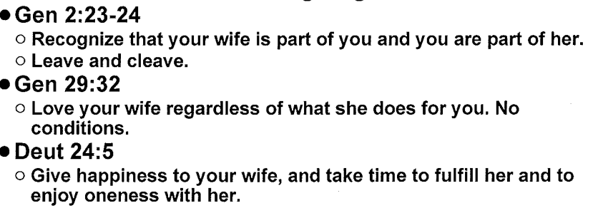

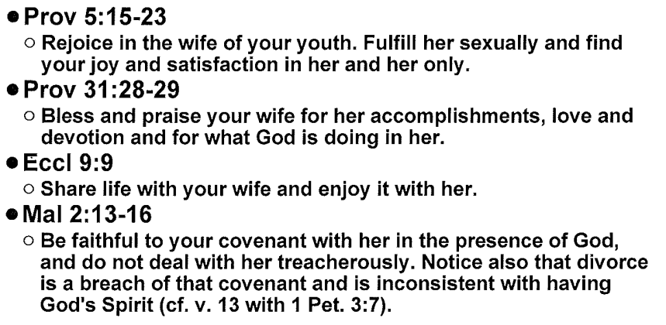

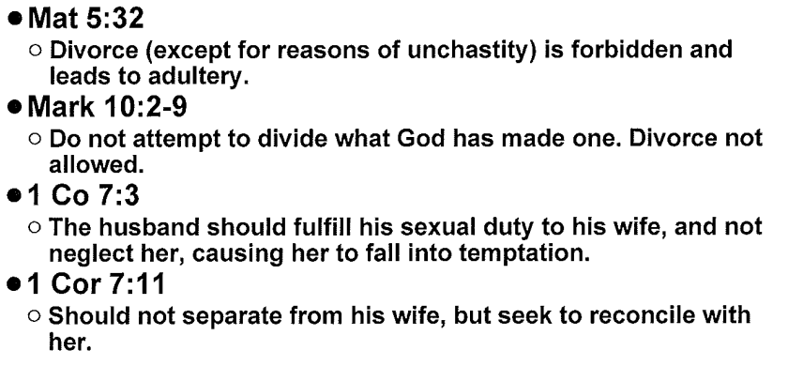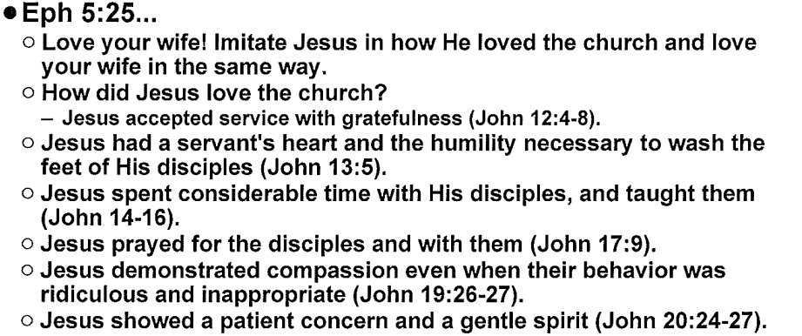

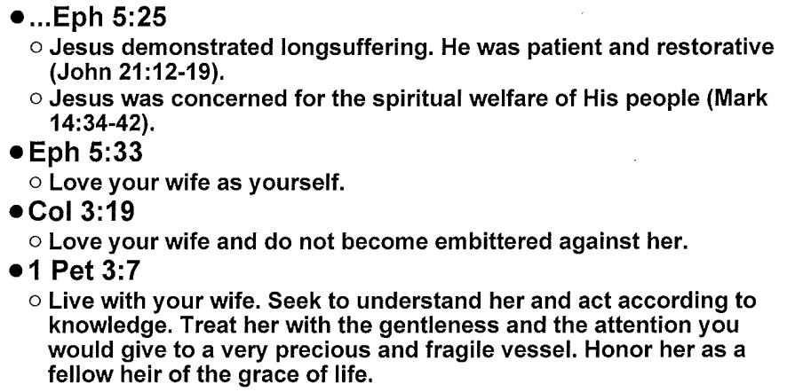

VI. **BIBLICAL ROLES AND RESPONSIBILITIES OF A WIFE**

Ephesians 5: 22-24 –

1 Peter 3: 1-6 –

1 Corinthians 11:3 –

A Wife Submits to Her Husband: Submission is a Military Term Meaning “To _VOLUNTARILY__ Arrange Yourself In Rank __UNDER AS TO THE LORD__________”

A. The history of mankind’s response to submission:

1. Started with __SATAN___ (Isaiah 14:13)

2. Continued in the __GARDEN___________ (Genesis 3:5)

3. Extended to all _MANKIND___ (Isaiah 53:6)

4. Mankind’s rebellion to authority is intensified in the last days (2 Tim. 3:1-2).

5. Sbmission is _MISREPRESENTED_ and misunderstood (Rom. 6:16)

B. Wrong ideas about submission:

1. That the wife is _INFERIOR________.

2. That the husband is _INFALLIBLE____________.

3. That a wife cannot __THINK___ and should not __SPEAK___.

4. That a wife has no _INFLUENCE______.

C. Biblical teaching about submission:

1. Demonstrated perfectly by Jesus (1 Corinthians 11:3).

2. It is a way of life for all __BELIEVERS____. (Ephesians 5:22 explains how husbands and wives do vs. 21, just as 6:1 explains how children and parents do vs. 21, and 6:5 explains how slaves and masters do vs. 21).

3. Submission is the mode for the most _SUITABLE__ __HELPER___.

4. Submission is an __ATTITUDE___ toward God (Romans 13:1-2).

5. Submission is proof of a wife’s __LOVE__ for her husband. Limited only by the Bible—a husband has no authority to ask his wife to sin.

VII. **A Wife Respects Her Husband.**

A. Respect includes:

1. Expressing acceptance of his __AUTHORITY_____.

2. Showing _CONFIDENCE________ in his decisions.

3. __FLEXIBILTY__of schedule to make room for his priorities.

4. Choosing not to remember his past ___FAILURES______.

5. Being _GRATEFUL_ to him, adjusting lifestyle to fit under family income.

6. Not publicly criticizing and not making statements that do not build him up.

B. Results of disobeying God and not reverencing/respecting husbands:

1. Jealousy, criticism, and resentment.

2. Anger, arguing or silence, and tension.

3. Unforgiveness, bitterness, contempt.

4. Depression, discouragement, despair, stonewalling.

5. In the case of a believing wife with an unbelieving husband, she refuses to do her part in winning him to Christ (1 Peter 3:1-2).

**VIII.** **A Wife Helps Her Husband**.

A. _SUITABLE______ __HELPER__ – “completing, complementing, corresponding to, fitted perfectly to, and adapted to meet needs.”

B. Literally, the Hebrew word means that the wife makes up what is lacking in her husband’s life (Genesis 2:18, 1 Cor. 11:8-9).

C. Helper is not a demeaning term, nor does it mean somehow “second class.” In fact, the same word for “helper” is used 14 other times in Scripture to describe God as our help (Psalm 27:9, 30:10, 40:17, 63:7, 70:5).

D. No one can ___COMPLEMENT______a husband like his wife can. Here just a few of the ways she can be his fitting helper/helpmate:

1. Provide companionship – emotional fulfillment

2. Provide sexual fulfillment – pleasure and protection.

3. ___SPIRITUALLY_____ – pray for, encourage.

4. ___MINISTRY______ – serve together

5. ____PARENTAL____ – authority over the children in unity with her husband

6. _____DOMESTICALLY___ – add color and depth

7. __ATTITUDINALLY______ – promote joyful submission to authority.

8. ___FINANCIALLY____– watchful and protective while cheerfully generous.

9. ___PREPARATION____ – discerning of possible future needs.

IV. Wife Submission – A Summary.

