

A summary of the Bible from beginning to end, using only the words of Scripture (English Standard Version).

We pray that you will grow in your appreciation of God's Word, and will embrace your place in God's story.

* Compiled by Mike Moses
* Art by John Minier

Holy, holy, holy, is the Lord God Almighty, who was and is and is to come!

In the beginning was the Word, and the Word was with God, and the Word was God. All things were made through him. In him was life, and the life was the light of men. The light shines in the darkness, and the darkness has not overcome it.

In the beginning, God created the heavens and the earth.
God said, “Let there be light,” and there was light.
God said, “Let the dry land appear.”
“Let the earth sprout plants yielding seed, and fruit trees bearing fruit.”
“Let there be lights in the expanse of the heavens.”
“Let the waters swarm with living creatures, and let birds fly above.”
“Let the earth bring forth livestock and creeping things and beasts of the earth.” And it was so.
Then God created man in his own image; male and female he created them. And God blessed them, and said to them, “Be fruitful and multiply and fill the earth and subdue it, and have dominion.”

And God saw everything that he had made, and behold, it was very good.

And the Lord God planted a garden in Eden, with every tree that is pleasant to the sight and good for food. The tree of life was in the midst of the garden, and the tree of the knowledge of good and evil.

The Lord God put the man in the garden of Eden to work it and keep it. And the Lord God commanded the man, saying, “You may surely eat of every tree of the garden, but of the tree of the knowledge of good and evil you shall not eat, for in the day that you eat of it you shall surely die.”

And the man and his wife were both naked and were not ashamed.

Now the serpent said to the woman, “Did God actually say, ‘You shall not eat of any tree in the garden’?”
And the woman said to the serpent, “We may eat of the fruit of the trees in the garden, but God said, ‘You shall not eat of the fruit of the tree that is in the midst of the garden, neither shall you touch it, lest you die.’”
But the serpent said to the woman, “You will not surely die. For God knows that when you eat of it your eyes will be opened, and you will be like God, knowing good and evil.”

So when the woman saw that the tree was good for food, and that it was a delight to the eyes, and that the tree was to be desired to make one wise, she took of its fruit and ate, and she also gave some to her husband who was with her, and he ate.

Then the eyes of both were opened, and they knew that they were naked.

The Lord God made for Adam and for his wife garments of skins and clothed them.
He said to the serpent: “I will put enmity between you and the woman, and between your offspring and her offspring; he shall bruise your head, and you shall bruise his heel.”
And to Adam he said: “Cursed is the ground because of you, thorns and thistles it shall bring forth for you.”

And he drove out the man, and at the east of the garden of Eden he placed the cherubim and a flaming sword to guard the way to the tree of life.

The whole creation has been groaning together in the pains of childbirth until now.

Sin came into the world through one man, and death through sin, and so death spread to all men because all sinned.

The wrath of God is revealed from heaven against all ungodliness and unrighteousness of men, who by their unrighteousness suppress the truth. For although they knew God, they did not honor him as God or give thanks to him, but they became futile in their thinking, and their foolish hearts were darkened.

Now the earth was corrupt in God’s sight, and filled with violence. And God said to Noah, “Make yourself an ark. For I will bring a flood of waters upon the earth to destroy all flesh. But I will establish my covenant with you, and you shall come into the ark, and your sons, your wife, and your sons’ wives with you. And of every living thing of all flesh, you shall bring two of every sort into the ark to keep them alive with you.

The flood continued forty days on the earth. The waters increased and bore up the ark, and it rose high above the earth. And all flesh died that moved on the earth, and all mankind. Only Noah was left, and those who were with him in the ark.

Now the Lord said to Abram, “Go from your country and your kindred to the land that I will show you. And I will make of you a great nation, and I will bless you and make your name great, so that you will be a blessing.
I will bless those who bless you, and him who dishonors you I will curse, and in you all the families of the earth shall be blessed.”
And Abram believed the Lord, and he counted it to him as righteousness.
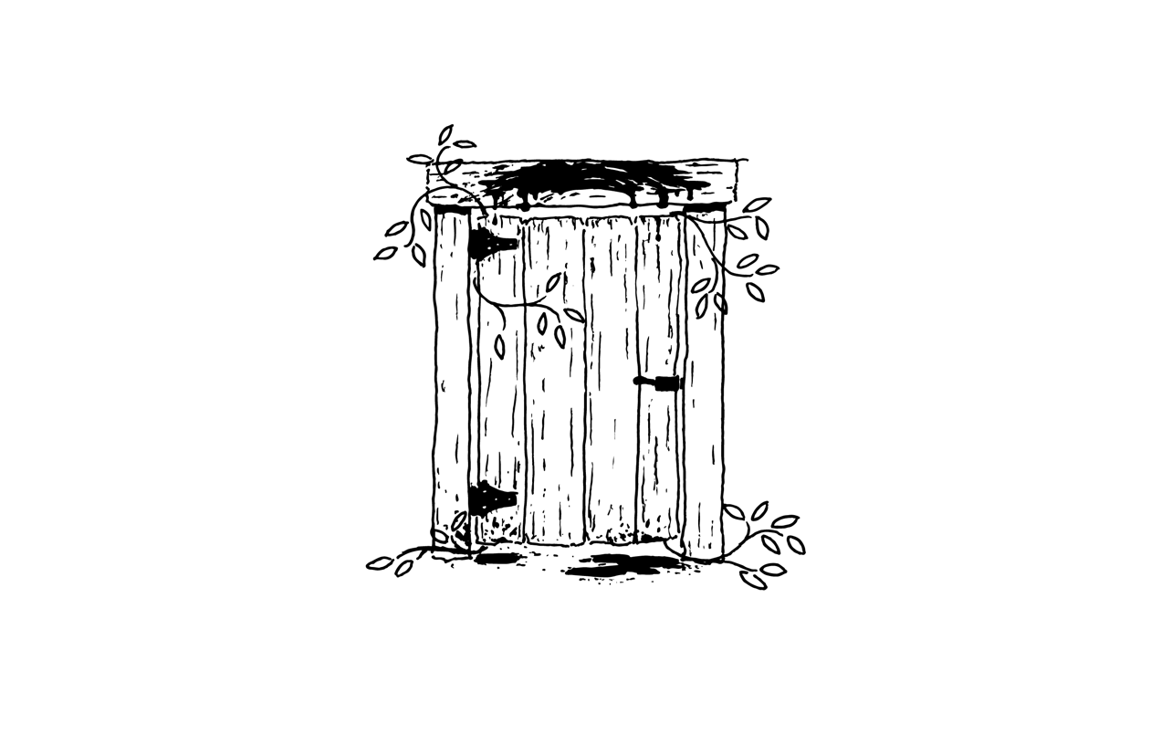
The angel of the Lord appeared to Moses in a flame of fire out of the midst of a bush. And he said, “I am the God of your fathers, the God of Abraham, the God of Isaac, and the God of Jacob. I have surely seen the affliction of my people and have heard their cry. I have come down to deliver them out of the hand of the Egyptians and to bring them up out of that land to a good and broad land, a land flowing with milk and honey.”

In the sight of Pharaoh Moses lifted up the staff and struck the water in the Nile, and all the water in the Nile turned into blood.
And frogs came up and covered the land of Egypt.
And gnats…and swarms of flies…
All the livestock of the Egyptians died.
And boils came upon all the Egyptians.
And the Lord sent thunder and hail, and fire ran down to the earth.
And locusts covered the face of the whole land.
And there was pitch darkness in all the land of Egypt three days.

Then the Lord said, “Every man shall take a lamb without blemish, and kill their lambs at twilight. Then they shall take some of the blood and put it on the doorposts and lintel of the houses.
I will pass through the land of Egypt that night, and I will strike all the firstborn in the land of Egypt; and on all the gods of Egypt I will execute judgments. The blood shall be a sign for you, and when I see the blood, I will pass over you, and no plague will befall you.

At midnight the Lord struck down all the firstborn of the land of Egypt. Then Pharaoh summoned Moses and said, “Up, go out from among my people, both you and the people of Israel.”

But the Lord hardened the heart of Pharaoh king of Egypt, and he pursued the people of Israel.
And Moses said to the people, “Fear not, stand firm, and see the salvation of the Lord.”
Then Moses stretched out his hand over the sea, and the Lord drove the sea back, and the waters were divided. And the people of Israel went into the midst of the sea on dry ground and walked through the sea. Then the waters returned and covered the Egyptian chariots and the horsemen. Thus the Lord saved Israel that day from the hand of the Egyptians.
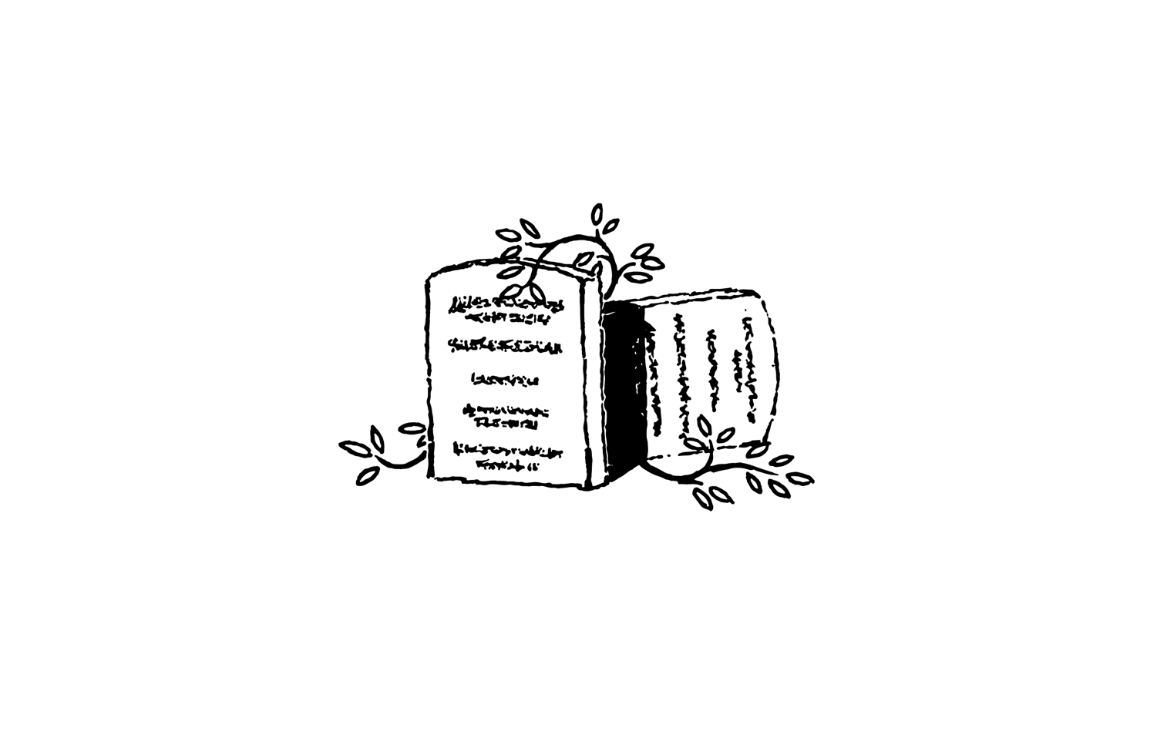
The Lord said “You yourselves have seen what I did to the Egyptians, and how I bore you on eagles’ wings and brought you to myself. Now therefore, if you will obey my voice and keep my covenant, you shall be my treasured possession among all peoples.” All the people answered together and said, “All that the Lord has spoken we will do.”

And God said,
“You shall have no other gods before me.
“You shall not make for yourself a carved image to bow down to or serve.
“You shall not take the name of the Lord your God in vain.
“Remember the Sabbath day.
“Honor your father and your mother.
“You shall not murder.
“You shall not commit adultery.
“You shall not steal.
“You shall not bear false witness.
“You shall not covet”

When Moses came down from Mount Sinai, with the two tablets of the testimony in his hand, he did not know that the skin of his face shone because he had been talking with God.
The Lord, a God merciful and gracious, slow to anger, and abounding in steadfast love and faithfulness, forgiving iniquity and transgression and sin, but who will by no means clear the guilty.

Now if the ministry of death, carved in letters on stone, came with such glory that the Israelites could not gaze at Moses’ face because of its glory, which was being brought to an end, will not the ministry of the Spirit have even more glory?

Aaron shall kill the goat of the sin offering that is for the people and bring its blood inside the veil, sprinkling it over the mercy seat. Thus he shall make atonement, because of the uncleannesses of the people of Israel and because of all their sins.

[But] The law can never, by the same sacrifices that are continually offered every year, make perfect those who draw near. For it is impossible for the blood of bulls and goats to take away sins.
So then, the law was our guardian until Christ came, in order that we might be justified by faith.
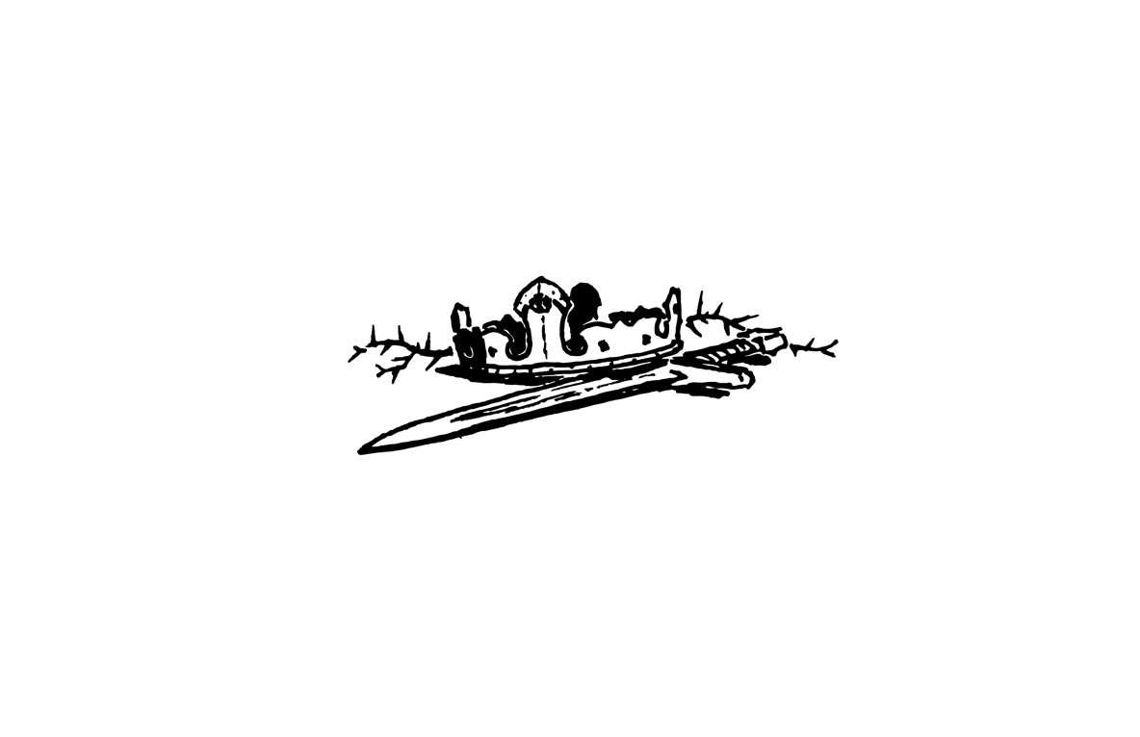
After the death of Moses, the Lord said to Joshua, “Arise, go over Jordan, you and all this people, into the land that I swore to their fathers to give them. This Book of the Law shall not depart from your mouth, but you shall meditate on it day and night, so that you may be careful to do according to all that is written in it. For then you will make your way prosperous, and then you will have good success. Be strong and courageous. Do not be frightened, and do not be dismayed, for the Lord your God is with you wherever you go.”

Thus the Lord gave to Israel all the land that he swore to give to their fathers. And they took possession of it, and they settled there. And the Lord gave them rest on every side. Not one word of all the good promises that the Lord had made to the house of Israel had failed; all came to pass.

[But] there arose another generation after them who did not know the Lord or the work that he had done for Israel. And the people of Israel abandoned the God of their fathers, who had brought them out of the land of Egypt. So the anger of the Lord was kindled against Israel, and he gave them over to plunderers, and they could no longer withstand their enemies.

The Lord was moved to pity by their groaning because of those who afflicted and oppressed them. Then the Lord raised up judges for them, and he saved them from the hand of their enemies all the days of the judge. But whenever the judge died, they turned back and were more corrupt than their fathers, going after other gods, serving them and bowing down to them.
Then all the elders of Israel gathered together and said to Samuel, “Appoint for us a king, that we also may be like all the nations, and that our king may judge us and go out before us and fight our battles.”

Then Samuel took the horn of oil and anointed David in the midst of his brothers. And the Spirit of the Lord rushed upon him from that day forward.

David said to the Philistine, “You come to me with a sword and with a spear and with a javelin, but I come to you in the name of the Lord of hosts, the God of the armies of Israel, whom you have defied. The battle is the Lord’s!” David took out a stone and slung it and struck the Philistine on his forehead. The stone sank into his forehead, and he fell on his face to the ground.

Even though I walk through the valley of the shadow of death, I will fear no evil, for you are with me.
You prepare a table before me in the presence of my enemies; you anoint my head with oil; my cup overflows.

The kings of the earth set themselves, and the rulers take counsel together, against the Lord and against his Anointed, saying, “Let us burst their bonds apart and cast away their cords from us.”
He who sits in the heavens laughs. Then he will speak to them in his wrath, saying, “As for me, I have set my King on Zion, my holy hill.”

Say to my servant David, “Thus says the Lord of hosts, your house and your kingdom shall be made sure forever before me. Your throne shall be established forever.”

And the song was raised, with trumpets and cymbals and other musical instruments, in praise to the Lord, “For he is good, for his steadfast love endures forever,” and the house was filled with a cloud, for the glory of the Lord filled the house of God.
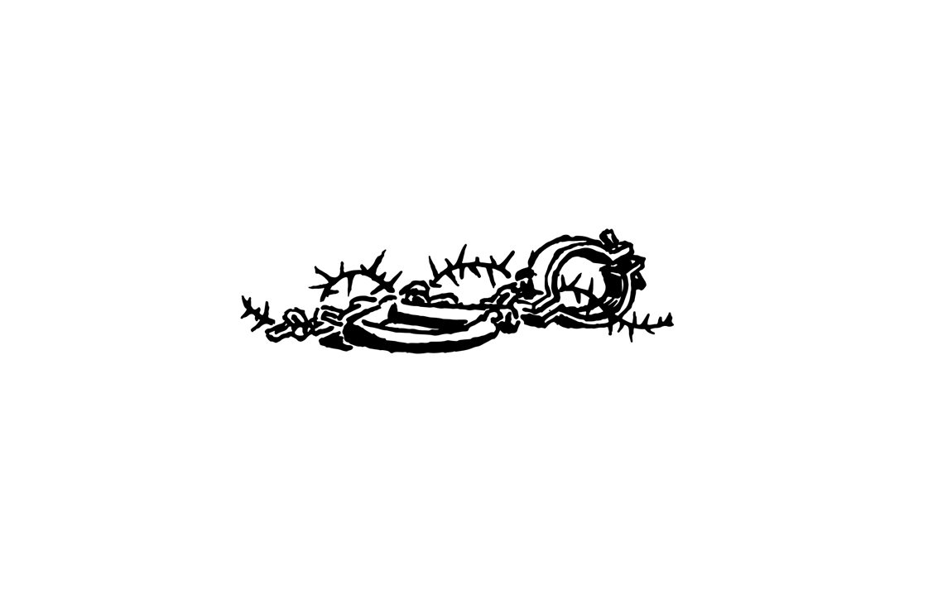
Trust in the Lord with all your heart, and do not lean on your own understanding. Be not wise in your own eyes; fear the Lord, and turn away from evil.

When Solomon was old his wives turned away his heart after other gods, and his heart was not wholly true to the Lord his God.

The people of Israel sinned against the Lord their God, and feared other gods and walked in the customs of the nations. And they did wicked things, provoking the Lord to anger, and they served idols. Yet the Lord warned Israel and Judah by every prophet, saying, “Turn from your evil ways and keep my commandments.” But they would not listen. They despised his statutes and his covenant that he made with their fathers and the warnings that he gave them. And they burned their sons and their daughters as offerings and sold themselves to do evil in the sight of the Lord. Therefore the Lord was very angry with Israel and removed them out of his sight.

The king of Assyria captured Samaria, and carried the Israelites away.
Nebuchadnezzar king of Babylon came and carried away all Jerusalem and all the officials and all the mighty men of valor.
How lonely sits the city that was full of people! How like a widow has she become, she who was great among the nations! Judah has gone into exile.
All, both Jews and Greeks, are under sin. None is righteous, no, not one; no one understands; no one seeks for God. All have turned aside; together they have become worthless; no one does good, not even one. All have sinned and fall short of the glory of God.

But this I call to mind, and therefore I have hope: The steadfast love of the Lord never ceases; his mercies never come to an end.

The Lord will have compassion on Jacob and will again choose Israel, and will set them in their own land.

When you pass through the waters, I will be with you; and through the rivers, they shall not overwhelm you. Because you are precious in my eyes, and honored, and I love you, I will bring your offspring from the east, and from the west I will gather you.
The Lord stirred up the spirit of Cyrus king of Persia, so he made a proclamation: “The God of heaven, has charged me to build him a house at Jerusalem. Whoever is among you of all his people, let him go up to Jerusalem and rebuild the house of the Lord.

Come, let us return to the Lord; for he has torn us, that he may heal us; he has struck us down, and he will bind us up. After two days he will revive us; on the third day he will raise us up. Let us know; let us press on to know the Lord.

“Behold, the days are coming,” declares the Lord, “when I will make a new covenant with the house of Israel and the house of Judah, not like the covenant that I made with their fathers that they broke. For I will put my law within them, and I will write it on their hearts. And I will be their God, and they shall be my people. And they shall all know me, from the least of them to the greatest. For I will forgive their iniquity, and I will remember their sin no more.”
And now the Lord says, “It is too light a thing that you should be my servant to bring back the preserved of Israel; I will make you as a light for the nations, that my salvation may reach to the end of the earth.”

There shall come forth a shoot from the stump of Jesse. And the Spirit of the Lord shall rest upon him, the Spirit of wisdom and understanding, the Spirit of counsel and might, the Spirit of knowledge and the fear of the Lord.

A bruised reed he will not break, and a faintly burning wick he will not quench.

O Bethlehem, from you shall come forth for me one who is to be ruler in Israel, whose coming forth is from of old, from ancient days.

To us a child is born, to us a son is given; and his name shall be called Wonderful Counselor, Mighty God, Everlasting Father, Prince of Peace.

When the fullness of time had come, God sent forth his Son, born of woman, born under the law, to redeem those who were under the law.

The angel Gabriel was sent to a virgin betrothed to a man whose name was Joseph, of the house of David. And the virgin’s name was Mary. “Behold, you will conceive in your womb and bear a son, and you shall call his name Jesus. And the Lord God will give to him the throne of his father David, and of his kingdom there will be no end. The Holy Spirit will come upon you, and the power of the Most High will overshadow you; therefore the child to be born will be called holy—the Son of God.”

And Joseph went up to the city of David, which is called Bethlehem, to be registered with Mary. And while they were there, she gave birth to her firstborn son and wrapped him in swaddling cloths and laid him in a manger, because there was no place for them in the inn.
And the Word became flesh and dwelt among us, and we have seen his glory, glory as of the only Son from the Father, full of grace and truth.
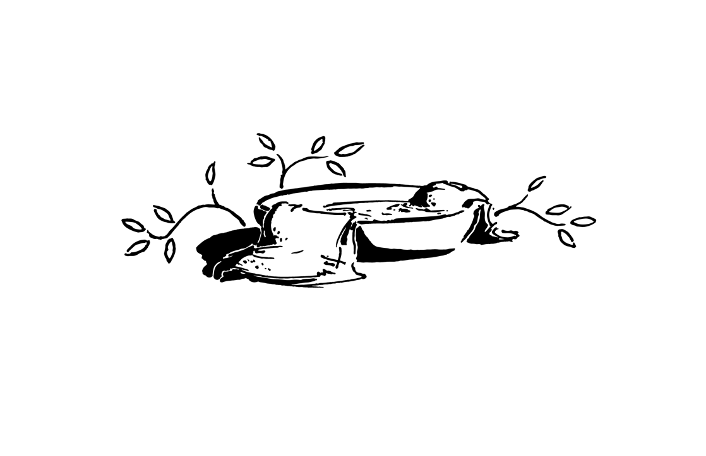
When Jesus had been baptized, the heavens were opened, and the Holy Spirit descended on him like a dove; and a voice came from heaven, “You are my beloved Son; with you I am well pleased.”

The woman said to him, “I know that Messiah is coming (he who is called Christ). When he comes, he will tell us all things.” Jesus said to her, “I who speak to you am he.”

He saw Simon Peter and Andrew his brother, casting a net into the sea, for they were fishermen. And he said to them, “Follow me, and I will make you fishers of men.”
He went out and saw a tax collector named Levi, sitting at the tax booth. And he said to him, “Follow me.”
And the Pharisees grumbled, saying, “Why do you eat and drink with tax collectors and sinners?” And Jesus answered them, “Those who are well have no need of a physician, but those who are sick. I have not come to call the righteous but sinners to repentance.”

What man of you, having a hundred sheep, if he has lost one of them, does not leave the ninety-nine in the open country, and go after the one that is lost, until he finds it? And when he has found it, he lays it on his shoulders, rejoicing.

And he went throughout all Galilee, teaching and proclaiming the gospel of the kingdom and healing every disease and every affliction among the people. So his fame spread, and they brought him all the sick, those afflicted with various diseases and pains, those oppressed by demons, those having seizures, and paralytics, and he healed them. And great crowds followed him.

And he taught them, saying:
“Blessed are the poor in spirit, for theirs is the kingdom of heaven.
“Blessed are those who mourn, for they shall be comforted.
“Blessed are the meek, for they shall inherit the earth.
“Blessed are those who hunger and thirst for righteousness, for they shall be satisfied.
And the crowds were astonished at his teaching, for he was teaching them as one who had authority, and not as their scribes.

Jesus declared, “I thank you, Father, Lord of heaven and earth, that you have hidden these things from the wise and understanding and revealed them to little children; yes, Father, for such was your gracious will.
Come to me, all who labor and are heavy laden, and I will give you rest. Take my yoke upon you, and learn from me, for I am gentle and lowly in heart, and you will find rest for your souls.”

And a great windstorm arose, and the waves were breaking into the boat.
And he awoke and rebuked the wind and said to the sea, “Peace! Be still!” And the wind ceased, and there was a great calm.
And they were filled with great fear and said to one another, “Who then is this, that even the wind and the sea obey him?”

He is the radiance of the glory of God and the exact imprint of his nature, and he upholds the universe by the word of his power.

Jesus led Peter, James, and John up a high mountain. And he was transfigured before them, and his face shone like the sun, and his clothes became white as light. A bright cloud overshadowed them, and a voice from the cloud said, “This is my beloved Son, with whom I am well pleased; listen to him.”
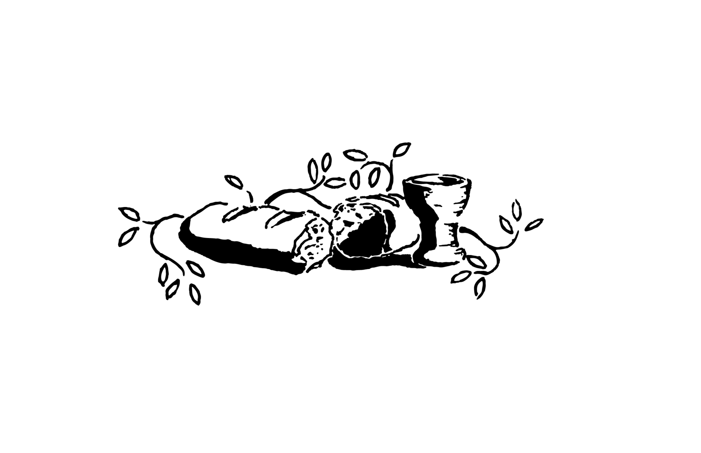
Jesus said to them, “I am the bread of life; whoever comes to me shall not hunger, and whoever believes in me shall never thirst.
“I am the light of the world. Whoever follows me will not walk in darkness, but will have the light of life.”
“I am the good shepherd. The good shepherd lays down his life for the sheep.”
“I am the resurrection and the life. Whoever believes in me, though he die, yet shall he live”
“I am the way, and the truth, and the life. No one comes to the Father except through me.”

“Father, I desire that they whom you have given me may be with me where I am, to see my glory that you have given me because you loved me before the foundation of the world.”

“The Son of Man came not to be served but to serve, and to give his life as a ransom for many.”

Christ Jesus, though he was in the form of God, emptied himself, by taking the form of a servant. And he humbled himself by becoming obedient to the point of death, even death on a cross.

And he said, “The Son of Man must suffer many things and be rejected, and be killed, and on the third day be raised.”

“Unless a grain of wheat falls into the earth and dies, it remains alone; but if it dies, it bears much fruit.”

And he took bread, and when he had given thanks, he broke it and gave it to them, saying, “This is my body, which is given for you. Do this in remembrance of me.” And likewise the cup after they had eaten, saying, “This cup that is poured out for you is the new covenant in my blood.
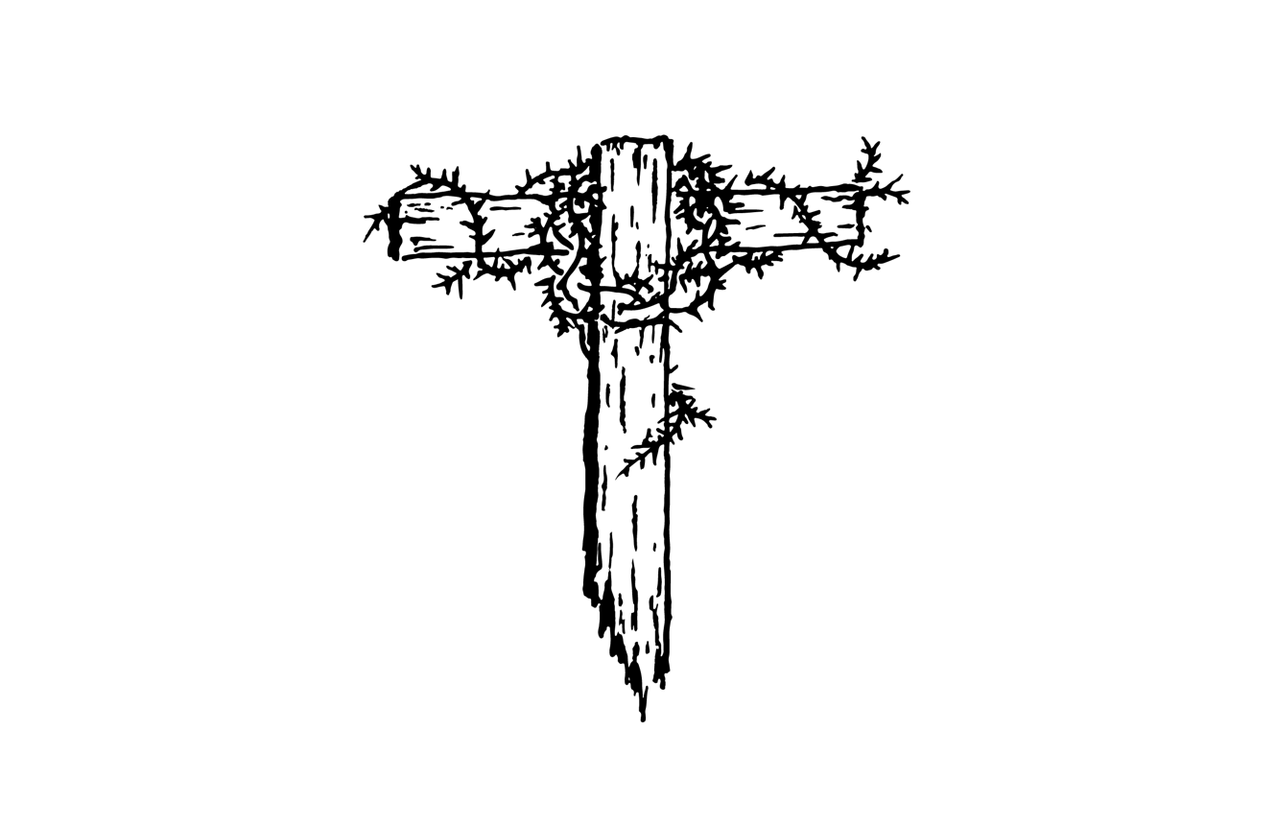
And he fell on his face and prayed, saying, “My Father, if it be possible, let this cup pass from me; nevertheless, not as I will, but as you will.”

There came a crowd, and the man called Judas, one of the twelve, was leading them. Then Jesus said to the chief priests and officers of the temple and elders, “This is your hour, and the power of darkness.”

The light has come into the world, and people loved the darkness rather than the light because their works were evil.

Then those who had seized Jesus led him to the high priest. The whole council were seeking false testimony against Jesus that they might put him to death, but they found none. The high priest said to him, “Tell us if you are the Christ, the Son of God.” Jesus said to him, “You have said so. But I tell you, from now on you will see the Son of Man seated at the right hand of Power and coming on the clouds of heaven.” Then the high priest tore his robes and said, “He has uttered blasphemy!”

And they bound him and led him away and delivered him over to Pilate the governor. Pilate said to him, “Do you not hear how many things they testify against you?” But he gave him no answer, not even to a single charge, so that the governor was greatly amazed. Pilate said to the crowd, “What shall I do with Jesus who is called Christ?” They all said, “Let him be crucified!” And he said, “Why? What evil has he done?” But they shouted all the more, “Let him be crucified!”
The world was made through him, yet the world did not know him. He came to his own, and his own people did not receive him.

So they took Jesus, and he went out, bearing his own cross, to the place called The Place of a Skull, Golgotha. There they crucified him, and with him two others, one on either side.

Christ redeemed us from the curse of the law by becoming a curse for us—for it is written, “Cursed is everyone who is hanged on a tree.”

Behold, the Lamb of God, who takes away the sin of the world!

One of the criminals said, “Jesus, remember me when you come into your kingdom.” And he said to him, “Truly, I say to you, today you will be with me in paradise.”

God shows his love for us in that while we were still sinners, Christ died for us.

Jesus said, “It is finished.”

And the curtain of the temple was torn in two, from top to bottom.

Then calling out with a loud voice he said, “Father, into your hands I commit my spirit!” And having said this he breathed his last.

Joseph from Arimathea took the body of Jesus down and wrapped it in a linen shroud and laid him in a tomb cut in stone.

He was despised and rejected by men, a man of sorrows and acquainted with grief;

He was pierced for our transgressions; he was crushed for our iniquities; upon him was the chastisement that brought us peace, and with his wounds we are healed.

All we like sheep have gone astray; we have turned—every one—to his own way; and the Lord has laid on him the iniquity of us all.

Yet it was the will of the Lord to crush him; he has put him to grief; when his soul makes an offering for guilt, he shall see his offspring; he shall prolong his days…
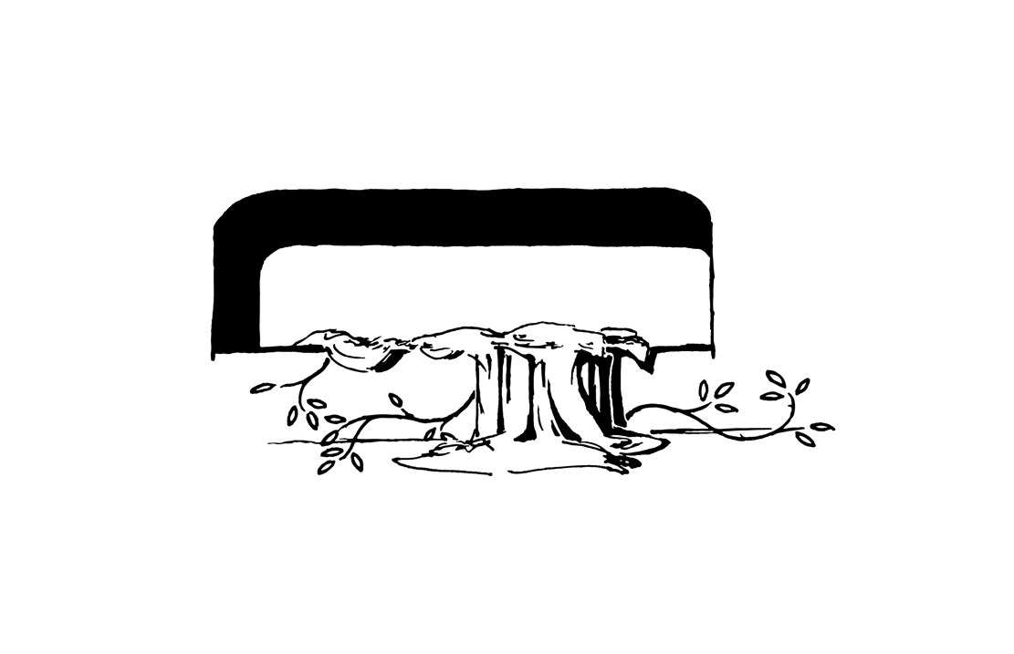
Christ died for our sins in accordance with the Scriptures, he was buried, and he was raised on the third day in accordance with the Scriptures.

On the first day of the week, at early dawn, they found the stone rolled away from the tomb and did not find the body of the Lord Jesus. While they were perplexed about this, behold, two men stood by them in dazzling apparel, and said to them, “Why do you seek the living among the dead? He is not here, but has risen!”

Jesus came and stood among them, and he showed them his hands and his side. Then the disciples were glad when they saw the Lord. Jesus said to them, “Peace be with you. As the Father has sent me, even so I am sending you.”

“All authority in heaven and on earth has been given to me. Go therefore and make disciples of all nations, baptizing them in the name of the Father and of the Son and of the Holy Spirit, teaching them to observe all that I have commanded you. And behold, I am with you always, to the end of the age.”

And when he had said these things, he was lifted up, and a cloud took him out of their sight. And behold, two men stood by them in white robes, and said, “Why do you stand looking into heaven? This Jesus, who was taken up from you into heaven, will come in the same way.”

God raised Christ from the dead and seated him at his right hand in the heavenly places, far above all rule and authority and power and dominion, and above every name that is named, not only in this age but also in the one to come. And he put all things under his feet and gave him as head over all things to the church.

When the day of Pentecost arrived, they were all filled with the Holy Spirit and began to speak in other tongues as the Spirit gave them utterance.
The multitude were amazed and astonished, saying, “How is it that we hear, each of us in his own native language?

Peter addressed them: “Jesus of Nazareth, attested to you by God with mighty works and wonders and signs that God did through him in your midst—this Jesus, delivered up according to the definite plan and foreknowledge of God, you crucified and killed by the hands of lawless men. God raised him up, loosing the pangs of death, because it was not possible for him to be held by it. Let all the house of Israel therefore know for certain that God has made him both Lord and Christ.”

Now when they heard this they were cut to the heart, and said to Peter and the rest of the apostles, “Brothers, what shall we do?”
And Peter said to them, “Repent and be baptized every one of you in the name of Jesus Christ for the forgiveness of your sins, and you will receive the gift of the Holy Spirit.

So those who received his word were baptized, and there were added that day about three thousand souls.

And they devoted themselves to the apostles’ teaching and the fellowship, to the breaking of bread and the prayers. And awe came upon every soul, and many wonders and signs were being done through the apostles. And all who believed were together and had all things in common, praising God and having favor with all the people. And the Lord added to their number day by day those who were being saved.

God, who said, “Let light shine out of darkness,” has shone in our hearts to give the light of the knowledge of the glory of God in the face of Jesus Christ.

I am not ashamed of the gospel, for it is the power of God for salvation to everyone who believes, to the Jew first and also to the Greek.

Jews demand signs and Greeks seek wisdom, but we preach Christ crucified, a stumbling block to Jews and folly to Gentiles, but to those who are called, both Jews and Greeks, Christ the power of God and the wisdom of God.

The priests and the Sadducees came upon them, greatly annoyed because they were teaching the people and proclaiming in Jesus the resurrection from the dead. And they arrested them.

Then Peter, filled with the Holy Spirit, said to them, “Jesus is the stone that was rejected by you, which has become the cornerstone. And there is salvation in no one else, for there is no other name under heaven given among men by which we must be saved.”

They charged them not to speak or teach at all in the name of Jesus. But Peter and John answered them, “We cannot but speak of what we have seen and heard.”

And they were all filled with the Holy Spirit and continued to speak the word of God with boldness.

“Remember the word [Jesus said]: ‘A servant is not greater than his master.’ If they persecuted me, they will also persecute you.”
“If anyone would come after me, let him deny himself and take up his cross daily and follow me.”

We rejoice in our sufferings, knowing that suffering produces endurance, and endurance produces character, and character produces hope, and hope does not put us to shame, because God’s love has been poured into our hearts through the Holy Spirit.

They cried out with a loud voice and stopped their ears and rushed together at Stephen. Then they cast him out of the city and stoned him. He gazed into heaven and saw the glory of God, and Jesus standing at the right hand of God. He called out, “Lord Jesus, receive my spirit. Do not hold this sin against them.” And when he had said this, he fell asleep.

This light momentary affliction is preparing for us an eternal weight of glory beyond all comparison. For the things that are seen are transient, but the things that are unseen are eternal.
Remember that at one time you Gentiles were separated from Christ, having no hope and without God in the world. But now in Christ Jesus you who once were far off have been brought near by the blood of Christ.

That through the church the manifold wisdom of God might now be made known to the rulers and authorities in the heavenly places.

Blessed be the God and Father of our Lord Jesus Christ, who has blessed us in Christ with every spiritual blessing. He chose us in him before the foundation of the world. In love he predestined us for adoption to himself as sons. In him we have redemption through his blood, the forgiveness of our trespasses, according to the riches of his grace, which he lavished upon us. In him you also, when you heard the word of truth, the gospel of your salvation, and believed in him, were sealed with the promised Holy Spirit, who is the guarantee of our inheritance until we acquire possession of it, to the praise of his glory.

You were dead in the trespasses and sins in which you once walked, following the course of this world, following the prince of the power of the air, carrying out the desires of the body and the mind, and were by nature children of wrath. But God, being rich in mercy, because of the great love with which he loved us, made us alive together with Christ and raised us up with him. For by grace you have been saved through faith. And this is not your own doing; it is the gift of God, not a result of works, so that no one may boast. For we are his workmanship, created in Christ Jesus for good works.

[Jesus said] You shall love the Lord your God with all your heart and with all your soul and with all your mind. This is the great and first commandment. And a second is like it: You shall love your neighbor as yourself.
I am the vine; you are the branches. Whoever abides in me and I in him, he it is that bears much fruit, for apart from me you can do nothing.
As the Father has loved me, so have I loved you. Abide in my love.

There is no condemnation for those who are in Christ Jesus.
For you did not receive the spirit of slavery to fall back into fear, but you have received the Spirit of adoption as sons, by whom we cry, “Abba! Father!”
And we know that for those who love God all things work together for good, for those who are called according to his purpose.
God is for us, who can be against us?

I am sure that neither death nor life, nor angels nor rulers, nor things present nor things to come, nor powers, nor height nor depth, nor anything else in all creation, will be able to separate us from the love of God in Christ Jesus our Lord.
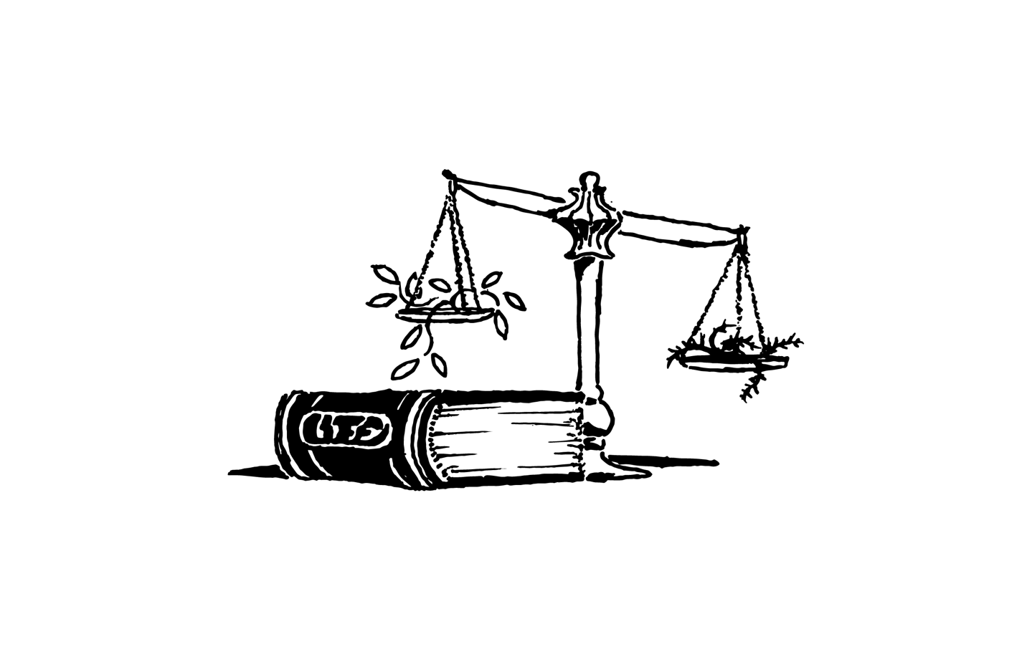
God has not destined us for wrath, but to obtain salvation through our Lord Jesus Christ.

The Lord himself will descend from heaven with a cry of command, with the voice of an archangel, and with the sound of the trumpet of God. And the dead in Christ will rise first. Then we who are alive, who are left, will be caught up together with them in the clouds to meet the Lord in the air, and so we will always be with the Lord.
Now war arose in heaven, Michael and his angels fighting against the dragon. And the great dragon was thrown down, that ancient serpent, who is called the devil and Satan, the deceiver of the whole world—he was thrown down to the earth, and his angels were thrown down with him.

Jesus said, “Nation will rise against nation, and there will be famines and earthquakes. Then they will deliver you up to tribulation and put you to death, and you will be hated by all nations for my name’s sake. And many false prophets will arise and lead many astray. And because lawlessness will be increased, the love of many will grow cold. But the one who endures to the end will be saved.
Immediately after the tribulation of those days the sun will be darkened, and the moon will not give its light, and the stars will fall from heaven, and the powers of the heavens will be shaken.

Then all the tribes of the earth will see the Son of Man coming on the clouds of heaven with power and great glory.
You must be ready, for the Son of Man is coming at an hour you do not expect.

Then I saw heaven opened, and behold, a white horse! The one sitting on it is called Faithful and True, and in righteousness he judges and makes war. His eyes are like a flame of fire, and on his head are many diadems. From his mouth comes a sharp sword with which to strike down the nations, and he will rule them with a rod of iron. He will tread the winepress of the fury of the wrath of God the Almighty. On his robe and on his thigh he has a name written, King of kings and Lord of lords.

And I saw the beast and the kings of the earth with their armies gathered to make war against him who was sitting on the horse and against his army. And the beast and the false prophet were thrown alive into the lake of fire. And the rest were slain by the sword that came from the mouth of him who was sitting on the horse.
Then I saw an angel coming down from heaven, holding in his hand the key to the bottomless pit and a great chain. And he seized the dragon, that ancient serpent, who is the devil and Satan, and bound him for a thousand years.

I saw the souls of those who had been beheaded for the testimony of Jesus and for the word of God. They came to life and reigned with Christ for a thousand years.

And when the thousand years are ended, Satan will be released from his prison and will come out to deceive the nations, to gather them for battle. But fire came down from heaven and consumed them, and the devil who had deceived them was thrown into the lake of fire, and will be tormented day and night forever and ever.
And if anyone’s name was not found written in the book of life, he was thrown into the lake of fire.

I looked, and behold, a great multitude that no one could number, from every nation, from all tribes and peoples and languages, standing before the throne and before the Lamb, clothed in white robes, and crying out with a loud voice, “Salvation belongs to our God who sits on the throne, and to the Lamb!”

Then I saw a new heaven and a new earth, and the holy city, new Jerusalem, coming down out of heaven from God, prepared as a bride adorned for her husband. And I heard a loud voice from the throne saying, “Behold, the dwelling place of God is with man. They will be his people, and God himself will be with them as their God.”

And this is eternal life, that they know you, the only true God, and Jesus Christ whom you have sent.

“He will wipe away every tear from their eyes, and death shall be no more, neither shall there be mourning, nor crying, nor pain anymore, for the former things have passed away.”

This perishable body must put on the imperishable, and this mortal body must put on immortality. Then shall come to pass what is written: “Death is swallowed up in victory.”

And he who was seated on the throne said, “Behold, I am making all things new.”
And I saw no temple in the city, for its temple is the Lord God the Almighty and the Lamb. And the city has no need of sun or moon to shine on it, for the glory of God gives it light, and its lamp is the Lamb.
Nothing unclean will ever enter it, only those who are written in the Lamb’s book of life.
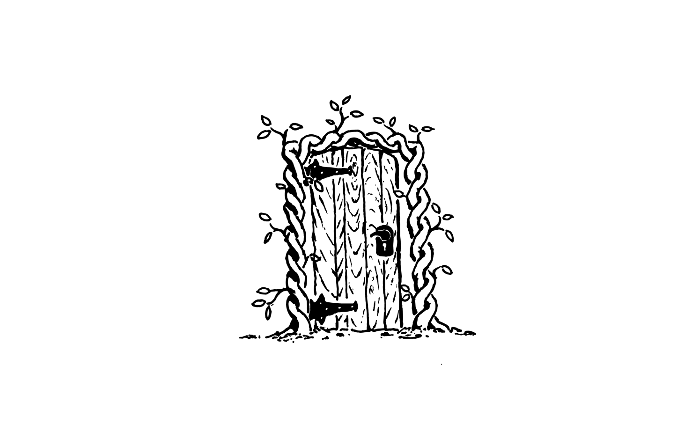
God so loved the world, that he gave his only Son, that whoever believes in him should not perish but have eternal life.

If you confess with your mouth that Jesus is Lord and believe in your heart that God raised him from the dead, you will be saved. The same Lord is Lord of all, bestowing his riches on all who call on him. For “everyone who calls on the name of the Lord will be saved.”

The Spirit and the Bride say, “Come.” And let the one who hears say, “Come.” And let the one who is thirsty come; let the one who desires take the water of life without price.



~~~HarvestDetroitWest.org~~~

Revelation 4:8
John 1:1-5
Genesis 1
Genesis 2
Genesis 3
Romans 8:22
Romans 5:12
Romans 1:18-21
Genesis 6-7
Gen 12:1-3
Genesis 15:6
Exodus 3
Exodus 7-10
Exodus 12
Exodus 14
Exodus 19
Exodus 20
Exodus 34:29
2 Corinthians 3:7-9
Leviticus 16:15-16
Hebrew 10
Galatians 3:24
Joshua 1
Joshua 21:43-45
Judges 2
1 Samuel 8
1 Samuel 16:13
1 Samuel 17:45-49
Psalm 23
Psalm 2
2 Samuel 7
2 Chronicles 5
Proverbs 3:5-7
1 Kings 11
2 Kings 17
2 Kings 24
Lamentations 1
Romans 3
Lamentations 3:21-22
Isaiah 14
Isaiah 43
Ezra 1:1-3
Hosea 6:1-3
Jeremiah 31:31-34
Isaiah 49:5-6
Isaiah 11:1-2
Isaiah 42:3
Micah 5:2
Isaiah 9:6-7
Galatians 4:4-5
Luke 1
Luke 2
John 1:14, 18
Luke 3:21-22
John 4:25-26
Matthew 4:18-19
Luke 5:27, 30-32
Luke 15:4-7
Matthew 4:23-25
Matthew 5:2-10
Matthew 7:28-29
Matthew 11:25-29
Mark 4:37-41
Hebrews 1:3
Matthew 17:1-5
John 6:35
John 8:12
John 10:11
John 11:25
John 14:6
John 17:24
Mark 10:45
Philippians 2:6-8
Luke 9:20-22
John 12:24
Luke 22:19-20
Matthew 26:39
Luke 22:47-53
John 3:19
Matthew 26:57-65
Matthew 27
John 1:10-11
Jn 19:16-18
Galatians 3:13
John 1:29
Luke 23:39-43
Romans 5:8
John 19:30
Matthew 27:51
Luke 23
Isaiah 53
1 Corinthians 15:3-4
Luke 24 1-6
John 20:19-21
Matthew 28:18-20
Acts 1:9-11
Eph 1:20-22
Acts 2
2 Corinthians 4:5-6
Romans 1:16
1 Cor 1:22-24
Acts 4
John 15:20
Luke 9:24
Romans 5:3-5
Acts 7:57-60
2 Corinthians 4:16-18
Ephesians 2
Ephesians 3:10
Ephesians 1-2
Matthew 22:37-39
John 15:5, 9
Romans 8
1 Thessalonians 5:9
1 Thessalonians 4:16-17
Revelation 12:7-11
Matthew 24
Revelation 19
Revelation 20
Revelation 7:9-10
Revelation 21
John 17:3
Revelation 21
1 Corinthians 15
Revelation 21
John 3:16
Romans 10:9-13
Revelation 22:17

