People with open Bibles and open hearts. The gospel was preached at 122 locations. In the work place, street side and in regular meeting places the gospel is shared and well received.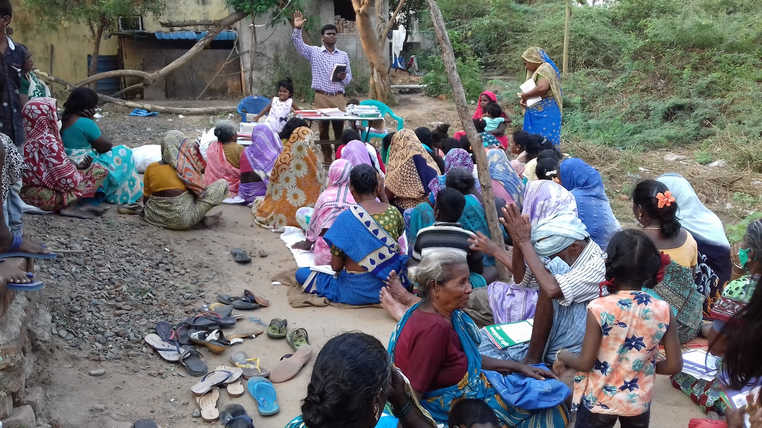

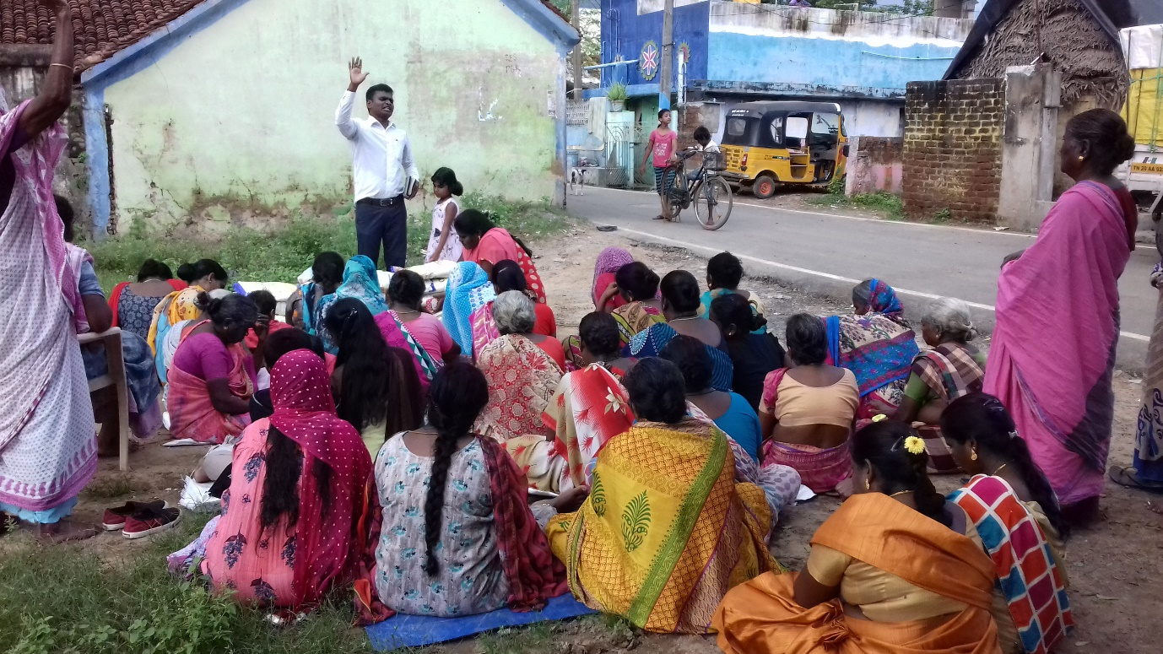
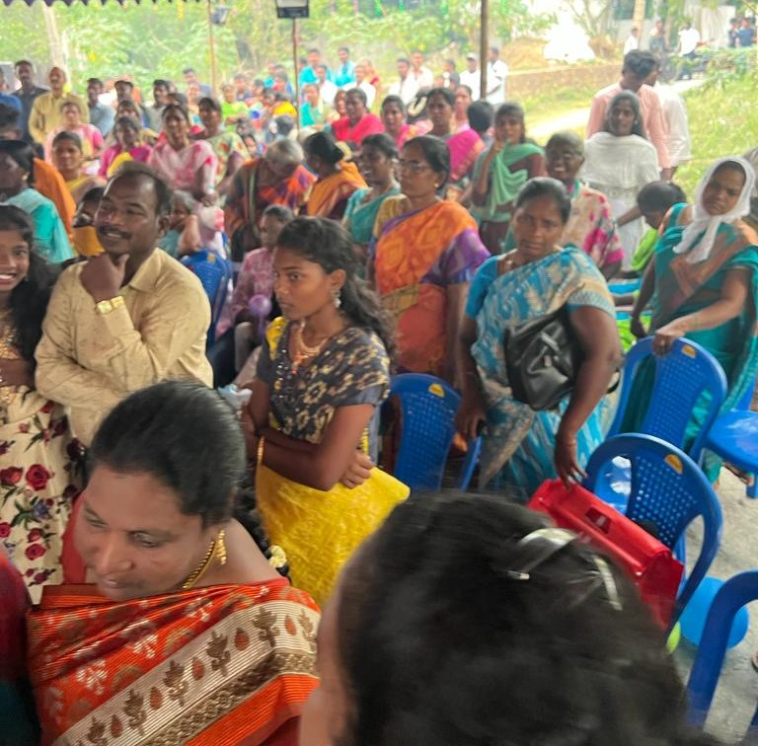
Those who believed put on Christ. 181 baptisms reported as an immediate result. The gospel was planted in the hearts of thousands. The body of believes encouraged to have new brothers and sisters in the Lord. They are eager to share with them the nurturing word of God to grow in the Lord.

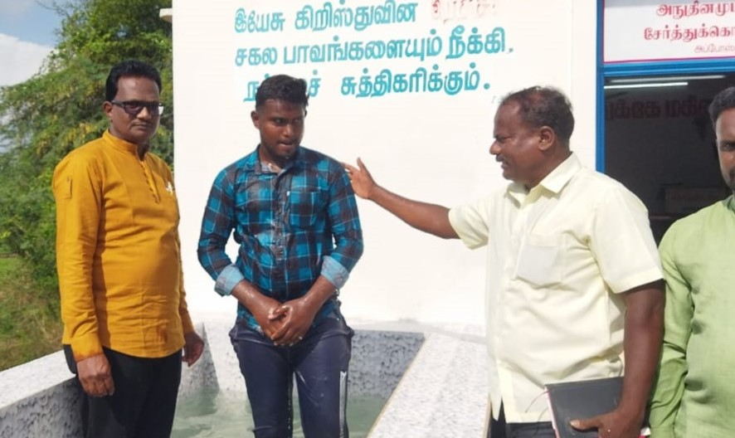
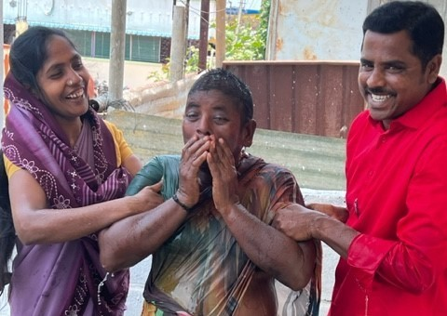

The Bible college dormitory was rebuilt, additional floor was built and the church building and classrooms renovate.

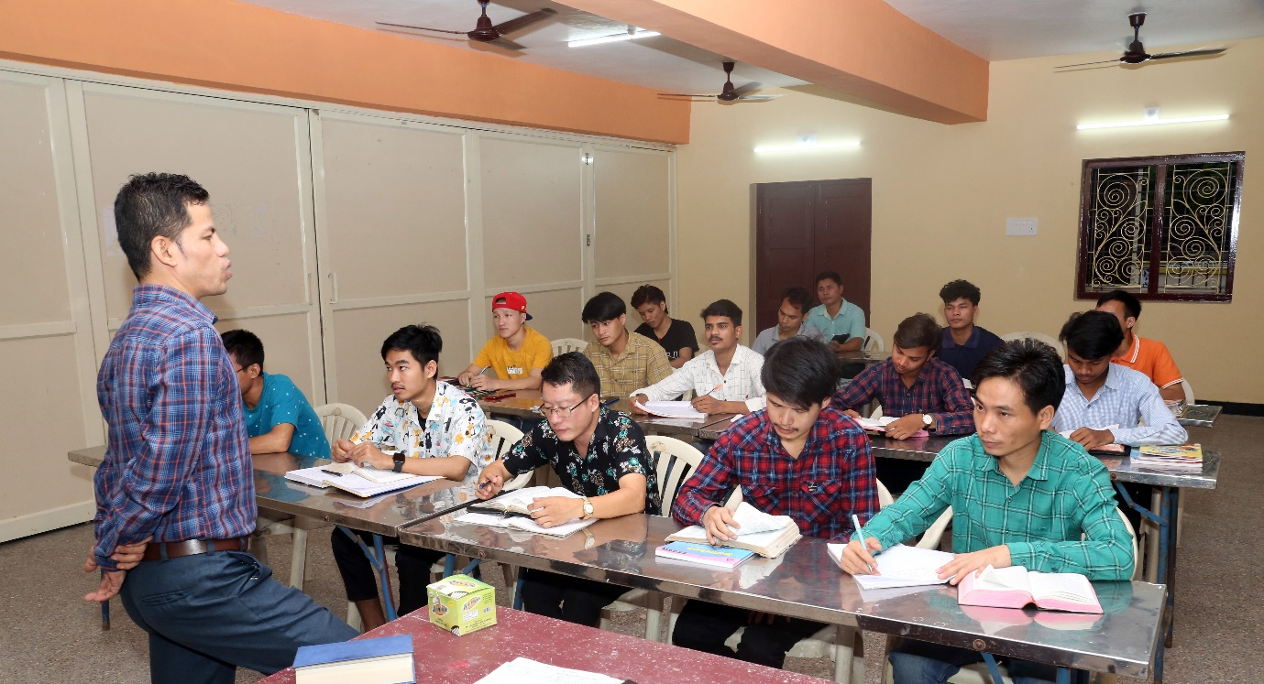
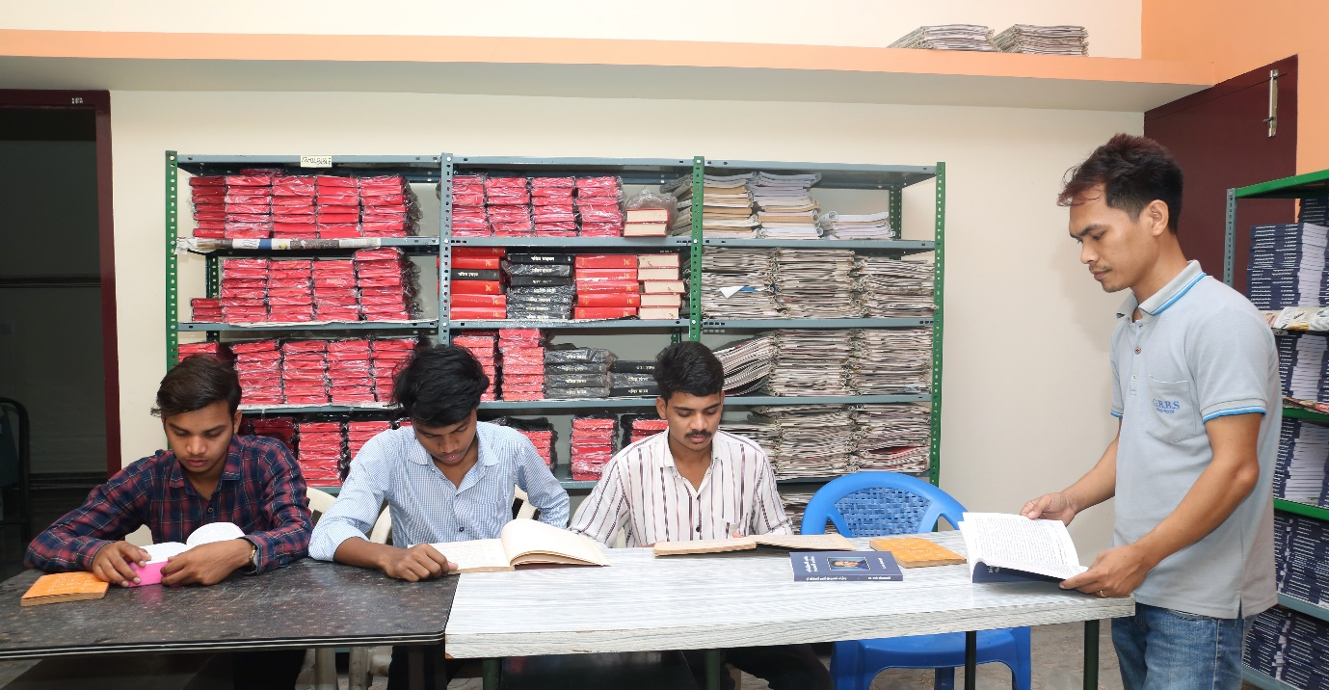
30 evening bible study on from the 1st of March. Separate classes for children, youth and others.
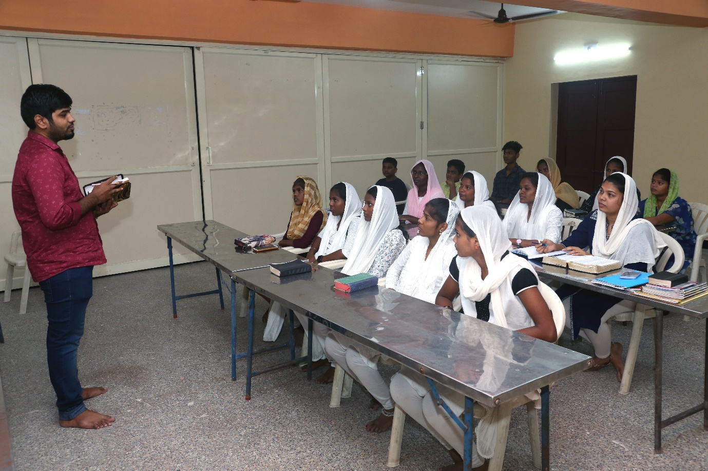
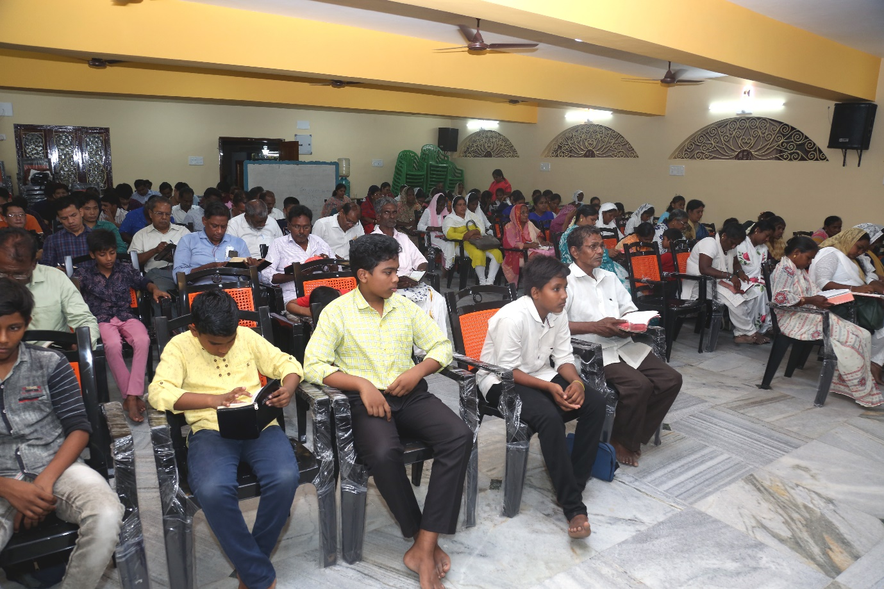
New church buildings dedicated at 4 locations. Had a houseful on the dedication day. They soon need to plan on expansion. God is at work in each location. His people are a willing lot to serve Him and the people.

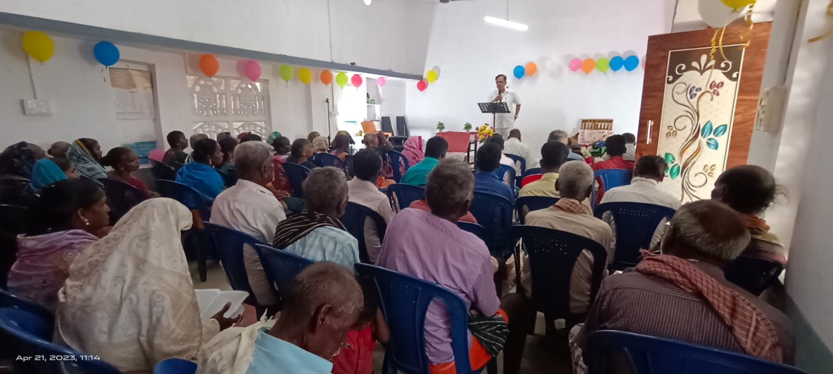
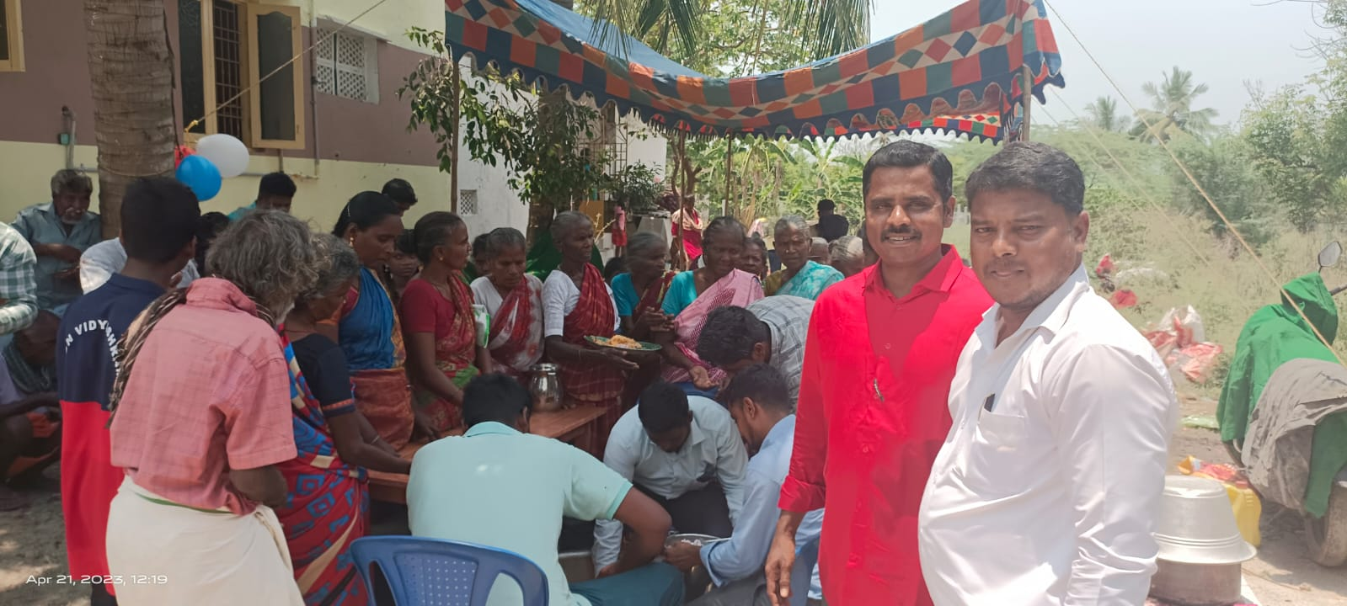
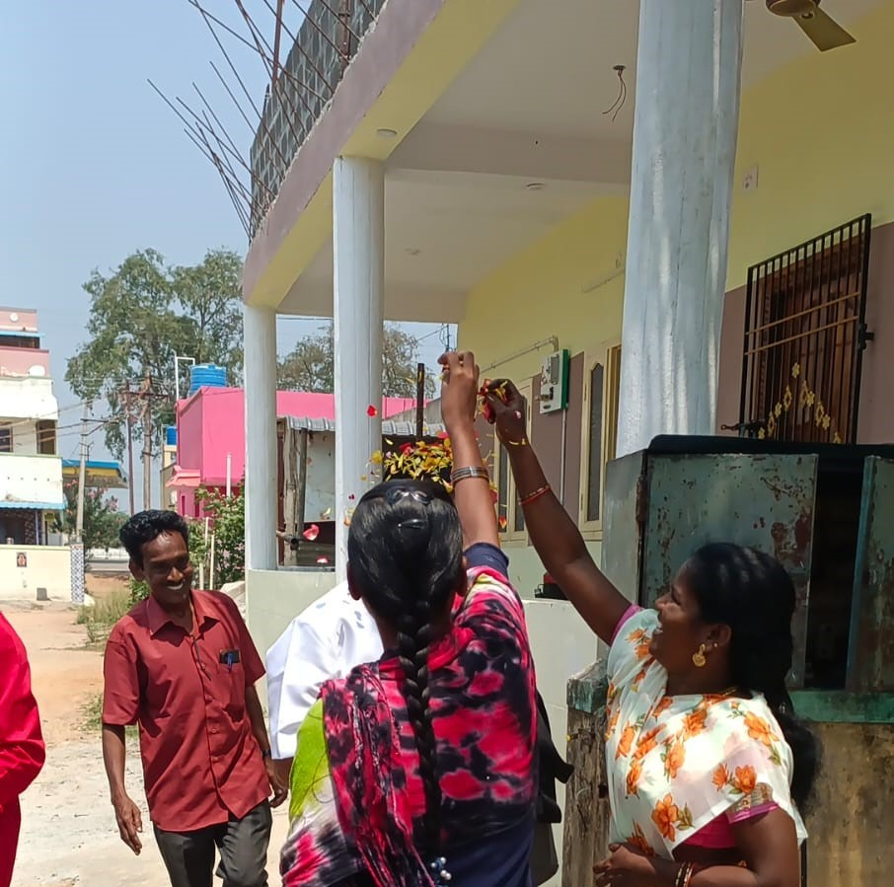

The construction started 22 years ago. They met in the unfinished building for many years. Now Its joyous times they have a common place to meet for worship, bible studies. The buildings house the disaster affected and homeless as and when needed.
Church building construction is on at 14 places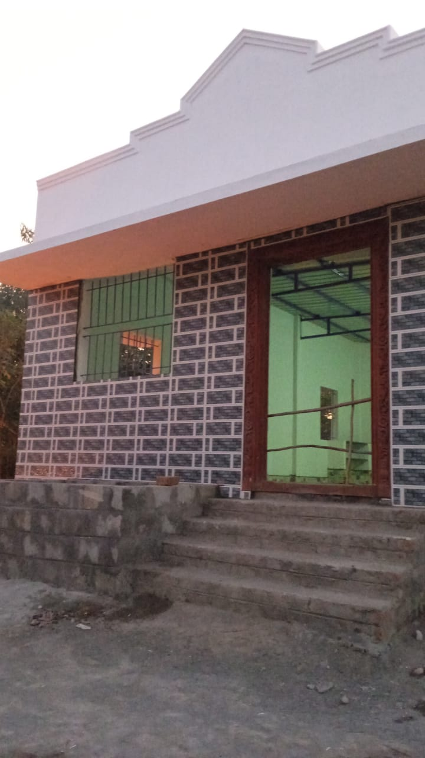
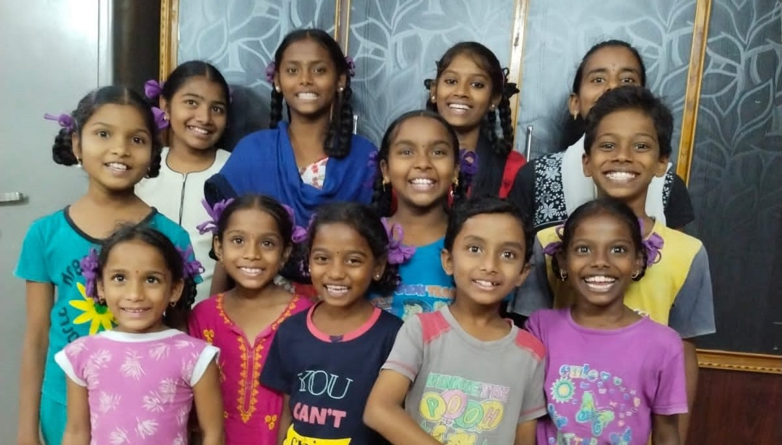
The children at the orphanages enjoy the summer vacation.
Appreciate your prayers and partnership
In Christian love
Paul Renganathan paul.renganathan@gmail.com

