
Donating to the
Kenmore Alliance Care Portal Fund

Thank you for considering donating to the Kenmore Alliance CarePortal Fund. This allows us to directly impact the most at-risk children and families right here in WNY.

    - KAC CarePortal Responders/Credit Cards: Anyone who is registered as a KAC CarePortal responder has access to see & respond to any/all CarePortal requests in our geographic region. Credit card donations can be made directly to the KAC CarePortal fund by responders via the KAC CarePortal site.
    - Stock Donations: send an email to donations@goproject.org with full donation and your contact information.
    - Check Donations: mail a check made out to The Global Orphan Project to:
The Global Orphan Project
3161 Wyandotte St.
Kansas City, MO 64111

      - Write Kenmore Alliance CarePortal Fund in the memo of your check.
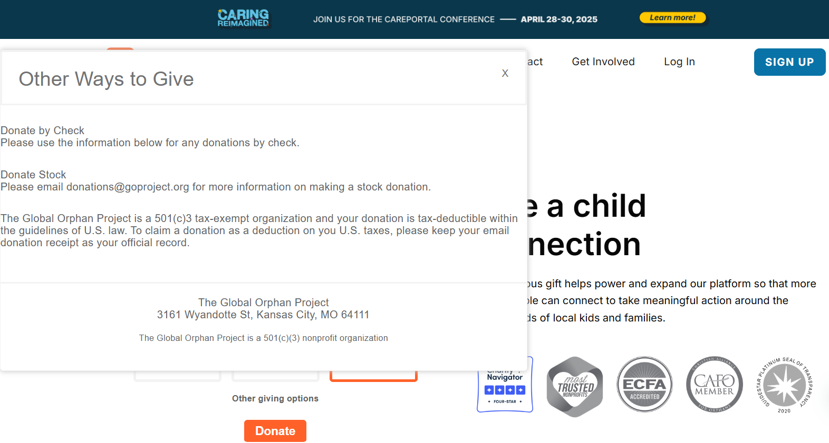
      - Also a good idea to include a simple note saying that the donation is for Kenmore Alliance Church CarePortal fund; and include your full contact information for questions and/or donation receipt purposes.

