COLLIDE — September 28th, 2025 (Week 4)
Bible Story: Ruth • Ruth 1 (supporting: Ruth 2–4)
Conversation Starter: When is it hard to be brave when you don’t know what’s next?
Bottom Line: God can give you courage when you don’t know what’s next.
Monthly Memory Verse: When I’m afraid, I put my trust in you. Psalm 56:3 (NIrV)

LARGE GROUP:

Optional Video: Countdown
Optional Video: Theme Loop

OPENER
HOST: “Hey, hey, hey, future world-changers! Welcome to our final week of this courage series! You’ve been amazing all month long, being ‘On the Move’ and facing challenges with bravery!

“Sometimes the biggest move, the bravest step, is the one you take when you have NO idea what’s coming next. You just have to make a decision and go for it! That’s kind of like our game today—it’s the ‘Destination Decision Dash’!”

SLIDE: “Destination Decision Dash”

Designate four “Destination” spots in the room with the following four signs—“BEACH,” “MOUNTAINS,” “CITY,” “SPACE STATION.” (“tent” signs are placed at designated areas.)

“Alright, everyone! Listen up! I’m going to call out different travel scenarios or needs. Your job is to quickly decide which of these amazing destinations (point to four signs as you name each one)—either the beach, mountains, city, or space station—best fits that scenario, and DASH to that spot!

“There might not be one perfect answer, so go with your gut! Last one to a spot or the one who looks totally confused might be out . . . just kidding! Or am I? Let’s just have some fun with it! “First scenario: You suddenly have a free weekend, and you want to relax and enjoy the sunshine! Where do you go? GO! (Pause while kids go to the areas they chose. Invite volunteers who want to share their reasoning for why they chose the destination they did!)

Call out scenarios:
- “You want an epic adventure with amazing views!”
- “You only packed hiking boots!”
- “You want to see a million stars!”
- “You want to see some tall structures!”
- “You want to put your feet in something squishy!”
You can create two more of your choice, fun scenarios.

AUDIO: Play high-energy music

“Nice dashing, everyone! It’s not always easy to make a quick decision when you don’t have all the info, is it? But sometimes, you just have to trust your instincts and take that step into the unknown.

“Our Bible Story today is about a woman who had to make a HUGE decision about her destination, with a future that was totally uncertain. But first, let’s worship the God who is with us no matter which path we take!”

WORSHIP
HOST: This is our time to sing, to shout, to focus on how amazing God is, and to tell Him how much He means to us. Are you ready to make some noise and give God your best today? Awesome! Let’s get started!
VIDEO: “(Lyric Video)”

Now why don’t we turn our eyes, ears and hearts towards the screen and watch this week’s bible story together.

VIDEO: Bible Story W4

AFTER BIBLE STORY
HOST: “When we think about Ruth, we can remember that even if we don’t know what’s next, we’re never going alone. God goes with us every step of the way. When we believe that He is the strongest, the biggest, and the kindest, and He is with us, He will give us courage to do whatever it is that’s in front of us!

“As you head to your Small Groups for the last time this month, really think about this Conversation Starter:

SLIDE: Conversation Starter

[Conversation Starter] “When is it hard to be brave when you don’t know what’s next?

“What makes uncertainty so challenging? How can Ruth’s story encourage you to trust God more when you’re facing the unknown? Talk about it with your group. Let’s pray.”

PRAYER
HOST: “God, thank You for Ruth, and her amazing example of loyalty and courage in the face of a really uncertain future. Teach us how to really believe that You are with us every step of the way. Teach us to trust that even though we may be walking into something unknown, we are going with You. Your presence with us makes us brave. We love You, and we pray these things in Jesus’ name. Amen.”

After prayer, Host dismisses kids to Small Group.

Small Group (15 minutes)
The BLESSED lifestyle
Begin with prayer
Take a few minutes to pray with your small group
We want to encourage the kids to start with prayer. Lead them by praying for the group. Ask if there are any prayer requests. To make them more comfortable you can start praying then ask if anyone would like to pray after you.
You can also use the Bottom line or monthly theme as key prayer points.

1. Take a Snapshot
Live for God | Application Activity
Made to Imagine

What You Need: “Courage Starters” Activity Pages, and pencils

What You Do:
- Gather the kids in a circle and give each kid a pencil.
- Place the strips from the “Courage Starters” Activity Page in the middle of the circle.
- Explain what to do:
  - “Take a moment to reflect on what you discovered today in Ruth’s story. Ruth didn’t have all the answers, but there was one thing that she did know—she could trust God. Let’s create one-liner sentences of encouragement or advice that you could share with someone who’s going through something hard, or use it to encourage yourself!”
  - Instruct the kids to finish the statements on each strip with their encouragement or advice.
- Invite several kids to share what they wrote.
- Challenge the kids to give a strip to a friend, family member, or someone they know who could use some encouragement!
- Ask:
  - “What do you hope someone feels when they read your courage strip?”
- [Make It Personal] (Share an age-appropriate time when you had to trust God with something that felt uncertain. What did God teach you during that process?)

Inclusive Pro Tip:
- Encourage kids to build their courage strip with symbols or pictures.
- Not every kid will want to share out loud. Let them know it’s okay to listen quietly, share with a leader one-on-one, or think about the prompt.

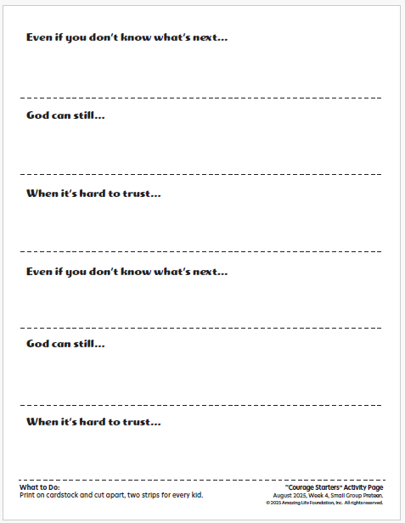

2. Discussion Questions
Talk about God | Bible Story Review
Made to Connect

What You Need: No supplies needed

What You Do:
Ask:
- What is the bravest thing you’ve ever done?
- What would you say to a friend who’s nervous about something new they have to do? How could you remind them that God is with them?
- Why do you think quitting or giving up when life feels confusing is sometimes easier?
- What are some truths you can remember about God that can help you be brave?
- How can the Holy Spirit help you to be brave this week?

Inclusive Pro Tips:
- Read each question twice and give time to process before prompting the kids to respond.
- Reduce the number of questions.
- Provide a small ball to toss from kid to kid as each kid shares.
- Provide fidget tools for every kid to hold while discussing.
- Offer sentence starters to support students who struggle to express their ideas. Example: “The bravest thing I did was _____.” “I would tell a friend who is nervous to ____.”

