COLLIDE — September 21st, 2025 (Week 3)
Bible Story: Rahab / The Promised Land • Joshua 2 (supporting: Joshua 6:22-25)
Conversation Starter: How can you show someone you care?
Bottom Line: God can give you courage to help someone in need.
Monthly Memory Verse: When I’m afraid, I put my trust in you. Psalm 56:3 (NIrV)

LARGE GROUP:

Optional Video: Countdown
Optional Video: Theme Loop

OPENER
HOST: “Welcome back, courageous crew! It’s awesome to see you all here, ready to move and be brave! Sometimes, being brave means reaching out to help someone, even if it seems like a long shot. It might feel like you’re trying to rescue something from across a giant canyon! And that, my friends, brings us to today’s challenge: the ‘Rescue Rope Toss’!”

SLIDE: “Rescue Rope Toss”

“Pick 8 kids and then place them in two teams. Let’s get into our teams!

Once kids are in teams, give each team a rope

“Listen up, rescuers! Do you see this ‘chasm(taped marked)’ here? (Point to tape-marked ‘chasm.’) Your mission is to save these stranded items! (Point to items on far side of the ‘chasm.’). Each team will take turns tossing their rescue rope, trying to loop it around an item, knock it, or drag it back across the chasm to their side without stepping into the chasm! If you successfully rescue an item, your team gets a point! We’ll see which team can rescue the most items in the next few minutes(Every team gets 30 seconds to rescue and item). It takes skill, it takes aim, and it takes a little bit of courage to make that toss! Does all of that make sense, teams? (Pause and answer questions.)

“Alright! Now that we know what we’re doing, let’s get started! Ready . . . aim . . . RESCUE!”

AUDIO: Play high-energy music

Start the game! Monitor for safety, keep score, and encourage the teams.

“And that’s time! Let’s count up those rescued items! Great job, teams! Give yourselves a hand! It’s not always easy to reach out and make that effort, but when you succeed, it feels pretty good, right?

“Today, we’re going to hear about someone who took a huge risk, using something as simple as a rope, to help others in a really big way. But first, let’s worship the God who gives us the courage to reach out and be kind like He is!”
WORSHIP
HOST: “We get to switch gears just a little bit and do something super-important, something that helps us connect with God, the One who gives us strength and courage for all those challenges. That’s worship! This is our time to sing, to shout, to focus on how amazing God is, and to tell Him how much He means to us. Are you ready to make some noise and give God your best today? Awesome! Let’s get started!

VIDEO: “(Lyric Video)”

Now why don’t we turn our eyes, ears and hearts towards the screen and watch this week’s bible story together.

VIDEO: Bible Story W3

AFTER BIBLE STORY
HOST: “As we saw this week, helping someone often involves stepping out of your comfort zone. It might feel a little scary. But when we trust God, like Rahab did, He can give us the courage we need. Trusting God can empower us to act, to be His hands and feet for someone who needs it. And when you do that, you’re showing them a glimpse of who God is and how He loves them. God can give you courage to help someone in need.”

COMMUNICATOR: “As you head to Small Groups, I want you to really dig into this Conversation Starter!

SLIDE: Conversation Starter

[Conversation Starter] “When have you needed courage to help someone?

SLIDE: Theme Background

“Think about those times. What made it hard? What helped you (or could help you) be brave? How can Rahab’s story inspire you this week to look for ways to help others, even if it takes a little courage? Let’s ask God to help you before you go.”

PRAYER
HOST: “God, thank You for Rahab’s example of courage and faith. Thank You that she trusted You, was kind, and helped others. We want to be kind like You are! Teach us how to listen to the nudges of Your Holy Spirit. Show us how You want us to help people, and then give us the courage to act. We love You, and we pray these things in Jesus’ name. Amen.

After prayer, Host dismisses kids to Small Group.

Small Group (15 minutes)
The BLESSED lifestyle
Begin with prayer
Take a few minutes to pray with your small group
We want to encourage the kids to start with prayer. Lead them by praying for the group. Ask if there are any prayer requests. To make them more comfortable you can start praying then ask if anyone would like to pray after you.
You can also use the Bottom line or monthly theme as key prayer points.

1. Bible Story Extension
Talk about God | Bible Story Review
Made to Imagine

What You Need: Bowl, and “Five Words” Activity Page

What You Do:
- Before you begin, place the ten cards from the “Five Words” Activity Page in the bowl.
- Gather the kids together.
- Explain how to play:
  - Each kid will draw a card with a word from today’s Bible Story (such as a person, place, or object).
  - On their turn, they’ll tell the group five things about that word (words that describe a person, or what color something is, what it does, what it’s near, what it's made of, or who used it).
  - For example, if the word is “Rahab,” someone might say, “Brave, woman, Jericho . . . ”
  - Give the kids a chance to try and come up with their own five words before offering help.
  - Encourage the rest of the kids to guess what the word from the Bible Story is from the kid’s five things.
  - Once a card is guessed correctly, ask: “How does this word relate to today’s Bible Story?”
- Continue until all the cards have been guessed.
- Tell the kids that Rahab took a huge risk helping the spies. Even though she wasn’t a member of God’s family like the two spies, she chose to trust God, and God gave her courage!
- Explain that when they choose to be brave and help someone else (maybe a kid getting picked on or someone who sits alone at lunch), others can see God’s love and kindness at work!

Inclusive Pro Tips:
- Allow kids to play as “guessers” for the entire game.
- The small group leader can quietly offer examples to each kid on their turn.

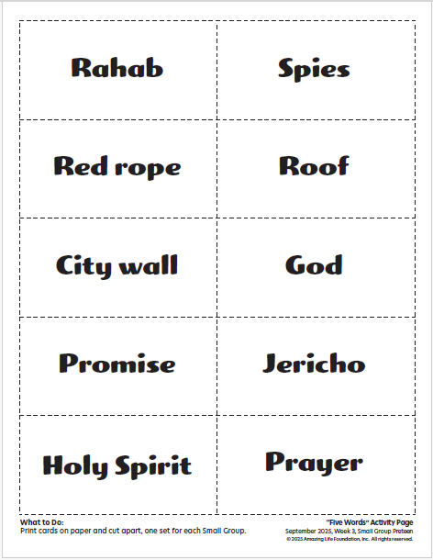

2. Discussion Questions
Talk about God | Bible Story Review
Made to Connect

What You Need: No supplies needed

What You Do:
Ask:
- When has someone helped you?
- If you were in Rahab’s shoes, what would you have done?
- Why do you think Rahab was willing to help the spies, even though it was dangerous?
- What are some truths about God you can remember that can help you when you’re scared to help?
- What does this moment show us about who God is and what He can do through unlikely people?

Inclusive Pro Tips:
- Allow additional time for kids to process and respond.
- Frequently check for understanding during discussion by asking questions like, “Can someone share in their own words what we’re talking about?”

