COLLIDE — October 5th, 2025 (Week 1)
Bible Story: Samuel Anoints David • 1 Samuel 16:1-13
Conversion Starter: What does it mean to be wise?
Bottom Line: God can help you make the wise choice.
Monthly Memory Verse: It is much better to get wisdom than gold. It is much better to choose understanding than silver. Proverbs 16:16 (NIrV)

LARGE GROUP

Optional Video: Countdown
Optional Video: Theme Loop

OPENER
HOST: “Welcome to Wisdomland, everybody! Wisdomland is a theme park, but you don’t just ride roller coasters, you become wiser! God, the wisest, wants to go with you through every up and down of your life and help you make choices to help you live well. My name’s [Host Name] and today, you’re going to be part of our special game in Wisdomlad called: Decision Dilemma!
“We all know theme parks are full of decisions. Which ride do you go on first? Do you get pizza or nachos or pizza nachos (that sounds amazing)? Who sits in the front seat of the coaster? But guess what? Life is the same way! Every day, you make decisions that matter. That’s what this whole series is about: God wants to help you make wise decisions so you live better and well!
“Today, we’ll kick things off with a team competition—Decision Dilemma. Here’s how it works: I’m going to read out some tricky scenarios, scenarios where we want to find wisdom, scenarios that you might face in real life. But the situations will be tricky, so we’ll talk them through.
“I’m going to give each team a buzzer (or paddle). Your job is to discuss the situation with your group, and buzz the buzzer (or raise your paddle) when you have some thoughts to share.
“I’ll divide our group into teams and give each team a buzzer (or paddle).
Divide the room into at least two teams, give each team a buzzer (or paddle).
“Ready for your first Decision Dilemma? I’ll call out a scenario. You discuss your group’s response, and hit the buzzer (or raise the paddle) when you’re ready to share your team’s thoughts. Here we go!
“You see someone being left out at lunch. Is it wise to sit with them, even if your friends tease you? What is the wise thing to do and why?
When a group signals in, invite them to share what they think the wise thing to do is. Encourage them to share their reasoning behind their answer, and try to make the point that God loves everyone and choosing courage over comfort is what God would do.
“Great job! Here’s the next decision to make! You have homework due, but your favorite show just dropped a new episode. Do you binge-watch your show first, or finish your work? What’s the wise thing to do and why?
When a group signals in, invite them to share what they think the wise thing to do is. Encourage them to share their reasoning behind their answer, and try to make the point that being a student is a priority, and it honors God to work hard and be faithful.
“Great discussion! Here’s your next decision you’re faced with: A friend tells you a secret that could hurt them or someone else. Should you keep the secret and not share it with anyone, or tell a trusted adult? What’s the wise thing to do and why?

Invite the groups to discuss amongst themselves what wisdom looks like in this scenario, signal when they’re ready, and discuss their reasoning behind their thoughts.

“Wow! I loved hearing everyone’s thoughts and reasoning behind that. Here’s our last decision dilemma: You have money to spend—do you buy candy, save your money, or give some away? What’s the wise thing to do and why?

Invite the groups to talk amongst themselves, buzz in when they have thoughts, and share their reasoning behind their thoughts. Prompt the kids to share stories of wise versus unwise spending.
“Decision Dilemma shows us something really important: Wisdom isn’t always about having a quick answer. Sometimes you need to pause, think, and ask God for help—especially when there isn’t an obvious right or wrong. God loves you and wants to help you go through any situation you face wisely and well!
“Today’s Bible Story is about someone who had to follow God’s leading to make the wise choice, but God walked him through it every step of the way. There were confusing moments and moments this person didn’t understand, but God still went with him through it all and told him what the wise thing to do was.
“But before we look at that true story from the Bible, let’s worship the One who goes with us through everything, and who wants to guide us to goodness with His wisdom!

WORSHIP
HOST: “Let’s keep the energy rolling! One of the most powerful things in the process of finding God’s wisdom is to turn your attention to God. Worship through music isn’t just singing songs—it’s about refocusing your heart, your mind, and your whole life on what matters most. As we worship, we draw near to the wisest One!

VIDEO: “(Lyric Video)”

Now why don’t we turn our eyes, ears and hearts towards the screen and watch this week’s bible story together.

VIDEO: Bible Story W1

AFTER BIBLE STORY
HOST: “When we think about Samuel, we can remember that God helped him see what was truly wise.
“But the story doesn’t end with Samuel, it continues with you. Every day, you have moments that matter—moments when you might feel nervous, invisible, or stuck. In those times, God sees you. He cares about your heart, and He loves to guide you, just like He did with Samuel and David.
“As you leave today, remember that wisdom isn’t about always having the answers—it’s about going with God through everything, asking Him for help. and being willing to trust Him, one step at a time.
“As you head into this week, here’s something to carry with you and talk about with God and others:
SLIDE: Conversation Starter

[Conversation Starter] “What does it mean to be wise?

SLIDE: Theme Background
“Does wisdom look like always having the right answer? Or is it about going with God through everything, and asking Him for help as you go? Think about where you need wisdom most right now. Who can you talk to? What’s one step you can take to listen for God’s voice and live out wisdom this week? Don’t rush past the question—let it shape your prayers, your friendships, and your choices. God is ready to guide you, moment by moment. But before we head out, let’s talk to God together now!

PRAYER
HOST: “God, thank You for seeing us and loving us. Thank You for helping Samuel listen, for choosing David, and for sending Jesus. Please give us wisdom for the moments ahead—at school, at home, and everywhere we go. Help us listen, trust, and follow You. We love You, and we pray these things in Jesus’ name. Amen.’
After prayer, Host dismisses kids to Small Group.

SMALL GROUP
The BLESSED lifestyle
Begin with prayer
Take a few minutes to pray with your small group
We want to encourage the kids to start with prayer. Lead them by praying for the group. Ask if there are any prayer requests. To make them more comfortable you can start praying then ask if anyone would like to pray after you.
You can also use the Bottom line or monthly theme as key prayer points.

1. Take a Snapshot
Live for God | Application Activity
Made to Connect

What You Need:
Pencils or pens
Fast Pass” Activity Page

What You Do:
- Give each kid one Fast Pass card from the “Fast Pass” Activity Page and a pencil or pen.
- Encourage them to write their names on their “Fast Pass.”
- Invite them to form groups of 2-3.
- Direct the kids to read the verse on their cards aloud to their group and answer the reflection questions on the back together.
- After reflection time, gather the entire group together.
- Invite kids to share their verses and their insights with the group if comfortable.
- [Make It Personal] (Share an age-appropriate time when God helped you make a wise choice. Briefly explain the situation, how you felt, and how God showed up!)
- Explain:
  - A “Fast Pass” gets you to the front of the line at an amusement park.
  - Wisdom is like a fast pass that leads you through life well. And God wants to give you wisdom! When we read the Bible, pause to reflect, and ask the Holy Spirit for help, God can speak directly to you and show you how to live wisely! God wants to give you wisdom!
  - God wants to give you wisdom right now, not just when you’re older. You might not be picking a college or deciding on a job yet, but you are choosing how to treat your friends, how to respond when someone’s unkind, or what to do when you feel left out. God cares about every single one of those moments, He goes through every single one of those moments with you through His Spirit, and as you seek Him, He will help you navigate them all!
- NOTE: Each week, kids will receive a “Fast Pass.” Encourage them to collect them and take them home!

Inclusive Pro-tips:
- If this activity works best when the kids work and reflect independently, allow them to do so.

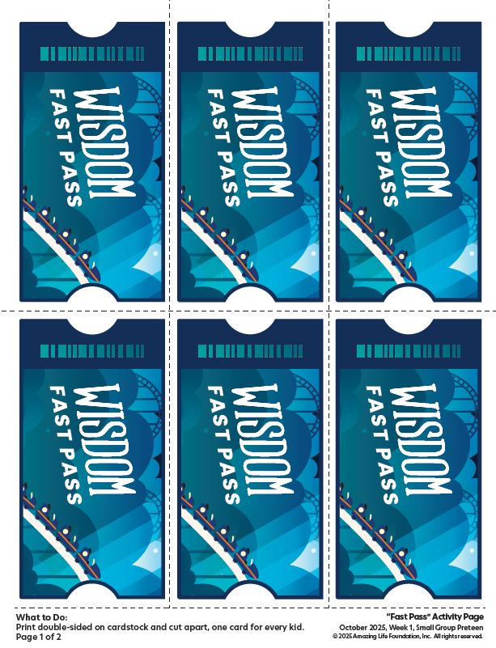

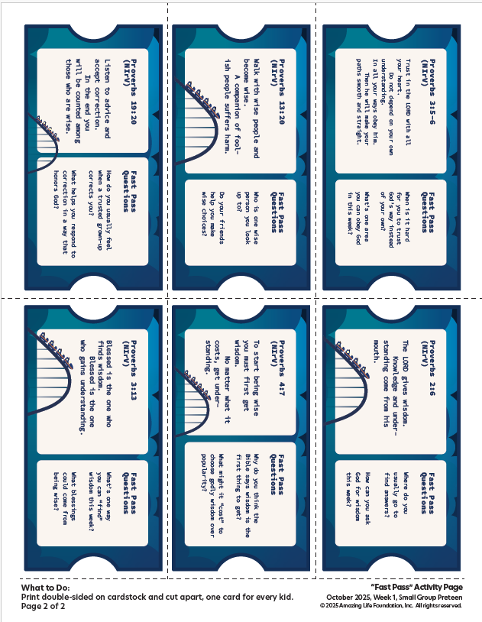

2. Discussion Questions
Talk about God | Bible Story Review
Made to Connect

What You Need:
No supplies needed

What You Do:
Ask:
- What does it mean to be wise?
- Why do you think God wants us to grow in wisdom?
- What makes it hard to make the wise choice when others around you choose not to?
- What helps you listen to God when making a decision?
- What can you pray to help you turn to God and ask Him for wisdom as you go through life with Him?

Inclusive Pro-Tips
- Be sensitive to kids who may need extra time to process their thoughts and respond. Be patient and create a safe space where everyone has a chance to share when they’re ready.
- Frequently check for understanding during discussion by asking questions like, “Can someone share in their own words what we’re talking about?”

