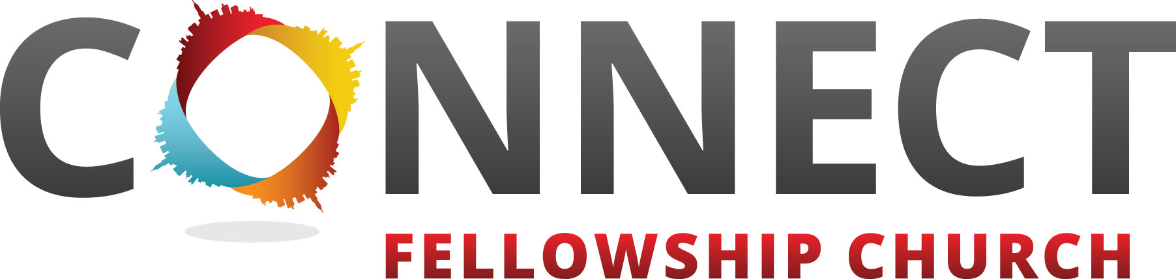

August 2025 Prayer Focus

Week 1: August 1st–2nd
- Start with worship – praise God and tell Him how much you love Him.
- Ask God for His favor, financial provision, and grace for the vision of Connect Fellowship Church.
- Lift up your pastors and family—Brian, Dawn, Taylor, Ethan, and Faith—asking God to fill them with supernatural strength, divine wisdom, and unwavering protection. Pray for physical health, emotional rest, and spiritual clarity as they lead with courage, vision, and love.
- Pray for your own needs and for your family to follow Jesus fully.
- Pray for the Power Team (our volunteer team) — for growth, encouragement, and new leaders to join.
- Pray for Connect Kids leaders and all serving from babies to elementary. Ask God to bring more leaders and children.

Week 2: August 3rd–9th
- Pray boldly for Connect Students — that middle and high schoolers would be drawn to Jesus in a powerful way. Ask God to ignite a hunger in their hearts for truth, identity, and purpose found only in Him. Pray for a generation to rise up unashamed of the Gospel, fully surrendered, and passionately following Jesus.
- Pray for our Worship Team — for a fresh anointing over every leader, vocalist, musician, and tech team member. Ask God to use their gifts to usher in His presence and lead people into life-changing encounters with Him.
- Pray for our Food Pantry — that God would multiply every resource and meet every need. Ask for continued generosity from donors and divine provision to feed both bodies and souls in our community.
- Pray for Connect Recovery — covering every Tuesday night with the power of the Holy Spirit. Ask for breakthrough, healing, and freedom for every leader and attender walking the road to restoration.
- Pray for Small Groups launching September 14 — for real, lasting community to form. Ask God to stir hearts, grow faith, and build spiritual family through every group.
- Pray for the unchurched — that they would be drawn by the Holy Spirit to Connect, find belonging, and encounter Jesus as Savior and Lord.
- Cry out for our city — asking God to shatter every chain of homelessness, poverty, addiction, human trafficking, mental illness, and spiritual darkness. Declare freedom, healing, and revival in Jesus’ name.

Week 3: August 10th–16th
- Pray for Family Fun Day on August 10th — that it would be more than just an event, but a moment where joy is contagious, hearts are connected, and families encounter the love of Jesus through laughter, fellowship, and meaningful conversations, and great weather.
- Pray for Kingdom Builders — ask God to bless every person who gives faithfully and sacrificially. Pray for new hearts to rise up in radical generosity to fuel ministry, missions, and the vision of Connect Fellowship Church.
- Pray for our building — that all legal and financial processes will be completed quickly and supernaturally. Believe that the building will be finalized, titled to Connect, and completely debt-free — a testimony of God’s faithfulness and provision.
- Pray for CMN and ARC — powerful church planting movements we support. Ask God to raise up bold, Spirit-led leaders who will launch life-giving churches that reach the unchurched and transform communities across the world.
- Pray for NLRN (Next Level Relational Network) — that God will continue using this ministry to refresh, support, and strengthen pastors and their families who lead on the frontlines of spiritual battle.
- Pray for our missionaries — the Sassers-Bosnia, Woods-MS State, Clements-Oxford, Bentleys-Macedonia, Hartsells-Africa, Taylors-MS Next Gen, and others. Ask God for

divine protection, supernatural provision, open doors, and an outpouring of fruit as they carry the Gospel into every corner of the globe.
- Pray for the Mississippi Assemblies of God District — for renewed vision, favor, and unity. Cover Superintendent Bob Wilburn and his family in strength, health, and spiritual clarity as they lead the churches in our region.
- Pray for salvations and baptisms — that the Holy Spirit would convict hearts, draw people to Jesus, and lead many to make a public declaration of faith. Pray that lives will be eternally changed through the ministry of Connect Fellowship.
- Pray for upcoming outreaches — that every event and opportunity to serve would open hearts to Jesus. Ask God to guide us to the people and places that need hope, healing, and a fresh start through the love of Christ.

Week 4: August 17th–23rd
- Pray for the Men’s Conference — that it would be a catalyst for transformation. Ask God to stir boldness, purpose, and spiritual leadership in every man who attends. May lives be changed, hearts be healed, and destinies be awakened.
- Pray for the Driftwood location — cover every resident and staff member in prayer. Ask that weekly services would be filled with the presence of God and that this would become a place of consistent salvation, restoration, and community.
- Pray for our military families — for peace, strength, and unity. Ask God to bless those who serve and protect, and to bring comfort and covering over every spouse, child, and service member connected to our church and community.
- Pray for the lost to be found — ask God to open blind eyes, soften hearts, and draw people to salvation. Pray for believers to grow strong in their faith and live out Connect’s core values: Be Free, Spiritually Fit, Purposefully Connected, Love All–Serve All, and Live Generously.
- Pray for our Connectors, Pastors, and Coaches — that God would refresh them, protect their families, and anoint their leadership with clarity, joy, and strength as they serve faithfully.
- Pray for Empowerment Track — our pathway to membership and discipleship. Ask God to use it to awaken callings, deepen roots, and raise up fully engaged followers of Jesus.
- Pray for a wave of growth — believing for 450 families to call Connect Fellowship Church their home every Sunday in Long Beach. Ask God to draw people hungry for hope, healing, and purpose.
- Pray for national revival — that hearts across America would turn back to God. Ask for a movement of repentance, reconciliation, and surrender that ignites spiritual awakening from coast to coast.

Week 5: August 24th–31st
- Pray for our national leaders — including the President, Congress, and Senate. Ask God to give them divine wisdom, godly counsel, and hearts that will humbly seek His will for this nation.
- Pray for our local leaders — including Governor Tate Reeves, Mayor Tim Pierce, and all city and state officials. Ask for integrity, discernment, and strength as they lead our communities.
- Pray for first responders — including law enforcement, firefighters, and state workers. Cover them in protection and peace as they serve on the frontlines with courage and sacrifice.
- Pray for spiritual renewal — that empty religion and man-made traditions would be replaced with real, vibrant faith in Jesus. Ask for people in our region to experience true relationship with Christ.
- Pray for the Diamondhead Launch — lift up the small group starting in October and the full-service launch in February 2026. Ask for favor, momentum, and divine alignment as we prepare to bring the hope of Jesus to a new community.
- End the month with praise — take time to worship and thank God for all He’s done and all He’s going to do. Rejoice in faith that every prayer matters, every seed is planted, and every promise will be fulfilled in His perfect timing.

www.connectfellowship.church

