January 21, 2026
Spring 2026 Growth Group Dates
Saturday, January 24 – Place of Hope Saturday Serve (10am-1pm)
Sunday, January 25 – Biblical Legacy Planning Luncheon (12:15pm-1:15pm)
Sunday, January 31 – Delray Green Market Outreach & Brunch (10:30am-12pm)
Sunday, February 1– Kickoff of Bod4God
- 10 Journey Hoodies Giveaways, Continental Breakfast, Big Bounce House for Kids and more!

Sunday, February 8 – Newcomers Reception
Week of Monday, February 9 – Spring 2026 Growth Groups Begin!
Wednesday, February 18 – Ash Wednesday (Lent Begins)
Sunday, February 22 – Membership Class 101
Sunday, March 1 – Baptism
Sunday, March 8 – Call to Ministry Luncheon & Discussion (12:15pm–1:15pm)
Wednesday, March 11 – The Difference Maker Seminar
Saturday, March 28 – Easter Outreach
Sunday, March 29 – Member’s Prayer Time after each service
Saturday, April 4 to Sunday, April 5 – Easter Services
Week of Monday, April 27 – Final Week of Spring 2026 Growth Groups

Journey Mission Statement

The Journey exists to give the people of South Florida the best opportunity
to become fully developing followers of Jesus.

“They worshiped together at the Temple each day, met in homes
for the Lord's Supper, and shared their meals with great joy and generosity
– all the while praising God and enjoying the goodwill of all the people.
And each day the Lord added to their group those who were being saved.”
– Acts 2:46-47

How Does My Growth Group “WIN”?

- My Growth Group “WINS” when together we apply _________________________

________________________________________________________ to our lives AND
________________________________________________________________________.

Growth Group Responsibilities

What does my Growth Group Do?

- Meets together once a week.

- Serves together once a month.

- Reaches out together once a semester.

WHAT DOES A GROWTH GROUP LEADER DO?

- Pray for group members once a day.

- Lead the group once a week.

- Form new groups from their current group at the end of the semester by identifying new leaders.

WHAT DOES A GROWTH GROUP COORDINATOR DO?

- Prepares to become a Growth Group Leader by serving as an apprentice who supports and assists the Group Leader.

- Sends out group reminders & prayer requests.

- Facilitates group discussion multiple times during the semester.

- Prays for the group.

Each week the Coordinator sends 2 emails to the group:

- Record prayer requests and email them to everyone in the group the day after the group meets.

- Send an attendance reminder email to everyone in the group each week a day or two before the group is scheduled to meet (and before group events).

Four F’s of Leading a Growth Group

1. F _____________________________________

Who can I invite to be a part of my Growth Group?

- People from previous Growth Groups.

- People I know from church.

- Friends or family who do not attend another church.

How do I tell people about my Growth Group?

Send a text to friends with details and asking them if they are interested.

Email an interest list with details about your group and invite them to sign up.

Post details about my Growth Group weekly on social media. Be creative!

Serve on the Welcome Team.

Serve at the Growth Group Table and hold a poster at the service.

KEY ACTIONS:

Invite as many people as I can to join my Growth Group THIS week.

Find a Growth Group Coordinator or Co-leader for my group.

Sign up for my group online. Double check the online listing. Improve the description if it’s not appealing. Change the details if receiving little interest.

*Challenge: List 3 people I can invite to join my Growth Group:

1. 2. 3.
2. F _____________________________________

How do people sign up for my Growth group?

Sunday & Online Signups: You receive an immediate email.

Weekly Roster: Each Tuesday you will receive an updated Growth Group roster.

Three types of communication…

_____________________________________ Communication

As soon as someone signs up, email them the details for your Growth Group.
(sample email included on page 13)

Within a few days of the initial sign-up, text and/or call them to introduce yourself.

_____________________________________Communication

Call and text your Group Members the week of your first meeting.

Two email reminders before the first meeting:

One 1 Week before

One 1 Day before

_____________________________________Communication

Two weekly emails:

Meeting reminder (1 or 2 days before meeting)

Prayer requests (day after meeting)

*Challenge: _______________________________________________________________________.

3. F _____________________________________

Preparing for my first Growth Group:

Pray for your group and the individuals who sign up

When someone signs-up, immediately add them to your Growth Group list (keep an excel file with everyone’s contact information).

Keep the names of your Growth Group Members in a place where you will see them every day (index card in your Bible, background of your phone, desktop of your computer, on your refrigerator) as a reminder to pray. Set a reminder every morning to pray for 3-4 Growth Group members.

Create a plan for your Growth Group

Create a simple syllabus for your Growth Group (sample on page 14).

- Follow the First Group Meeting Itinerary (page 15).

- Each Monday we will send you an icebreaker, helpful tips, and important announcements to share with your Growth Group.

Your study or book may have questions after each chapter or a discussion guide to use. You may have to create your own. You can also discuss the message from the previous Sunday and have discussion around that.

Lead your group through the Growth Group Covenant & Syllabus at your first meeting.

Walk through the Syllabus with your Group during the first group meeting

(page 14).

Read through the Growth Group Covenant and have members of your Growth Group sign (physical copy or online) (page 16).

*Challenge: _______________________________________________________________________.
4. F _____________________________________

How can I keep everyone in engaged in my Growth Group discussion?

Make sure everyone can comfortably see and hear one another.

Online Group Leaders:

Turn your camera on and use a headphone mic (if possible) to minimize background noise and feedback.

Use “Group View” mode so you can see everyone on the screen.

Encourage everyone to turn on their camera (if possible), but let them connect however they feel most comfortable.

In-Person Groups:

Sit where you can see everyone, and they can see you.

Speak up and speak clearly, while inviting others to do the same.
  - Make sure temperature and noise levels are comfortable.

Begin and end on time every time.

Include an icebreaker each week to help group members relax and warm up.

Ask group members what stood out to them. Utilize questions provided by your study. Invite group members to read a passage of scripture aloud.

Ping Pong Ball…. …Keep it in Play! 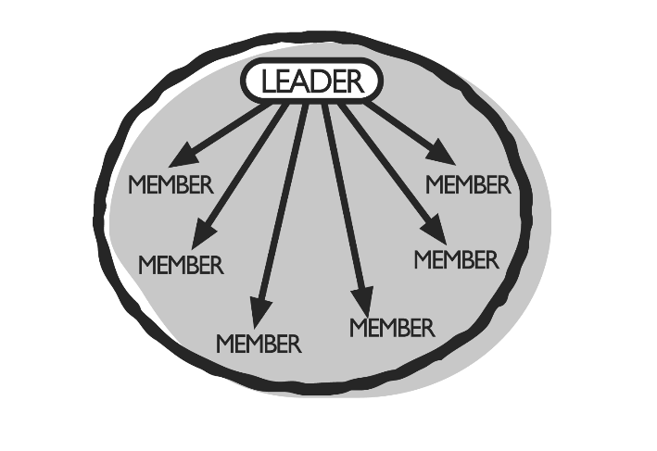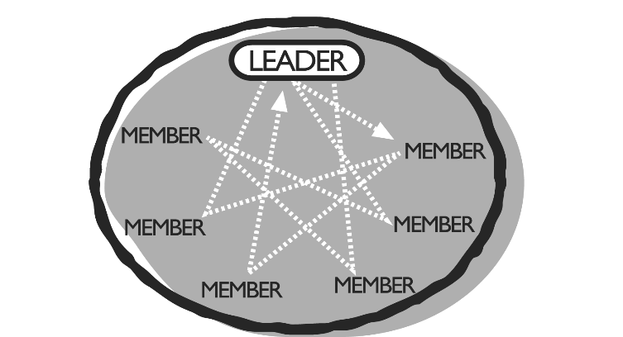

Don’t let one person ruin it for everyone else.

Provide the “2 C’s” –

Care to Growth Group members

Communication to Staff

End every group by praying for prayer requests and emailing them out.

Serve at a Sunday service once a month this semester (see page 17 for schedule).

Lead your group to serve at the Easter Outreach (see page 17 for schedule).

*Challenge: _______________________________________________________________________.

Four F’s Checklist:

FILL-UP CHECKLIST:

__ Secure a Coordinator for your Growth Group.

__ Serve at the Growth Group Table and ask people on Sunday to join my group.

__ Invite friends, neighbors, and co-workers to join my group.

FOLLOW-UP CHECKLIST:

__ Email every person who signs up for my group immediately with all the important information: day/time/location, start date, syllabus, contact info, etc.

__ Call/text everyone who signs up for my group at least once before the group begins.

__ Send an email reminder two days before my group begins.

__ Follow up personally with those who don’t show up for Growth Group at least 3 weeks into the group (and don’t remove their name from the list until they request it).

FOCUS CHECKLIST:

__ Pray daily for those who have signed up for my group.

__ Secure a place for my group to meet.

__ Have the Syllabus and GG Covenant ready at the 1st group meeting.

FACILITATE CHECKLIST:

__ Send 2 weekly emails to my Growth Group: Group Reminder Email (one or two days before group meeting) and Prayer Requests (day after group meets).

__ Write down my group’s Sunday serving dates and communicate those dates to my group. Be faithful in leading my group to serve.

__ Continually identify potential leaders from my group and give them the opportunity to serve/lead within my group.
How To Study The Bible

“Study this Book of Instruction continually. Meditate on it day and night so you
will be sure to obey everything written in it. Only then will you prosper and succeed in all you do.” – Joshua 1:8

- Learn to _________________ the Bible.

“Study this Book of Instruction…”

“Open my eyes to see the wonderful truths in your instructions.”
- Psalm 119:18

Tool to Help Me: ____________________________

- Commit to Bible study as a _______________________.

“Study this Book of Instruction continually…”

“Focus on reading the Scriptures to the church,
encouraging the believers, and teaching them.” - 1 Timothy 4:13

Tool to Help Me: _________________________

- R______________________ what I am studying.

“…Meditate on it day and night…”

“I have hidden your word in my heart, that I might not sin against you.”
- Psalm 119:11

Tool to Help Me: ____________________________

- ________________ what the Bible says.

“…be sure to obey everything written in it.
Only then will you prosper and succeed in all you do.”

“ 22 But don’t just listen to God’s word. You must do what it says.
Otherwise, you are only fooling yourselves. 23 For if you listen to the word and don’t obey, it is like glancing at your face in a mirror. 24 You see yourself, walk away, and forget what you look like. 25 But if you look carefully into the perfect law that sets you free,
and if you do what it says and don’t forget what you heard,
then God will bless you for doing it.” - James 1:22-25

Tool to Help Me: _________________________

Sample Follow-up Email

Subject: Welcome to our Spring Growth Group!
To: Everyone who signs up for your group

Hi <<First Name>>,

My name is <<Name>> and I’m so excited that you’re going to be part of our Spring Growth Group! I wanted to shoot you a quick email to introduce myself and give you some details about our group.

Our group will meet on Monday mornings this spring and will be studying <<Book Title>>.

We meet for the first time on Monday, February 9 at 7:00pm. Our final group meeting will be Monday, April 27. It's just 11 weeks – but we are going to get so much out of it!

Here are the details…

WHAT: Spring Growth Group – [BOOK TITLE]
WHEN: Mondays at 7:00pm beginning on Monday, February 9
WHERE: [ADDRESS]

Here’s the link so you can purchase your book: [LINK TO BOOK]

If you know of others who would be interested in joining our group – feel free to invite them. Here is the link where they can find out more and sign up: [LINK TO SIGNUP FORM]

I’m really looking forward to our Growth Group and I hope you are as well! Reply to this email and let me know if you’ll be at our first meeting.

See you on Sunday and I am praying for you!

[YOUR NAME]

Sample Growth Group Syllabus

Welcome to your Spring 2026 Growth Group. Your group will meet weekly beginning the week of February 9 and will conclude the week of April 27.

We will be studying [BOOK TITLE] together. Be sure to keep up with your weekly reading and come to the group prepared to participate in the discussion.

Below is a week-by-week breakdown for our group:

Week #1: Week of Feb 9 – Introduction: Welcome, Intros, Group Covenants

Week #2: Week of Feb 16 – Chapter 1-2

Week #3: Week of Feb 23 – Chapter 3-4

Week #4: Week of March 2 –Chapter 5-6

Week #5: Week of March 9 – Chapter 7-8

Week #6: Week of March 16 – Chapter 9-10

Week #7: Week of March 23 – Chapter 11-12
Saturday, March 28 – Easter Outreach

Week #8: Week of March 30 – Chapter 13-14

Week #9: Week of April 6 – Chapter 15-16

Week #11: Week of April 20 – Chapter 17-18

Week #12: Week of April 27 – Growth Group Fun Event

SUNDAY SERVING DATES:

________________ ________________ ________________ ________________

Spring 2026 Growth Groups
Itinerary for your 1st Growth Group Meeting

- First 5 Minutes: Allow people to arrive and talk. Leaders – be sure to be ready to receive people in-person or online 10 min before the group begins. Arrive early.

- Introductions: Have everyone introduce themselves and share what they do, where they are from and why they decided to join the group. (10 min)

- Ice Breakers (See some favorite ideas below): (10 min)

- (Online Group) A Scavenger Hunt: The Leader will have a list of items that each group member will have to find in their apartment and present. The first person to present the item wins a point.

- Little Known Facts: Ask each person in the group to think of two interesting, unusual, or humorous facts about themselves that no one else would know. Everyone takes a turn sharing their little-known facts with the group. Be prepared for some wacky revelations!

- Penny for Your Thoughts: Ask each person to get a coin, look at the date and then share something interesting that happened in their life that year.

- Introduce Your Group Study: Walk through GG Syllabus. Answer any questions.
(5 minutes)

- Growth Group Covenant: Read through the Covenant carefully with the group. Explain the points as you read each one. Answer any questions. If anyone tries to be difficult and disagreeable, offer to talk with them individually at the end of the meeting. (10 min)

- Explain and ask for volunteers for the different roles within the group: Snack Coordinator, Fun Event Coordinator, Prayer Coordinator, etc. (5 min)

- Share prayer requests and pray together. (10 min)

- Talk – Give people a few minutes to talk before ending the group.

The Journey’s Spring 2026 Growth Group Covenant

Welcome to your Spring Growth Group at The Journey. Congratulations on your desire to grow deeper in your relationship with God through this weekly study and the relationships that will begin in this Growth Group.

As a member of this group, you will be asked to enter into a covenant with the other members to make this Growth Group a priority. To be a part of the group, you are asked to make the following commitments:

- I will make this group a priority by attending each week, keeping up with my assignments, and participating in group discussion.

- I will regularly attend The Journey services and contribute to the ministry of the church through my attendance, giving, service, and inviting of others.

- I will strive to build authentic relationships with those in this group by showing care, providing encouragement, and praying for their needs.

- I will intentionally share my faith with those around me by reaching out to lost and unchurched friends by praying, giving a verbal witness, and inviting them to The Journey.

- I will serve at Church together with my group once a month.

- I will explore honestly my next steps for spiritual growth.

________________________________ _______________
Sign Your Name Date

________________________________
Print Your Name

Growth Group Members can also complete the Covenant here:
BocaJourney.com/Covenant

Spring 2026 GG Welcome Team Serving Schedule

Leaders | Date 1 | Date 2 | Date 3 | Date 4
Jason / Financial Peace | Feb 8 @ 9:30am or 11:00am | Mar 8 @ 9:30am or 11:00am | April 5 @ 9:30am or 11:00am | May 3 @ 9:30am or 11:00am
Students | Feb 8  @ 9:30am or 11:00am | Mar 8 @ 9:30am or 11:00am | April 5 @ 9:30am or 11:00am | May 3 @ 9:30am or 11:00am
College & Young Adult | Feb 15  9:30am | Mar 15  9:30am | April 12  9:30am | May 10  9:30am
Carol & Dawn | Feb 15  11:00am | Mar 15  11:00am | April 12  11:00am | May 10  11:00am
Regina & Jobi / Scott | Feb 15  11:00am | Mar 15  11:00am | April 12  11:00am | May 10  11:00am
Sam & Natasha | Feb 22  9:30am | Mar 22  9:30am | April 19  9:30am | May 17  9:30am
Del & Erv / Loren & Vince | Feb 22  11:00am | Mar 22  11:00am | April 19  11:00am | May 17  11:00am
Pam / Sam & Lori | March 1  9:30am | Mar 29  9:30am | April 26  9:30am | May 24  9:30am
Danetra & Gwen / Jim & Daphne | March 1  11:00am | March 29  11:00am | April 26  11:00am | May 24  11:00am

Easter Schedule | Leaders
4/4 6:00pm | Del & Erv & Regina & Jobi
4/5 9:30am | Dee & Gwen/Jason/Students
4/5 11am | Jason & Students / Carol & Dawn
4/5 1pm | Sam & Natasha / Pam

Easter Outreach Date
Saturday, March 28 from 10:00am-1:00pm

Growth Group Leader/Coordinator Covenant
Spring 2026

Thank you for serving as a Growth Group Leader/Coordinator at The Journey. As a Growth Group Leader/Coordinator you will be viewed by those in your group as a leader in the church. As a result, we ask that you enter into covenant with the other Growth Group Leaders/Coordinators by making the following commitments:

- I will embody and reflect the values and principles of The Journey and will follow the leadership of the staff team.

2. I will faithfully attend The Journey on Sundays and:
- Participate in the church by becoming a member and giving in a measurable way.
- Leading my group in serving together once a month.

3. I will make my Growth Group a priority by:
- Faithfully attending my Growth Group.
- Preparing beforehand for my group each week.
- Inviting/welcoming others to join my group.
- Identifying new leaders in my Growth Group.

4. I understand I am responsible for the care of my Growth Group. As a result, I will:
- Pray for the individuals in my group.
- Follow up with each person in my group.
- Lead my group in providing care for one another.

5. I will strive to create an environment of growth in my group by:
- Involving as many people as possible in group discussion.
- Creating a safe, comfortable, and welcoming environment.
- Beginning and ending on time.

6. I will intentionally share my faith with those around me by:
- Reaching out to lost and unchurched friends and inviting them to The Journey.
- Encouraging my Growth Group members to reach out to lost and unchurched friends and inviting them to The Journey.

________________________________________________ __________________________
Sign Your Name Date

_____________________________________
Print Your Name

