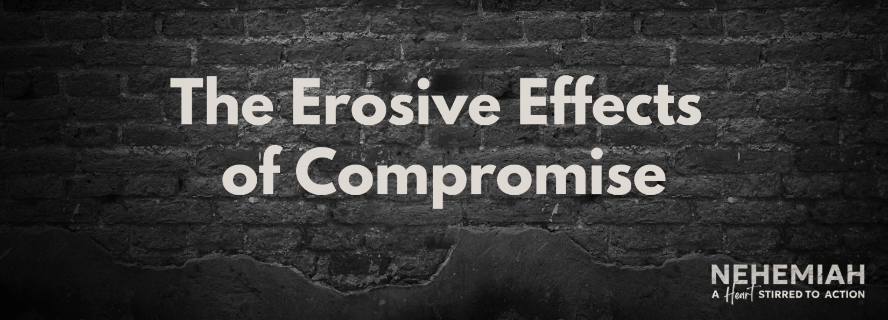

Pastor Keith Thompson
Nehemiah 13:1-31 (ESV)

Principle: Avoiding minor spiritual ____________________ today insulates us against major ____________________ one day.
- Protect a high view of __________ __________.
- Preserve a sober view of __________.
- Pursue an honest ____________________.
- Ministry leaders are supported by a faithful __________________ (47).

