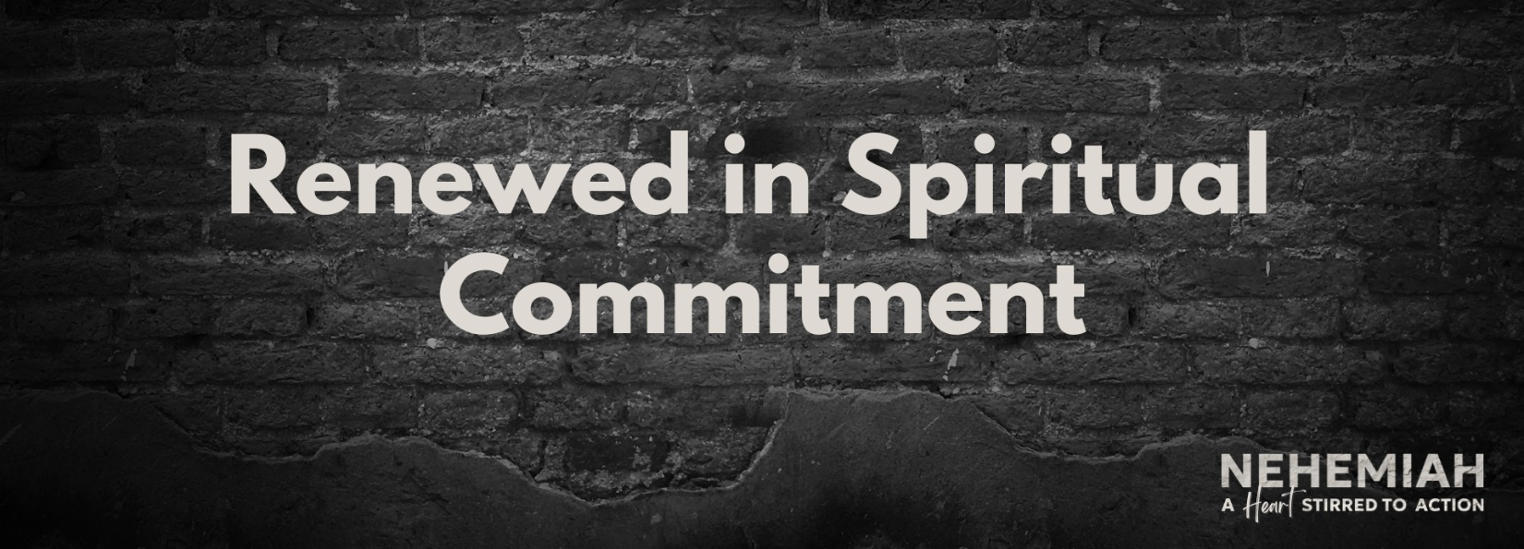

Pastor Keith Thompson
Nehemiah 9:38-10:39 (ESV)

Principle: Spiritual renewal requires an ongoing ____________________ to God that results in a ____________________ life.
- When we get serious about our spiritual lives, we begin to value God’s __________ (10:28-29).
- When we get serious about our spiritual lives, we begin to pursue ___________________ (10:30-31).
- When we get serious about our spiritual lives, we begin to prioritize ________________ (10:32-39).

