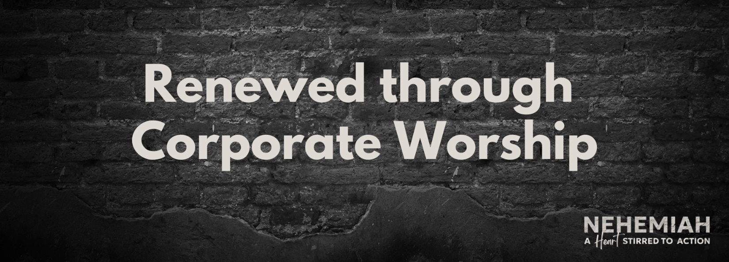

Pastor Keith Thompson
Nehemiah 9:1-38 (ESV)

Principle: Spiritual renewal requires regular worship of God with ________________.
- Authentic worship begins with personal ________________ (1-2).
- Authentic worship centers in biblical __________ (3a).
- Authentic worship engenders honest ________________ (3b).
- Authentic worship erupts in fervent ____________ (5-37).
- Authentic worship moves to lasting _____________________ (38).

