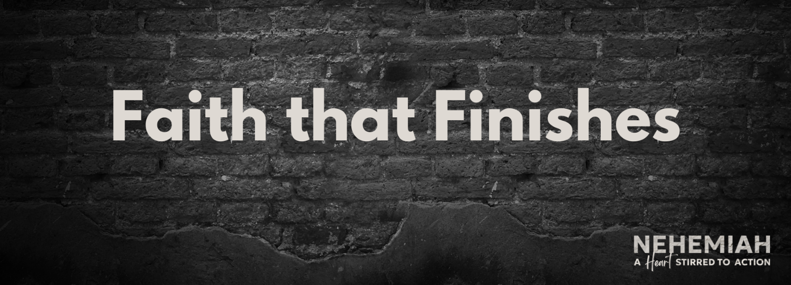

**Pastor Randall Hosea**

**Nehemiah 6:1-19 (ESV)**

**Principle: We should expect __________________ to God’s Kingdom ________________ and be on ___________ against it.**

1. The Schemes of the Saboteurs (1-4)  
   Use ______________: Satan desires to __________ those who pursue God’s purposes.
2. The Slanderous Scroll (5-9)  
   Use ______________: Satan attempts to __________ __________ those who pursue God’s purposes.
3. The Setup in the Sanctuary (10-14)  
   Use ____________________: Satan attempts to ____________ those who pursue God’s purposes.
4. The Successful Completion (15-16)  
   Use ____________________: God ______________endurance for those who pursue God’s purposes.
5. The Subtle Subversion (17-19)  
   Use ______________: Satan continues to ______ those who pursue God’s purposes.