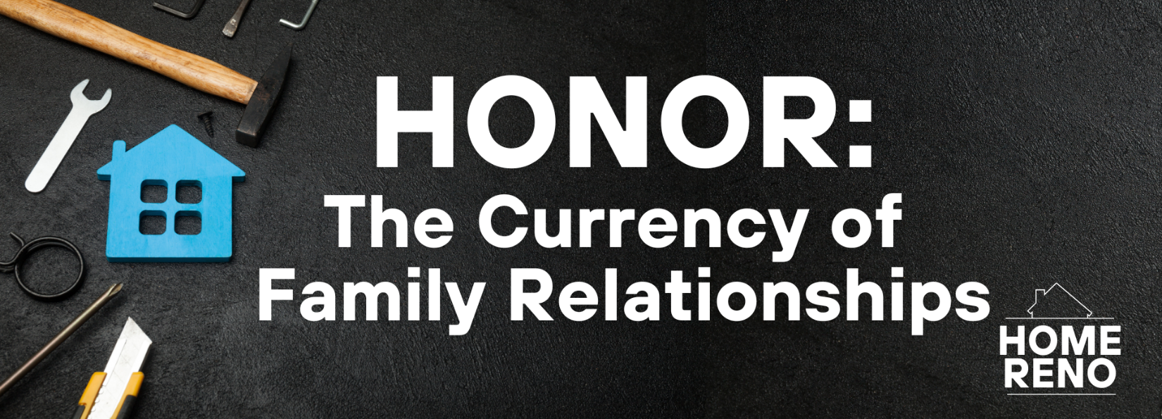

**Pastor Keith Thompson**

**Ephesians 6:1-4 (ESV)**

**Principle: God has designed the family to be a safe place for children and adults to learn to relate well to others.**

1. Children honor their parents through __________ ____________________ (1-3).
2. Parents honor their children through ____________ ____________________ (4).