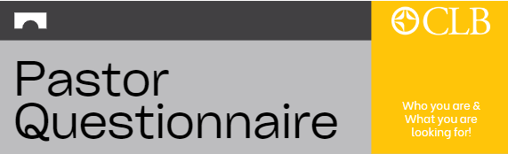
Pastor! (Or soon-to-be Pastor!) This questionnaire is designed to help local congregations and CLB leadership get to know you better. We hope this will help churches get a glimpse of who you (and your family) are, what prior leadership positions you have served, and where your passions lie. Please return the completed questionnaire to:
CLB Director of Operations: Paul Tjelta | Email: ptjelta@clba.org | Mail: PO Box 655, Fergus Falls, MN 56538
NAME: _________________________________CURRENT LOCATION:_________________________________
PHONE: ________________________________EMAIL:_____________________________________________
YOUR STORY
- Please tell us about your upbringing, your family and your faith story.
- How did God call you into ministry?
- What congregation(s) has the Lord allowed you to serve and how has He used you at each? (As volunteer or paid staff member.)
YOUR GIFTING
- What leadership roles have you held? (In business/church/community at any age.)
- How do you interact with church leadership/Elders (or anticipate working with them based on past leadership experience)?
- Pastors typically excel in 2 out of 3 of the main areas of ministry. It is normal to have an area that is an opportunity for improvement. Please identify the area(s) you feel you are strongest in and briefly explain why!
  - Preaching & Teaching
  - Administration
  - Pastoral Care (Visitation/Community Engagement)
YOUR CALL
- As you move forward, what type of role(s) are you open to?
- How do you see God using you to teach and encourage disciple making amongst the people?
- What circumstances lead you to seek a new call? (If this is your first call, what brought you to this point?)

