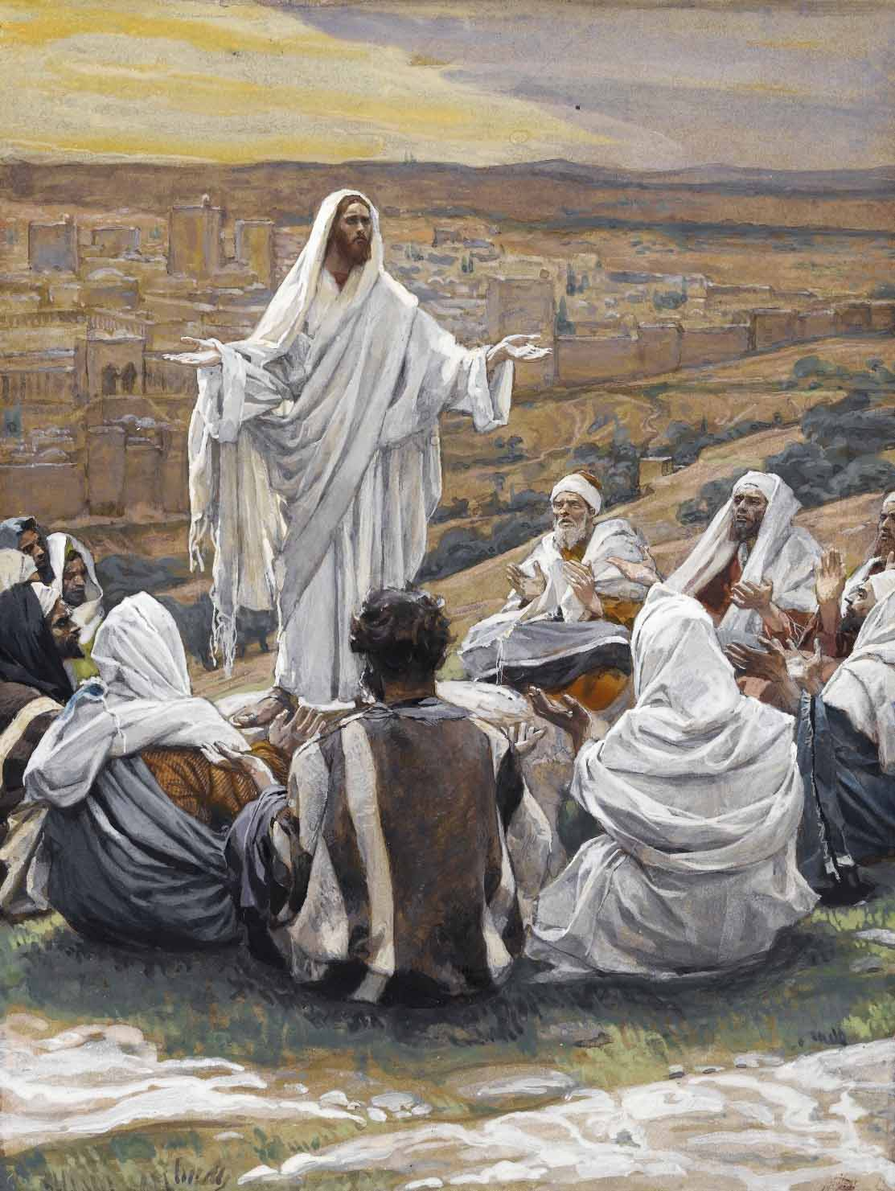

St. John’s Lutheran Church

East Moline, IL 61244

July 27th, 2025

Prelude- St. John’s Ensemble

*“Blessed Legacy” Arr. by: Robert Sheldon*

Hymn- *“Praise the Almighty My Soul Adore Thee” 797*

Text: Johann Daniel Herrnschmidt, 1675–1723; tr. Alfred E. R. Brauer, 1866–1949, alt.  
Tune: New-vermehrte Christliche Seelenharpf, 1665, Ansbach  
Text and tune: Public domain

Stand

Opening Versicles

L This is the day which the Lord has made;

C **let us rejoice and be glad in it.**

L From the rising of the sun to its setting,

C **the name of the Lord is to be praised.**

L Better is one day in Your courts than a thousand elsewhere;

C **I would rather be a doorkeeper in the house of my God than dwell in the tents of the wicked.**

L Make me to know Your ways, O Lord.

C **Teach me Your paths.**

L Sanctify us in Your truth.

C **Your Word is truth.**

L From the rising of the sun to its setting,

C **the name of the Lord is to be praised.**

C **Glory be to the Father and to the Son and to the Holy Spirit;  
as it was in the beginning, is now, and will be forever. Amen.**

Old Testament Canticle *LSB 261*

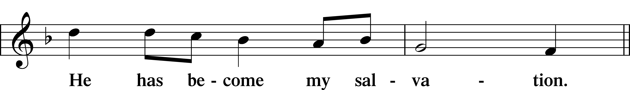

Sit

Readings From Holy Scripture

L A reading from Genesis, the eighteenth chapter.

Then the Lord said, “Because the outcry against Sodom and Gomorrah is great and their sin is very grave, I will go down to see whether they have done altogether according to the outcry that has come to me. And if not, I will know.”

So the men turned from there and went toward Sodom, but Abraham still stood before the Lord. Then Abraham drew near and said, “Will you indeed sweep away the righteous with the wicked? Suppose there are fifty righteous within the city. Will you then sweep away the place and not spare it for the fifty righteous who are in it? Far be it from you to do such a thing, to put the righteous to death with the wicked, so that the righteous fare as the wicked! Far be that from you! Shall not the Judge of all the earth do what is just?” And the Lord said, “If I find at Sodom fifty righteous in the city, I will spare the whole place for their sake.”

Abraham answered and said, “Behold, I have undertaken to speak to the Lord, I who am but dust and ashes. Suppose five of the fifty righteous are lacking. Will you destroy the whole city for lack of five?” And he said, “I will not destroy it if I find forty-five there.” Again he spoke to him and said, “Suppose forty are found there.” He answered, “For the sake of forty I will not do it.” Then he said, “Oh let not the Lord be angry, and I will speak. Suppose thirty are found there.” He answered, “I will not do it, if I find thirty there.” He said, “Behold, I have undertaken to speak to the Lord. Suppose twenty are found there.” He answered, “For the sake of twenty I will not destroy it.” Then he said, “Oh let not the Lord be angry, and I will speak again but this once. Suppose ten are found there.” He answered, “For the sake of ten I will not destroy it.” And the Lord went his way, when he had finished speaking to Abraham, and Abraham returned to his place. *Genesis 18:20–33*

L This is the Word of the Lord.

C **Thanks be to God.**

Heavenly Ringers

*“He’s Got the Whole World In His Hands*” Arr. by: Dobrinski and Braddy

L A reading from Colossians, the second chapter.

Therefore, as you received Christ Jesus the Lord, so walk in him, rooted and built up in him and established in the faith, just as you were taught, abounding in thanksgiving.

See to it that no one takes you captive by philosophy and empty deceit, according to human tradition, according to the elemental spirits of the world, and not according to Christ. For in him the whole fullness of deity dwells bodily, and you have been filled in him, who is the head of all rule and authority. In him also you were circumcised with a circumcision made without hands, by putting off the body of the flesh, by the circumcision of Christ, having been buried with him in baptism, in which you were also raised with him through faith in the powerful working of God, who raised him from the dead. And you, who were dead in your trespasses and the uncircumcision of your flesh, God made alive together with him, having forgiven us all our trespasses, by canceling the record of debt that stood against us with its legal demands. This he set aside, nailing it to the cross. He disarmed the rulers and authorities and put them to open shame, by triumphing over them in him.

Therefore let no one pass judgment on you in questions of food and drink, or with regard to a festival or a new moon or a Sabbath. These are a shadow of the things to come, but the substance belongs to Christ. Let no one disqualify you, insisting on asceticism and worship of angels, going on in detail about visions, puffed up without reason by his sensuous mind, and not holding fast to the Head, from whom the whole body, nourished and knit together through its joints and ligaments, grows with a growth that is from God.  *Colossians 2:6–19*

L This is the Word of the Lord.

C **Thanks be to God.**

Stand

L A reading from Luke, the eleventh chapter.

Now Jesus was praying in a certain place, and when he finished, one of his disciples said to him, “Lord, teach us to pray, as John taught his disciples.” And he said to them, “When you pray, say: “Father, hallowed be your name. Your kingdom come. Give us each day our daily bread, and forgive us our sins, for we ourselves forgive everyone who is indebted to us. And lead us not into temptation.” And he said to them, “Which of you who has a friend will go to him at midnight and say to him, ‘Friend, lend me three loaves, for a friend of mine has arrived on a journey, and I have nothing to set before him’; and he will answer from within, ‘Do not bother me; the door is now shut, and my children are with me in bed. I cannot get up and give you anything’? I tell you, though he will not get up and give him anything because he is his friend, yet because of his impudence he will rise and give him whatever he needs. And I tell you, ask, and it will be given to you; seek, and you will find; knock, and it will be opened to you. For everyone who asks receives, and the one who seeks finds, and to the one who knocks it will be opened. What father among you, if his son asks for a fish, will instead of a fish give him a serpent; or if he asks for an egg, will give him a scorpion? If you then, who are evil, know how to give good gifts to your children, how much more will the heavenly Father give the Holy Spirit to those who ask him!”  *Luke 11:1–13*

L This is the Word of the Lord.

C **Thanks be to God.**

Responsory

L Forever, O Lord, Your Word is firmly set in the heavens.

C **Lord, I love the habitation of Your house and the place where Your glory dwells.**

L Blessed are those who hear the Word of God and keep it.

C **Lord, I love the habitation of Your house and the place where Your glory dwells.**

L Glory be to the Father and to the Son and to the Holy Spirit.

C **Lord, I love the habitation of Your house and the place where Your glory dwells.**

**Catechism**

*What is Confession?*

**Confession has two parts. First, that we confess our sins, and second, that we receive absolution, that is, forgiveness, from the pastor as from God Himself, not doubting, but firmly believing that by it our sins are forgiven before God in heaven.**

*What sins should we confess?*

**Before God we should plead guilty of all sins, even those we are not aware of, as we do in the Lord’s Prayer; but before the pastor we should confess only those sins which we know and feel in our hearts.**

*Which are these?*

**Consider your place in life according to the Ten Commandments: Are you a father, mother, son, daughter, husband, wife, or worker? Have you been disobedient, unfaithful, or lazy? Have you been hot-tempered, rude, or quarrelsome? Have you hurt someone by your words or deeds? Have you stolen, been negligent, wasted anything, or done any harm?**

*What is the Office of the Keys?*

**The Office of the Keys is that special authority which Christ has given to His Church on earth to forgive the sins of repentant sinners, but to withhold forgiveness from the unrepentant as long as they do not repent.**

*Where is this written?*

**This is what St. John the Evangelist writes in chapter twenty: The Lord Jesus breathed on His disciples and said, “Receive the Holy Spirit. If you forgive anyone his sins, they are forgiven; if you do not forgive them, they are not forgiven.”** *(John 20:22–23)*

*What do you believe according to these words?* **I believe that when the called ministers of Christ deal with us by His divine command, in particular when they exclude openly unrepentant sinners from the Christian congregation and absolve those who repent of their sins and want to do better, this is just as valid and certain, even in heaven, as if Christ our dear Lord dealt with us Himself.**

Sit

“Jesus Loves Me” Alice Schmidt piano solo

**Children’s Sermon**

Sermon- Pastor Umbarger “Never Give Up” *(Luke 11:1-13)*

766 Our Father, Who from Heaven Above*Men sing v. 3 and 7; women sing v. 4 and 8*

Men women

5 Give us this day our daily bread,  
And let us all be clothed and fed.  
 Save us from hardship, war, and strife;  
 In plague and famine, spare our life,  
That we in honest peace may live,  
To care and greed no entrance give.

6 Forgive our sins, Lord, we implore,  
That they may trouble us no more;  
 We, too, will gladly those forgive  
 Who hurt us by the way they live.  
Help us in our community  
To serve each other willingly.

*(men)* 7 Lead not into temptation, Lord,  
Where our grim foe and all his horde  
 Would vex our souls on ev’ry hand.  
 Help us resist, help us to stand  
Firm in the faith, a mighty host,  
Through comfort of the Holy Ghost.

*(Women)* 8 From evil, Lord, deliver us;  
The times and days are perilous.  
 Redeem us from eternal death,  
 And, when we yield our dying breath,  
Console us, grant us calm release,  
And take our souls to You in peace.

9 Amen, that is, so shall it be.  
Make strong our faith in You, that we  
 May doubt not but with trust believe  
 That what we ask we shall receive.  
Thus in Your name and at Your Word  
We say, “Amen, O hear us, Lord!”

Text: Martin Luther, 1483–1546; (sts. 1, 6, 8–9): tr. The Lutheran Hymnal, 1941, alt.; (sts. 2–5, 7): tr. F. Samuel Janzow, 1913–2001, alt.  
Tune: attr. Martin Luther, 1483–1546  
Text (sts. 1, 6, 8–9): Public domain  
Text (sts. 2–5, 7): © 1980 Concordia Publishing House. Used by permission: LSB Hymn License no. 110001214  
Tune: Public domain

Stand

Prayer

L In peace let us pray to the Lord:

C **Lord, have mercy.**

*Prayers continue….*

L Finally, for these and for all our needs of body and soul, let us pray to the Lord:

C **Lord, have mercy. Christ, have mercy. Lord, have mercy.**

Collect of the Day

L O Lord, let Your merciful ears be attentive to the prayers of Your servants, and by Your Word and Spirit teach us how to pray that our petitions may be pleasing before You; through Jesus Christ, Your Son, our Lord, who lives and reigns with You and the Holy Spirit, one God, now and forever.

C **Amen.**

Collect for the Word

L Blessed Lord, You have caused all Holy Scriptures to be written for our learning. Grant that we may so hear them, read, mark, learn, and take them to heart that, by the patience and comfort of Your holy Word, we may embrace and ever hold fast the blessed hope of everlasting life; through Jesus Christ, Your Son, our Lord, who lives and reigns with You and the Holy Spirit, one God, now and forever.

C **Amen.**

Morning Prayer

C **I thank You, my heavenly Father, through Jesus Christ, Your dear Son, that You have kept me this night from all harm and danger; and I pray that You would keep me this day also from sin and every evil, that all my doings and life may please You. For into Your hands I commend myself, my body and soul, and all things. Let Your holy angel be with me, that the evil foe may have no power over me. Amen.**

New Testament Canticle *LSB 266*

Blessing

P Let us bless the Lord.

C **Thanks be to God.**

P The almighty and merciful Lord, the Father, the T Son, and the Holy Spirit, bless and preserve you.

C **Amen.**

Choir with flute accompaniment

“The God of Peace” Arr. by: John A. Behnke

**Farewell And Godspeed To A Pastor Entering Retirement**

P Dear brothers and sisters in Christ, Pastor Kent Umbarger is retiring from his pastorate at this congregation. At this time of farewell and Godspeed, let us hear the Word of the Lord…I lift up my eyes to the hills. From where does my help come? **My help comes from the Lord,** **who made heav’n and earth.**

Lord, you have been our dwelling place in all generations.  
**Before the mountains were brought forth, or ever you had formed the earth and the world, from everlasting to everlasting you are God.**

The years of our life are seventy, or even by reason of strength eighty;  
**yet their span is but toil and trouble; they are soon gone, and we fly away.**

Satisfy us in the morning with your steadfast love, that we may rejoice and be

glad all our days.  
**Let your work be shown to your servants, and your glorious power to their children.**

Let the favor of the Lord our God be upon us, and establish the work of our

hands upon us; yes, establish the work of our hands!  
**Glory be to the Father and to the Son** **and to the Holy Spirit;**  
**as it was in the beginning,** **is now, and will be forever. Amen.**

P Let us pray. Lord God, heavenly Father, we give thanks for all the blessings you have bestowed upon this congregation, and your servant through his service and fellowship with us. By your Holy Spirit grant him grace that by his example and faithful devotion to your Word he may continue to be a blessing to many. In your mercy support and strengthen him in life, and grant him peace and blessedness, now and forever; through your Son, our great High Priest, Jesus Christ, our Lord.

**C Amen.**

P Finally, brother, go in peace and joy. The almighty and most merciful God, the Father, the T Son, and the Holy Spirit, be with you, and bless and strengthen you for faithful service in His name.

C **Amen.**

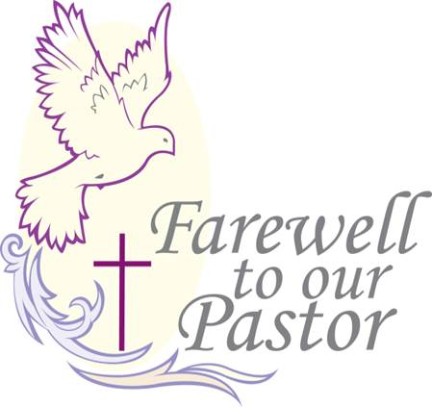

793 Praise, My Soul, the King of Heaven

Text: Henry F. Lyte, 1793–1847  
Tune: John Goss, 1800–80  
Text and tune: Public domain

Postlude- Brass Ensemble

“God of Grace” Arr. by: Jonathan Crutchfield

Acknowledgments

Service of Prayer and Preaching from Lutheran Service Book

Unless otherwise indicated, Scripture quotations are from the ESV® Bible (The Holy Bible, English Standard Version®), copyright © 2001 by Crossway, a publishing ministry of Good News Publishers. Used by permission. All rights reserved.

Created by Lutheran Service Builder © 2025 Concordia Publishing House.

**General Announcements** Welcome to our guests.  We are glad you have joined us in worshipping our Lord and Savior.  We trust you will draw strength, peace, and hope as together we hear God's Word spoken here today.  So that we may serve you better, we ask that you fill out a yellow attendance card located on the back of the pew, including your address and noting that you are a visitor.

**ETERNAL CANDLE** The eternal candle glows to the glory of God from Larry and Sharon Ripka.

**ALTAR FLOWERS** The flower bouquet that adorns the Altar is from Chuck and Bev Brokaw, in celebration of their anniversary.

**DOLLARS FOR MISSIONS** The current Dollar for Missions project is replacement of insulation in the chancel ceiling at Wittenberg Lutheran Center, Normal. 45-year-old insulation has fallen from its original place under the roof.  It needs to be replaced, in what figures to be an expensive job calling for ingenious work involving a high ceiling. This DFM project is for $10,000.

**WASP ALERT** It has been mentioned to the office that there are large wasps flying around the office doors. According to Kenny’s Pest Control, they are called Cicada Killers– they are NOT human aggressive (although very alarming looking), and there is no chemical treatment to be used against them. There is not a nest to avoid or remove– they will burrow individually in the landscape after catching a cicada.

**STEWARDSHIP THOUGHTS *Matthew 5:23 – “So if you are offering your gift at the altar. . .”*** Jesus connects our generosity toward God’s Kingdom to our love and forgiveness toward our brethren in the Kingdom. Both grow out of God’s love toward us. We forgive as we have been forgiven, and we give as we have been given to. All our growth in sanctification is growing into our Heavenly Father’s own actions through thankful imitation.

Memory Verse Challenge: **Deuteronomy 6:6–7** *And these words that I command you today shall be on your heart. You shall teach them diligently to your children, and shall talk of them when you sit in your house, and when you walk by the way, and when you lie down, and when you rise.*

**BUILDING HEALTHY FAMILIES:** Whether it’s your growing awareness of the number of hours in your day tinged with anxiety or depression, or a gnawing feeling in your gut about the distance you’re feeling from your spouse, know that you don’t have to wait for a crisis to seek support. It’s often easier to prevent a problem from growing worse than to recover from one in full bloom. Pay attention to your mental, emotional, spiritual, and relational health. Talk to your pastor, a trusted Christian friend, or an LFS counselor, and remember (as the tee shirt says): It’s okay to have Jesus and a therapist, too! **Lutheran Family Service** [*www.LutheranFamilyService.org*](http://www.LutheranFamilyService.org)

**CHRIST FOR YOU this week KFUO.org:** On Sharper Iron (weekdays at 8:00 a.m.), we are continuing our study of the Psalms. This week, we’ll take a look at Psalms 50, 57, 67, 73, and 80. Tune in to Thy Strong Word (weekdays at 11 a.m.) as we begin a new study of the book of Galatians! Don’t forget to join us for the Coffee Hour (weekdays at 9:00 a.m.)! This week is Bach week, and we have some special episodes lined up to celebrate! Find your favorite programs on demand at [kfuo.org](http://kfuo.org/) or in the KFUO Radio app!

**FOOD PANTRY ASSISTANCE NEEDED** Target has recently become a very generous and beneficial donor of food to us. If anyone would be able to assist Greg on Monday, Wednesday, or Friday mornings, it would really help him out. All you have to do is: meet at church at 8:45am, ride with him to Target, load up the donations, bring it back to church and unload and inventory it. If you could help any of the days it would be greatly appreciated. You will not be contractually bound to his service if you volunteer once! Please call Debbie Girard at 309-235-8822 if you have any questions or would like to do a ride- a- long.

Also, we are getting low on plastic grocery bags if you would like to donate.

**CAKE RECEPTION** The fellowship committee invites the congregation to welcome our vacancy pastor, Rev. Steven Anderson, with a cake reception following worship on Sunday, August 10th.

**If you took home any of the free plants that came out of the courtyard, could you please return the buckets and containers they were in? The Trustees would like them back. Thank you!

**The Lord’s Week:**

**Sunday, July 27th**

9:00am– Worship

10:15am– Bible study/ Sunday school

**Monday, July 28th**

11:00am– Band luncheon

1:00pm– staff meeting

**Tuesday, July 29th**

10:00am- Food Pantry

6:30pm– Guitar Jam

**Wednesday, July 30th**

9:00am– TOPS

1:30pm– Activities Room

**Saturday, August 2nd**

5:00pm– Worship w/Communion- (Pastor Astrowski)

**Sunday, August 3rd**

9:00am– Worship w/ Communion- (Pastor Hagan)

10:15am– Bible study/ Sunday school

**Bible Study Opportunities**

***Pastors And Bishops:****Divine Authority or Satanic Power*As our congregation prepares for the Holy Spirit to send us a new undershepherd it may be helpful for us to review the theology of the pastoral ministry.  A biblical understanding will help us determine whether our pastors and bishops exercise divine authority or wield satanic power.  Our primary text will be the Holy Scriptures, but we will also take a peek at our Lutheran Confessions to see how that Word is properly understood and applied.

***Holy Land Geography, Customs & History*** In this class Clark Stojan, who has engaged in extensive study and made many trips to the Holy Land, leads us to explore the world of the Bible along with select events recorded in Scripture.

**Serving the Lord this Week:**

**Organist:** Christine Engebrecht

**Greeters:**

**Ushers: *(Sat.)*** Glen McMillin, Stratton Churchill, Evan and Easton Antolik, and Brian Nielson

**Special Thank you to:**

Adult Choir, Heavenly Ringers, St. John’s Ensemble, and Alice Schmidt.

**ST. JOHN’S PRAYER CARD July 26th and 27th, 2025**

***Please remember the following in your prayers this week...***

**Anniversaries**

Chuck & Bev Brokaw (68)

Dennis & Lois Kelly (52)

Chris & Diana Caldwell (48)

Steve & Cris Braddy (23)

**Sister Congregation** Rev. Martin Eden

Our Redeemer Lutheran

Quincy, IL

**Members**

Nicholas Johanson

Jennifer Johnson

Carrie Johnson

**Missionaries Serving**

Rev. Dr. Gerald and Heidi Paul– Cayman Islands

**Military Chaplains**

 MAJ Edward Wright

MAJ Phillip Callahan

**Ill & Hospitalized**

Joan Britton

Angie Fischer

Cindy Hart

Judy Kirklin

Rick Mayerhofer

Karen Schmidt

**Prolonged Illness &**

**Special Needs:**

Bev Brokaw

Chuck Brokaw

Diana Castro

Kodie Esparza

Nic Fellows

Steve Fors

Duane Gosa

Nancy Gosa

Kathy Herron

Jerry Hill

Jane Hipple

Carole Hodshire

Chris Hoehn (Janet Newlon’s nephew, aplastic anemia)

Dale Johnson

Merle Loete

Reid McDonald

Jean Morrical

RaeJean Murphy

Tom Nielsen

Robin Passman

Brenda Roggendorf

Kathleen Schmidt

David Sountris

Alivia Voelkers

Ken Weidenbach

**Homebound:**

Nancy Bonow

Ann Bowman

Don, Wanda, and Jason Cass

Darlene Dopson

Mary Ann Eckert

Rick & Sylvia Fauser

Angie Fischer

Ron & Peg Heitzman

Christopher Higgins

Barbara Honert

Ingrid Hodshire

Lori Hopkins

Mary McGee

Nancy Smart

Terry Tipsword

Barbara Veskauf

Cora Whipple