
Safe Church Concerns Person

Each church should appoint a “Safe Church Concerns Persons.” to receive all complaints, concerns and queries about abuse & misconduct.

This is a two-fold role:

- This person will assist in the process of reporting abuse to the relevant authorities and

- Should also be able to provide pastoral care and debriefing with persons who have concerns about abuse and/or misconduct.

The Safe Church Concerns Person is not responsible for the implementation of all safe ministry procedures, or for doing all the risk assessments (that is the responsibility of individual teams) but rather the one to respond to concerns of abuse and misconduct.

Safe Church Concerns Reporting Procedure

When a person discloses abuse, or discloses that they are at risk, or when reasonable grounds have been established, follow these steps:

1. Report to your Safe Church Concerns Person. Note: When a disclosure occurs or a person’s immediate safety is at risk (sexual and physical abuse), go directly to the on-site activity leader, who will in turn phone the police or relevant authority and organise appropriate support for the person concerned.

2. Complete the applicable form e.g. Safe Church Concerns Anecdotal Record or Risk of Significant Harm Form. The Safe Church Concerns Person will also keep a local church log, upholding privacy principles.

3. When notified of an incident or a concern, the Safe Church Concerns Person will then take appropriate steps, e.g. report to police, government agency, denomination liaisons, and other church leaders. The Safe Church Concerns Person may also contact the Professional Standards Worker for further assistance.

4. The Safe Church Concerns Person should keep a local church log of events, upholding privacy principles.

Ongoing support: The church’s role does not end here. This is only the beginning; it is now the role of the church to support the vulnerable person and their family as much as is practical and possible.

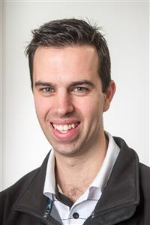
New Community Ringwood Safe Church Concerns Person is:

Phil Walker

Phone: 0415 828 588

Email: Phil.Walker@ymca.org.au

