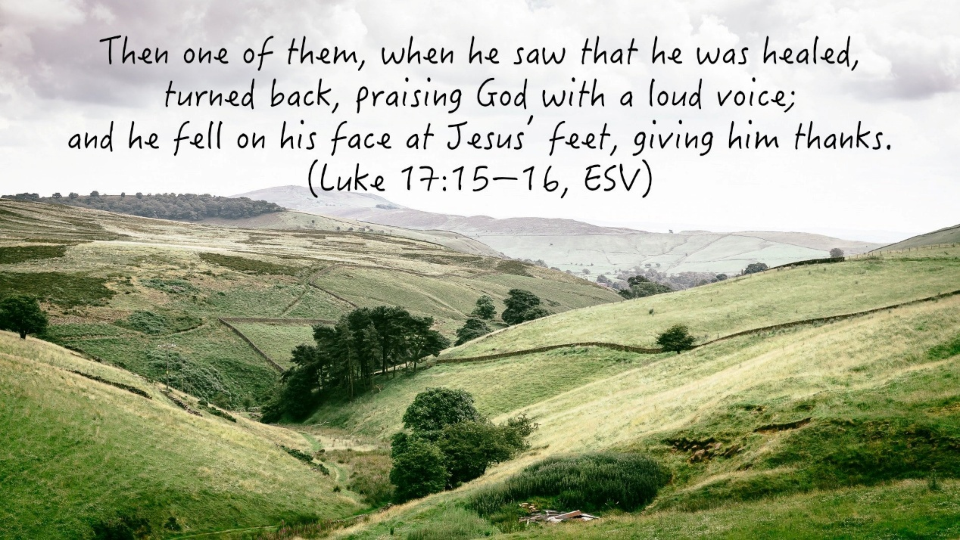

FRIDAY WORDS FOR NOVEMBER 7, 2025

Who is the most ungrateful person you know?
I mean that person has everything you could ever want and is always complaining that they don’t have anything.

Now maybe you don’t know such a person and that’s great, but if we take the time to think about it this could probably be said about us at one time or another. Maybe a time when you opened up all your presents on Christmas morning and looked around and said… “I did’t get a ________.”

So instead of being filled with thanksgiving for what you did receive you were focusing on what you didn’t.
Or maybe you received some great blessing and never said thank you to the one who provided that blessing. You were so wrapped up in the blessing you forgot who the one who blessed you.

Thanksgiving is not the default for many of us because we are so easily consumed with our own needs and wishes. Therefore, it’s necessary to cultivate a grateful heart day by day.

That’s why parents are so diligent to teach their child to say, “thank you.” The hope is that builds a habit into their child’s life.

In the Scripture passage above ten lepers had come to Jesus to be healed and the Lord graciously healed them all, but only one of them returned to the Healer to say thank you and the Lord makes a point of this sad reality.

We need to be like the one who returned, not like the nine who never said “thank you.”

So go and tell someone “thank you” today….if nothing else tell the Lord!

