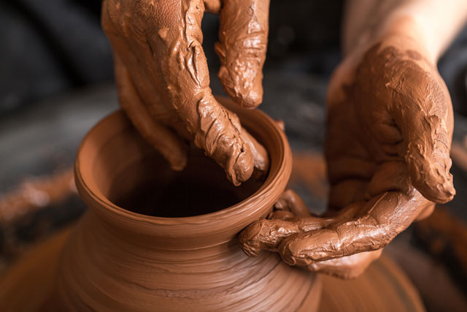

FRIDAY WORDS
January 9, 2026

Too many people think that they are in complete control of their lives. They are the final word and no one has any business telling them how to live.

Unfortunately, this is also true not just of people generally, but of many professing believers. They think that their life belongs to them and while God certainly deserves their obedience for the most part, they call the shots.

Nothing could be further from the truth.

In Isaiah 64:8 the prophet Isaiah writes regarding the relationship of the people of God to God as being similar to that of a potter’s relationship with the clay.

The potter has the authority to sculpt that piece of clay in any way he desires.

The conclusion isn’t hard to miss from this illustration. God has the authority to shape our lives and direct us as He desires. He molds each individual believer in Christ according to His will. People often time resist His hand and He has to smash the clay and start over but rest assured He is molding and making something new.

The ultimate goal for every believer is that they are made to look more and more like Jesus every day.

That is what the Great Potter is doing with us. He is shaping and sculpting and directing our lives as we yield to His good hands for His glory and our good.

In the end the results will be beautiful.

