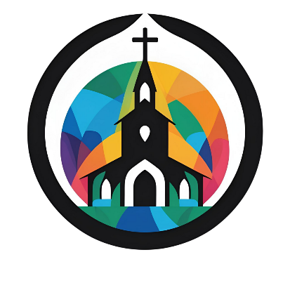
Back to Church Resources
What is the Church?
From the Bible Study Tools website, and excellent study about what the Bible says about the church.
https://www.biblestudytools.com/bible-study/topical-studies/what-is-the-church-according-to-the-bible.html
The Theology of the Church
Friday Holy Communion | DOMA Synod 2021 on Vimeo
The Falls Church Anglice Rector, Sam Furgeson preaches at a church Synod about the theology of “the church”. The talk starts at minute 14:38.
https://vimeo.com/643072165
Why Attend Church
A paper by Karis Roberts
https://storage2.snappages.site/P5SWH6/assets/files/Church-Attendance-_-Karis-Roberts.pdf

Quotes
“The difference between listening to a radio sermon and going to church...is almost like the difference between calling your girl on the phone and spending an evening with her.” DH Moody (https://www.azquotes.com/quote/780443)
“I believe that every Christian ought to be joined to some visible church; that is his
plain duty, according to the Scriptures. God’s people are not dogs, else they might go
about one by one; but they are sheep, and therefore they should be in flocks.” Charles Spurgeon (https://www.azquotes.com/quote/703882?ref=church)

Do you have a resource to suggest be included here?
Please email Patricia@LoudounAwakening.org

