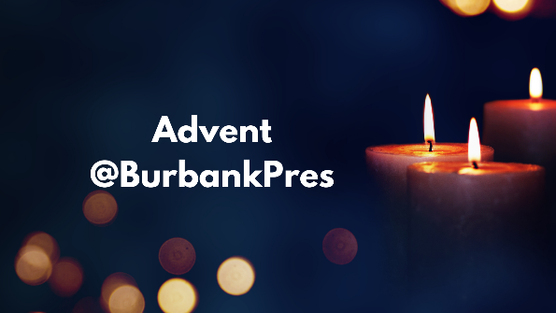
ADVENT 2023
Dear Church Family and Friends:
The Advent Season is almost here! That means Christmas is coming soon! Whether this is your tenth or your thirtieth or your eightieth Christmas, it is a joyous time of the year for everyone, especially for us who celebrate the coming of Christ into our world and into our lives as the Way, the Truth and the Life. As we come to Advent, which begins on Sunday, December 3rd, we want to let you know about some of the events taking place at First Pres Burbank.
Christmas “Inn” the Courtyard–presented by “The Yard” and Burbank Pres with two events– Sunday, December 17 at 5:00 p.m. – “Christmas with Cinnamon and Friends” - a musical celebration of Christmas and special songs of the season led by Cinnamon La Canela and friends. Sunday, December 24 at 5:00 p.m. and 6:00 p.m. - “A Charlie Brown Christmas Musical Event”, A Jazz trio presents the entire Charlie Brown Christmas movie in concert while the movie plays simultaneously. Enjoy last minute shopping, gift wrapping and treats from the Burbank Pres Coffee Cart! This will be a time for families–people of all ages–to come and celebrate.
Sunday Worship during Advent
December 3 – First Sunday in Advent
Sermon: “God’s Biggest Voice is Small and Quiet” – Isaiah 64:1-9
Lighting of the Prophecy Candle – David and Lucy Masselink
Holy Communion
December 10 – Second Sunday in Advent
Sermon: “God’s Comfort Pursues Our Flawed Humanity” – Isaiah 40:1-11 Lighting of the Bethlehem Candle – Cinnamon Legget & Family
December 17 – Third Sunday in Advent
Sermon: “God’s Good News Lives in the Face of Bad News” – Isaiah 61:1-4, 8-11 Lighting of the Shepherds’ Candle – Patty & Oscar Mendoza
December 24 –Fourth Sunday in Advent – Christmas Eve Morning 10:30 a.m. Sermon: “God’s Covenant with Humanity: to Build a Permanent House” Scripture: II Samuel 7:1-11
Lighting of the Angel Candle – KC, Debbie & Tyler Wahe
December 24 – Christmas Eve Service – 7:00 p.m. Family Service
Sermon: “God’s Great Light is a Human Child” – Isaiah 9:2-7
Lighting of the Advent Candles and the Christ Candle – Holly Hitchin & Lorraine Essex December 31 – New Year’s Eve Sunday
Sermon: “God’s Ultimate Purpose is Glory and Joy” – Isaiah 61:10-62:3
January 7, 2024 – Sermon: “God’s Light Attracts People Stuck in Darkness” Isaiah 60:1-6 Holy Communion
Other Advent/Christmas Events
Saturday, December 2 – 9:00 a.m. Come and help decorate the Sanctuary–hang banners and wreathes, set out poinsettias and the manger scene. Help is especially needed to set up and decorate the large Christmas tree. Most of the Advent items are stored in the catwalk, so we need people who are willing to climb stairs to the balcony. It does take some time and effort, but the final result is wonderful and festive for our worshippers during the Advent season. Needless to say, the more help we have, the more easily the decorating is finished. As an enticement, doughnuts and coffee will be served!
Saturday, December 16 – 4:00 p.m. Sing Joy to All the World, a Christmas Cantata presented by the Chancel Choir, with narration.
Christmas is also a time when we give an extra amount to the church. Christmas offering envelopes are available in the Narthex. Or you can use a regular pew envelope, just indicate the extra amount for Christmas offering. You can also go online to the church website to make your Christmas offering. We trust that, along with your gifts to your family and friends, you will also remember your church.
Please make special note of the service times above. Two services on Christmas Eve, one in the morning at the regular 10:30 time, and a Family Service in the evening at 7:00 p.m., with our usual candle lighting.
A Savior has been born to us! Since God is not bound by time, the event of the birth of Jesus is as fresh today as it was over 2,000 years ago. He arrived at a time when the world needed a Savior–and that is as true today as it was then. Let us receive Christ anew in our hearts this Holy Season.
Your Pastors,
Gareth Icenogle and K.C. Wahe

