Foundational Truths - Spiritual and Natural Realms

Realm - A royal jurisdiction or extent of government; a kingdom; a king's dominions

Colossians 1:15-17 NKJV - “He is the image of the invisible God, the firstborn over all creation. For by Him all things were created that are in heaven and that are on earth, visible and invisible, whether thrones or dominions or principalities or powers. All things were created through Him and for Him. And He is before all things, and in Him all things consist.”

There are created things that are visible and invisible.

John 4:24 NKJV - “God is Spirit, and those who worship Him must worship in spirit and truth.””

The spirit realm is just as real as the natural realm.

I Thessalonians 5:23 NKJV - “Now may the God of peace Himself sanctify you completely; and may your whole spirit, soul, and body be preserved blameless at the coming of our Lord Jesus Christ.”

Whole - all the parts of you. You are a spirit being, you have a soul (mind, will, emotions) and you live in a physical body.

II Corinthians 4:7 NKJV - “But we have this treasure in earthen vessels, that the excellence of the power may be of God and not of us.”

Earthen vessel - your physical body. He is talking here about the light of the Gospel of Jesus Christ being in our hearts.

II Corinthians 4:16 NKJV - “Therefore we do not lose heart. Even though our outward man is perishing, yet the inward man is being renewed day by day.”

Here Paul talks about the inward man and the outward man. Your spirit man, the real you on the inside is not dying. Although this physical body you live in is perishing.

II Corinthians 4:18 NKJV - “while we do not look at the things which are seen, but at the things which are not seen. For the things which are seen are temporary, but the things which are not seen are eternal.”

Spiritual things are eternal, physical things are temporary.

II Corinthians 12:2 NKJV - “I know a man in Christ who fourteen years ago—whether in the body I do not know, or whether out of the body I do not know, God knows—such a one was caught up to the third heaven.”

II Corinthians 10:3-5 NKJV - “For though we walk in the flesh, we do not war according to the flesh. For the weapons of our warfare are not carnal but mighty in God for pulling down strongholds, casting down arguments and every high thing that exalts itself against the knowledge of God, bringing every thought into captivity to the obedience of Christ,”

There are spiritual laws that govern the spirit realm, and natural laws that govern the natural realm. Spiritual laws override natural laws.

This is because everything in the natural realm was created from the spirit realm.

Hebrews 11:3 NKJV - “By faith we understand that the worlds were framed by the word of God, so that the things which are seen were not made of things which are visible.”

Everything you see in the natural realm came from the spirit realm; came from something you cannot see with your natural eyes.

II Kings 6:4-7 NKJV - “So he went with them. And when they came to the Jordan, they cut down trees. But as one was cutting down a tree, the iron ax head fell into the water; and he cried out and said, “Alas, master! For it was borrowed.” So the man of God said, “Where did it fall?” And he showed him the place. So he cut off a stick, and threw it in there; and he made the iron float. Therefore he said, “Pick it up for yourself.” So he reached out his hand and took it.”

Gravity has been suspended at this moment. Not by a physical power, but a spiritual power. Elisha used power from the spirit realm, the power of God, to make this axe head float.

Luke 16:19-23 NKJV - ““There was a certain rich man who was clothed in purple and fine linen and fared sumptuously every day. But there was a certain beggar named Lazarus, full of sores, who was laid at his gate, desiring to be fed with the crumbs which fell from the rich man’s table. Moreover the dogs came and licked his sores. So it was that the beggar died, and was carried by the angels to Abraham’s bosom. The rich man also died and was buried. And being in torments in Hades, he lifted up his eyes and saw Abraham afar off, and Lazarus in his bosom.”

This was not a parable. This was a certain rich man and a certain beggar, Lazarus.

Jesus is saying THEY are somewhere else. Not in the physical realm anymore, in the spirit realm. The rich man was in hell. Lazarus was in Abraham’s bosom.

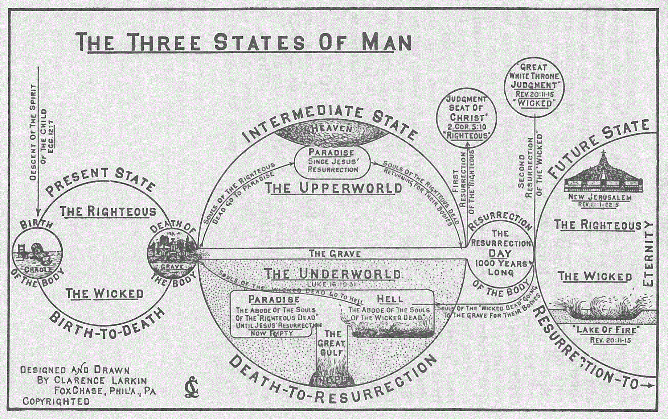

Luke 16:24-26 NKJV - ““Then he cried and said, ‘Father Abraham, have mercy on me, and send Lazarus that he may dip the tip of his finger in water and cool my tongue; for I am tormented in this flame.’ But Abraham said, ‘Son, remember that in your lifetime you received your good things, and likewise Lazarus evil things; but now he is comforted and you are tormented. And besides all this, between us and you there is a great gulf fixed, so that those who want to pass from here to you cannot, nor can those from there pass to us.’”

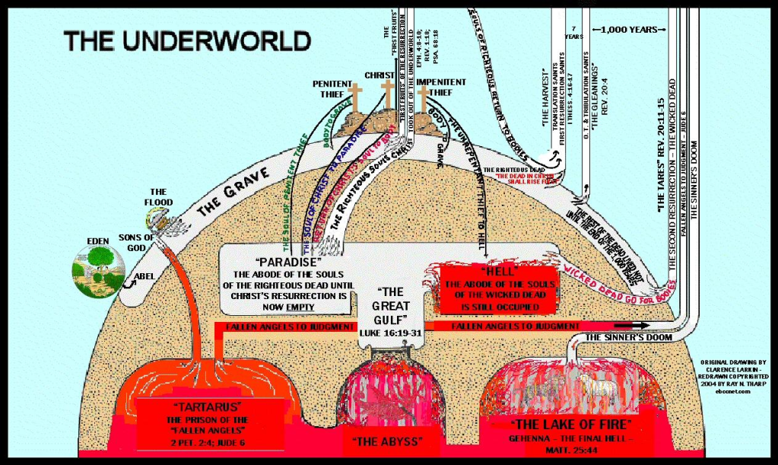

You are a spirit being and you are immortal. Your spirit is going to live forever. But there is a thing call “spiritual death”.

John 11:25-26 NKJV - “Jesus said to her, “I am the resurrection and the life. He who believes in Me, though he may die, he shall live. And whoever lives and believes in Me shall never die. Do you believe this?””

First Death - Physical
Second Death - Spiritual (separation from God)

Revelation 20:6 NKJV - “Blessed and holy is he who has part in the first resurrection. Over such the second death has no power, but they shall be priests of God and of Christ, and shall reign with Him a thousand years.”

The first resurrection is the spiritual resurrection that takes place when you are born again. For a born-again believer, the second death has no power.

Revelation 20:12-15 NKJV - “And I saw the dead, small and great, standing before God, and books were opened. And another book was opened, which is the Book of Life. And the dead were judged according to their works, by the things which were written in the books. The sea gave up the dead who were in it, and Death and Hades delivered up the dead who were in them. And they were judged, each one according to his works. Then Death and Hades were cast into the lake of fire. This is the second death. And anyone not found written in the Book of Life was cast into the lake of fire.”

Revelation 21:8 NKJV - “But the cowardly, unbelieving, abominable, murderers, sexually immoral, sorcerers, idolaters, and all liars shall have their part in the lake which burns with fire and brimstone, which is the second death.””

