Foundational Truths - Creation

Does science disagree with the Bible? How do we know creation actually happened and we didn’t just evolve?

Science is a systematic and methodical enterprise that seeks to understand, explain, and predict natural phenomena in the physical universe through empirical observation, evidence-based reasoning, experimentation, and the formulation of testable hypotheses and theories.

For something to be scientific, it must be observed, there needs to be evidence, and we should be able to have testable theories that can be proven.

The only person present at creation was God.

Genesis 1:1 NKJV - “In the beginning God created the heavens and the earth.”

As a Christian, God’s Word is final authority in our lives. Even with no evidence we would believe. But there is scientific evidence and true science agrees with the Bible.

Hebrews 3:4 NKJV - “For every house is built by someone, but He who built all things is God.”

There is nothing that came from nothing. There is no scientific proof that nothing can create something. Evolutionists always use “billions of years” to explain how something happened but is not scientifically observed.

Colossians 1:16 NKJV - “For by Him all things were created that are in heaven and that are on earth, visible and invisible, whether thrones or dominions or principalities or powers. All things were created through Him and for Him.”

By Him (Jesus) every was created. How is this possible? Jesus is the Word of God. The Word became flesh.

Psalms 19:1 NKJV - “The heavens declare the glory of God; And the firmament shows His handiwork.”

Everything we see that has been created was created by God. Creation is His handiwork.

Romans 1:20 NKJV - “For since the creation of the world His invisible attributes are clearly seen, being understood by the things that are made, even His eternal power and Godhead, so that they are without excuse,”

Romans 1:20 AMPC - “For ever since the creation of the world His invisible nature and attributes, that is, His eternal power and divinity, have been made intelligible and clearly discernible in and through the things that have been made (His handiworks). So [men] are without excuse [altogether without any defense or justification], [Ps. 19: 1-4.]”

When we look at creation, we can see His handiwork. True science points to a creator.

Things in nature that defy evolution. (Youtube “Incredible creatures that defy evolution”)

Example 1 - The Bombardier Beetle

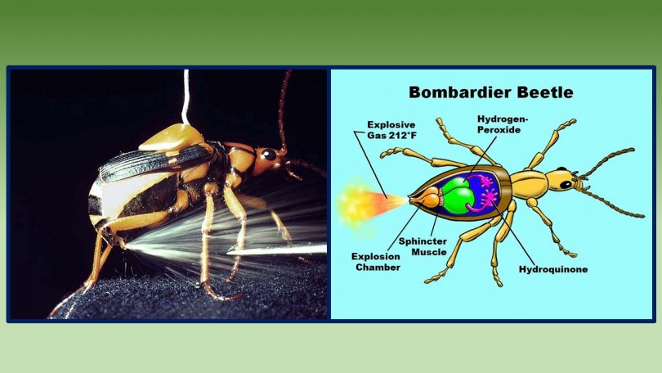
When a bombardier beetle feels threatened by a predator, it releases a toxic smokey poison out it’s behind. It’s a hot vapor over 200 degrees. Inside the beetle’s body there are three chemicals, each in its own chamber. Two of the chemicals mixed together does nothing, but when the third chemical is introduced (a mixture of enzymes), an explosion takes place. How could this have evolved? How did the exit hole evolve if there is no design or designer there to put the hole? The beetle would have exploded!

www.evolutionisamyth.com

Example 2 - Giraffe -


A giraffe has a long neck. It takes a lot of blood flow and a powerful heart to pump blood all the way up the neck to the brain. If you don’t have blood flow to the brain, you pass out. But what happens when a giraffe lowers its head? With the amount of blood flowing to the brain of a giraffe, its head should explode, but it doesn’t. This is how they fight each other; they lower their head. Turns out, there are valves inside the neck of a giraffe that regulate the amount of blood flow to and from the brain. As the giraffe lowers its head, the blood flow is restricted. As it raises its head, the blood flow restriction adjusts. He doesn’t pass out; his head doesn’t explode. How could all of this have evolved?

Where there is design there is a designer.

You can’t have a partially functional lung, pancreas, kidney. You must have the whole system or organ there functioning properly, or you don’t live.

What about dinosaurs?

The Bible says that God created all the animals in Genesis 1 then created man, which means dinosaurs and men walked the earth together. Is there proof of this?

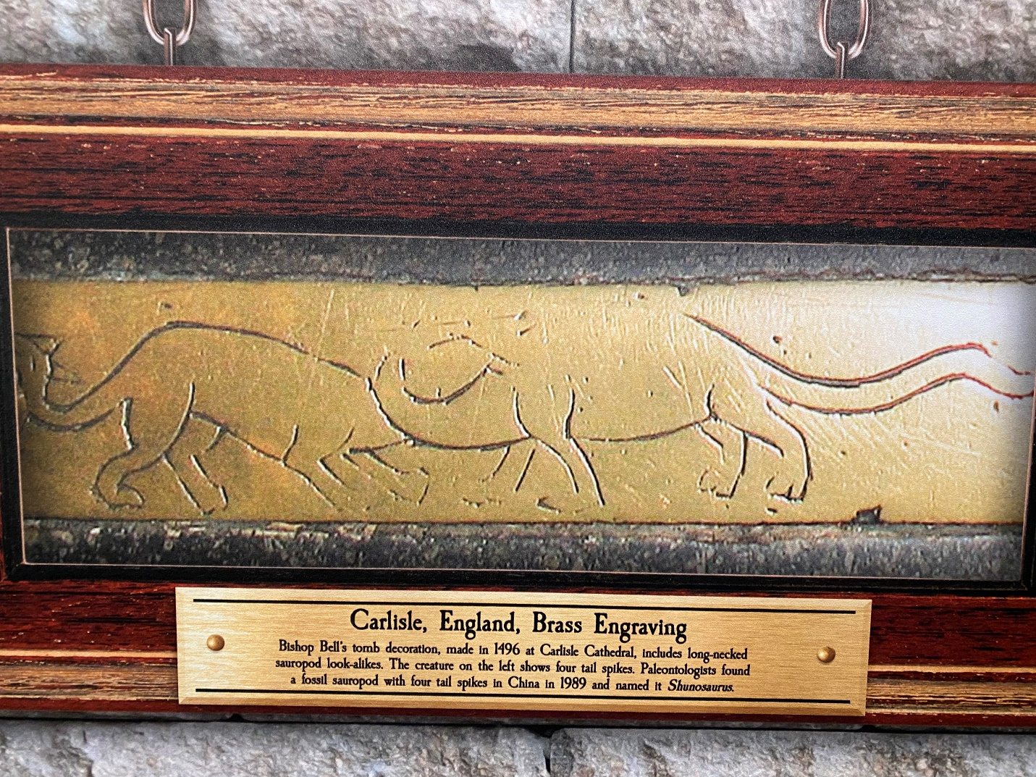

Example 1 - Brass engraving from 1496. Look at the animals and the spikes on their tails. It certainly looks like a dinosaur. We must ask the question - how would someone living in 1496 know what a dinosaur looks like? They didn’t have the technology we have today to recreate those animals nor the tech to dig up and piece together all the bones.

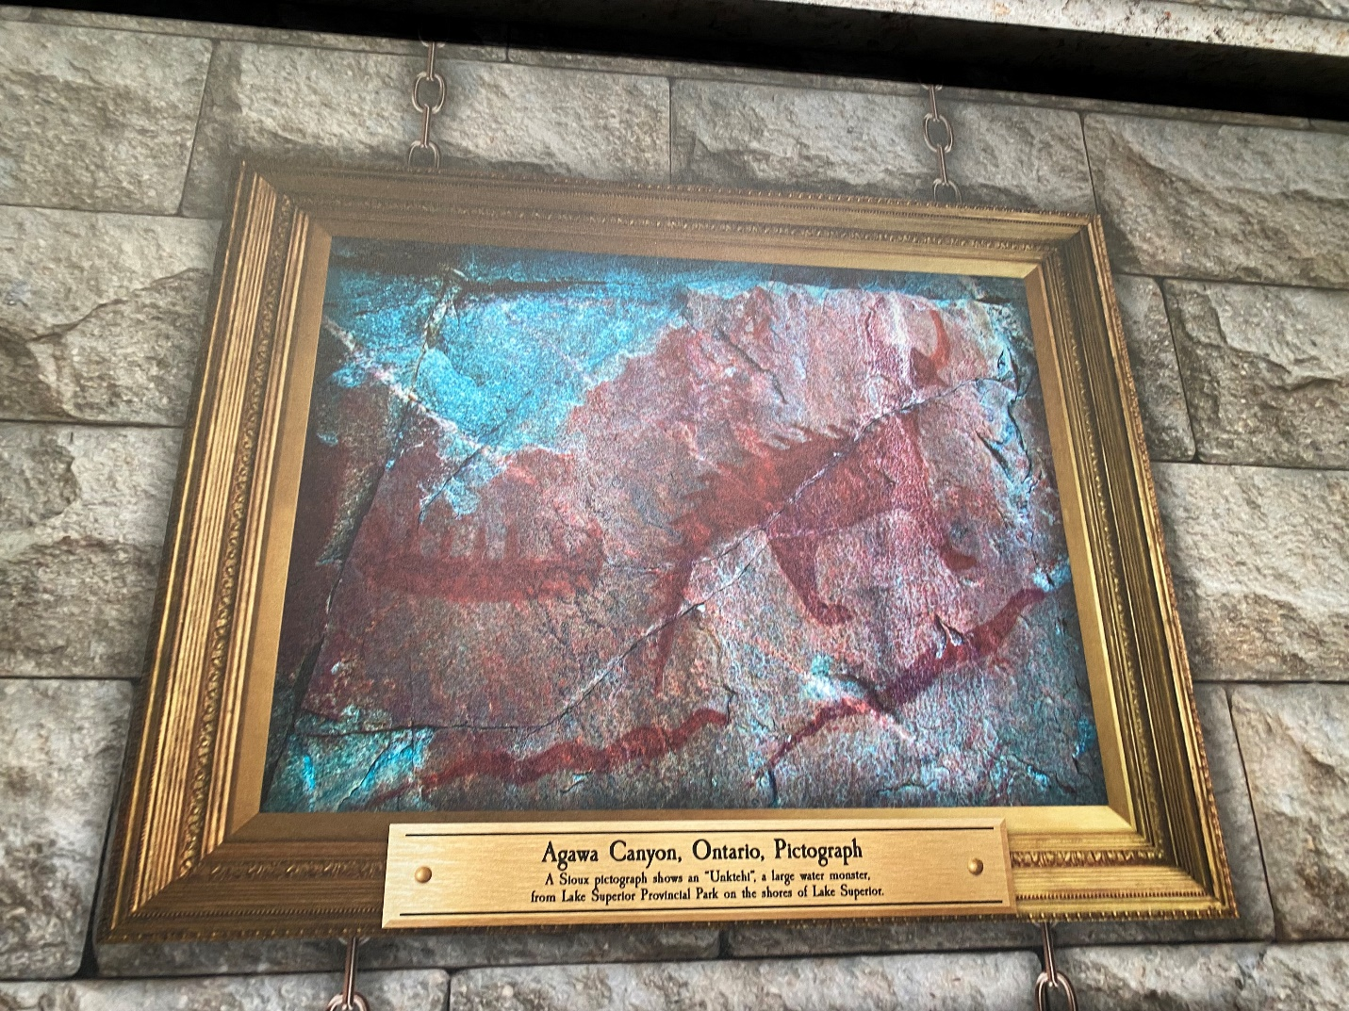
Example - Dino 2 - a large sea serpent looking animal. There is no modern animal like this.

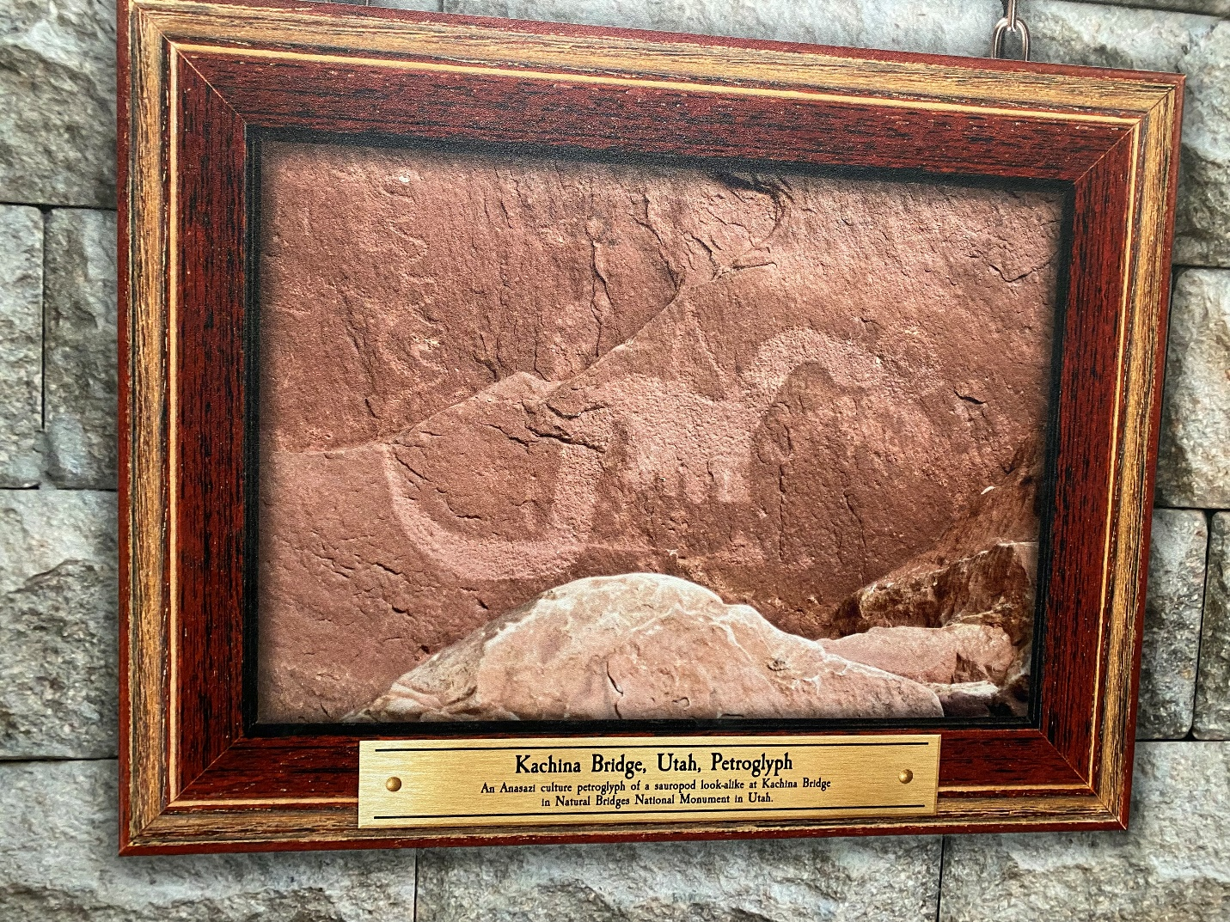
Example - 3 – Evolutionists claim that water caused this to look this way. How did someone draw this if they had never seen one?

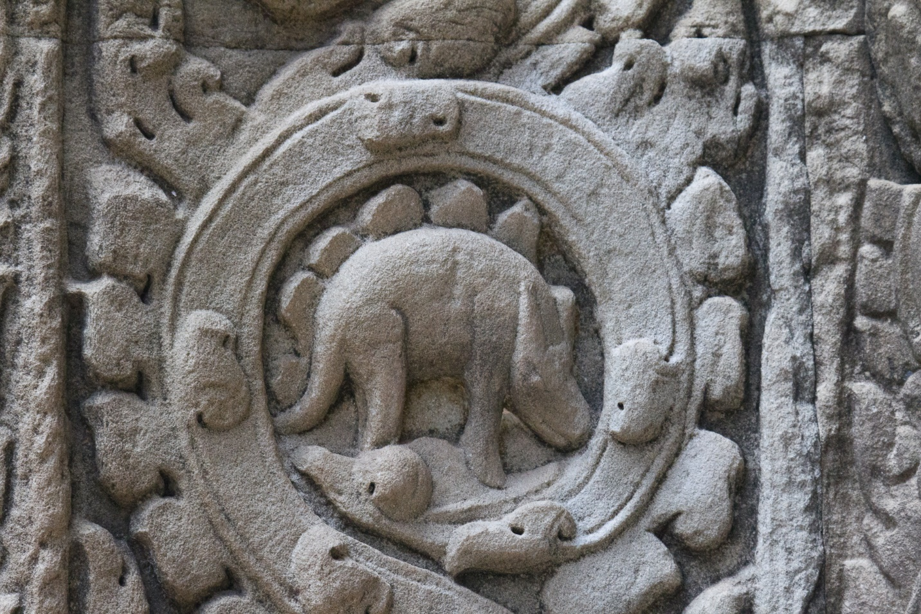

Example – 4 - Ta Prohm temple dinosaur in Cambodia. This temple was built around the year 1180. Evolutionists claim that this doesn’t really resemble a dinosaur and that this could be a rhino or a hippo.

What does the Bible have to say about dinosaurs?

Behemoth
Job 40:15-24 NKJV - ““Look now at the behemoth, which I made along with you; He eats grass like an ox. See now, his strength is in his hips, And his power is in his stomach muscles. He moves his tail like a cedar; The sinews of his thighs are tightly knit. His bones are like beams of bronze, His ribs like bars of iron. He is the first of the ways of God; Only He who made him can bring near His sword. Surely the mountains yield food for him, And all the beasts of the field play there. He lies under the lotus trees, In a covert of reeds and marsh. The lotus trees cover him with their shade; The willows by the brook surround him. Indeed the river may rage, Yet he is not disturbed; He is confident, though the Jordan gushes into his mouth, Though he takes it in his eyes, Or one pierces his nose with a snare.”

This can’t be an elephant or a hippo because both have tails nothing like a cedar tree!

Leviathan
Job 41:1-2 NKJV - ““Can you draw out Leviathan with a hook, Or snare his tongue with a line which you lower? Can you put a reed through his nose, Or pierce his jaw with a hook?”

Job 41:7 NKJV - “Can you fill his skin with harpoons, Or his head with fishing spears?”

Job 41:12-33 NKJV - ““I will not conceal his limbs, His mighty power, or his graceful proportions. Who can remove his outer coat? Who can approach him with a double bridle? Who can open the doors of his face, With his terrible teeth all around? His rows of scales are his pride, Shut up tightly as with a seal; One is so near another That no air can come between them; They are joined one to another, They stick together and cannot be parted. His sneezings flash forth light, And his eyes are like the eyelids of the morning. Out of his mouth go burning lights; Sparks of fire shoot out. Smoke goes out of his nostrils, As from a boiling pot and burning rushes. His breath kindles coals, And a flame goes out of his mouth. Strength dwells in his neck, And sorrow dances before him. The folds of his flesh are joined together; They are firm on him and cannot be moved. His heart is as hard as stone, Even as hard as the lower millstone. When he raises himself up, the mighty are afraid; Because of his crashings they are beside themselves. Though the sword reaches him, it cannot avail; Nor does spear, dart, or javelin. He regards iron as straw, And bronze as rotten wood. The arrow cannot make him flee; Slingstones become like stubble to him. Darts are regarded as straw; He laughs at the threat of javelins. His undersides are like sharp potsherds; He spreads pointed marks in the mire. He makes the deep boil like a pot; He makes the sea like a pot of ointment. He leaves a shining wake behind him; One would think the deep had white hair. On earth there is nothing like him, Which is made without fear.”

Other scripture references for Leviathan.
Psalms 74:14, 104:25-26
Isaiah 27:1

