***September 2025***

***Opportunities for Service and Growth***

Wed. Sept 3 7:00pm Bible Study

MID-WEEK @ the CRIB (teens)

Fri. Sept. 5 5:30pm **God is Love Conference - 1**

Sat. Sept 6 5:30pm **God is Love Conference -2**

**Sun. Sept 7 Kingdomtide**

9:45am Sunday School

10:00am Online Sunday School -Bonnie Kornegay

11:00am Worship & Celebration

4:50pm Choir Rehearsal

5:30pm **God is Love Conference - 3** 6:00pm KIDS (5th grade and under)

Adults - Sanctuary

Tues. Sept 9 11:00am **Women 3:18 – Fellowship Hall**

Wed. Sept 10 7:00pm Bible Study

MID-WEEK @ the CRIB (teens)

Fri. Sept. 12 6:00pm Concession Stand @ NLHS - Ayden-Grifton

**Sat. Sept. 13 Church Stand @ Garden Spot Festival**

**Sun. Sept 14 1st Sunday after Kingdomtide**

9:15am Partners in Prayer – Room 7

9:45am Sunday School

10:00am Online Sunday School-Jennifer Sutton

11:00am Worship & Celebration

4:50pm Choir Rehearsal

5:30pm CRIB (6th grade and up)

6:00pm **Proverbs 31 Women – Church Library**

KIDS (5th grade and under)

Adults - Sanctuary

Wed. Sept 17  7:00pm Bible Study

MID-WEEK @ the CRIB (teens)

**Sun. Sept 21**  **2nd Sunday after Kingdomtide**

8:30am **Men’s Fellowship**

9:15am Partners in Prayer – Room 7

9:45am Sunday School

10:00am Online Sunday School-Ashley Holland

11:00am Worship & Celebration

4:50pm Choir Rehearsal

5:30pm CRIB (6th grade and up)

6:00pm KIDS (5th grade and under)

Adults-Sanctuary

Wed Sept 24 7:00pm Adult Bible Study

7:00pm MID-WEEK @ the CRIB (teens)

**Sun. Sept 28 3rd Sunday after Kingdomtide**

9:45am Sunday School

10:00am Online Sunday School-David Letchworth

11:00am Worship & Celebration

4:50pm Choir Rehearsal

5:30pm CRIB (6th grade and up)

6:00pm KIDS (5th grade and under)

Adults-Sanctuary

Tues Sept 30  **6:30pm UMO Dinner (here)**

***WE WISH YOU A HAPPY BIRTHDAY!***

|  |  |  |
| --- | --- | --- |
| 1-Abigail Harrison | 6- Laura Beth Daughety | 7- Cleo Hinson |
| 7- Gary Taylor | 7- Ava Wade | 10-Anna Baird |
| 11- Megan Wade | 13- De’Anna Gray | 13-Nelson Harrison |
| 14- Ellen Harrison | 17-Darlene Creech | 17-Holland Smith |
| 17-Angela Taylor | 18-Lucille Harrison | 19-Crystal Ryan |
| 19-Sherwood Shivar | 20- Hoyt Killette | 21- Sue Shivar |
| 24-Parker Harrison | 24-Sheila Harrison | 25-Fran Gibbons |
| 28-Bruce Bannister | 30-Maverick Allen |  |

**GOD IS LOVE Conference**

**September 5-7 @ the CRIB @ 5:30pm**

**(6th grade and up)**



**UMO Dinner:**

**Greene/Lenoir/Wayne**

**La Grange First FWB Church**

**Tuesday, September 30th @ 6:30pm**

**Marian Kennedy, Church Dinner Chair**



***September 2025***

***Deacon of the Month – Bonnie Kornegay***

***September is Church Planting and Renewal Month***

**Greeters/Ushers for Worship**

|  |  |  |  |
| --- | --- | --- | --- |
|  | **Sanctuary** | **North Vestibule** | **Gathering Hall** |
| **7** | Kendrick Harrison | Carolyn Massengill | Justin & Madison Hardy |
| **14** | Laura Eason | Sandra Rouse | Hilda Sutton & Christi Wilhelm |
| **21** | Mary Gresham | Bruce Bannister | Massengill family |
| **28** | Sandra Rouse | Greg Herring | Mike Sullivan family |

**Candlelighters**

7- Griffin and Marley Daniels 14-Declan and Finn Bannister

21-Hutton and Holland Smith 28-Lela Wade

**Children’s Church**

|  |  |  |  |
| --- | --- | --- | --- |
| 7 | Tara & Ryan Carroll | 14 | Morgan & Brad Hunter |
| 21- | Jennifer Sutton & Olivia Sutton | 28 | Heather & Jamie Ham |

**Church Nursery**

7- Leah & Steve Killette 14-Katie & Rusty Wooten

21- Kendra & Mike Sullivan 28-Conner & Parker Harrison

|  |  |
| --- | --- |
|  | **Grass Cutting (Church and CRIB)** |
| **6** | Kirk Tuchten |
| **13** | Jason Fields |
| **20** | David Letchworth |
| **27** | Ted Harrison |
|  |  |

**Pro-Presenter Teams**

***Sanctuary***

7-Heather Ham 14-Janet Hines 21- Olivia Sutton 28-Maura Ham

***The CRIB***

7-Heather Ham 14-Maura Ham 21-Heather Ham 28-Maura Ham

***Sanctuary-Wednesday***

3- Marian Kennedy 10- Vicki Bannister 17-David Letchworth 24- Marian Kennedy

**Sunday School Team Teachers**

|  |  |  |  |
| --- | --- | --- | --- |
| **Date** | **Middle School** | **High School** | **College/Careers** |
| 7 | Emily Daniels | David Letchworth | Kim Hipkiss |
| 14 | Heather Ham | Tara Carroll | Dustin Bannister |
| 21 | Jennifer Sutton | Kim Hipkiss | Dustin Bannister |
| 28 | Bonnie Kornegay | David Letchworth | Kelley Black |



*802 S. Caswell Street* • *La Grange, N.C.*

*Joshua T. Hobgood, Pastor*

_________________________________________________________________________________

**Newsletter –September 2025**

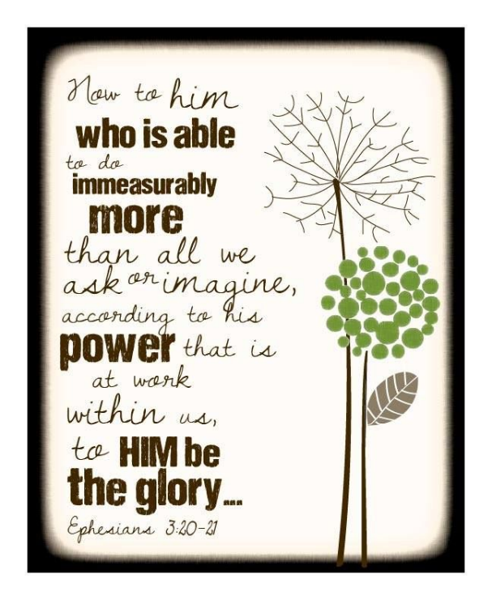

\_____________________________________________________________

***Christ-First • Bible-First • Ministry-First***

_________________________________________________________________________________

**Visit us at…**

www.lagrangefwb.org

Facebook: @ LaGrange1stFWB

YouTube: La Grange Free Will Baptist

Email @ Lagrangeffwb@suddenlinkmail.com

________________________________________________________________________________

**Live Streaming & YouTube Services**

Sundays *•* Sunday School & Worship

Wednesday ***•*** Bible Study