***October 2025***

***Opportunities for Service and Growth***

Wed. Oct 17:00pm Bible Study

MID-WEEK @ the CRIB (teens

**Sun. Oct. 5 4th Sunday after Kingdomtide**

9:45am Sunday School

10:00am Online Sunday School -Ronnie Hobgood

11:00am Worship & Celebration

5:00pm Choir Rehearsal

5:30pm CRIB (6th grade and up)

6:00pm KIDS (5th grade and under)

Adults – Sanctuary

7:00pm Sanders Family Christmas Rehearsal

Wed. Oct. 8 7:00pm Bible Study

MID-WEEK @ the CRIB (teens)

**Sun. Oct 12 5th Sunday after Kingdomtide**

9:15am Partners in Prayer – Room 7

9:45am Sunday School

10:00am Online Sunday School-Gale Yarborough

11:00am Worship & Celebration

5:00pm Choir Rehearsal

5:30pm CRIB (6th grade and up)

6:00pm KIDS (5th grade and under)

Adults – Sanctuary

7:00pm Sanders Family Christmas Rehearsal

Tues. Oct. 14 11:00am **Women 3:18 – Fellowship Hall**

7:00pm **Deacons’ Meeting**

Wed. Oct 15  7:00pm Bible Study

MID-WEEK @ the CRIB (teens)

Sat. Oct.18 ***FAM FUSION @ UMO***

**Sun. Oct. 19**  **6th Sunday after Kingdomtide**

8:30am **Men’s Fellowship**

9:15am Partners in Prayer – Room 7

9:45am Sunday School

10:00am Online Sunday School-Dustin Bannister

11:00am Worship & Celebration

5:00pm Choir Rehearsal

5:30pm CRIB (6th grade and up)

6:00pm **Proverbs 31 Women – Church Library**

6:00pm KIDS (5th grade and under)

Adults-Sanctuary

7:00pm Sanders Family Christmas Rehearsal

Wed Oct. 22 7:00pm Adult Bible Study

7:00pm MID-WEEK @ the CRIB (teens)

**Sun. Oct. 26 7th Sunday after Kingdomtide**

9:45am Sunday School

10:00am Online Sunday School-Kelley Black

11:00am Worship & Celebration

5:00pm ***FAMILY FUN NIGHT***

Wed. Oct. 29 7:00pm ***Quarterly Business Meeting***

***WE WISH YOU A HAPPY BIRTHDAY!***



|  |  |  |
| --- | --- | --- |
| 2- James Kennamer | 4- Trey Cahoon | 4-Lucretia Creech |
| 5- Abigail Jernigan | 7- Don Fader | 8- Wyatt Allen |
| 8- Edna Johnson | 8- Eloise Killette | 8-William Moss |
| 10-Daryll Johnson | 10-Johnathan Mobley | 11-Bruce Baird |
| 11-Ashley Holland | 15- Joe Harrison | 15-Gale Yarborough |
| 16- Ethan Dail | 16-Angie Sanders | 16-Don Sperry |
| 17-Katie Wooten | 18-Andrew McCausley | 18-Wilbur Taylor |
| 20-Griffin Daniels | 22-Angela Fader | 22-Ashlyn Hines |
| 22-Jessica Jernigan | 23-Randy Westbrook | 27-Wayne Carlyle |
| 28-Bonnie Kornegay | 29-Kellan Bannister | 30-Owen Holland |
| 30-David Jones | 30-Jimmy Jones |  |



***October 2025***

***Deacon of the Month – Wilbur Taylor***

***October is Ministers’ Program Month***

**Greeters/Ushers for Worship**

|  |  |  |  |
| --- | --- | --- | --- |
|  | **Sanctuary** | **North Vestibule** | **Gathering Hall** |
| **5** | Sue Shivar | Bobby Wadsworth | Robie & Eloise Killette |
| **12** | Terry Yarborough | Sue Shivar | Bobby &/Braxton Holland family |
| **191** | Tiffany Creech | Bonnie Kornegay | Bruce & Sharon Baird |
| **26** | Tony Parrish | Sue Shivar | Fred & Carolyn Massengill |

**Candlelighters**

5- Madi Herring 12-Anne Matchett and Fletcher Cox

19-Benjamin Carroll 26 – James and Allie Wooten

**Children’s Church**

|  |  |  |  |
| --- | --- | --- | --- |
| 5 | Dustin & Danielle Bannister | 12 | Tiffany Creech & Dee Cox |
| 19 | Ted & Sheila Harrison | 26 | Vicki Bannister & Stacie Smith |

**Church Nursery**

5- Tara & Ryan Carroll 12-Tracey & Chris Roddy

19- Jennifer & Olivia Sutton 26-Laura Eason & Tiffany Creech

|  |  |
| --- | --- |
|  | **Grass Cutting (Church and CRIB)** |
| **4** | Kirk Tuchten |
| **11** | Ted Harrison |
| **18** | Randy Westbrook |
| **25** | Josh Hobgood |
|  |  |

**Pro-Presenter Teams**

***Sanctuary***

5-Heather Ham 12-Janet Hines 19- Olivia Sutton 26-Maura Ham

***The CRIB***

7-Heather Ham 14-Maura Ham 21-Heather Ham 28-Maura Ham/FFN

***Sanctuary-Wednesday***

1- Marian Kennedy 8- Marian Kennedy 15-Vicki Bannister 22- Vicki Bannister

29-Business Meeting

**Sunday School Team Teachers**

|  |  |  |  |
| --- | --- | --- | --- |
| **Date** | **Middle School** | **High School** | **College/Careers** |
| 5 | Bonnie Kornegay | Tara Carroll | Kim Hipkiss |
| 12 | Emily Daniels | Kim Hipkiss | Dustin Bannister |
| 19 | Heather Ham | David Letchworth | Dustin Bannister |
| 26 | Jennifer Sutton | Tara Carroll | Kelley Black |



*802 S. Caswell Street* • *La Grange, N.C.*

*Joshua T. Hobgood, Pastor*

_________________________________________________________________________________

**Newsletter –October 2025**

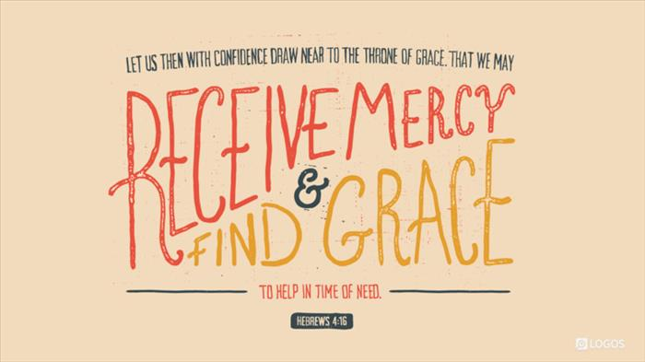

\_____________________________________________________________

***Christ-First • Bible-First • Ministry-First***

_________________________________________________________________________________

**Visit us at…**

www.lagrangefwb.org

Facebook: @ LaGrange1stFWB

YouTube: La Grange Free Will Baptist

Email @ Lagrangeffwb@suddenlinkmail.com

________________________________________________________________________________

**Live Streaming & YouTube Services**

Sundays *•* Sunday School & Worship

Wednesday ***•*** Bible Study