November 2025

Opportunities for Service and Growth

Sun. Nov. 2 Homecoming Day Services
Building Fund Sunday
9:45am Sunday School
10:00am Online Sunday School - Cleo Hinson
11:00am Worship & Celebration
Covered Dish Lunch – Everyone is Invited
No Evening Services
Wed. Nov. 5 7:00pm Bible Study
MID-WEEK @ the CRIB (teens)
Thu. Nov. 6 9:00am Central Conference Meeting
Black Jack OFWB Church

Sun. Nov. 9 9th Sunday after Kingdomtide
9:15am Partners in Prayer – Room 7
9:45am Sunday School
10:00am Online Sunday School - Bonnie Kornegay
11:00am Worship & Celebration
2:00pm Sanders Family Christmas Rehearsal
5:00pm Choir Rehearsal
5:30pm CRIB (6th grade and up)
6:00pm KIDS (5th grade and under)
Adults – Sanctuary
Tues. Nov. 11th 11:00am Women 3:18 – Fellowship Hall
7:00pm Sanders Family Christmas Rehearsal Wed. Nov. 12th 7:00pm Church Business Conference
MID-WEEK @ the CRIB (teens)
Sat. Nov. 15th 10:00am Sanders Family Christmas Rehearsal (?)

Sun. Nov. 16 10th Sunday after Kingdomtide
8:30am Men’s Fellowship
9:15am Partners in Prayer – Room 7
9:45am Sunday School
10:00am Online Sunday School - Jennifer Sutton
11:00am Worship & Celebration
5:00pm Choir Rehearsal
5:30pm CRIB (6th grade and up)
6:00pm Proverbs 31 Women – Church Library
6:00pm KIDS (5th grade and under)
Adults-Sanctuary
7:00pm Sanders Family Christmas Rehearsal
Tues. Nov. 18th 7:00pm Sanders Family Christmas Rehearsal
Wed Nov. 19th 7:00pm Adult Bible Study
7:00pm MID-WEEK @ the CRIB (teens)

Sun. Nov. 23rd 11th Sunday after Kingdomtide
9:45am Sunday School
10:00am Online Sunday School - Ashley Holland
11:00am Worship & Celebration
2:00pm Sanders Family Christmas Dress Rehearsal
5:30pm CRIBsgiving (6th grade and up)
6:00pm KIDS (5th grade and under)
7:00pm Community Thanksgiving Service
La Grange Christian Church
Wed. Nov. 26th NO Bible Study this week
NO Mid-Week @ the CRIB this week

Sun. Nov. 30 First Sunday of Advent
9:15am Partners in Prayer – Room 7
9:45am Sunday School
10:00am Online Sunday School - David Letchworth
11:00am Worship & Celebration
TBA Sanders Family Christmas Dress Rehearsal

WE WISH YOU A HAPPY BIRTHDAY!


1 - Mary Gresham | 2 – Tyler Holmes | 3 –Braxton Holland
5- Cooper Roddy | 6- Johnna Stroud | 7 Robert Maready
8- Abigail Hull | 8- Swain Vermeulen | 9- Anya Mills
10- Max Killette | 14-Alex Harrison | 14- Emma Moss
22- Carolyn Massengill | 23- Linda Taylor | 24- Wendy Boyette
24- Barrett Harrison | 24- Connor Herring | 25- Harper Ryan
26- Ryan Carroll | 30- Leo Mills
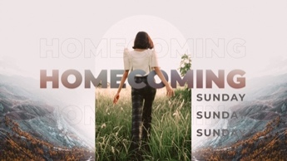

We’d like to invite you, your family, and your friends to Homecoming Sunday November 2, 2025. Homecoming is a time where we celebrate Jesus’ victory over death for our loved ones who have gone on before us, and we celebrate table fellowship following the service. The Scripture is full of people gathered around tables sharing life together. Homecoming is an opportunity for us to do that in an intentional way. Come worship with us!


November 2025

Deacon of the Month – Jimmy Jones
November is Free Will Baptist Press Month

Greeters/Ushers for Worship
 | Sanctuary | North Vestibule | Gathering Hall
2 | Sue Shivar | Terry Yarborough | Cliff & Carol Hardison
9 | Bonnie Kornegay | Bobby Wadsworth | Conner & Parker Harrison
16 | Brian Jones | Kendrick Harrison | Daughety Family
23 | Bruce Bannister | Sandra Rouse | Megan Wade & Erin Dawson
30 | Carol Hardison | Bruce Bannister | Flo & Curtis Smith
Candlelighters
2 Griffin & Marley Daniels 9-Declan & Finn Bannister
16-Hutton & Holland Smith 23 –Lela Wade 30 Madi Herring
Children’s Church
2 | Homecoming | 9 |  | Carolyn Massengill & Christi Wilhelm
16 | Laura Eason & Christie Westbrook |  | 23 | Bonnie Kornegay & Dee Ann Maready
30 | Kendra Sullivan & Anna Baird
Church Nursery
2- Asa & Tiffany Creech 9-Sharon Baird & Kim Fields
16- Dustin & Danielle Bannister 23-Guy & Janet Hines
30- Mary Gresham & Tiffany Creech

 | Grass Cutting (Church and CRIB)
1 | Kirk Tuchten
15 | OPEN
30 | OPEN
Pro-Presenter Teams
Sanctuary
2-Heather Ham 9--Janet Hines 16- Olivia Sutton 23-Maura Ham 30-Heather Ham
The CRIB

2-No CRIB 9-Maura Ham 16-Heather Ham 23-Maura Ham 30-Heather Ham
Sanctuary-Wednesday
5- Vicki Bannister 12- Marian Kennedy 19-Vicki Bannister 26- Marian Kennedy

Sunday School Team Teachers
Date | Middle School | High School | College/Careers
2 | Jennifer Sutton | David Letchworth | Kim Hipkiss
9 | Bonnie Kornegay | Kim Hipkiss | Dustin Bannister
16 | Emily Daniels | Tara Carroll | Dustin Bannister
23 | Heather Ham | Kim Hipkiss | Kelley Black
30 | Heather Ham | David Letchworth | Kim Hipkiss



802 S. Caswell Street • La Grange, N.C.

Joshua T. Hobgood, Pastor
_________________________________________________________________________________

Newsletter –November 2025

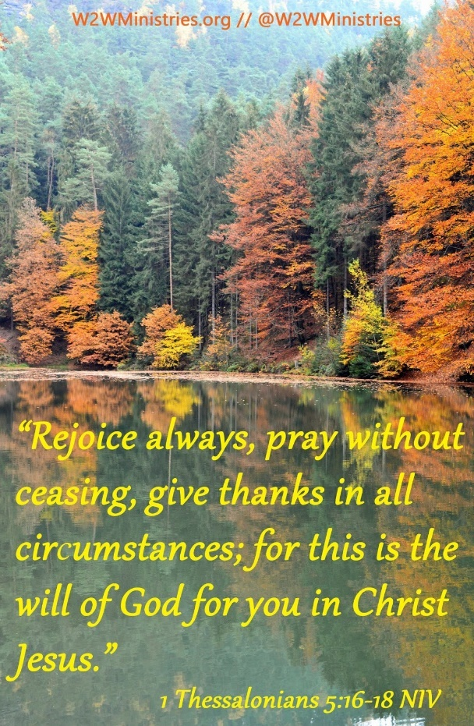

_______________________________________________________________________________
Christ-First • Bible-First • Ministry-First
_________________________________________________________________________________
Visit us at…
www.lagrangefwb.org
Facebook: @ LaGrange1stFWB
YouTube: La Grange Free Will Baptist
Email @ Lagrangeffwb@suddenlinkmail.com
________________________________________________________________________________

Facebook, Website, App, & YouTube Services
Sundays • Sunday School & Worship
Wednesday • Bible Study

