December 2025

Opportunities for Service and Growth

Mon. Dec. 1 7:00pm Sanders Family Christmas Rehearsal
Tues. Dec. 2 7:00pm Sanders Family Christmas Rehearsal
Wed. Dec. 3 7:00pm Sanders Family Christmas Rehearsal
MID-WEEK @ the CRIB (teens)
Thu. Dec.4 7:00pm Sanders Family Christmas Rehearsal
Fri. Dec. 5 7:00pm Sanders Family Christmas Rehearsal

Sun. Dec.7 Second Sunday of Advent
9:15am Partners in Prayer – Room 7
9:45am Sunday School
10:00am Online Sunday School –Ronnie Hobgood
11:00am Worship & Celebration
2:00pm Sanders Family Christmas Dress Rehearsal
6:00pm Sanders Family Christmas (seating)
Mon. Dec 8 6:00pm Sanders Family Christmas (seating)
Wed. Dec. 10 7:00pm Serve Night (adults and teens)
Sat. Dec 13 8:00am Teen Shopping Trip

Sun. Dec. 14 Third Sunday of Advent
9:15am Partners in Prayer – Room 7
9:45am Sunday School
10:00am Online Sunday School – Gale Yarborough
11:00am Worship & Celebration
5:00pm Church Christmas Celebration
@ the Hams
Wed Dec 17 7:00pm Kids Play Rehearsal
7:00pm MID-WEEK @ the CRIB (teens)

Sun. Dec. 21 Fourth Sunday of Advent
8:30am Kids Sing Christmas Rehearsal
9:45am Sunday School
10:00am Online Sunday School – Kelley Black
11:00am Worship & Celebration – Fellowship Hall
Kids Sing Christmas
6:00pm Christmas Caroling
7:00pm Pizza in Fellowship Hall
Rev. John Wiggins – Israel Trip Information
Wed. Dec. 24 10:00am Christmas Eve Worship & Communion

Sun. Dec 28 First Sunday after Christmas
9:15am Partners in Prayer – Room 7
9:45am Sunday School
10:00am Online Sunday School – Cleo Hinson
11:00am Worship & Celebration
No Evening Services

WE WISH YOU A HAPPY BIRTHDAY!


12-1 Jackie Taylor | 12-2 Bobby Holland | 12-4 Jacob Maready
12-6 Sharon Baird | 12-6 Madison Parrish | 12-8 Chris Roddy
12-8 Rusty Wooten | 12-9 Mark Westbrook | 12-12 Allie Wooten
12-13 Angie Herring | 12-13 Carrie Harrison | 12-16 Bryce Harrison
12-16 Florence Smith | 12-18 Baylie Cody | 12-18 Mitzi Hobgood
12-19 Dean Johnson | 12-20 Declan Bannister | 12-20 Christine Parrish
12-21 Yvonne Stroud | 12-21 William Sutton | 12-24 Tracey Roddy
12-26 David Letchworth | 12-27 Shannan Harrison | 12-27 Vickie Singleton
12-31 Brandon Harrison

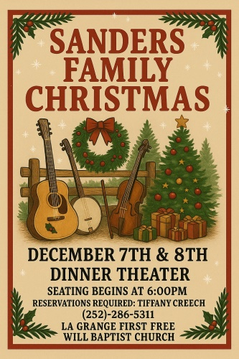

Church Christmas Celebration @ the Hams
2945 Promiseland Road, La Grange, NC
Sunday, December 14th
5:00pm-7:30pm
Food, Santa Visit, and a Live Nativity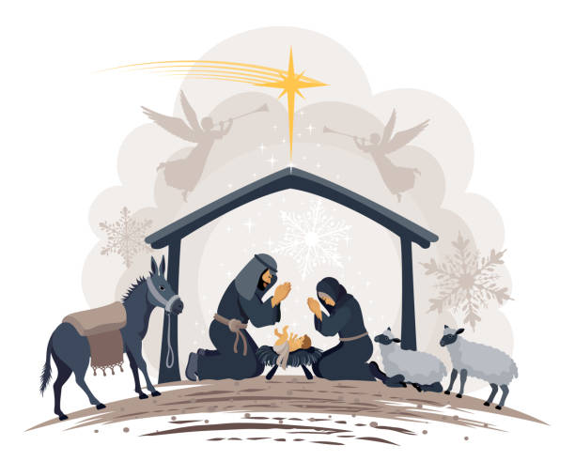

December 2025

Deacon of the Month – Carter Daniels
December is OFWBI Month

Greeters/Ushers for Worship
 | Sanctuary | North Vestibule | Gathering Hall
7 | Sue Shivar | Greg Herring | Brent Herring Family
14 | Christi Wilhelm | Bobby Wadsworth | Guy Hines Family
21 | Tony Parrish | Carolyn Massengill | Ham Family
28 | David Letchworth | Bonnie Kornegay | James Sutton Family
Candlelighters
7- Anne Matchett & Fletcher Cox 14-Benjamin Carroll
21-James & Allie Wooten 28- Griffin & Marley Daniels

Children’s Church
7- Emily Daniels & Katie Wooten | 14- Bethany & Jimmy Jones
21-Kids Christmas Program | 28-Tara & Ryan Carroll

Church Nursery
7- Ashley & John Kennamer 14-Morgan & Brad Hunter
21- Tiffany & Asa Creech 28-Anna Baird & Sara Hobgood

Pro-Presenter Teams
Sanctuary
7-Heather Ham 14—Olivia Sutton 21- Maura Ham 28-Heather Ham

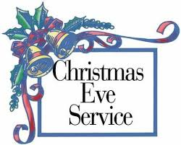
Wednesday, December 24th @ 10:00 am
Worship and Communion



802 S. Caswell Street • La Grange, N.C.

Joshua T. Hobgood, Pastor
_________________________________________________________________________________

Newsletter –December 2025

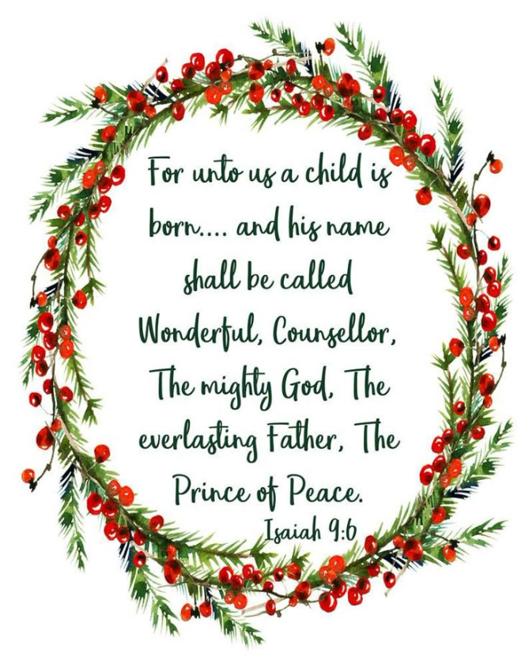
_______________________________________________________________________________
Christ-First • Bible-First • Ministry-First
_________________________________________________________________________________
Visit us at…
www.lagrangefwb.org
Facebook: @ LaGrange1stFWB
YouTube: La Grange Free Will Baptist
Email @ Lagrangeffwb@suddenlinkmail.com
________________________________________________________________________________

Live Streaming & YouTube Services
Sundays • Sunday School & Worship
Wednesday • Bible Study

