Worship & Celebration

The Lord’s Day • August 10, 2025 • Eleven O’clock



Prelude Musicians

Welcome & Announcements Youth Pastor

Preparation for Worship Lighting of the Candles

Call to Worship “Come Now is the Time to Worship”
Invocation Youth Pastor

Songs of Praise “In Christ Alone”
“The Lord Will Provide”
Time of Fellowship
LGS Kids Laity

Offertory Scripture Malachi 3:10 NIV
¹⁰ Bring the whole tithe into the storehouse, that there may be food in my house. Test me in this,” says the Lord Almighty, “and see if I will not throw open the floodgates of heaven and pour out so much blessing that there will not be room enough to store it.

Tithes and Offering Boxes – Back of Sanctuary
Doxology

Morning Prayer James 5:16 NIV
The prayer of a righteous person is powerful and effective.

Scripture: Psalm 23 NIV Youth Pastor
Leader: This is the Word of the Lord / People: Thanks be to God.

Anthem: “Go Light Your World” Choir
(Children ages 3 – 3rd grade dismissed to Children’s Worship)

Message from God’s Word Rev. Dustin Bannister
“The Weight of the Mantle” 1st Kings 19 NIV

Response “I Surrender All”

Altar Prayer & Benediction Rev. Dustin Bannister

Postlude Musicians

A m e n

_________________________________________________________________________________

Pastoral Search:
On August 6, 2025, Josh Hobgood was called as the next pastor of La Grange First Free Will Baptist Church! The installation service will be held next Sunday August 17, 2025. After worship, lunch will follow in the fellowship hall. Please invite friends and family to celebrate.
_________________________________________________________________________________



Sunday, August 10, 2025 @ 6pm
Lake Pines Pool

Building Fund Sunday

August 24, 2025

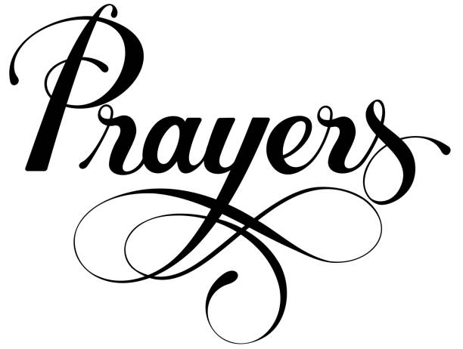
PRAISE…
Praise the Lord for the great and mighty things He has done!
SALVATION & RENEWAL…
The lost of the world and for workers in the field., Persecuted Christians, all Christians, and Revival in the church.
SICK…
Maverick Allen, Jerry Barr, Joy Brock, Mike Braswell (Sandra Rouse),Rodney Creech (Cleo Hinson); Margaret Creech (Sue Shivar), Laura Eason, Henry Edwards (Amy Edwards), Krew Ginn (Brent Herring), Jay Greenway (Father of Crystal Ryan), Andy Harrison, Theo & Barrett Harrison, Carrol Henderson, Elvin Herring (Angie Herring), Paul Herring (Nelson & Susie Harrison), Remi Hill (Ann Burke), Carly Humphrey (Angela Taylor), Johnny Johnson (Sue Shivar), Frankie Jones, Leona LeNeave (Mother of Bethany Jones), Tony Lopez (Cliff Hardison), Cristy Mobley (Jonathan Mobley), Tammy Moore; Austin Mozingo (Josh Hobgood), Larry Mann (Mary Gresham), Jimmy Newman (Uncle/Carrie Harrison), Judy Parrott, Randy & Sharon Patterson (Sue Shivar), Chris Roddy, Emma Rouse (Stacie Smith), Frank Rouse (Sue Shivar), Thomas Rouse, Lennie Smith (Curtis Smith), Vernon Sorrell, Lee Spivey (Ernie & Linda Spivey), Vicki Stafford (Linda Spivey), Rusty & K. J. Strong (Sue Shivar), Donald Stroud, Kerri Stroud (Friend of Emily Daniels), J. J. Sutton, Trish Tanner (Sister/Fran Gibbons), Gary Taylor, Michelle Taylor (Kelley Black), Tom & Kathryn Thutt (Carol Hardison), Ping Tuchten (Kurt Tuchten), Pat Turner (Stepmother of Laura Eason), Ricky Ward (Women 3:18), Connie Weyant (Ernie & Linda Spivey), Wayne Wheeler (Sue Shivar), Marie Williams (Angela Taylor), Peggy Williamson (Gary & Jackie Taylor) Tracy Zacharzuk (Sara Hobgood), Carol Zimmerman (Bannister family).
ASSISTED LIVING & HOMEBOUND…
Jeannie Bannister (Spring Arbor), Barbara Corbett (Cherry Point Bay), Esther Flowers, Betty Pelt (Brookdale), & Betty Valenti (Mother of Vickie Phillips).
CHURCH / DENOMINATIONAL & OUTREACH …
First Church, Pastor, Youth Pastor, Deacons, Sunday School Leaders/Teachers, College Students, Convention of Original FWB, Denominational Ministries, Rev. Dr. Ricky Warren (Convention President), Rev. Dr. Dustin Bannister (Director of Church Planting & Renewal), Rev. Donald Fader (Director of Church Finance), Disaster Relief (Cragmont Assembly), Rev. Chris Singleton, (Missions).
SPECIAL REQUESTS…
Macy and students in P.T. School, Josh Ryan (training in Mississippi)
MILITARY…
Rob Bittner (Service/Sara Hobgood), Nick Cornatzer (Marines / Holmes family), DeAnna Gray (US Marines), Rev. Richard Holmes (OFWB Chaplain), Emily Johnson (Army), Jason Nipple (Wade family), Tyler Proctor (Navy/ Elsie Holmes), Joshua Ryan (USAF). Jami Sutton (Navy/Angela Taylor), & Austin Tyner (Navy/Elsie Holmes).
LA GRANGE/LENOIR COUNTY… Mayor Bobby Wooten, Town Commissioners, County Commissioners, County & Private Schools, and Lenoir Community College. The countries of Israel & Ukraine.
OUR COMMUNITY, NATION, & WORLD…
US: President Donald Trump, Vice-President J. D. Vance, Cabinet, Congress, and the Supreme Court NC: Governor Josh Stein, NC Senators and NC Representatives.

In an effort to keep the prayer list updated, we will be updating the list at the beginning of each month. If someone needs to stay on the list, please contact Josh by text or fill out a card in the pew and give it to him.

