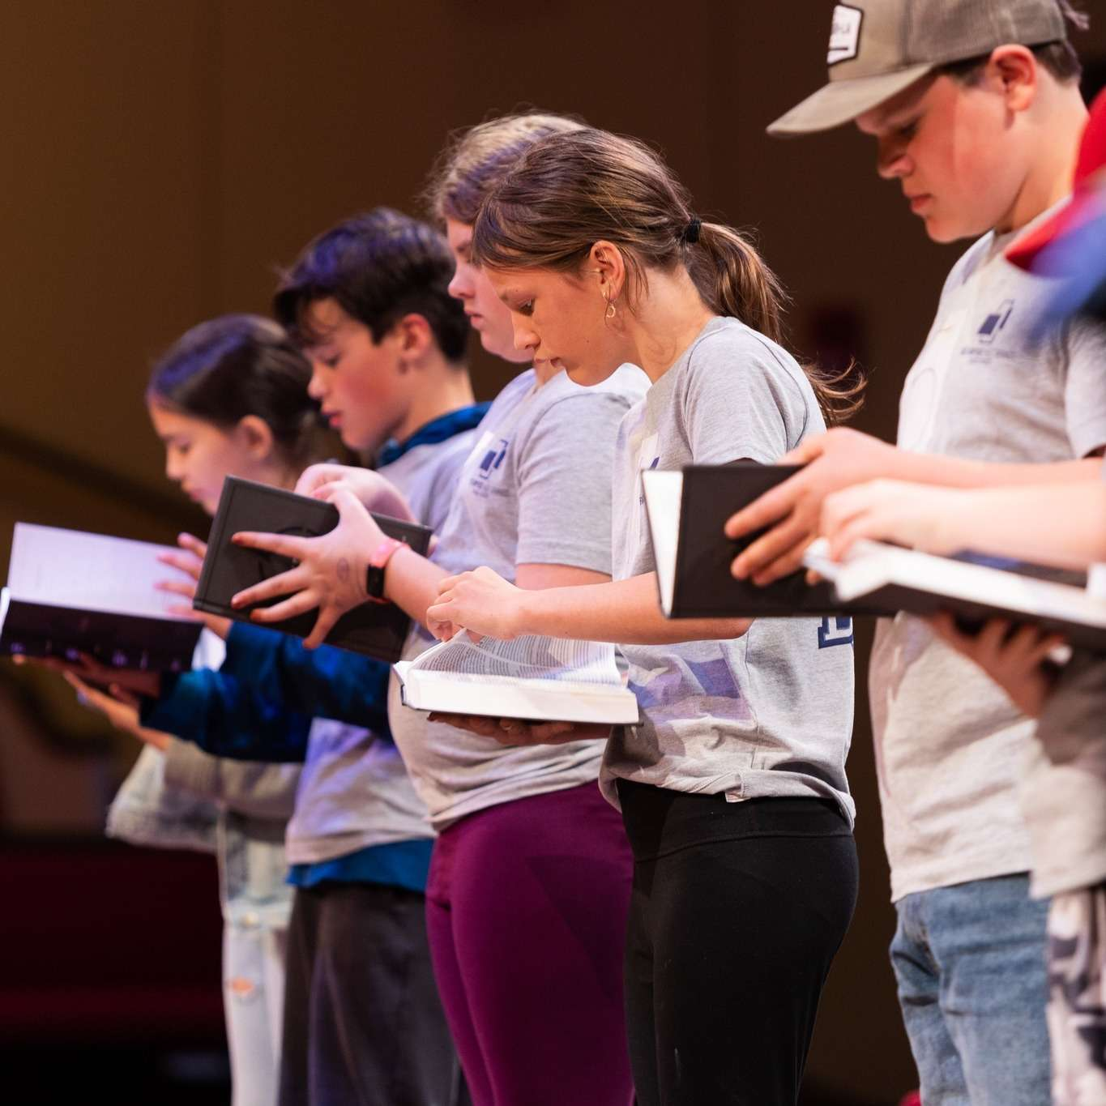

**BIBLE DRILL 2025 – 2026**

*The next generation is projected to be biblically illiterate .....let's defy those odds.*

**DEAR PARENTS:**

We are super excited that your child is participating in Bible Drill. Over the course of the next year your child will have the opportunity to learn the books of the Bible, the Bible divisions, 10 Key Passages and how to find them, and over 25 Bible verses and how to apply them. In addition, they will study Bible stories, Bible history, and Bible people. Your child will not accomplish this by attending class for an hour on Wednesday. Nor are they going to think memorizing and finding scripture is always fun. I know you're shocked! Ha! This is why it's critical that you work with your child at home and be a source of encouragement throughout the year. What could be more worth it?!?!

Each week we will cover 2 verses, a division of the books of the Bible and a key passage. We will have designated review weeks for a bit of a break. Every Thursday we will send a text that explains what we covered that week, so parents can work with their children at home. Our prayer is that through Bible Drill the whole family will be engaged in learning scripture.

Your child has been given a **Green** Bible Drill Card, which contains all material to be learned this year. Place a card in your car, by your child’s bed, on the refrigerator, in their backpacks….

**Helpful Tips**:  Drive time is a perfect place to work on scripture memorization. Or get in the habit of sending kids to bed 30 minutes early. In the past, kids have practiced bible drill with friends at school on the playground, at lunch or during free time.

**COMPETITION DATES:**

Wednesday, March 18, 2026

Wednesday, April 8, 2026

**IMPORTANT STATEMENT REGARDING COMPETITION DRILL:**

We understand that each child learns at their own unique pace. We also know that every child isn’t driven by competition. Our BIGGEST prayer for Bible Drill is and will continue to be for kids to hide the Word of the Lord in their hearts, so that they may live a life that honors HIM. We also pray that the outcome of their daily scripture memorization will result in a hunger to spend time with HIM every day, even beyond their days in Bible Drill. For these reasons, we will not push your child to compete on stage. We will, however, encourage them throughout the year to give their very best effort to the Lord and for some that’s presenting what they learned on stage. Join us in praying this for all our Bible Drill participants. This commitment from our young people and you, their parents’, can win over our homes, churches, schools, cities…… for the Lord. AMEN!

**QUESTIONS:**

Heather Murphy 479.806.7187

Katy Packard  501.269.8198

**CARPOOL & FBC BUS/VAN RIDERS:**

If your child is sick and won't be at school on a Wednesday, please let us know, so we can notify our drivers. (Heather 479.806.7187 or Katy 501.269.8198 )

**WEDNESDAY SCHEDULE:**

3:15 - 3:55   Drop-off at the church (snacks, gym, games)

4:00 - 5:15     Class Time

5:15 - 5:50     Supper & Break

5:45               Students - Excite Night

6:00 - 7:30     Excite Night

7:30               Parents pick-up

**HANDOUTS & BACK PACKS**

All **backpacks** will be collected and placed to the right of the entrance of the kid’s wing. (See picture below.) Each Wednesday please get in the habit of checking here for your child's backpack before you leave the church.

