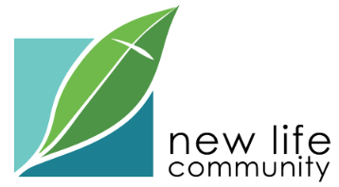
Current Opening: Worship Ministries Leader (Part-Time)
New Life Community Church — Dinuba, CA
Our Jesus-centered and outward-facing church is seeking a part-time Worship Ministries Leader (approx. 15–20 hours/week) to join our staff and help lead musical worship, volunteer coordination, and worship production.
Position summary & full job description:
*JOB DESCRIPTION*
How to Apply
Please email the following to pastorbrad@newlifedinuba.org with the subject line:
“Worship Ministries Leader Application – [Your Name]”
- Résumé
- A brief cover letter (1 page) describing your Christian testimony and your philosophy of worship
- At least one video sample of you leading worship (This could be a Sunday service clip, rehearsal video, or a simple at-home recording. YouTube or Vimeo links welcome)
- Two to three references: At least one should be from a pastor or ministry supervisor; others may be musical, professional, or character references
Applications will be reviewed as they are received. The position will remain open until filled.
If you have any questions, feel free to call our church office at (559) 591-1176 or email pastorbrad@newlifedinuba.org

