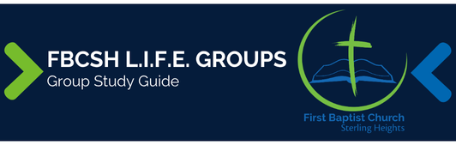
Sermon Text: Psalm 94 Date: September 7, 2025
Sermon Title: God of Vengeance
Sermon Notes:

Sermon Text: Psalm 94 Date: September 7, 2025
Sermon Title: God of Vengeance
Main Idea: The certainty of God’s vengeance provides confidence to live righteously.
Breaking the Ice
- Describe a situation where you wanted to retaliate against someone who wronged you?

Excavating the Truth
- Reread Psalm 94
- How is the Psalmist’s frustration (1-3) adjusted by the reality of verses 22-23?

- What is the significance of the repeated use of “chasten” and “teach” in verses 10-13?

Applying the Truth Personally
- How can I cry for God's vengeance while obeying the command to love my enemies?

- How does trusting in God's plan help me manage anger and despair over injustice?

Applying the Truth Congregationally

- In today’s world of instant communication and social media, how can we help one another rightly respond to the endless stream of injustice we witness?

- How can we create an environment in our church that supports those who are suffering persecution?

- What potential dangers might our church face by overemphasizing the wicked?

Digging Deeper
- Read Psalm 93 and 94 and detail how God’s sovereignty impacts God’s vengeance.

- Consider these verses; Leviticus 19:17-18, Romans 12:10, Hebrews 12:5-11 with Psalm 94. How do we adjust our reactions in light of God’s vengeance.

Looking Ahead to Next Sunday
Read Psalm 46

