Sermon Text: Psalm 24 Date: January 18, 2026
Sermon Title: Our Glorious God
Sermon Notes:
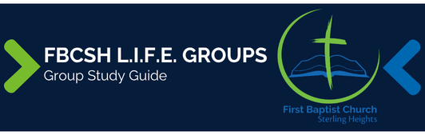

Sermon Text: Psalm 24 Date: January 18, 2026
Sermon Title: Our Glorious God
Main Idea: Our preparation should reflect that we worship the King of glory.
Breaking the Ice
- What is one thing that you spend a lot of time and energy preparing for?

Excavating the Truth
- Reread Psalm 24
- What clues do we have in this psalm that the writer has corporate worship in mind?

- Explain in your own words what the phrase “King of glory” means.

Applying the Truth Personally
- What are three ways Psalm 24:1–2 impacts my life?

- Based on verses 3 and 4, what is one thing that I can do to properly prepare myself for worship each week?

- Given that only someone with “clean hands and a pure heart” (v. 4) can stand before a holy God in worship, where should my focus lie in my own worship? What secondary elements of worship consume too much of my attention?

Applying the Truth Congregationally
- How can we echo the joy of verses 7–10 in our corporate worship more each week?

- The Jews came to sing Ps 24 weekly. How can we learn to value the regular singing of songs more?

Digging Deeper
- How does the repetitive use of the Hebrew word “lift up” in vv. 4, 5 (NASB “receive”), 7 (twice), and 9 (twice) strengthen this psalm’s point?

- How does Paul’s quotation of Psalm 24:1 in 1 Corinthians 10:26 support his argument in that chapter?

Looking Ahead
- Read Luke 15:1–10 daily.

