Sermon Text: _______________________ Speaker: ___________________
Sermon Title: _______________________ Date: ___________________
Main Idea:
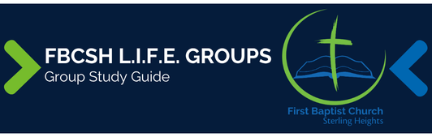
Sermon Notes:

Breaking the Ice
- What would you find most difficult about living where the missionary serves?

Excavating the Truth
- Reread the sermon text.
- What was the main idea presented?

- What were the main points presented?

- Did the sermon illuminate anything in the text that you had not seen before?

Applying the Truth Personally
- What idea of the sermon did I find the most encouraging?

- Based on the sermon, what is one change that I need to implement in my life?

Applying the Truth Congregationally
- What are some ways that the sermon showed God displaying His grace and mercy? In what ways is God showing the same grace and mercy in and through our church?

- What was one idea presented in the sermon that would increase the impact of our church for Christ? What can our church do to achieve this? How can our Life Group contribute?

Digging Deeper
- Review the sermon text and look up cross-reference passages listed in your Bible. How do these additional passages help you understand the text better?

- Select, memorize, and contemplate upon a key verse from the sermon text.

Looking Ahead
- Read next week’s sermon text daily.

