Sermon Text: Luke 1:67–79 Date: December 21, 2025
Sermon Title: Born to Point to Hope
Sermon Notes:
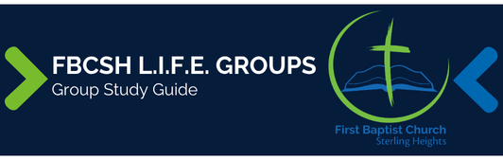

Sermon Text: Luke 1:67–79 Date: December 21, 2025
Sermon Title: Born to Point to Hope
Main Idea: We must point to Jesus, the Source of hope.
Breaking the Ice
- What are some things that most point to Christmas in your mind?

Excavating the Truth
- Reread Luke 1:67–79
- How does the lineage recorded in verse 5 demonstrate that Zacharias is not speaking about his newborn son in verse 69?

- What various implications of salvation does Zacharias list in verses 77–79?

Applying the Truth Personally
- How does Zacharias’ prayer of praise help me appreciate my salvation more fully?

- In what ways have I been most affective pointing people to Jesus in 2025? How can I increase my impact in 2026?

Applying the Truth Congregationally
- In what ways has our church been most affective pointing people to Jesus in 2025? How can we increase our impact in 2026?

- What can our LG do to increase the awe of our salvation in 2026 so that we “might serve Him without fear” (verse 74)?

Digging Deeper
- In what ways did John the Baptist fulfill the prophecy of Isaiah 40:3?

- Using a Bible with cross-references, look up all the OT allusions and quotations you find in Luke 1:68–79. How do these OT references enrich your understanding of Zacharias’ prayer?

Looking Ahead
- Establish a personal Bible reading plan for 2026 that you will begin on January 1.

- Pray for a specific person you want an opportunity to share the gospel with in 2026.

