Sermon Text: Luke 14:1–6 Date: November 30, 2025
Sermon Title: Care-Focused
Sermon Notes:
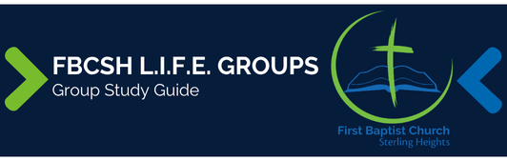

Sermon Text: Luke 14:1–6 Date: November 30, 2025
Sermon Title: Care-Focused
Main Idea: We must emphasize compassion over tradition.
Breaking the Ice
- Describe one time that someone showed unexpected compassion to you? What impact did that have on you?

Excavating the Truth
- Reread Luke 14:1–6
- Make four observations about the circumstances recorded in Luke 14:1.

- Verse 6 literally states, “And they could make no reply to these things.” Why would Luke use a plural “these” rather than the singular “this”?

Applying the Truth Personally
- What attitudes keep me from showing compassion to others in need? What can I do to change these attitudes?

- What positive or negative traditions do I embrace that affect my influence on others?

Applying the Truth Congregationally
- This is the fourth time that Jesus addressed religious traditions in Luke. What traditions in our church demonstrate that we need this repeated lesson?

- How has our church allowed concern for image overshadow our concern for people?

Digging Deeper
- Luke 14:1–6 marks the fourth and final record of a Sabbath controversy. Compare it with Luke 6:1–5, 6–11; and 13:10–17. What does the repetition demonstrate about the religious leaders?

- Romans 9:20 is the only other NT usage of the word used in Luke 14:6, translated “reply.” This is a stronger word than the word used for “silence” in Luke 14:4, which Luke also uses as an author in Luke 23:56; Acts 11:18, and 21:14. What significance does the stronger word carry in the context of Luke 14.

Looking Ahead
- Read Luke 14:7–14 daily.

