Sermon Text: Luke 14:7–14 Date: December 7, 2025
Sermon Title: Humility-Focused
Sermon Notes:
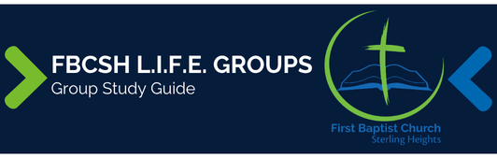

Sermon Text: Luke 14:7–14 Date: December 7, 2025
Sermon Title: Humility-Focused
Main Idea: Our Lord calls us to live in humility.
Breaking the Ice
- Describe a time when you were forced to learn humility.

Excavating the Truth
- Reread Luke 14:7–14
- How many times is the word invite (the Greek word “call”) used in these verses? How does the word tie verses 14:7–14 together?

- There are verbs in verses 11 and 14 referred to as “divine passives.” What is the significance of these verbs in these verses?

Applying the Truth Personally
- What is one area of my life where I tend to exalt myself? How can this passage help me remain humble?

- How do I operate like the host of verse 12 who only invites his friends, and what must I change to show the generosity that Jesus demands?

Applying the Truth Congregationally
- In what ways might we show personal humility while engaging in collective arrogance as a church?

- What does it mean for us to show humility as a church? Where are we failing and how can this passage help us?

Digging Deeper
- How does Luke 6:32–36 strengthen the idea of Luke 14:12-14?

- Compile a list from Proverbs regarding humility. How does your collection of verses reinforce the point of Luke 14:7-14?

Looking Ahead
- Read Luke 14:15–24 daily.

