Sermon Text: Luke 14:25–35 Date: January 11, 2026
Sermon Title: Discipleship Focus
Sermon Notes:
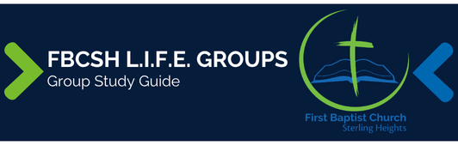

Sermon Text: Luke 14:25–35 Date: January 11, 2026
Sermon Title: Discipleship Focus
Main Idea: A disciple must remain intentionally focused on usefulness.
Breaking the Ice
- Describe a time when a distraction created an unexpected problem.

Excavating the Truth
- Reread Luke 14:25–35.
- Notice to whom Jesus addresses these words in verse 25. How does that inform us that Jesus’ original purpose is somewhat different than Luke’s purpose in recording these words?

- In the original Greek, Jesus uses the same phrase “not able to be My disciple” three times (vv. 26, 27, 33). How does the repetitive phrase emphasize Jesus’ point?

Applying the Truth Personally
- Which “cost” of discipleship do you find most challenging and why? How can this passage help you willingly accept this cost?

- What is one thing that you will commit to doing in 2026 to intentionally focus on usefulness to Christ?

Applying the Truth Congregationally
- How can our LIFE Group help us fulfill our personal commitments from above?

- How does this passage refute the idea of “easy believism” (praying a salvation prayer is all that is required to be saved)?

- How should this passage affect our evangelistic efforts?

Digging Deeper
- Consider Gen 29:30–31 and Deut 21:15–17 where the OT uses a love/hate contrast. How do these examples help us harmonize Jesus’ words of Luke 14:26 with what He has said already in 6:27?

- Consider the following verses: Matt 11:15; 13:9, 43; Mark 4:9, 23;7:16; Luke 8:8; 14:35; Rev 2:7, 11, 17, 29; 3:6, 13, 22; 13:9. Describe the significance of the common phrase in these verses and develop a list of actions you should take based on these verses.

Looking Ahead
- Read Psalm 24 daily.

