Sermon Text: Luke 12:54–59 Date: October 19, 2025
Sermon Title: Our Great Need
Sermon Notes:
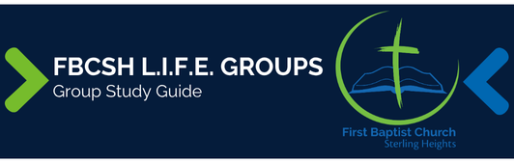

Sermon Text: Luke 12:54–59 Date: October 19, 2025
Sermon Title: Our Great Need
Main Idea: Our greatest need is to look beyond the superficial to see the looming judgment of God.
Breaking the Ice
- What are some things that distract us from deep thinking in our culture?

Excavating the Truth
- Reread Luke 12:54–59

- The word “hypocrite” in v. 56 means “one who plays a part,” often used for an actor in a play. Why might Jesus have chosen that word for His accusation of the listening crowds?

- How does the illustration of vv. 58–59 reinforce Jesus’ main point about the crowds’ rejection of Him?

Applying the Truth Personally
- What is one way in which I have allowed something superficial to distract me from God’s looming judgment?

- What is something that I need to do this week to look past the superficial to see more clearly the looming judgment of God?

Applying the Truth Congregationally
- How are we as a church letting the secondary or frivolous distract us from our mission?

- What can our Life Group do to help our church focus on the looming judgment of God rather than the mundane?

- How would our church look different if we saw the looming judgment of God as the world’s greatest need?

Digging Deeper
- Luke uses the phrase “what is right” from verse 57 again in Acts 4:19. How does comparing the phrase in that second usage help you understand verse 57?

- Meditate on the idea that your debt had to be paid to “the very last cent” (v. 59). Write out a prayer of thanksgiving to God for paying your debt in full.

Looking Ahead
- Read Luke 13:1–9 daily.

