Sermon Text: Luke 12:49–53 Date: September 28, 2025
Sermon Title: Our Great Divider
Sermon Notes:
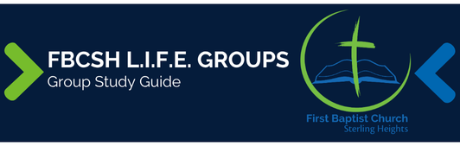

Sermon Text: Luke 12:49–53 Date: September 28, 2025
Sermon Title: Our Great Divider
Main Idea: We will face God’s judgment either through the cross or because of the cross.
Breaking the Ice
- What is one way in which following Christ has cost you something?

Excavating the Truth
- Reread Luke 12:49–53
- The word “baptism” is normally used for submersing something in water. How does that word give a vividness to Jesus’ pending death in v. 50?

- How can we harmonize Luke’s statement about Jesus not bringing peace in 12:51 with what he wrote earlier about Jesus bringing peace in 1:79 and 2:14?

Applying the Truth Personally
- How does the reality of God’s judgment beginning at the cross impact you personally?

- Is there any personal fear holding you back from fully following Christ?

Applying the Truth Congregationally
- What can we do to press each other to move beyond our fears to more fully serve Jesus?

- How can we use the pending reality of judgment to motivate us to increase our passion for outreach?

Digging Deeper
- Study Micah 7:6 and its surrounding context. How does Jesus’ reference of this verse help support His point in Luke 12:53?

- The word “distressed” in Luke 12:50 is also used in the following verses: Matt 4:24; Luke 4:38; 8:37, 45; 19:43; 22:63; Acts 7:57; 18:5; 28:8; 2 Cor 5:14; Phil 1:23. How do these additional verses help us understand the emotions Jesus was enduring as He contemplated the cross?

Looking Ahead
- Read Psalm 77:11–15 daily and think about all that the Lord has done through FBCSH over the past 60 years in preparation for our anniversary celebration.

