Sermon Text: Hebrews 10:24–25 Date: August 31, 2025
Sermon Title: Intentional Encouragement
Sermon Notes:
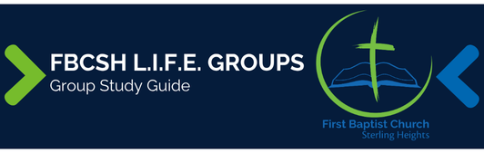

Sermon Text: Hebrews 10:24–25 Date: August 31, 2025
Sermon Title: Intentional Encouragement
Main Idea: Intentionally encouraging one another as we gather for worship is our Christian duty.
Breaking the Ice
- How has this Life Group encouraged me over the past three months?

Excavating the Truth
- Reread Hebrews 10:19–25
- The word “stimulate/encourage” (NASB) in v. 24 often has a negative sense and is translated as “irritate” or “exasperate.” How does such a strong negative flavor aid our understanding of the positive use in this verse?

- Why would the writer of Hebrews place “encouraging” (“exhorting/comforting”) in contrast to “not forsaking our own assembling together” in v. 25?

Applying the Truth Personally
- “Let us consider” implies careful observation and mental attention. How can I improve in my consideration of stirring others to “love and good deeds”?

- “Forsaking” in verse 25 indicates wrongful abandonment. In what ways do I rationalize any absences from church as less severe than “forsaking” and why?

Applying the Truth Congregationally
- How should an intentional concern for mutual encouragement change our thinking about our Sunday morning gatherings?

- How does our future day of judgment motivate us to encourage one another?

Digging Deeper
- All three of the “Let us” commands of verses 22, 23, and 24 are based on the all-sufficient sacrifice of Christ. How does the sacrifice of our Savior generate a desire to “stimulate one another to love and good deeds”?

- John 13:34–35 lists love for one another as the distinguishing mark of a Christian. Why then would the author if Hebrews urge us to “love and good works” in verse 25?

Looking Ahead
- Read Psalm 94 daily.

