ST. PAUL’S
ANGLICAN CHURCH
VISALIA, CALIFORNIA

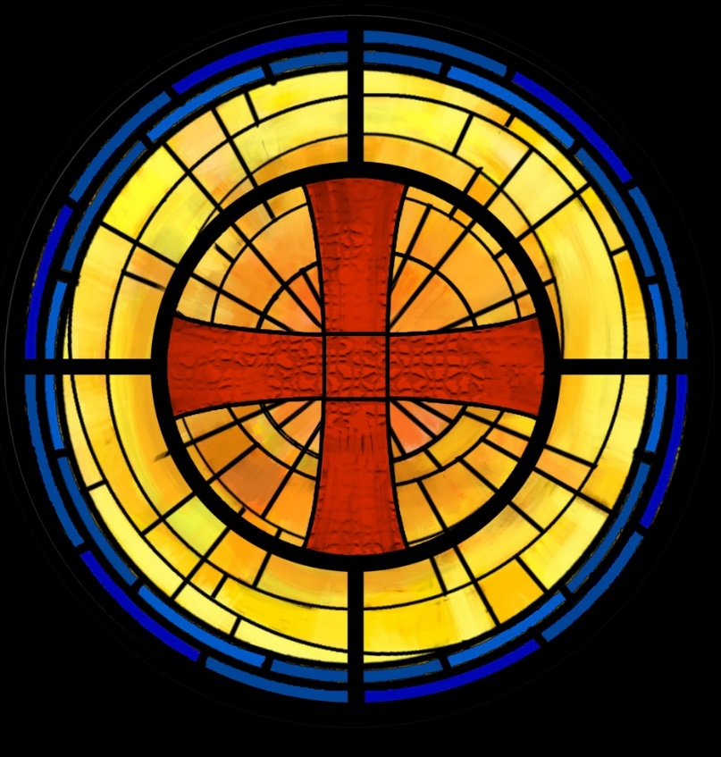

Thirteenth Sunday after Pentecost
September 7, 2025
10:30 A.M

Welcome!

St. Paul’s Anglican Church extends a warm welcome to all visitors and newcomers, whether worshiping in person or at home via livestream.

Visitors’ Guide

St. Paul’s Church is a parish in the Diocese of San Joaquin of the Anglican Church in North America, which includes both Catholic and Protestant traditions. We accept Jesus Christ as Savior, and we promise to follow him as Lord. We believe in One God,

- the Father who created us and all things,
- the Son who redeems us from sin and death,
- the Holy Spirit who renews and sanctifies us.

We believe the Holy Scriptures to be the Word of God and to contain all things necessary for salvation, and we accept the Apostles’ and Nicene Creeds as essential beliefs of the Christian faith.

All followers of Jesus who are baptized in the name of the Trinity are invited to receive Holy Communion. If for whatever reason you feel you cannot receive communion, we invite you to come forward to receive a blessing. Please indicate you’d like a blessing by crossing your arms. All people are welcome at the Altar of the Lord.

Visitors are invited to sign the guest book at the entrance table and introduce themselves to the clergy following the service.

The Holy Eucharist

Prelude: “Andante” Handel
Opening Hymn: #686 – “Come, Thou Font of Every Blessing” p. 4
Opening Acclamation p. 5
The Collect for Purity p. 5
Summary of the Law p. 5
Kyrie p. 5
Gloria p. 6
Collect of the Day p. 7
Lesson: Deuteronomy 30 :15-20 p. 7
Gradual: Psalm 1 p. 7
Epistle: Philemon 1-25 p. 8
Sequence Hymn: #675 – “Take Up Your Cross” p. 10
Gospel: Luke 14:25-33 p. 10
Sermon: The Rev. Robert Longbottom
Nicene Creed p. 11
Prayers of the People p. 12
The Peace p. 14
Offertory: “Tis So Sweet to Trust in Jesus”
Duet: Ellen Daniels & Jackie Iseman
The Offertory p. 15
Sursum Corda p. 15
Sanctus p. 16
The Lord’s Prayer p. 18
Fraction p. 19
Prayer for Humble Access p. 19
Agnus Dei p. 19
Communion Celebration Hymn: #459 – “We Remember You” p. 20
Post Communion Prayer p. 21
Blessing p. 21
Closing Hymn: #473 – “Left High the Cross” p. 22
Dismissal p. 22
Postlude: “Tocatta in F” Buxtehude

Opening Hymn: Come, Thou Font of Every Blessing
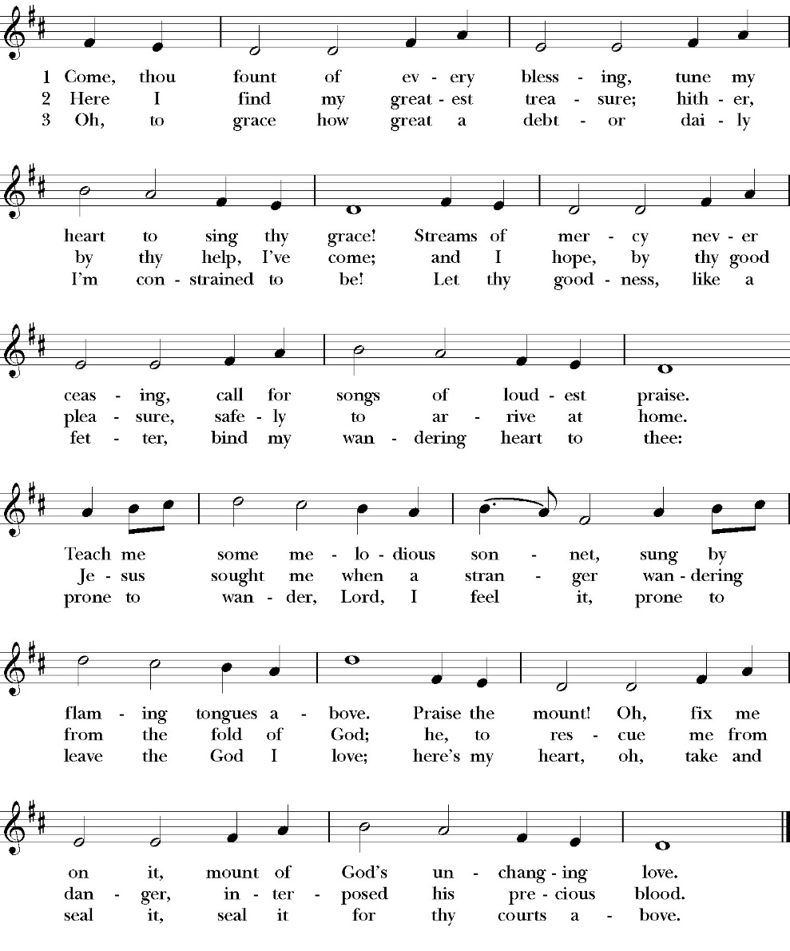

Opening Acclamation

Celebrant Blessed be God: the Father, the Son, and the Holy Spirit. People And blessed be his kingdom, now and for ever.
Amen.

Collect for Purity

People: Almighty God, to you all hearts are open, all desires
known, and from you no secrets are hid: Cleanse the thoughts of our hearts by the inspiration of your Holy Spirit, that we may perfectly love you, and worthily magnify your holy Name; through Christ our Lord. Amen.

Summary of the law

Celebrant: Hear what our Lord Jesus Christ says: You shall love the Lord your God with all your heart and with all your soul
and with all your mind. This is the first and great commandment. And the second is like it: You shall love your neighbor as yourself. On these two commandments depend all the Law and the Prophets.

The Kyrie

Gloria

Celebrant The Lord be with you.
People And with your spirit.
Celebrant Let us pray.

The Collect of the Day
O Lord God, grant your people grace to withstand the temptations of the world, the flesh, and the devil, and with pure hearts and minds to follow you, the only God; through Jesus Christ our Lord, who lives and reigns with you and the Holy Spirit, one God, now and for ever. Amen.

Lesson: Deuteronomy 30:15-20
“See, I have set before you today life and good, death and evil. 16 If you obey the commandments of the LORD your God that I command you today, by loving the LORD your God, by walking in his ways, and by keeping his commandments and his statutes and his rules, then you shall live and multiply, and the LORD your God will bless you in the land that you are entering to take possession of it. 17 But if your heart turns away, and you will not hear, but are drawn away to worship other gods and serve them, 18 I declare to you today, that you shall surely perish. You shall not live long in the land that you are going over the Jordan to enter and possess. 19 I call heaven and earth to witness against you today, that I have set before you life and death, blessing and curse. Therefore choose life, that you and your offspring may live, 20 loving the LORD your God, obeying his voice and holding fast to him, for he is your life and length of days, that you may dwell in the land that the LORD swore to your fathers, to Abraham, to Isaac, and to Jacob, to give them.”

Reader: The Word of the Lord
People: Thanks be to God

Gradual: Psalm 1
1Blessed is the man who has not walked in the counsel of the
ungodly, *
nor stood in the way of sinners, and has not sat in the seat of the scornful;
2 But his delight is in the law of the LORD, *
and on his law will he meditate day and night.
3 And he shall be like a tree planted by the waterside, *
that will bring forth his fruit in due season.
4 His leaf also shall not wither; *
and look, whatever he does, it shall prosper.
5 As for the ungodly, it is not so with them; *
but they are like the chaff, which the wind scatters away from the face of the earth.
6 Therefore the ungodly shall not be able to stand in the judgment, * neither the sinners in the congregation of the righteous.
7 For the LORD knows the way of the righteous, * but the way of the ungodly shall perish.

Glory be to the Father, and to the Son, and to the Holy Spirit;
as it was in the beginning, is now, and ever shall be, world without end. Amen

Epistle: Philemon 1-3-25
Paul, a prisoner for Christ Jesus, and Timothy our brother, To Philemon our beloved fellow worker 2 and Apphia our sister and Archippus our fellow soldier, and the church in your house: 3 Grace to you and peace from God our Father and the Lord Jesus Christ.

4 I thank my God always when I remember you in my prayers, 5 because I hear of your love and of the faith that you have toward the Lord Jesus and for all the saints, 6 and I pray that the sharing of your faith may become effective for the full knowledge of every good thing that is in us for the sake of Christ. 7 For I have derived much joy and comfort from your love, my brother, because the hearts of the saints have been refreshed through you.

8 Accordingly, though I am bold enough in Christ to command you to do what is required, 9 yet for love's sake I prefer to appeal to you—I, Paul, an old man and now a prisoner also for Christ Jesus— 10 I appeal to you for my child, Onesimus, whose father I became in my imprisonment. 11 Formerly he was useless to you, but now he is indeed useful to you and to me. 12 I am sending him back to you, sending my very heart. 13 I would have been glad to keep him with me, in order that he might serve me on your behalf during my imprisonment for the gospel, 14 but I preferred to do nothing without your consent in order that your goodness might not be by compulsion but of your own accord. 15 For this perhaps is why he was parted from you for a while, that you might have him back forever, 16 no longer as a bondservant but more than a bondservant, as a beloved brother—especially to me, but how much more to you, both in the flesh and in the Lord.

17 So if you consider me your partner, receive him as you would receive me. 18 If he has wronged you at all, or owes you anything, charge that to my account. 19 I, Paul, write this with my own hand: I will repay it—to say nothing of your owing me even your own self. 20 Yes, brother, I want some benefit from you in the Lord. Refresh my heart in Christ.

21 Confident of your obedience, I write to you, knowing that you will do even more than I say. 22 At the same time, prepare a guest room for me, for I am hoping that through your prayers I will be graciously given to you.

23 Epaphras, my fellow prisoner in Christ Jesus, sends greetings to you,

24 and so do Mark, Aristarchus, Demas, and Luke, my fellow workers.

25 The grace of the Lord Jesus Christ be with your spirit.

Reader: The Word of the Lord
People: Thanks be to God

Sequence Hymn: Take Up the Cross
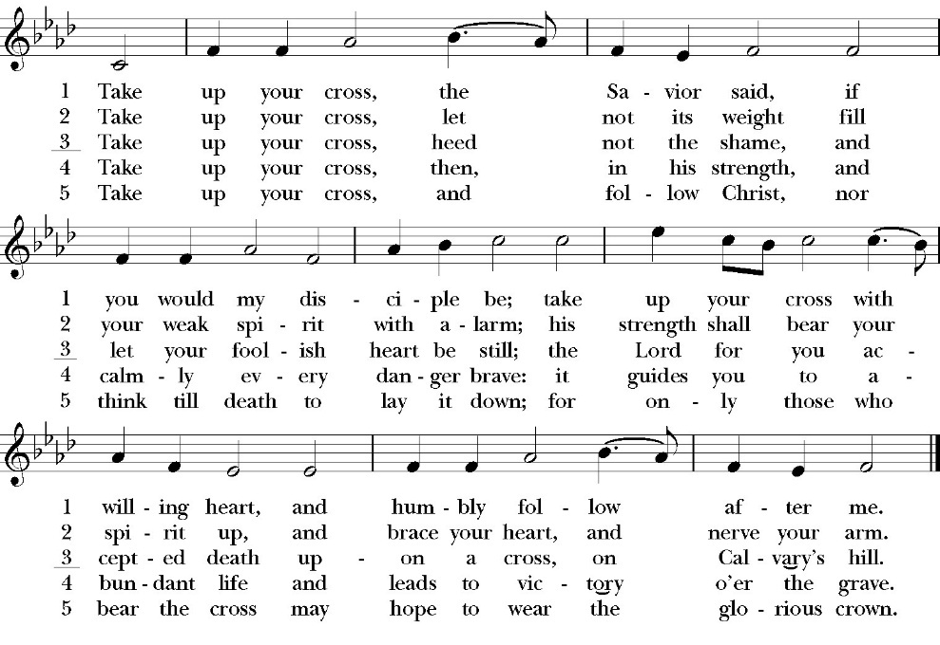
(Verse 1-3 before Gospel verse 4-5 after)

Clergy: The Holy Gospel of Our Lord Jesus Christ,
according to St. Luke
People: Glory to you, Lord God

Gospel: Luke 14:25-33
Now great crowds accompanied him, and he turned and said to them, 26 “If anyone comes to me and does not hate his own father and mother and wife and children and brothers and sisters, yes, and even his own life, he cannot be my disciple. 27 Whoever does not bear his own cross and come after me cannot be my disciple. 28 For which of you, desiring to build a tower, does not first sit down and count the cost, whether he has enough to complete it? 29 Otherwise, when he has laid a foundation and is not able to finish, all who see it begin to mock him, 30 saying, ‘This man began to build and was not able to finish.’ 31 Or what king, going out to encounter another king in war, will not sit down first and deliberate whether he is able with ten thousand to meet him who comes against him with twenty thousand? 32 And if not, while the other is yet a great way off, he sends a delegation and asks for terms of peace. 33 So therefore, any one of you who does not renounce all that he has cannot be my disciple.

Clergy: The Gospel of the Lord
People: Praise to you, Lord Christ

Sermon
The Rev. Robert longbottom

The Nicene Creed

The people stand

We believe in one God,
the Father, the Almighty,
maker of heaven and earth,
of all that is, visible and invisible.

We believe in one Lord, Jesus Christ,
the only-begotten Son of God,
eternally begotten of the Father,
God from God, Light from Light,
true God from true God,
begotten, not made,
of one Being with the Father.
through him all things were made.
For us and for our salvation he came down from heaven:
was incarnate from the Holy Spirit and the Virgin Mary,
and was made man.
For our sake he was crucified under Pontius Pilate;
he suffered death and was buried.
On the third day he rose again in accordance with the
Scriptures;
he ascended into heaven
and is seated at the right hand of the Father.
He will come again in glory to judge the living and the dead,
and his kingdom will have no end.
We believe in the Holy Spirit, the Lord, the giver of life,
who proceeds from the Father and the Son,
who with the Father and the Son is worshiped and glorified.
who has spoken through the Prophets.
We believe in one holy catholic and apostolic Church.
We acknowledge one Baptism for the forgiveness of sins.
We look for the resurrection of the dead,
and the life of the world to come. Amen.

The Prayers of the People
The People kneel or are seated if you are unable to kneel
The Deacon or other person appointed says these prayers. reader pauses after each bidding, and the people may add petitions, either silently or aloud.
Let us pray for the Church and for the world, saying,
“hear our prayer.”

For the peace of the whole world, and for the well-being and unity of the people of God.

Reader Lord, in your mercy:
People Hear our prayer.

For Stephen, our Archbishop, and Eric, our Bishop, and for all the clergy and people of our Diocese and Congregation.

Reader Lord, in your mercy:
People Hear our prayer.

For all those who proclaim the Gospel at home and abroad; and for all who teach and disciple others.

Reader Lord, in your mercy:
People Hear our prayer.

For our brothers and sisters in Christ who are persecuted for their faith.

Reader Lord, in your mercy:
People Hear our prayer.

For our nation, for those in authority, and for all in public service especially Donald our President and Gavin our Governor.

Reader Lord, in your mercy:
People Hear our prayer.

For all those who are in trouble, sorrow, need, sickness, or any other adversity [especially _____________].

Reader Lord, in your mercy:
People Hear our prayer.

For all those who have departed this life in the certain hope of the resurrection, [especially ______,] in thanksgiving let us pray.

Reader Lord, in your mercy:
People Hear our prayer.

In the St. Paul’s cycle of prayer will pray for all ministries of mission and outreach to our community and in the world. We pray specifically for the medical mission to Honduras, St. Paul’s School, Visalia Senior Housing, Turning Point ministries and all ministries which, we support as a parish.

Reader Lord, in your mercy:
People Hear our prayer.

In the ACNA Cycle of Prayer, today we pray for the Diocese of the Southeast (REC), Bishop William White and his wife, Gail; and Bishop Willie Hill and his wife and his wife, Gale.

Reader Lord, in your mercy:
People Hear our prayer.

The Celebrant concludes with this or some other appropriate Collect.
Heavenly Father, grant these our prayers for the sake of Jesus Christ, our only Mediator and Advocate, who lives and reigns with you in the unity of the Holy Spirit, one God, now and for ever. Amen.
The Confession and Absolution

Deacon Let us humbly confess our sins to Almighty God.

Most merciful God,
we confess that we have sinned against you
in thought, word and deed,
by what we have done, and by what we have left undone.
We have not loved you with our whole heart;
we have not loved our neighbors as ourselves.
We are truly sorry and we humbly repent.
For the sake of your Son Jesus Christ,
have mercy on us and forgive us;
that we may delight in your will, and walk in your ways,
to the glory of your Name. Amen.

Almighty God, our heavenly Father, who in his great mercy has
promised forgiveness of sins to all those who sincerely repent and
with true faith turn to him, have mercy upon you, pardon and deliver
you from all your sins, confirm and strengthen you in all goodness,
and bring you to everlasting life; through Jesus Christ our Lord.
Amen.

Hear the Word of God to all who truly turn to him.

Come to me, all who labor and are heavy laden, and I will give
you rest. -Matthew 11:28

God so loved the world, that he gave his only-begotten Son, that
whoever believes in him should not perish but have eternal life.
-John 3:16t

The Peace
Celebrant The Peace of the Lord be always with you.
People And with your spirit.

Offertory Anthem
Duet by Ellen Daniels and Jackie Iseman
“tis so sweet to trust in Jesus”

The Doxology
(Verse 3 only)

Offertory

Celebrant All things come from you, O Lord,
People And of your own have we given you.

The Eucharistic Liturgy

Celebrant The Lord be with you.
People And with your spirit.
Celebrant Lift up your hearts.
People We lift them up to the Lord.
Celebrant Let us give thanks to the Lord our God.
People It is right to give him thanks and praise.
It is right, our duty and our joy, always and everywhere to give thanks to you, Father Almighty, Creator of heaven and earth.
Through Jesus Christ our Lord, who on the first day of the week overcame death and the grave, and by his glorious resurrection opened to us the way of everlasting life.

Therefore, we praise you, joining our voices with Angels and Archangels and with all the company of heaven, who for ever sing this hymn to proclaim the glory of your Name:

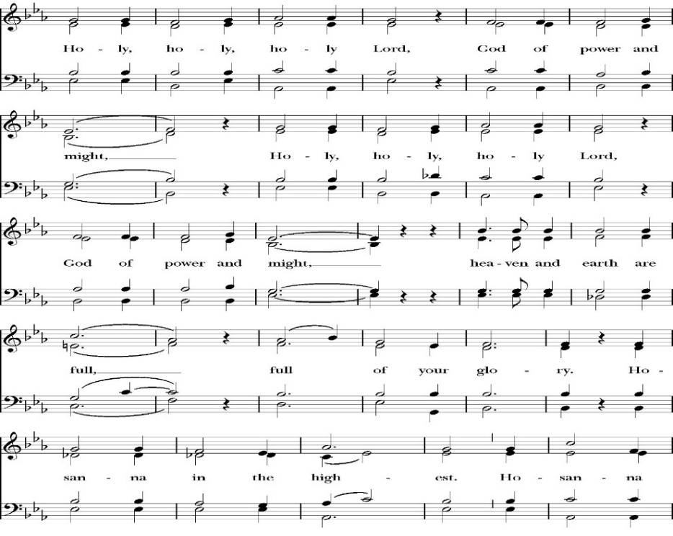
Sanctus

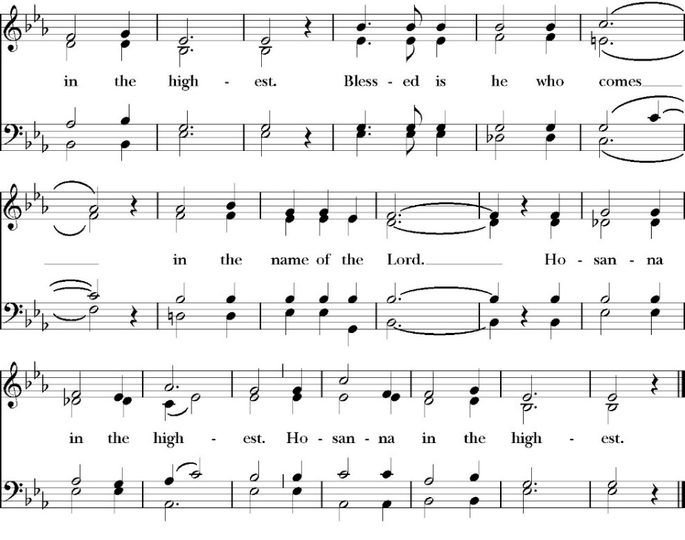
People kneel or are seated if you are unable to kneel

Holy and gracious Father: In your infinite love you made us for yourself; and when we had sinned against you and become subject to evil and death, you, in your mercy, sent your only Son Jesus Christ

into the world for our salvation. By the Holy Spirit and the Virgin Mary he became flesh and dwelt among us. In obedience to your will, he stretched out his arms upon the Cross and offered himself once for all, that by his suffering and death we might be saved. By his resurrection he broke the bonds of death, trampling Hell and Satan under his feet. As our great high priest, he ascended to your right hand in glory, that we might come with confidence before the throne of grace.

On the night that he was betrayed, our Lord Jesus Christ took bread; and when he had given thanks, he broke it,* and gave it to his disciples, saying, “Take, eat; this is my Body, which is given for you: Do this in remembrance of me.”

Likewise, after supper, Jesus took the cup, and when he had given thanks, he gave it to them, saying, “Drink this, all of you; for this is my Blood of the New Covenant, which is shed for you, and for many, for the forgiveness of sins: Whenever you drink it, do this in remembrance of me.”
Therefore we proclaim the mystery of faith:

Christ has died.
Christ is risen.
Christ will come again.

We celebrate the memorial of our redemption, O Father, in this sacrifice of praise and thanksgiving, and we offer you these gifts.

Sanctify them by your Word and Holy Spirit to be for your people the Body and Blood of your Son Jesus Christ. Sanctify us also, that we may worthily receive this holy Sacrament, and be made one body with him, that he may dwell in us and we in him. In the fullness of time, put all things in subjection under your Christ, and bring us with all your saints into the joy of your heavenly kingdom, where we shall see our Lord face to face.

All this we ask through your Son Jesus Christ: By him, and with him, and in him, in the unity of the Holy Spirit, all honor and glory is yours, Almighty Father, now and for ever. Amen

And now, as our Savior Christ has taught us, we are bold to pray,

Our Father, who art in heaven,
hallowed be thy Name,
thy kingdom come,
thy will be done,
on earth as it is in heaven.
Give us this day our daily bread.
And forgive us our trespasses,
as we forgive those
who trespass against us.
And lead us not into temptation,
but deliver us from evil.
For thine is the kingdom,
and the power, and the glory,
for ever and ever. Amen

Fraction

Celebrant Alleluia! Christ our Passover is sacrificed for us.
People Therefore let us keep the feast. Alleluia!

The Prayer for Humble Access

We do not presume to come to this your table, O merciful Lord,
trusting in our own righteousness,
but in your abundant and great mercies.
We are not worthy so much as to gather up
the crumbs under your table;
but you are the same Lord
whose character is always to have mercy.
Grant us, therefore, gracious Lord,
so to eat the flesh of your dear Son Jesus Christ,
and to drink his blood,
that our sinful bodies may be made clean by his body,
and our souls washed through his most precious blood,
and that we may evermore dwell in him, and he in us.
Amen

Agnus Dei

The Ministration of Communion

The gifts of God for the People of God. Take them in remembrance that Christ died for you and feed on him in your hearts by faith, with thanksgiving.

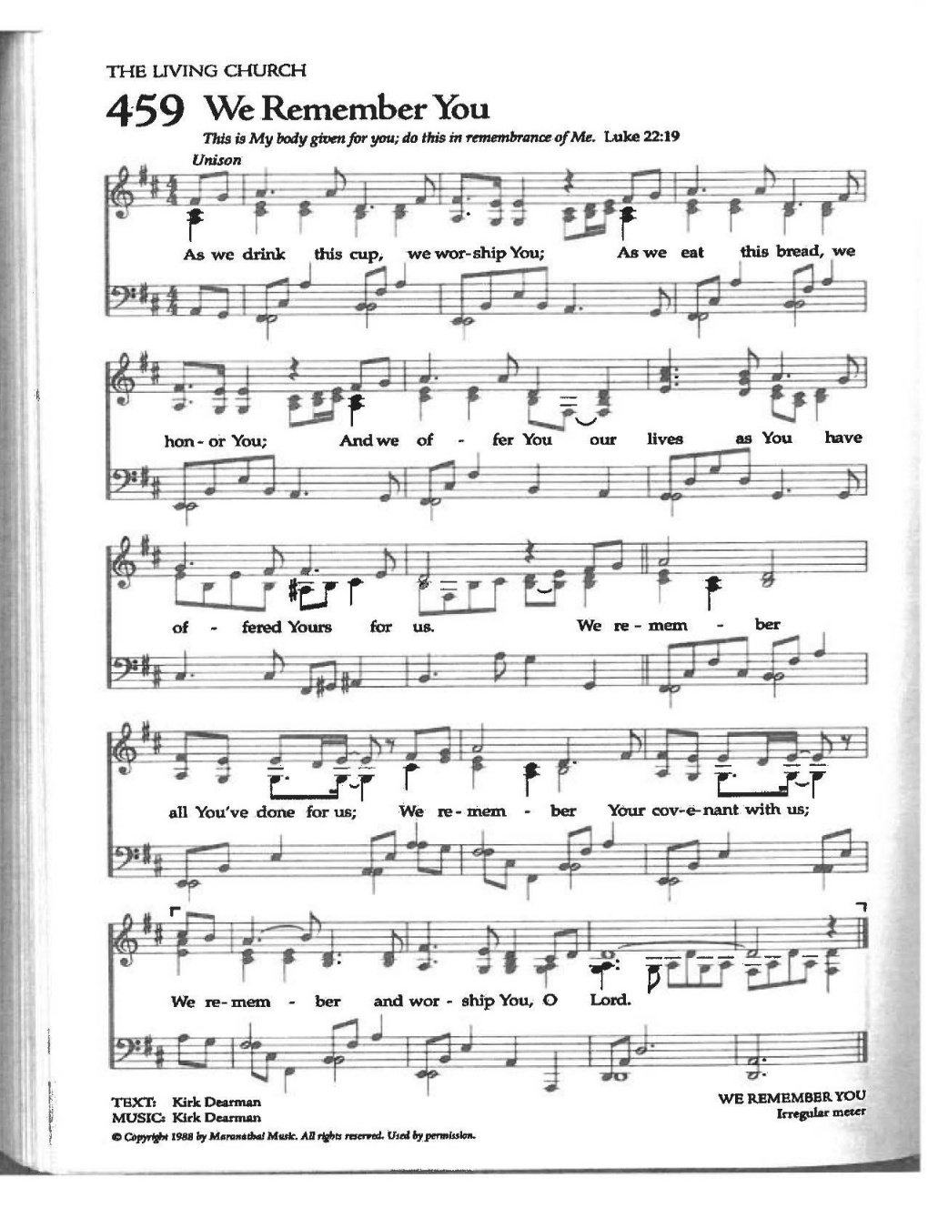
Communion Hymn: We Remember You
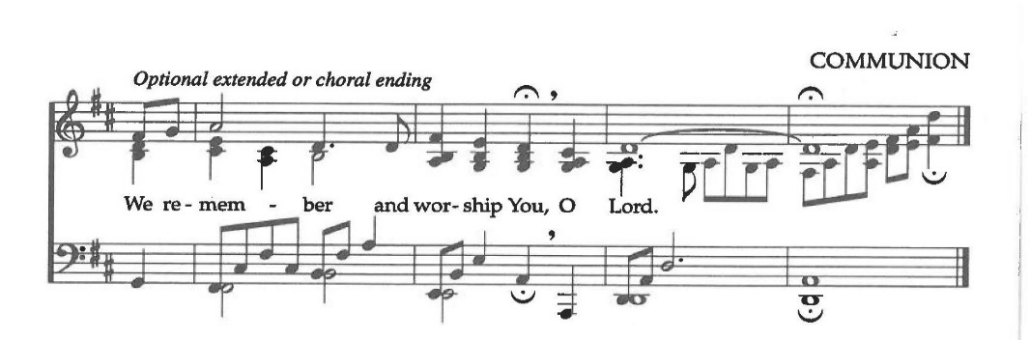
The Post Communion Prayer

The People kneel or are seated if you are unable to kneel

Let us pray.

Heavenly Father,
We thank you for feeding us with the spiritual food
of the most precious Body and Blood
of your Son our Savior Jesus Christ;
and for assuring us in these holy mysteries
that we are living members of the body of your Son,
and heirs of your eternal Kingdom.
And now, Father, send us out to do the work you have
given us to do,
to love and serve you as faithful witnesses of Christ our
Lord.
To him, to you, and to the Holy Spirit,
be honor and glory, now and for ever. Amen.

The Blessing

The peace of God, which passes all understanding, keep your hearts and minds in the knowledge and love of God, and of his Son Jesus Christ our Lord; and the blessing of God Almighty, the Father, the Son, and the Holy Spirit, be among you, and remain with you always. Amen.

Closing Hymn: Lift High the Cross

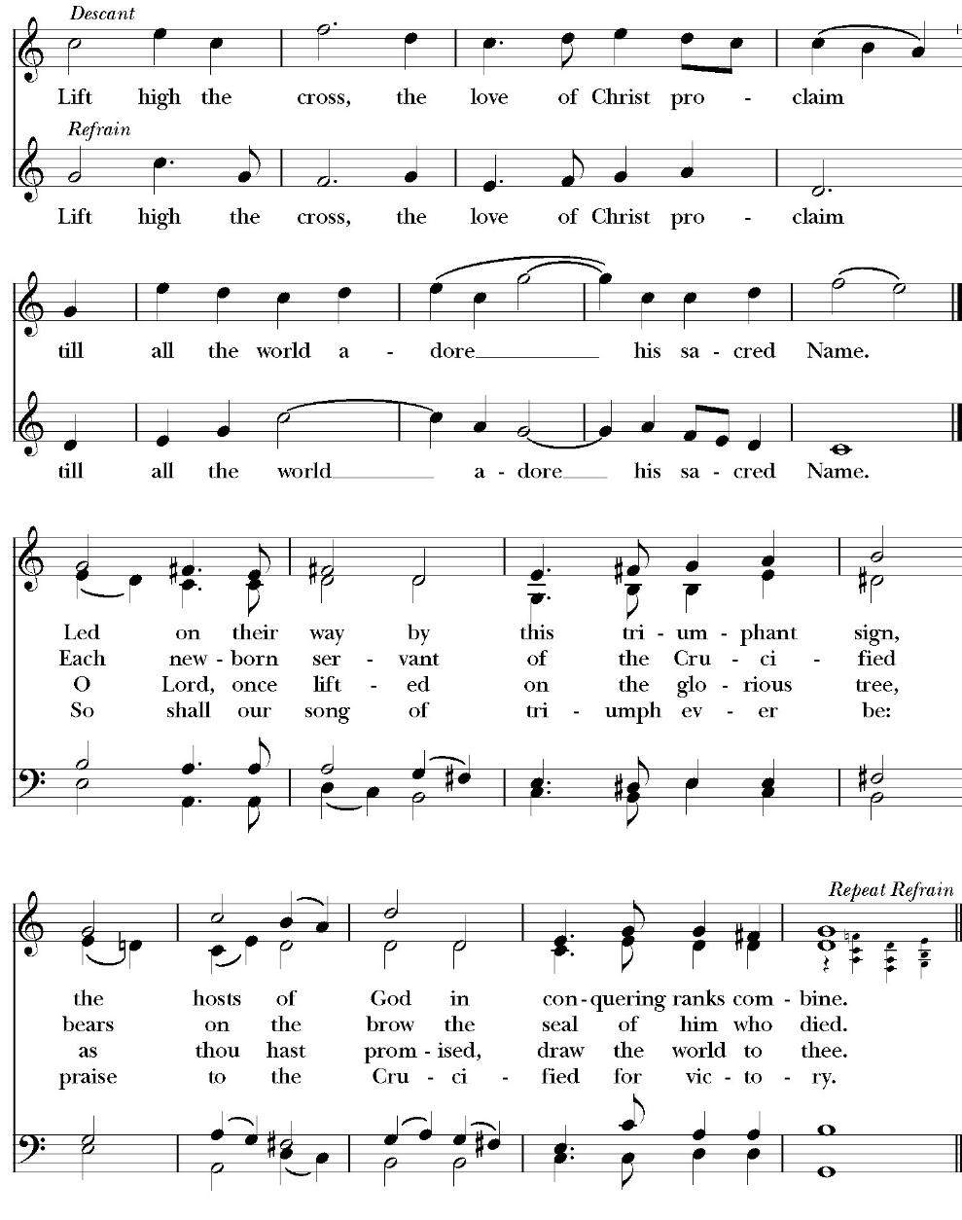

Deacon Alleluia, Alleluia! Let us go forth in the name of Christ.
People Thanks be to God. Alleluia! Alleluia!

St. Paul’s Parish Calendar
Sunday September 7 – Sunday September 14

SUNDAY, September 7 – Thirteenth Sunday after Pentecost
9:30 AM Choir Practice, Music Room
10:30 AM Children’s Sunday School, (Pre-K – 6th Grade)
10:30 AM Holy Eucharist, Church

MONDAY, September 8
6:30 PM Women’ s Bible Study, Conference Room

TUESDAY, September 9
6:00 PM Bell Choir Rehearsal, Music Room
6:00 PM Vestry, Conference Room

WEDNESDAY, September 10
9:30 AM Holy Eucharist, Chapel
10:15 AM Bible Study, Conference Room
7:00 PM Choir Rehearsal, Music Room

THURSDAY, September 11

FRIDAY, September 12
6:30 AM Men’s Bible Study, Valhalla Restaurant

SATURDAY, September 13

SUNDAY, September 14 – Fourteenth Sunday after Pentecost
9:15 AM Sunday Morning Class, Conference Room
10:30 AM Children’s Sunday School, (Pre-K – 6th Grade)
10:30 AM Holy Eucharist, Church

Church Office Hours
Monday-Thursday 8:00 AM-4:00 PM

Announcements

Vocal Choir Rehearsals Wednesday at 7:00 PM
Music Room & Chapel
The St. Paul’s vocal choir is beginning, and we want to add your voice to the choir. We will be present in church beginning Sunday, September 7. Our Choir Director, Cyndi Culp, would love to talk with you about choir and soloist opportunities on Sunday mornings. Please join us at our first vocal choir rehearsal of the year and learn more about musical opportunities for singers of all levels in choir and the church.

Operation Christmas Child, Coordinator: Mark Morales
Operation Christmas Child is a ministry of Samaritan’s Purse in which local churches help fill special shoe boxes with toiletries and a small Christmas gift for needy children around the world. Shoe boxes with supplies and gifts need to be completed in September so to get in the hands of needy children by Christmas. Our Operation Christmas Child outreach coordinator is Mark Morales. He will be making announcements in church and is available to answer any questions on Sunday mornings at church.

Sunday Morning Class, Conference Room
The Lord and His Prayer
Sundays, September 14 through October 26
9:15-10:00AM

“If we are serious about our Christian commitment, we will want to grow in prayer.” NT Wright, The Lord and His Prayer, page 1

“Prayer is the only entryway into genuine self-knowledge. It is also the main way we experience deep change-the reordering of our loves.” Tim Keller, Prayer, page 18

What is Prayer? Prayer is the turning of my heart toward God, to listen and to speak with him” To Be a Christian: An Anglican Catechism, page 66

This fall our Sunday morning class will be on The Lord’s prayer as a model for a life of prayer for all Christians. All Christians are given the spiritual gift of prayer upon our baptism. It is at the heart of our relationship with God. Yet many Christians feel that they do not know how to pray or what benefits it offers other than asking God for help. Prayer is much more than just asking God to intervene in our lives, it is an avenue of true change within us and within the world around us.

Our Sunday morning class will explore the Lord’s Prayer as a primer for growing in prayer in our Christian life. This opportunity to explore the Lord’s prayer is open to all members of the congregation and is beneficial to those who are just learning to use prayer at a deeper level and for those who have a meaningful prayer life. We will be using three resources for this class: The Anglican Catechism: The Lord’s Prayer and the Christian Life, Tim Keller’s book Prayer: Experiencing Awe and intimacy with God and NT Wright’s, The Lord And His Prayer.

Our Expected Schedule

September 14 Introduction: Prayer and The Lord’s Prayer: Turning our hearts toward God
September 21 Our Father, who art in heaven. Hallowed be thy name.
September 28 Thy kingdom come, thy will be done on earth as it is in heaven.
October 5 Give us this day our daily bread

October 12 Forgive us our trespasses as we forgive those who trespass against us
October 19 Lead us not into temptation and deliver us from evil
October 26 For thine is the Kingdom, the power and glory, forever and ever. Amen.

Praise Music Team Forming
St. Paul’s uses a variety of Chrisitan music genres in our Sunday worship and mid-week programs. We are looking to form a team of musicians and vocalist who love to sing and play more contemporary forms of Christian with our worship and programs. If you love to sing or play an instrument, please reach out to our praise music team leader Kevin Robinson. Kevin is available on Sunday mornings or you can call or text his cell at (559) 303-7533. He would love to talk with you about being part of a new praise music team for our church.

A Food Bank for Hurley Families
The next Neighborhood Market to benefit students at Hurley School will be Wednesday September 17 from 2:30 to 4:00 at St Paul’s Church parking lot. If you are interested in helping that day, please contact Sue Nyberg. My home phone number is 559-733-8244. Since we packed so much food the first time, we will NOT have a packing day this time around.

PROVIDED BY VISALIA EMERGENCY AID
AND ST. PAUL’S CHURCH
Wednesday September 17, 2025
From 2:30 to 4:00
LOCATION:
ST. PAUL'S CHURCH PARKING LOT
ACROSS THE STREET FROM HURLEY






ST. PAUL'S ANGLICAN CHURCH
"WHERE GOD BUILD'S THINGS"
-

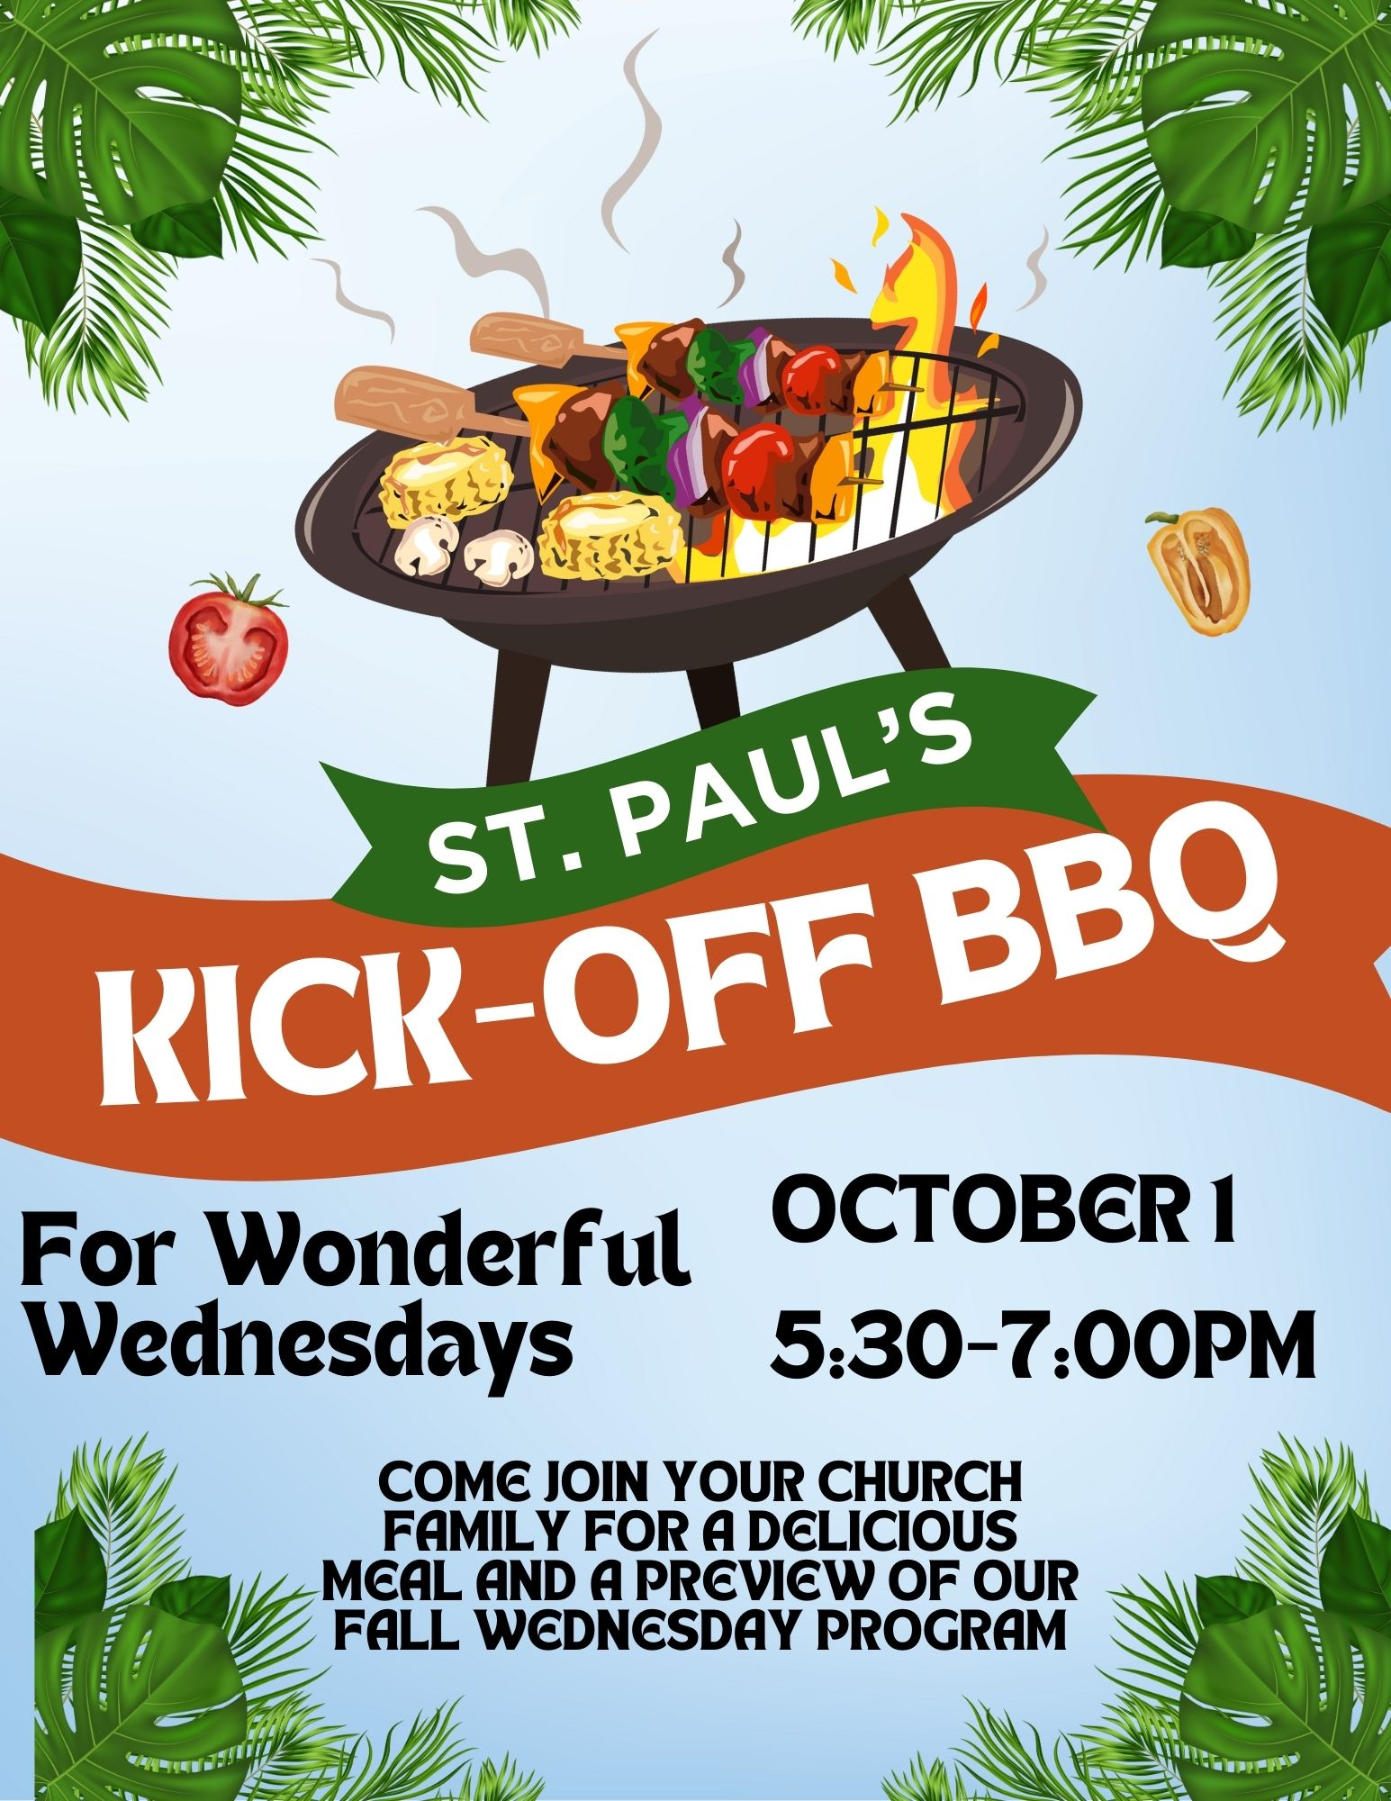

St. Paul’s Anglican Church
Parish Office
6436 W. Hurley Ave
Visalia, California 93291
559-732-4821
Office Hours: 8:00 – 4:00
Monday – Thursday

Worship: Sundays at 10:30AM
In person: St. Paul’s Anglican Church
Livestream: Link at spvisalia.com
and on our Facebook page
Please be advised that this service is being recorded for broadcast
and/or archival purposes. By attending, you consent
to the inclusion of your likeness in these recordings.

St. Paul’s Clergy and Staff
The Rev. Robert Longbottom, Rector
rector@spvisalia.com
(559)802-2928
The Rev. John Iseman, Pastoral Associate for Family Ministries
family@spvisalia.com
Antoinette Horsting, Parish Administrator
bookkeeper@spvisalia.com
Marguerite Crownover, Organist and Accompanist
Cynthia Culp, Choral Director
Jackie Iseman, Nursery Coordinator
Shane Motl, Sexton

Next Week’s Lessons
Exodus 32:17-14
Psalm 51:1-17
1 Timothy 1:12-17
Luke 15:1-10

The Altar Flowers
The flowers at the altar are given to the Glory of God,
by Maria Round, in thanksgiving for family.

