ST. PAUL’S
ANGLICAN CHURCH
VISALIA, CALIFORNIA

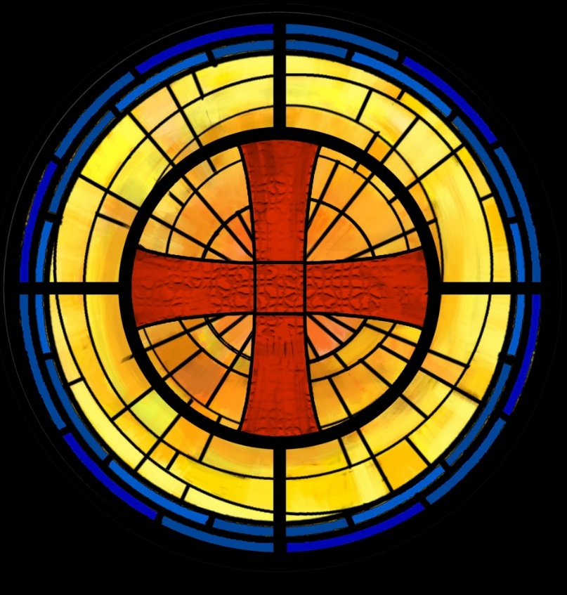

Fourteenth Sunday after Pentecost
September 14, 2025
10:30 A.M

Welcome!

St. Paul’s Anglican Church extends a warm welcome to all visitors and newcomers, whether worshiping in person or at home via livestream.

Visitors’ Guide

St. Paul’s Church is a parish in the Diocese of San Joaquin of the Anglican Church in North America, which includes both Catholic and Protestant traditions. We accept Jesus Christ as Savior, and we promise to follow him as Lord. We believe in One God,

- the Father who created us and all things,
- the Son who redeems us from sin and death,
- the Holy Spirit who renews and sanctifies us.

We believe the Holy Scriptures to be the Word of God and to contain all things necessary for salvation, and we accept the Apostles’ and Nicene Creeds as essential beliefs of the Christian faith.

All followers of Jesus who are baptized in the name of the Trinity are invited to receive Holy Communion. If for whatever reason you feel you cannot receive communion, we invite you to come forward to receive a blessing. Please indicate you’d like a blessing by crossing your arms. All people are welcome at the Altar of the Lord.

Visitors are invited to sign the guest book at the entrance table and introduce themselves to the clergy following the service.

The Holy Eucharist

Prelude: “Chromatic Fugue and Fantasia” Pachelbel
Opening Hymn: #423 – “Immortal, Invisible, God only Wise” p. 4
Opening Acclamation p. 5
The Collect for Purity p. 5
Summary of the Law p. 5
Kyrie p. 5
Gloria p. 6
Collect of the Day p. 7
Lesson: Exodus 32 :1,-14 p. 7
Gradual: Psalm 51 :1-17 p. 8
Epistle: 1 Timothy 1:12-17 p. 9
Sequence Hymn: #470 – “There’s a Wideness in God’s Mercy” p. 10
Gospel: Luke 15:1-10 p. 11
Sermon: The Rev. Robert Longbottom
Nicene Creed p. 12
Prayers of the People p. 13
The Peace p. 15
Offertory: “10,000 Reasons” Choir
The Offertory p. 16
Sursum Corda p. 16
Sanctus p. 17
The Lord’s Prayer p. 19
Fraction p. 20
Prayer for Humble Access p. 20
Agnus Dei p. 20
Communion Praise Song Hymn: - “Wonderful Merciful Savior” p. 21
Post Communion Prayer p. 22
Blessing p. 22
Closing Hymn: #488 – “O Love, How Deep” p. 23
Dismissal p. 23
Postlude: “Processional in G Major” Stanley

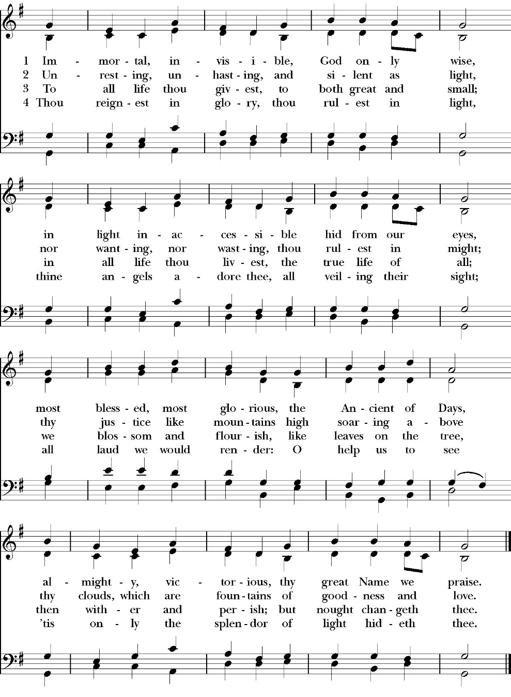
Opening Hymn: Immortal, Invisible, God only Wise

Opening Acclamation

Celebrant Blessed be God: the Father, the Son, and the Holy Spirit. People And blessed be his kingdom, now and for ever.
Amen.

Collect for Purity

People: Almighty God, to you all hearts are open, all desires
known, and from you no secrets are hid: Cleanse the thoughts of our hearts by the inspiration of your Holy Spirit, that we may perfectly love you, and worthily magnify your holy Name; through Christ our Lord. Amen.

Summary of the law

Celebrant: Hear what our Lord Jesus Christ says: You shall love the Lord your God with all your heart and with all your soul
and with all your mind. This is the first and great commandment. And the second is like it: You shall love your neighbor as yourself. On these two commandments depend all the Law and the Prophets.

The Kyrie

Gloria

Celebrant The Lord be with you.
People And with your spirit.
Celebrant Let us pray.

The Collect of the Day
O God, because without you we are not able to please you, mercifully grant that your Holy Spirit may in all things direct and rule our hearts; through Jesus Christ our Lord, who lives and reigns with you and the Holy Spirit, one God, now and forever. Amen.

Lesson: Exodus 32:1,7-14
When the people saw that Moses delayed to come down from the mountain, the people gathered themselves together to Aaron and said to him, “Up, make us gods who shall go before us. As for this Moses, the man who brought us up out of the land of Egypt, we do not know what has become of him.”

7 And the LORD said to Moses, “Go down, for your people, whom you brought up out of the land of Egypt, have corrupted themselves. 8 They have turned aside quickly out of the way that I commanded them. They have made for themselves a golden calf and have worshiped it and sacrificed to it and said, ‘These are your gods, O Israel, who brought you up out of the land of Egypt!’” 9 And the LORD said to Moses, “I have seen this people, and behold, it is a stiff-necked people. 10 Now therefore let me alone, that my wrath may burn hot against them and I may consume them, in order that I may make a great nation of you.”

11 But Moses implored the LORD his God and said, “O LORD, why does your wrath burn hot against your people, whom you have brought out of the land of Egypt with great power and with a mighty hand? 12 Why should the Egyptians say, ‘With evil intent did he bring them out, to kill them in the mountains and to consume them from the face of the earth’? Turn from your burning anger and relent from this disaster against your people. 13 Remember Abraham, Isaac, and Israel, your servants, to whom you swore by your own self, and said to them, ‘I will multiply your offspring as the stars of heaven, and all this land that I have promised I will give to your offspring, and they shall inherit it forever.’” 14 And the LORD relented from the disaster that he had spoken of bringing on his people.
Reader: The Word of the Lord
People: Thanks be to God

Gradual: Psalm 51:1-17
1 Have mercy upon me, O God, in your great goodness; *
according to the multitude of your mercies wipe away my offences.
2 Wash me thoroughly from my wickedness *
and cleanse me from my sin.
3 For I acknowledge my faults, *
and my sin is ever before me.
4 Against you only have I sinned, and done this evil in your sight, * so that you are justified in your sentence, and blameless in your judgment.
5 Behold, I was brought forth in wickedness, *
and in sin my mother conceived me.
6 But behold, you desire truth in the inward parts *
and shall make me understand wisdom secretly.
7 You shall purge me with hyssop, and I shall be clean; *
you shall wash me, and I shall be whiter than snow.
8 You shall make me hear of joy and gladness, *
that the bones which you have broken may rejoice.
9 Turn your face from my sins, *
and blot out all my misdeeds.
10 Create in me a clean heart, O God, *
and renew a right spirit within me.
11 Cast me not away from your presence, *
and take not your holy Spirit from me.
12 O give me the comfort of your help again, *
and sustain me with your willing Spirit.
13 Then shall I teach your ways unto the wicked, *
and sinners shall return unto you.
14 Deliver me from blood-guilt, O God, the God of my salvation, * and my tongue shall sing of your righteousness.
15 O Lord, open my lips, *
and my mouth shall show forth your praise.
16 For you desire no sacrifice, or else I would give it to you; *
but you delight not in burnt-offerings.

17 The sacrifice of God is a troubled spirit; *
a broken and contrite heart, O God, you shall not despise.

Glory be to the Father, and to the Son, and to the Holy Spirit;
as it was in the beginning, is now, and ever shall be, world without end. Amen

Epistle: 1 Timothy 1:12-17
I thank him who has given me strength, Christ Jesus our Lord, because he judged me faithful, appointing me to his service, 13 though formerly I was a blasphemer, persecutor, and insolent opponent. But I received mercy because I had acted ignorantly in unbelief, 14 and the grace of our Lord overflowed for me with the faith and love that are in Christ Jesus. 15 The saying is trustworthy and deserving of full acceptance, that Christ Jesus came into the world to save sinners, of whom I am the foremost. 16 But I received mercy for this reason, that in me, as the foremost, Jesus Christ might display his perfect patience as an example to those who were to believe in him for eternal life. 17 To the King of the ages, immortal, invisible, the only God, be honor and glory forever and ever. Amen.

Reader: The Word of the Lord
People: Thanks be to God

Sequence There’s a Wideness in God’s Mercy
(Verse 1-2 before Gospel verse 3 after)
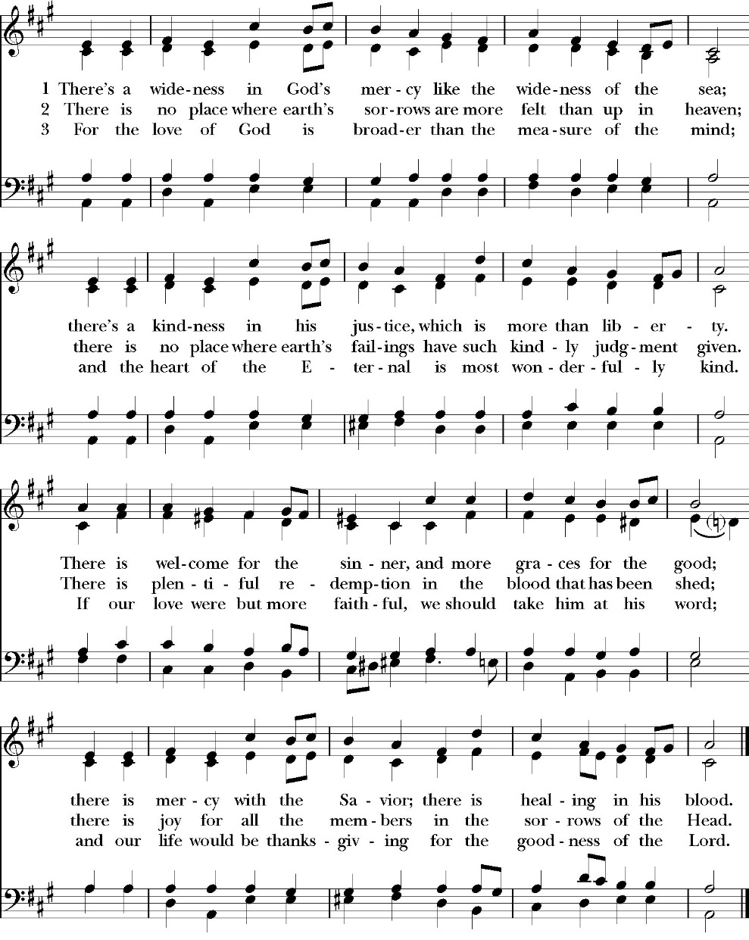

Clergy: The Holy Gospel of Our Lord Jesus Christ,
according to St. Luke
People: Glory to you, Lord God

Gospel: Luke 15:1-10
Now the tax collectors and sinners were all drawing near to hear him. 2 And the Pharisees and the scribes grumbled, saying, “This man receives sinners and eats with them.”

3 So he told them this parable: 4 “What man of you, having a hundred sheep, if he has lost one of them, does not leave the ninety-nine in the open country, and go after the one that is lost, until he finds it? 5 And when he has found it, he lays it on his shoulders, rejoicing. 6 And when he comes home, he calls together his friends and his neighbors, saying to them, ‘Rejoice with me, for I have found my sheep that was lost.’ 7 Just so, I tell you, there will be more joy in heaven over one sinner who repents than over ninety-nine righteous persons who need no repentance.

8 “Or what woman, having ten silver coins, if she loses one coin, does not light a lamp and sweep the house and seek diligently until she finds it? 9 And when she has found it, she calls together her friends and neighbors, saying, ‘Rejoice with me, for I have found the coin that I had lost.’ 10 Just so, I tell you, there is joy before the angels of God over one sinner who repents

Clergy: The Gospel of the Lord
People: Praise to you, Lord Christ

Sermon
The Rev. Robert longbottom

The Nicene Creed

The people stand

We believe in one God,
the Father, the Almighty,
maker of heaven and earth,
of all that is, visible and invisible.

We believe in one Lord, Jesus Christ,
the only-begotten Son of God,
eternally begotten of the Father,
God from God, Light from Light,
true God from true God,
begotten, not made,
of one Being with the Father.
through him all things were made.
For us and for our salvation he came down from heaven:
was incarnate from the Holy Spirit and the Virgin Mary,
and was made man.
For our sake he was crucified under Pontius Pilate;
he suffered death and was buried.
On the third day he rose again in accordance with the
Scriptures;
he ascended into heaven
and is seated at the right hand of the Father.
He will come again in glory to judge the living and the dead,
and his kingdom will have no end.
We believe in the Holy Spirit, the Lord, the giver of life,
who proceeds from the Father and the Son,
who with the Father and the Son is worshiped and glorified.
who has spoken through the Prophets.
We believe in one holy catholic and apostolic Church.
We acknowledge one Baptism for the forgiveness of sins.
We look for the resurrection of the dead,
and the life of the world to come. Amen.

The Prayers of the People
The People kneel or are seated if unable to kneel
The Deacon or other person appointed says these prayers. reader pauses after each bidding, and the people may add petitions, either silently or aloud.
Let us pray for the Church and for the world, saying,
“Hear our prayer.”

For the peace of the whole world, and for the well-being and unity of the people of God.

Reader Lord, in your mercy:
People Hear our prayer.

For Stephen, our Archbishop, and Eric, our Bishop, and for all the clergy and people of our Diocese and Congregation.

Reader Lord, in your mercy:
People Hear our prayer.

For all those who proclaim the Gospel at home and abroad; and for all who teach and disciple others.

Reader Lord, in your mercy:
People Hear our prayer.

For our brothers and sisters in Christ who are persecuted for their faith.
Reader Lord, in your mercy:
People Hear our prayer.

For our nation, for those in authority, and for all in public service especially Donald our President and Gavin our Governor.

Reader Lord, in your mercy:
People Hear our prayer.

In the St. Paul’s cycle of prayer, we pray for our Sunday morning worship and welcoming ministries. We pray for the Altar Guild, our Lay Eucharistic Ministers, our Lectors, and our Acolytes. We pray for our music ministry and the musicians and vocalists. We pray for our ushers, greeters, and prayer table ministries.

Reader Lord, in your mercy:
People Hear our prayer.

In the ACNA Cycle of Prayer, today we pray for the Anglican Province of Nigeria and The Most Rev. Henry Ndukuba, Metropolitan and Primate of All Nigeria, and his wife, Angela.

Reader Lord, in your mercy:
People Hear our prayer.

For all those who are in trouble, sorrow, need, sickness, or any other adversity [especially _____________].

Reader Lord, in your mercy:
People Hear our prayer.

For all those who have departed this life in the certain hope of the resurrection, [especially ______,] in thanksgiving let us pray.

Reader Lord, in your mercy:
People Hear our prayer.

The Celebrant concludes with this or some other appropriate Collect.
Heavenly Father, grant these our prayers for the sake of Jesus Christ, our only Mediator and Advocate, who lives and reigns with you in the unity of the Holy Spirit, one God, now and for ever. Amen.

The Confession and Absolution

Deacon Let us humbly confess our sins to Almighty God.

Most merciful God,
we confess that we have sinned against you
in thought, word and deed,
by what we have done, and by what we have left undone.
We have not loved you with our whole heart;
we have not loved our neighbors as ourselves.
We are truly sorry and we humbly repent.
For the sake of your Son Jesus Christ,
have mercy on us and forgive us;
that we may delight in your will, and walk in your ways,
to the glory of your Name. Amen.

Almighty God, our heavenly Father, who in his great mercy has
promised forgiveness of sins to all those who sincerely repent and
with true faith turn to him, have mercy upon you, pardon and deliver
you from all your sins, confirm and strengthen you in all goodness,
and bring you to everlasting life; through Jesus Christ our Lord.
Amen.

Hear the Word of God to all who truly turn to him.

Come to me, all who labor and are heavy laden, and I will give
you rest. -Matthew 11:28

God so loved the world, that he gave his only-begotten Son, that
whoever believes in him should not perish but have eternal life.
-John 3:16t

The Peace
Celebrant The Peace of the Lord be always with you.
People And with your spirit.

Offertory Anthem
10,000 Reasons (Bless the Lord)
Words & Music by Jonas Myrin & Matt Redman
Choral Setting by Lloyd Larson
The Doxology
(Verse 3 only)

Offertory

Celebrant All things come from you, O Lord,
People And of your own have we given you.

The Eucharistic Liturgy

Celebrant The Lord be with you.
People And with your spirit.
Celebrant Lift up your hearts.
People We lift them up to the Lord.
Celebrant Let us give thanks to the Lord our God.
People It is right to give him thanks and praise.

It is right, our duty and our joy, always and everywhere to give thanks to you, Father Almighty, Creator of heaven and earth.
Through Jesus Christ our Lord, who on the first day of the week overcame death and the grave, and by his glorious resurrection opened to us the way of everlasting life.

Therefore, we praise you, joining our voices with Angels and Archangels and with all the company of heaven, who for ever sing this hymn to proclaim the glory of your Name:

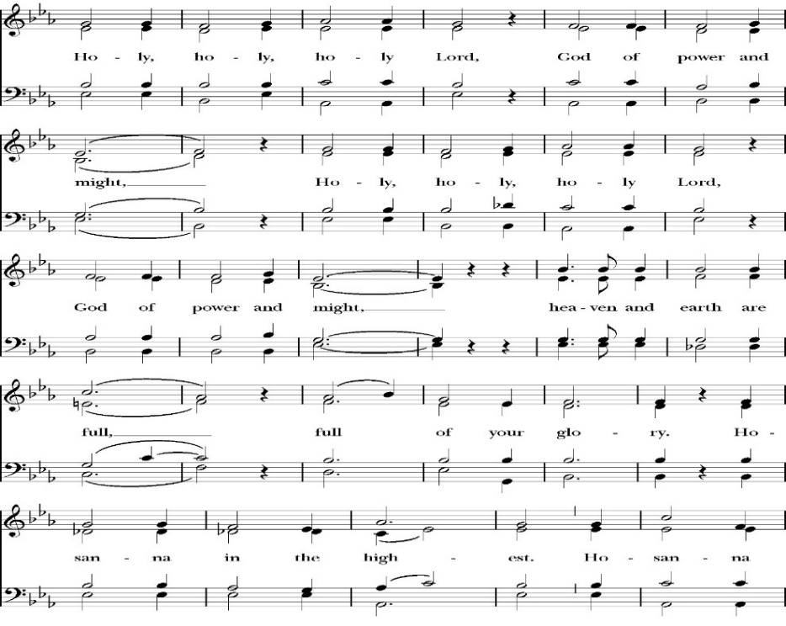
Sanctus

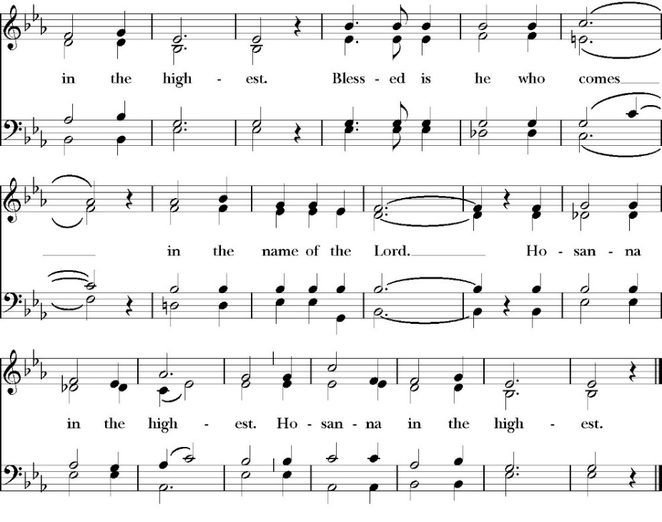
People kneel or are seated if unable to kneel

Holy and gracious Father: In your infinite love you made us for yourself; and when we had sinned against you and become subject to evil and death, you, in your mercy, sent your only Son Jesus Christ
into the world for our salvation. By the Holy Spirit and the Virgin Mary he became flesh and dwelt among us. In obedience to your will, he stretched out his arms upon the Cross and offered himself once for all, that by his suffering and death we might be saved. By his resurrection he broke the bonds of death, trampling Hell and Satan under his feet. As our great high priest, he ascended to your right hand in glory, that we might come with confidence before the throne of grace.

On the night that he was betrayed, our Lord Jesus Christ took bread; and when he had given thanks, he broke it,* and gave it to his disciples, saying, “Take, eat; this is my Body, which is given for you: Do this in remembrance of me.”

Likewise, after supper, Jesus took the cup, and when he had given thanks, he gave it to them, saying, “Drink this, all of you; for this is my Blood of the New Covenant, which is shed for you, and for many, for the forgiveness of sins: Whenever you drink it, do this in remembrance of me.”
Therefore we proclaim the mystery of faith:

Christ has died.
Christ is risen.
Christ will come again.

We celebrate the memorial of our redemption, O Father, in this sacrifice of praise and thanksgiving, and we offer you these gifts.

Sanctify them by your Word and Holy Spirit to be for your people the Body and Blood of your Son Jesus Christ. Sanctify us also, that we may worthily receive this holy Sacrament, and be made one body with him, that he may dwell in us and we in him. In the fullness of time, put all things in subjection under your Christ, and bring us with all your saints into the joy of your heavenly kingdom, where we shall see our Lord face to face.

All this we ask through your Son Jesus Christ: By him, and with him, and in him, in the unity of the Holy Spirit, all honor and glory is yours, Almighty Father, now and for ever. Amen

And now, as our Savior Christ has taught us, we are bold to pray,

Our Father, who art in heaven,
hallowed be thy Name,
thy kingdom come,
thy will be done,
on earth as it is in heaven.
Give us this day our daily bread.
And forgive us our trespasses,
as we forgive those
who trespass against us.
And lead us not into temptation,
but deliver us from evil.
For thine is the kingdom,
and the power, and the glory,
for ever and ever. Amen

Fraction
Celebrant Alleluia! Christ our Passover is sacrificed for us.
People Therefore let us keep the feast. Alleluia!

The Prayer for Humble Access

We do not presume to come to this your table, O merciful Lord,
trusting in our own righteousness,
but in your abundant and great mercies.
We are not worthy so much as to gather up
the crumbs under your table;
but you are the same Lord
whose character is always to have mercy.
Grant us, therefore, gracious Lord,
so to eat the flesh of your dear Son Jesus Christ,
and to drink his blood,
that our sinful bodies may be made clean by his body,
and our souls washed through his most precious blood,
and that we may evermore dwell in him, and he in us.
Amen

Agnus Dei

The Ministration of Communion

The gifts of God for the People of God. Take them in remembrance that Christ died for you and feed on him in your hearts by faith, with thanksgiving.

Communion Praise Hymn: Wonderful Merciful Savior
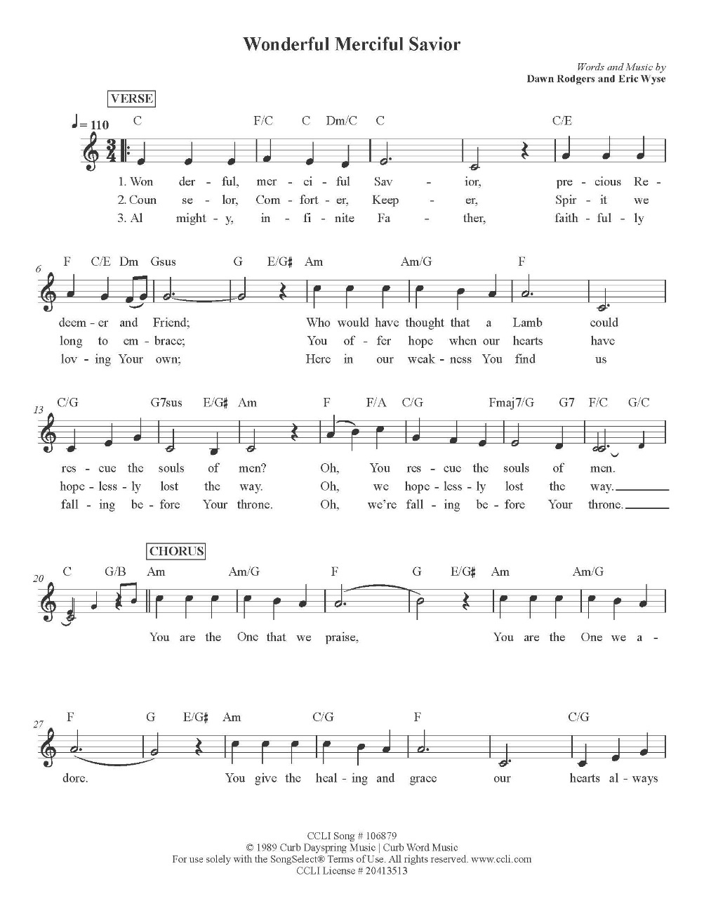

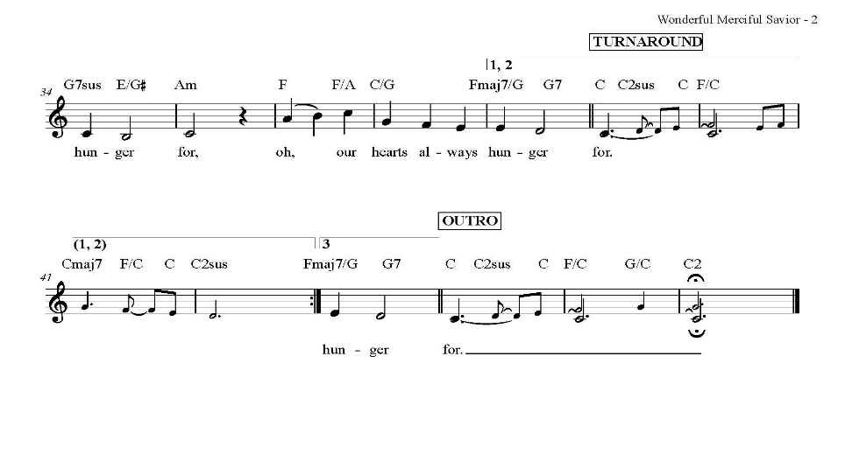
The Post Communion Prayer

The People kneel or are seated if unable to kneel

Let us pray.

Heavenly Father,
We thank you for feeding us with the spiritual food
of the most precious Body and Blood
of your Son our Savior Jesus Christ;
and for assuring us in these holy mysteries
that we are living members of the body of your Son,
and heirs of your eternal Kingdom.
And now, Father, send us out to do the work you have
given us to do,
to love and serve you as faithful witnesses of Christ our
Lord.
To him, to you, and to the Holy Spirit,
be honor and glory, now and for ever. Amen.

The Blessing

The peace of God, which passes all understanding, keep your hearts and minds in the knowledge and love of God, and of his Son Jesus Christ our Lord; and the blessing of God Almighty, the Father, the Son, and the Holy Spirit, be among you, and remain with you always. Amen.
Closing Hymn: O Love, How Deep

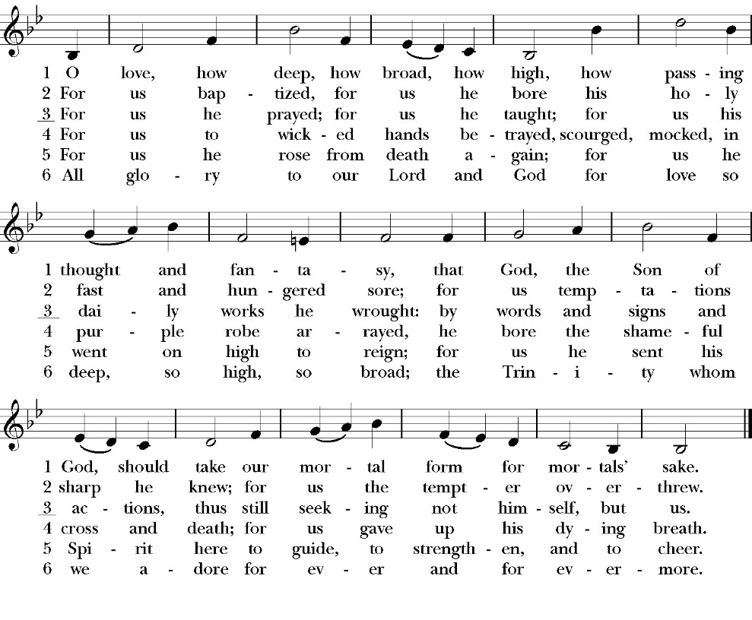

Deacon Alleluia, Alleluia! Let us go forth in the name of Christ.
People Thanks be to God. Alleluia! Alleluia!

St. Paul’s Parish Calendar
Sunday September 14 – Sunday September 21

SUNDAY, September 14 – Fourteenth Sunday after Pentecost
9:15 AM Sunday Morning Class, Conference Room
9:30 AM Choir Practice, Music Room
10:30 AM Children’s Sunday School, (Pre-K – 6th Grade)
10:30 AM Holy Eucharist, Church

MONDAY, September 15

TUESDAY, September 16
6:00 PM Bell Choir Rehearsal, Music Room

WEDNESDAY, September 17
9:30 AM Holy Eucharist, Chapel
10:15 AM Bible Study, Conference Room
2:30 to 4:00 Food Bank for Hurley School, Church Parking Lot
7:00 PM Choir Rehearsal, Music Room

THURSDAY, September 18

FRIDAY, September 19
6:30 AM Men’s Bible Study, Valhalla Restaurant

SATURDAY, September 20

SUNDAY, September 21 – Fifteenth Sunday after Pentecost
9:15 AM Sunday Morning Class, Conference Room
9:30 AM Choir Practice, Music Room
10:30 AM Children’s Sunday School, (Pre-K – 6th Grade)
10:30 AM Holy Eucharist, Church

Church Office Hours
Monday-Thursday 8:00 AM-4:00 PM

Announcements

Operation Christmas Child. Coordinator: Mark Morales
Operation Christmas Child is a ministry of Samaritan’s Purse in which local churches help fill special shoe boxes with toiletries and a small Christmas gift for needy children around the world. Shoe boxes with supplies and gifts need to be completed in September so to get in the hands of needy children by Christmas. Our Operation Christmas Child outreach coordinator is Mark Morales. He will be making announcements in church and is available to answer any questions on Sunday mornings at church.

Sunday Morning Class, Conference Room
The Lord and His Prayer
Sundays, September 14 through October 26
9:15-10:00AM

“If we are serious about our Christian commitment, we will want to grow in prayer.” NT Wright, The Lord and His Prayer, page 1

“Prayer is the only entryway into genuine self-knowledge. It is also the main way we experience deep change-the reordering of our loves.” Tim Keller, Prayer, page 18

“What is Prayer? Prayer is the turning of my heart toward God, to listen and to speak with him.” To Be a Christian: An Anglican Catechism, page 66

This fall our Sunday morning class will be on The Lord’s prayer as a model for a life of prayer for all Christians. All Christians are given the spiritual gift of prayer upon our baptism. It is at the heart of our relationship with God. Yet many Christians feel that they do not know how to pray or what benefits it offers other than asking God for help. Prayer is much more than just asking God to intervene in our lives, it is an avenue of true change within us and within the world around us.

Our Sunday morning class will explore the Lord’s Prayer as a primer for growing in prayer in our Christian life. This opportunity to explore the Lord’s prayer is open to all members of the congregation and is beneficial to those who are just learning to use prayer at a deeper level and for those who have a meaningful prayer life. We will be using three resources for this class: The Anglican Catechism: The Lord’s Prayer and the Christian Life; Tim Keller’s book Prayer: Experiencing Awe and intimacy with God; and NT Wright’s, The Lord and His Prayer.

Our Expected Schedule

September 21 Our Father, who art in heaven. Hallowed be thy name.
September 28 Thy kingdom come, thy will be done on earth as it is in heaven.
October 5 Give us this day our daily bread

October 12 Forgive us our trespasses as we forgive those who trespass against us
October 19 Lead us not into temptation but deliver us from evil
October 26 For thine is the Kingdom, the power and glory, forever and ever. Amen.

Praise Music Team Forming
St. Paul’s uses a variety of Christian music genres in our Sunday worship and mid-week programs. We are looking to form a team of musicians and vocalists who love to sing and play more contemporary forms of Christian music for our worship and other programs. If you love to sing or play an instrument, please reach out to our praise music team leader, Kevin Robinson. Kevin is available on Sunday mornings or you can call or text his cell at (559) 303-7533. He would love to talk with you about being part of a new praise music team for our church.

A Food Bank for Hurley Families
The next Neighborhood Market to benefit students at Hurley School will be Wednesday September 17 from 2:30 to 4:00 at St Paul’s Church parking lot. If you are interested in helping that day, please contact Sue Nyberg. My home phone number is 559-733-8244. Since we packed so much food the first time, we will NOT have a packing day this time around.

PROVIDED BY VISALIA EMERGENCY AID
AND ST. PAUL’S CHURCH
Wednesday, September 17, 2025
From 2:30 to 4:00
LOCATION:
ST. PAUL'S CHURCH PARKING LOT
ACROSS THE STREET FROM HURLEY






ST. PAUL'S ANGLICAN CHURCH
"WHERE GOD BUILDS THINGS"
-

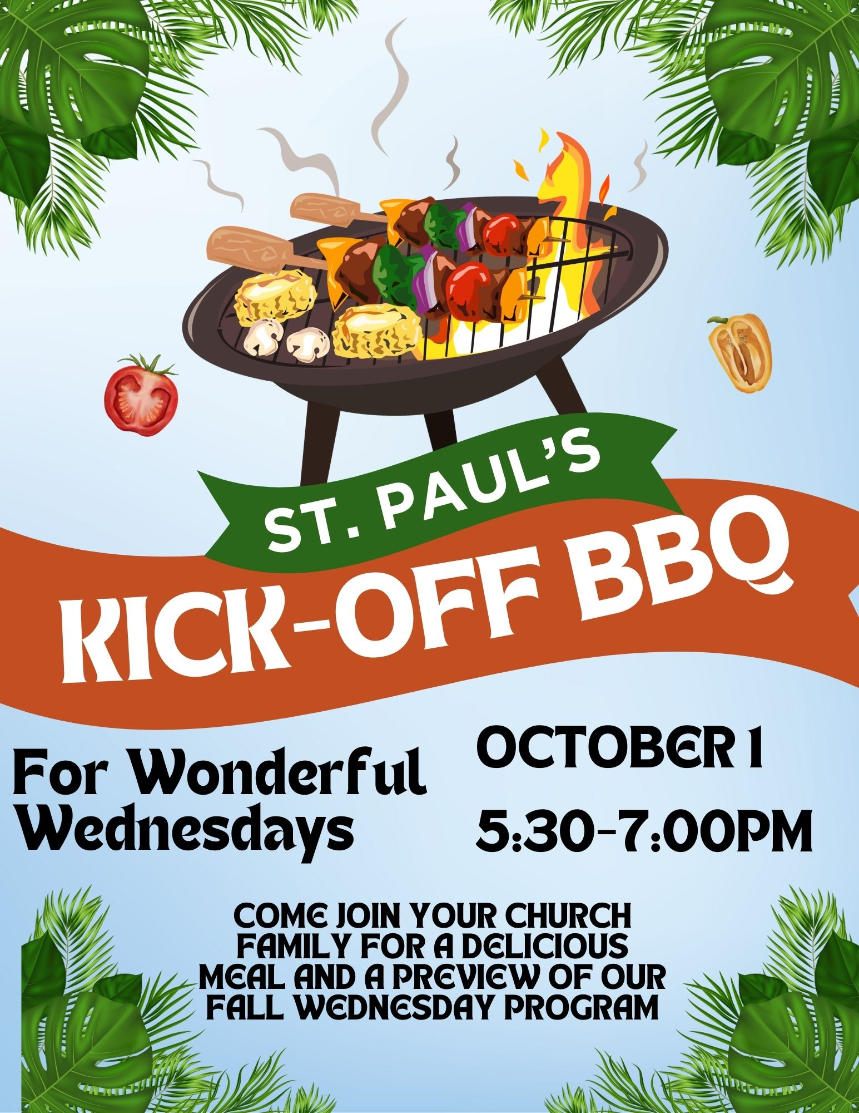

St. Paul’s Anglican Church
Parish Office
6436 W. Hurley Ave
Visalia, California 93291
559-732-4821
Office Hours: 8:00 – 4:00
Monday – Thursday

Worship: Sundays at 10:30AM
In person: St. Paul’s Anglican Church
Livestream: Link at spvisalia.com
and on our Facebook page
Please be advised that this service is being recorded for broadcast
and/or archival purposes. By attending, you consent
to the inclusion of your likeness in these recordings.

St. Paul’s Clergy and Staff
The Rev. Robert Longbottom, Rector
rector@spvisalia.com
(559)802-2928
The Rev. John Iseman, Pastoral Associate for Family Ministries
family@spvisalia.com
The Rev. Kashy Rowland-Smith, Deacon
kashyrs@aol.com
Antoinette Horsting, Parish Administrator
bookkeeper@spvisalia.com
Marguerite Crownover, Organist and Accompanist
Cynthia Culp, Choral Director
Jackie Iseman, Nursery Coordinator
Shane Motl, Sexton

Next Week’s Lessons
Amos 8:4-12
Psalm 138
1 Timothy 2:7-15
Luke 16:19-31

