ST. PAUL’S
ANGLICAN CHURCH
VISALIA, CALIFORNIA

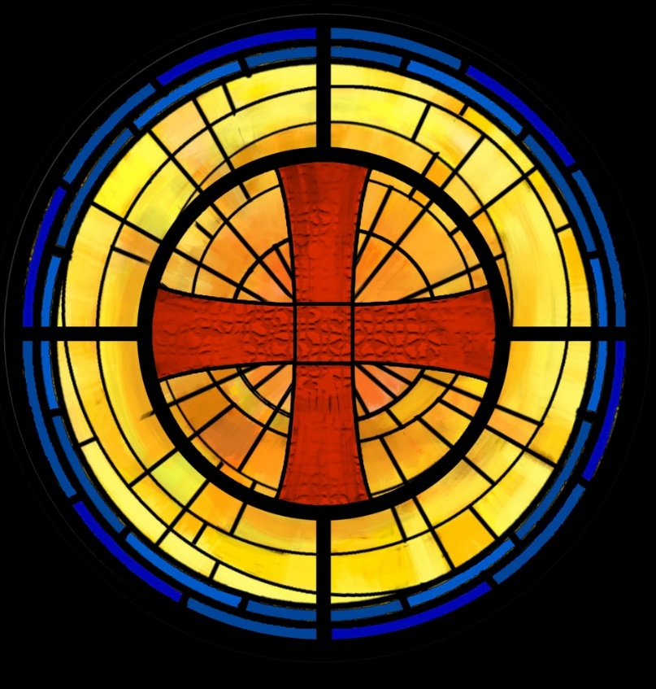

Ninth Sunday after Pentecost
August 10, 2025
10:30 A.M

Welcome!

St. Paul’s Anglican Church extends a warm welcome to all visitors and newcomers, whether worshiping in person or at home via livestream.

Visitors’ Guide

St. Paul’s Church is a parish in the Diocese of San Joaquin of the Anglican Church in North America, which includes both Catholic and Protestant traditions. We accept Jesus Christ as Savior, and we promise to follow him as Lord. We believe in One God,

- the Father who created us and all things,
- the Son who redeems us from sin and death,
- the Holy Spirit who renews and sanctifies us.

We believe the Holy Scriptures to be the Word of God and to contain all things necessary for salvation, and we accept the Apostles’ and Nicene Creeds as essential beliefs of the Christian faith.

All followers of Jesus who are baptized in the name of the Trinity are invited to receive Holy Communion. If for whatever reason you feel you cannot receive communion, we invite you to come forward to receive a blessing. Please indicate you’d like a blessing by crossing your arms. All people are welcome at the Altar of the Lord.

Visitors are invited to sign the guest book at the entrance table and introduce themselves to the clergy following the service.

The Holy Eucharist

Opening Hymn: #637 – “How Firm a Foundation” p. 4
Opening Acclamation p. 5
The Collect for Purity p. 5
Summary of the Law p. 6
Kyrie p. 6
Gloria p. 6
Collect of the Day p. 7
Lesson : Generis 15 :1-6 p. 7
Gradual: Psalm 33 p. 7
Epistle: Hebrews 11:1-16 p. 9
Sequence Hymn: # 635 – “If Thou but Trust in God to Guide Thee” p. 10
Gospel: Luke 12:32-40 p. 11
Sermon: The Rev. Robert Longbottom
Nicene Creed p. 12
Prayers of the People p. 13
The Peace p. 15
Offertory
The Offertory p. 16
Sursum Corda p. 16
Sanctus p. 17
The Lord’s Prayer p. 18
Prayer for Humble Access p. 19
Agnus Dei p. 19
Communion Hymn: Celebration Hymn - “Here I am, Lord” p. 20
Post Communion Prayer p. 21
Blessing p. 22
Closing Hymn: #533 – “How Wondrous and Great Thy Works” p. 22
Dismissal p. 22

Opening Hymn: How Firm a Foundation
(Verses 1-3 only)

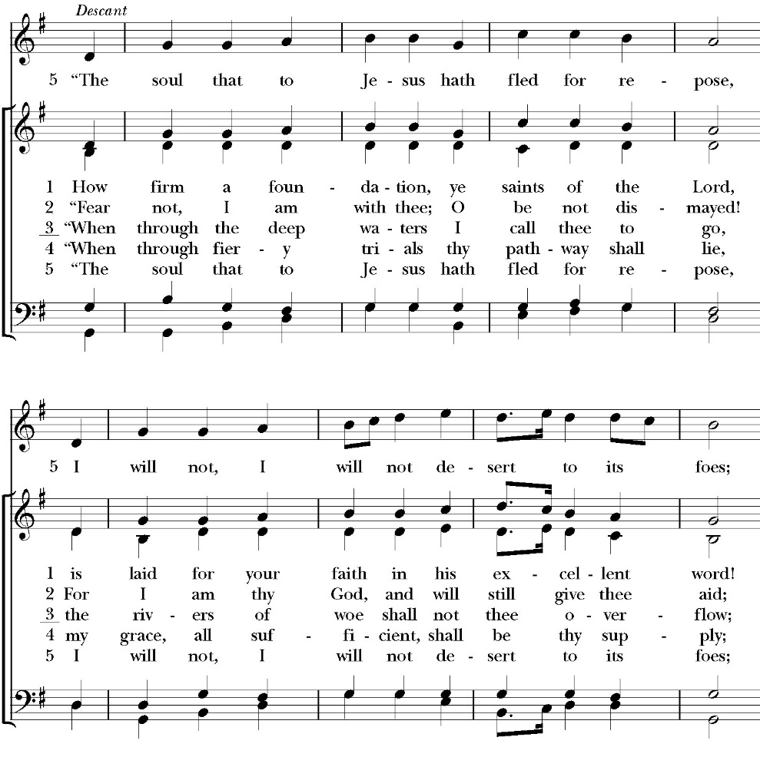

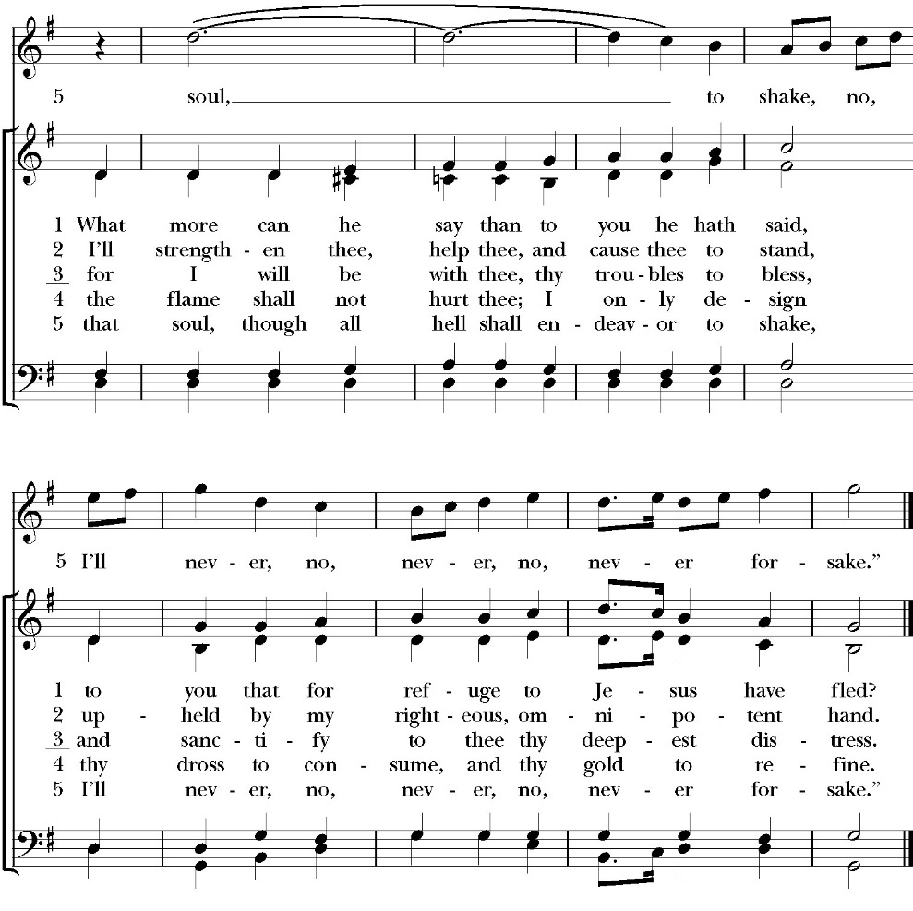

Opening Acclamation

Celebrant Blessed be God: the Father, the Son, and the Holy Spirit. People And blessed be his kingdom, now and for ever.
Amen.

Collect for Purity

People: Almighty God, to you all hearts are open, all desires
known, and from you no secrets are hid: Cleanse the thoughts of our hearts by the inspiration of your Holy Spirit, that we may perfectly love you, and worthily magnify your holy Name; through Christ our Lord. Amen.
Summary of the law

Celebrant: Hear what our Lord Jesus Christ says: You shall love the Lord your God with all your heart and with all your soul
and with all your mind. This is the first and great commandment. And the second is like it: You shall love your neighbor as yourself. On these two commandments depend all the Law and the Prophets.

Kyrie

Lord, have mercy upon us
Christ, have mercy upon us
Lord, have mercy upon us

Gloria

Glory to God in the highest,
and peace to his people on earth.
Lord God, heavenly King,
almighty God and Father,
we worship you, we give you thanks,
we praise you for your glory.
Lord Jesus Christ, only Son of the Father,
Lord God, Lamb of God,
you take away the sin of the world:
have mercy on us;
you are seated at the right hand of the Father:
receive our prayer.
For you alone are the Holy One,
you alone are the Lord, you
alone are the Most High,
Jesus Christ,
with the Holy Spirit,
in the glory of God the Father. Amen.

Celebrant The Lord be with you.
People And with your spirit.
Celebrant Let us pray.

The Collect of the Day

Almighty God, give us the increase of faith, hope, and love; and, that we may obtain what you have promised, make us love what you command; through Jesus Christ our Lord, who lives and reigns with you and the Holy Spirit, one God, for ever and ever. Amen.

Lesson: Genesis 15:1-6
After these things the word of the LORD came to Abram in a vision: “Fear not, Abram, I am your shield; your reward shall be very great.” 2 But Abram said, “O Lord God, what will you give me, for I continue childless, and the heir of my house is Eliezer of Damascus?” 3 And Abram said, “Behold, you have given me no offspring, and a member of my household will be my heir.” 4 And behold, the word of the LORD came to him: “This man shall not be your heir; your very own son shall be your heir.” 5 And he brought him outside and said, “Look toward heaven, and number the stars, if you are able to number them.” Then he said to him, “So shall your offspring be.” 6 And he believed the LORD, and he counted it to him as righteousness.

Reader: The Word of the Lord
People: Thanks be to God

Gradual: 33
1 Rejoice in the LORD, O you righteous; *
it is fitting for the just to be thankful.
2 Praise the LORD with the harp; *
sing praises unto him with the ten-stringed lute.
3 Sing unto him a new song; *
make skillful melody and cry aloud with joy.
4 For the word of the LORD is true, *
and all his works are faithful.
5 He loves righteousness and true judgment; *
the earth is full of the goodness of the LORD.
6 By the word of the LORD were the heavens made, *
and all the hosts of them by the breath of his mouth.
7 He gathers the waters of the sea together, as in a heap, *
and lays up the deep, as in a treasure house.
8 Let all the earth fear the LORD; *
stand in awe of him, all you that dwell in the world.
9 For he spoke, and it was done; *
he commanded and it stood fast.
10 The LORD brings the counsel of the nations to naught; *
he makes the devices of the peoples to be of no effect, and casts out the counsels of princes.
11 The counsel of the LORD shall endure for ever, *
and the thoughts of his heart from generation to generation.
12 Blessed is the nation whose God is the LORD, *
and blessed are the people he has chosen for himself to be his inheritance.
13 The LORD looks down from heaven and beholds all the children of men; *
from the habitation of his dwelling he considers all those who dwell on the earth.
14 He fashions all the hearts of them *
and understands all their works.
15 There is no king who can be saved by a mighty host; *
neither is any mighty man delivered by great strength.
16 A horse is considered a vain hope to save a man; *
neither shall it deliver anyone by its great strength.
17 Behold, the eye of the LORD is upon those who fear him, *
and upon those who put their trust in his mercy,
18 To deliver their soul from death, *
and to feed them in the time of famine.
19 Our soul has patiently waited for the LORD, *
for he is our help and our shield.
20 Our heart shall rejoice in him, *
because we have hoped in his holy Name.
21 Let your merciful kindness, O LORD, be upon us, *
as we have put our trust in you.
Glory be to the Father, and to the Son, and to the Holy Spirit;
as it was in the beginning, is now, and ever shall be, world without end. Amen
Epistle: Hebrews 11:1-16
Now faith is the assurance of things hoped for, the conviction of things not seen. 2 For by it the people of old received their commendation. 3 By faith we understand that the universe was created by the word of God, so that what is seen was not made out of things that are visible.

4 By faith Abel offered to God a more acceptable sacrifice than Cain, through which he was commended as righteous, God commending him by accepting his gifts. And through his faith, though he died, he still speaks. 5 By faith Enoch was taken up so that he should not see death, and he was not found, because God had taken him. Now before he was taken he was commended as having pleased God. 6 And without faith it is impossible to please him, for whoever would draw near to God must believe that he exists and that he rewards those who seek him. 7 By faith Noah, being warned by God concerning events as yet unseen, in reverent fear constructed an ark for the saving of his household. By this he condemned the world and became an heir of the righteousness that comes by faith.

8 By faith Abraham obeyed when he was called to go out to a place that he was to receive as an inheritance. And he went out, not knowing where he was going.

9 By faith he went to live in the land of promise, as in a foreign land, living in tents with Isaac and Jacob, heirs with him of the same promise. 10 For he was looking forward to the city that has foundations, whose designer and builder is God. 11 By faith Sarah herself received power to conceive, even when she was past the age, since she considered him faithful who had promised. 12 Therefore from one man, and him as good as dead, were born descendants as many as the stars of heaven and as many as the innumerable grains of sand by the seashore.

13 These all died in faith, not having received the things promised, but having seen them and greeted them from afar, and having acknowledged that they were strangers and exiles on the earth. 14 For people who speak thus make it clear that they are seeking a homeland.

15 If they had been thinking of that land from which they had gone out, they would have had opportunity to return. 16 But as it is, they desire a better country, that is, a heavenly one. Therefore God is not ashamed to be called their God, for he has prepared for them a city.

Reader: The Word of the Lord
People: Thanks be to God

Sequence Hymn: If Thou but Trust in God to Guide Thee
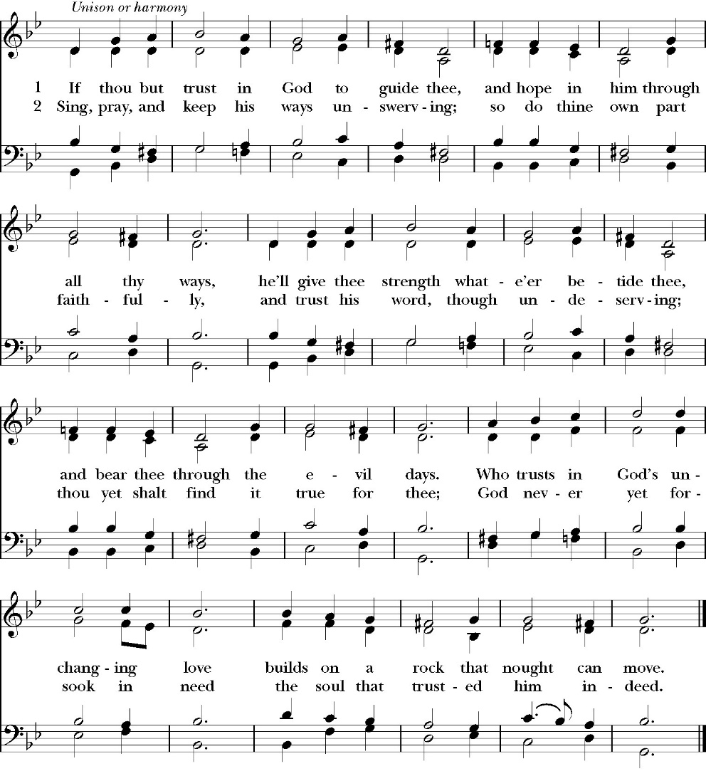
(Verse 1 before Gospel verse 2 after)

Clergy: The Holy Gospel of Our Lord Jesus Christ,
according to St. Luke
People: Glory to you, Lord God

Gospel: Luke 12:32-40
“Fear not, little flock, for it is your Father's good pleasure to give you the kingdom. 33 Sell your possessions, and give to the needy. Provide yourselves with moneybags that do not grow old, with a treasure in the heavens that does not fail, where no thief approaches and no moth destroys. 34 For where your treasure is, there will your heart be also.

35 “Stay dressed for action and keep your lamps burning, 36 and be like men who are waiting for their master to come home from the wedding feast, so that they may open the door to him at once when he comes and knocks. 37 Blessed are those servants whom the master finds awake when he comes. Truly, I say to you, he will dress himself for service and have them recline at table, and he will come and serve them. 38 If he comes in the second watch, or in the third, and finds them awake, blessed are those servants! 39 But know this, that if the master of the house had known at what hour the thief was coming, he would not have left his house to be broken into. 40 You also must be ready, for the Son of Man is coming at an hour you do not expect.”

Clergy: The Gospel of the Lord
People: Praise to you Lord Christ

Sermon
The Rev. Robert Longbottom

The Nicene Creed

The people stand

We believe in one God,
the Father, the Almighty,
maker of heaven and earth,
of all that is, visible and invisible.

We believe in one Lord, Jesus Christ,
the only-begotten Son of God,
eternally begotten of the Father,
God from God, Light from Light,
true God from true God,
begotten, not made,
of one Being with the Father.
through him all things were made.
For us and for our salvation he came down from heaven:
was incarnate from the Holy Spirit and the Virgin Mary,
and was made man.
For our sake he was crucified under Pontius Pilate;
he suffered death and was buried.
On the third day he rose again in accordance with the
Scriptures;
he ascended into heaven
and is seated at the right hand of the Father.
He will come again in glory to judge the living and the dead,
and his kingdom will have no end.
We believe in the Holy Spirit, the Lord, the giver of life,
who proceeds from the Father and the Son,
who with the Father and the Son is worshiped and glorified.
who has spoken through the Prophets.
We believe in one holy catholic and apostolic Church.
We acknowledge one Baptism for the forgiveness of sins.
We look for the resurrection of the dead,
and the life of the world to come. Amen.

The Prayers of the People
The People kneel or are seated if you are unable to kneel
The Deacon or other person appointed says these prayers. reader pauses after each bidding, and the people may add petitions, either silently or aloud.
Let us pray for the Church and for the world, saying,
“hear our prayer.”

For the peace of the whole world, and for the well-being and unity of the people of God.

Reader Lord, in your mercy:
People Hear our prayer.

For Stephen, our Archbishop, and Eric, our Bishop, and for all the clergy and people of our Diocese and Congregation.

Reader Lord, in your mercy:
People Hear our prayer.

For all those who proclaim the Gospel at home and abroad; and for all who teach and disciple others.

Reader Lord, in your mercy:
People Hear our prayer.

For our brothers and sisters in Christ who are persecuted for their faith.

Reader Lord, in your mercy:
People Hear our prayer.

For our nation, for those in authority, and for all in public service especially Donald our President and Gavin our Governor.

Reader Lord, in your mercy:
People Hear our prayer.
For all those who are in trouble, sorrow, need, sickness, or any other adversity [especially _____________].

Reader Lord, in your mercy:
People Hear our prayer.

For all those who have departed this life in the certain hope of the resurrection, [especially ______,] in thanksgiving let us pray.

Reader Lord, in your mercy:
People Hear our prayer.

In the St. Paul’s cycle of prayer, we pray for all ministries to children, youth and families both in our church and through our church into the community around us. We pray for Sunday Funday, Sunday School, Youth Group and for all our family ministry volunteers. We pray for the children and youth you have given to our care and for their formation in the Christian faith. We pray for all children and youth to whom we are reaching out with the Good News of Jesus Christ.
Reader Lord, in your mercy:
People Hear our prayer.

In the ACNA Cycle of Prayer, today we pray for the Anglican Province of Rwanda and The Most Rev. Laurent Mbanda, Archbishop, and his wife, Chantal.

Reader Lord, in your mercy:
People Hear our prayer.

The Celebrant concludes with this or some other appropriate Collect.
Heavenly Father, grant these our prayers for the sake of Jesus Christ, our only Mediator and Advocate, who lives and reigns with you in the unity of the Holy Spirit, one God, now and for ever. Amen.

The Confession and Absolution

Deacon Let us humbly confess our sins to Almighty God.

Most merciful God,
we confess that we have sinned against you
in thought, word and deed,
by what we have done, and by what we have left undone.
We have not loved you with our whole heart;
we have not loved our neighbors as ourselves.
We are truly sorry and we humbly repent.
For the sake of your Son Jesus Christ,
have mercy on us and forgive us;
that we may delight in your will, and walk in your ways,
to the glory of your Name. Amen.

Almighty God, our heavenly Father, who in his great mercy has
promised forgiveness of sins to all those who sincerely repent and
with true faith turn to him, have mercy upon you, pardon and deliver
you from all your sins, confirm and strengthen you in all goodness,
and bring you to everlasting life; through Jesus Christ our Lord.
Amen.

Hear the Word of God to all who truly turn to him.

Come to me, all who labor and are heavy laden, and I will give
you rest. -Matthew 11:28

God so loved the world, that he gave his only-begotten Son, that
whoever believes in him should not perish but have eternal life.
-John 3:16t

The Peace
Celebrant The Peace of the Lord be always with you.
People And with your spirit.

The Doxology
(Verse 3 only)

Offertory

Celebrant All things come from you, O Lord,
People And of your own have we given you.

The Eucharistic Liturgy

Celebrant The Lord be with you.
People And with your spirit.
Celebrant Lift up your hearts.
People We lift them up to the Lord.
Celebrant Let us give thanks to the Lord our God.
People It is right to give him thanks and praise.

It is right, our duty and our joy, always and everywhere to give thanks to you, Father Almighty, Creator of heaven and earth.
Through Jesus Christ our Lord, who on the first day of the week overcame death and the grave, and by his glorious resurrection opened to us the way of everlasting life.

Therefore we praise you, joining our voices with Angels and Archangels and with all the company of heaven, who for ever sing this hymn to proclaim the glory of your Name:

Holy, Holy, Holy, Lord God of power and might, heaven and
earth are full of your glory.
Hosanna in the highest.
Blessed is he who comes in the Name of the Lord.
Hosanna in the highest.

Holy and gracious Father: In your infinite love you made us for yourself; and when we had sinned against you and become subject to evil and death, you, in your mercy, sent your only Son Jesus Christ into the world for our salvation. By the Holy Spirit and the Virgin Mary he became flesh and dwelt among us. In obedience to your will, he stretched out his arms upon the Cross and offered himself once for all, that by his suffering and death we might be saved. By his resurrection he broke the bonds of death, trampling Hell and Satan under his feet. As our great high priest, he ascended to your right hand in glory, that we might come with confidence before the throne of grace.

On the night that he was betrayed, our Lord Jesus Christ took bread; and when he had given thanks, he broke it,* and gave it to his disciples, saying, “Take, eat; this is my Body, which is given for you: Do this in remembrance of me.”

Likewise, after supper, Jesus took the cup, and when he had given thanks, he gave it to them, saying, “Drink this, all of you; for this is my Blood of the New Covenant, which is shed for you, and for many, for the forgiveness of sins: Whenever you drink it, do this in remembrance of me.”

Therefore we proclaim the mystery of faith:

Christ has died.
Christ is risen.
Christ will come again.

The People kneel or are seated if you are unable to kneel

We celebrate the memorial of our redemption, O Father, in this sacrifice of praise and thanksgiving, and we offer you these gifts.

Sanctify them by your Word and Holy Spirit to be for your people the Body and Blood of your Son Jesus Christ. Sanctify us also, that we may worthily receive this holy Sacrament, and be made one body with him, that he may dwell in us and we in him. In the fullness of time, put all things in subjection under your Christ, and bring us with all your saints into the joy of your heavenly kingdom, where we shall see our Lord face to face.

All this we ask through your Son Jesus Christ: By him, and with him, and in him, in the unity of the Holy Spirit, all honor and glory is yours, Almighty Father, now and for ever. Amen

And now, as our Savior Christ has taught us, we are bold to pray,

Our Father, who art in heaven,
hallowed be thy Name,
thy kingdom come,
thy will be done,
on earth as it is in heaven.
Give us this day our daily bread.
And forgive us our trespasses,
as we forgive those
who trespass against us.
And lead us not into temptation,
but deliver us from evil.
For thine is the kingdom,
and the power, and the glory,
for ever and ever. Amen

The Prayer for Humble Access

We do not presume to come to this your table, O merciful Lord,
trusting in our own righteousness,
but in your abundant and great mercies.
We are not worthy so much as to gather up
the crumbs under your table;
but you are the same Lord
whose character is always to have mercy.
Grant us, therefore, gracious Lord,
so to eat the flesh of your dear Son Jesus Christ,
and to drink his blood,
that our sinful bodies may be made clean by his body,
and our souls washed through his most precious blood,
and that we may evermore dwell in him, and he in us.
Amen

Agnus Dei
Lamb of God, you take away the sin of the world;
have mercy on us.
Lamb of God, you take away the sin of the world;
have mercy on us.
Lamb of God, you take away the sin of the world;
grant us your peace.

The Ministration of Communion

The gifts of God for the People of God. Take them in remembrance that Christ died for you and feed on him in your hearts by faith, with thanksgiving.

Communion Hymn: Here I Am, Lord
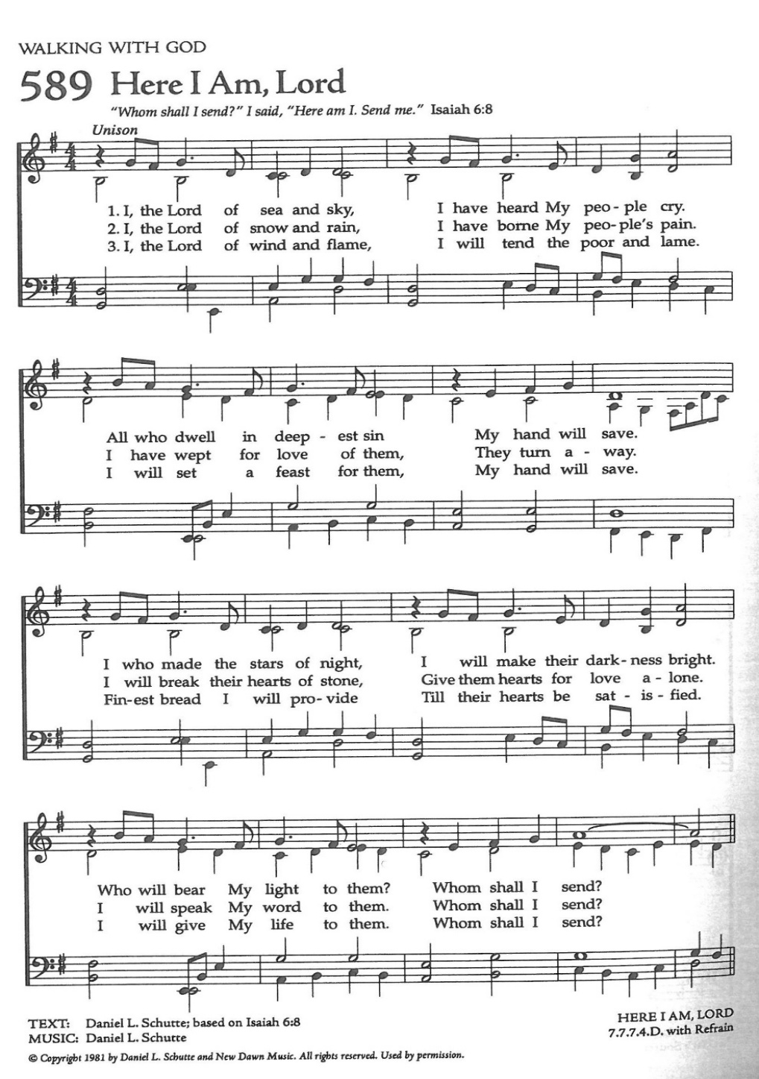

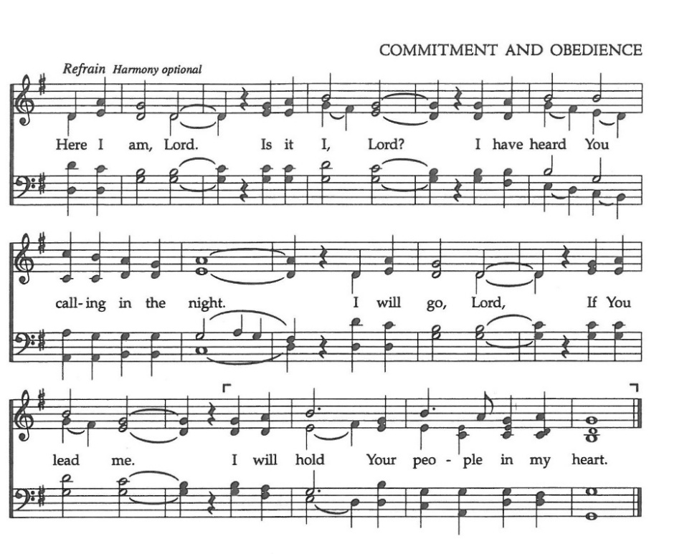

The Post Communion Prayer

The People kneel or are seated if you are unable to kneel

Let us pray.

Heavenly Father,
We thank you for feeding us with the spiritual food
of the most precious Body and Blood
of your Son our Savior Jesus Christ;
and for assuring us in these holy mysteries
that we are living members of the body of your Son,
and heirs of your eternal Kingdom.
And now, Father, send us out to do the work you have
given us to do,
to love and serve you as faithful witnesses of Christ our
Lord.
To him, to you, and to the Holy Spirit,
be honor and glory, now and for ever. Amen.

The Blessing

The peace of God, which passes all understanding, keep your hearts and minds in the knowledge and love of God, and of his Son Jesus Christ our Lord; and the blessing of God Almighty, the Father, the Son, and the Holy Spirit, be among you, and remain with you always. Amen.

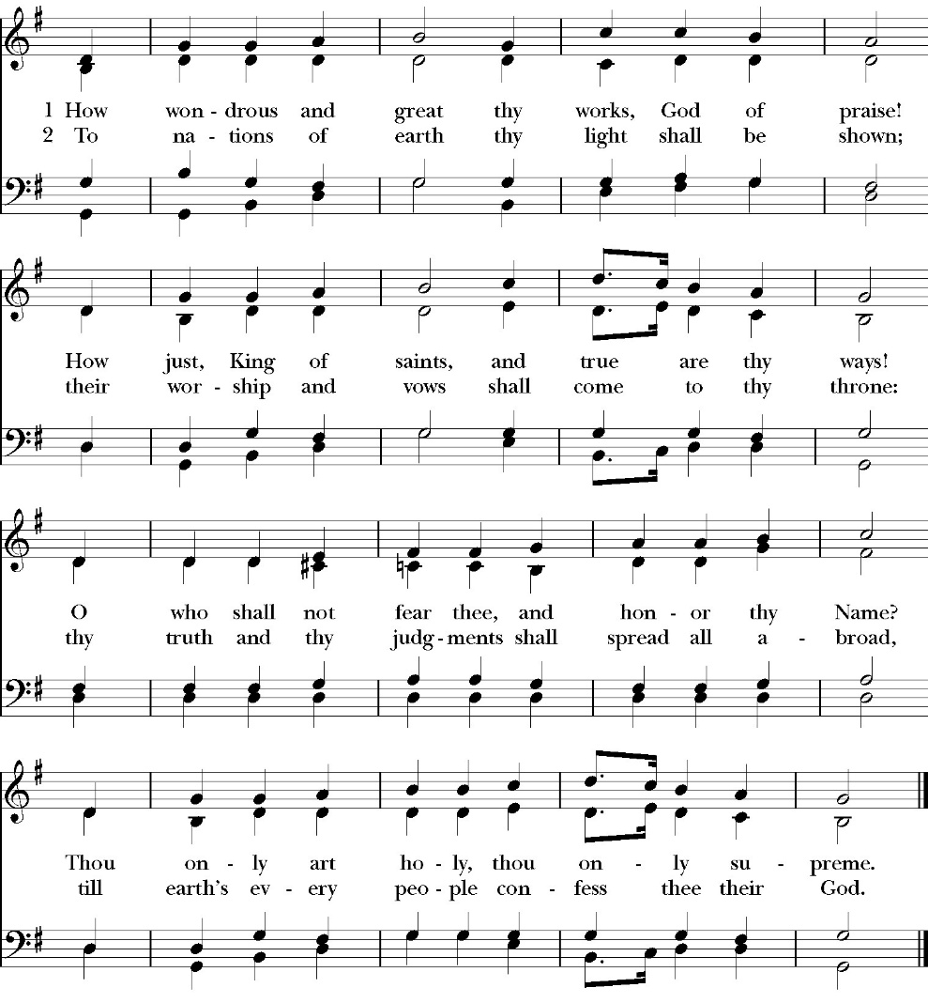
Closing Hymn: How Wondrous and Great Thy Works

Deacon Alleluia, Alleluia! Let us go forth in the name of Christ.
People Thanks be to God. Alleluia! Alleluia!
St. Paul’s Parish Calendar
Sunday August 10 – Sunday August 17

SUNDAY, August 10 – Ninth Sunday after Pentecost
9:00 AM Sunday Fun Day, Youth Room
9:15 AM Catechism Classes, Conference Room
10:30 AM Children’s Sunday School, (Pre-K – 6th Grade)
10:30 AM Holy Eucharist, Church

MONDAY, August 11
6:30 PM Women’ s Bible Study, Conference Room

TUESDAY, August 12
2:15PM-3:30PM Food Bank for Hurley Families, Church Parking Lot
6:00 PM Vestry, Conference Room

WEDNESDAY, August 13
9:30 AM Holy Eucharist, Chapel
10:15 AM Bible Study, Conference Room

THURSDAY, August 14

FRIDAY, August 15
6:30 AM Men’s Bible Study, Valhalla Restaurant

SATURDAY, August 16

SUNDAY, August 17 – Tenth Sunday after Pentecost
9:00 AM Sunday Fun Day, Youth Room
9:15 AM Catechism Classes, Conference Room
10:30 AM Children’s Sunday School, (Pre-K – 6th Grade)
10:30 AM Holy Eucharist, Church

Church Office Hours
Monday-Thursday 8:00 AM-4:00 PM

Announcements

Pastoral Care and Visitation Team Forming
Pastoral care is the lifeblood of a vibrant church. Pastoral care can take many forms. It can be visiting the sick and homebound, responding to emergencies, catching up with a church member we have not seen in a while, and really offers so many more opportunities to be present with all the members of the body of Christ. This work is not done just by our clergy, but by the whole church, and we are looking for people of the church who feel they may be called to the ministry of pastoral care. If you are interested in learning more about being a pastoral visitor for St. Paul’s, please reach out to Deacon Kashy Rowland-Smith who would love to talk with you about our needs and opportunities. Deacon Kashy can be reached at 909-3305.

Sunday Morning Anglican Catechism Class
The Sacraments of the Church
Sundays in August, 9:15 AM, Conference Room
The Anglican Catechism is a summary of our faith and doctrines in the Anglican Church and helps us know what we believe as orthodox Anglican Christians. This session of four classes will focus on the Sacraments of the church. This first class will focus on the two primary sacraments of Baptism and Holy Communion and will then move towards the five lesser sacraments of ordination, holy unction (healing), confirmation, marriage, and confessions.

August 10 Holy Eucharist and Baptism
August 17 Confirmation, Holy Unction (anointing the sick), Absolution, Ordination,
August 24 Holy Matrimony

A FOOD BANK FOR HURLEY FAMILIES

If you are interested in helping, please contact me, Sue Nyberg. My home phone number is 559-733-8244. Since we packed so much food the first time, we will NOT have a packing day this time around.

PROVIDED BY VISALIA EMERGENCY AID

AND ST. PAUL’S CHURCH
Tuesday AUGUST 12, 2025
From 2:15 to 3:30,
LOCATION:
ST. PAUL'S CHURCH PARKING LOT
ACROSS THE STREET FROM HURLEY



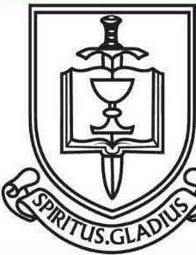

ST. PAUL'S ANGLICAN CHURCH
"WHERE GOD
BUILD'S THINGS"
-

St. Paul’s Anglican Church
Parish Office
6436 W. Hurley Ave
Visalia, California 93291
559-732-4821
Office Hours: 8:00 – 4:00
Monday – Thursday

Worship: Sundays at 10:30AM
In person: St. Paul’s Anglican Church
Livestream: Link at spvisalia.com
and on our Facebook page
Please be advised that this service is being recorded for broadcast
and/or archival purposes. By attending, you consent
to the inclusion of your likeness in these recordings.

St. Paul’s Clergy and Staff
The Rev. Robert Longbottom, Rector
rector@spvisalia.com
(559)802-2928
The Rev. John Iseman, Pastoral Associate for Family Ministries
family@spvisalia.com
Antoinette Horsting, Parish Administrator
bookkeeper@spvisalia.com
Marguerite Crownover, Organist and Accompanist
Cynthia Culp, Choral Director
Jackie Iseman, Nursery Coordinator
Shane Motl, Sexton

Next Week’s Lessons
Jeremiah 23:23-29
Psalm 82
Hebrews 12:1-14
Luke 12:1-14

