ST. PAUL’S
ANGLICAN CHURCH
VISALIA, CALIFORNIA

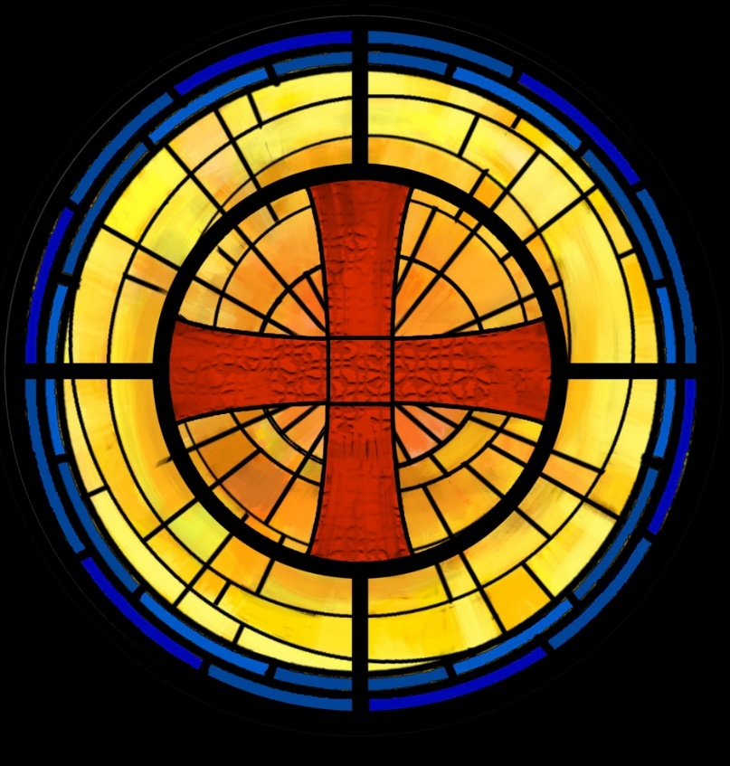

Sixth Sunday after Pentecost
July 20, 2025
10:30 A.M

Welcome!

St. Paul’s Anglican Church extends a warm welcome to all visitors and newcomers, whether worshiping in person or at home via livestream.

Visitors’ Guide

St. Paul’s Church is a parish in the Diocese of San Joaquin of the Anglican Church in North America, which includes both Catholic and Protestant traditions. We accept Jesus Christ as Savior, and we promise to follow him as Lord. We believe in One God,

- the Father who created us and all things,
- the Son who redeems us from sin and death,
- the Holy Spirit who renews and sanctifies us.

We believe the Holy Scriptures to be the Word of God and to contain all things necessary for salvation, and we accept the Apostles’ and Nicene Creeds as essential beliefs of the Christian faith.

All followers of Jesus who are baptized in the name of the Trinity are invited to receive Holy Communion. If for whatever reason you feel you cannot receive communion, we invite you to come forward to receive a blessing. Please indicate you’d like a blessing by crossing your arms. All people are welcome at the Altar of the Lord.

Visitors are invited to sign the guest book at the entrance table and introduce themselves to the clergy following the service.

The Holy Eucharist

Prelude: “Prelude and Fugue in C” Bach
Opening Hymn: #401 – “God of Abraham Praise” p. 4
Opening Acclamation p. 5
The Collect for Purity p. 5
Summary of the Law p. 5
Kyrie p. 5
Gloria p. 5
Collect of the Day p. 6
Lesson : Genesis 18 :1-14 p. 6
Gradual: Psalm 15 p. 7
Epistle: Colossians 1:21-29 p. 8
Sequence Hymn: #488 – “Be Thou My Vision” p. 9
Gospel: Luke10:38-42 p. 9
Sermon: Rev John Iseman
Nicene Creed p. 10
Prayers of the People p. 11
The Peace p. 13
Offertory
The Offertory p. 14
Sursum Corda p. 14
Sanctus p. 15
The Lord’s Prayer p. 15
Fraction p. 16
Prayer for Humble Access p. 16
Agnus Dei p. 16
Communion Hymn: #325 – “Let Us Break Bread Together” p. 17
Post Communion Prayer p. 18
Blessing p. 18
Closing Hymn: #620 – “Jerusalem My Happy Home” p. 19
Dismissal p. 19

Opening Hymn: God of Abraham Praise
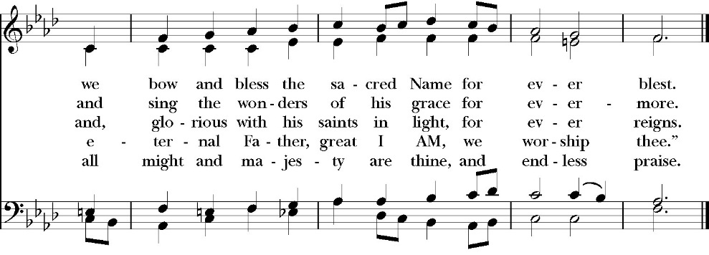
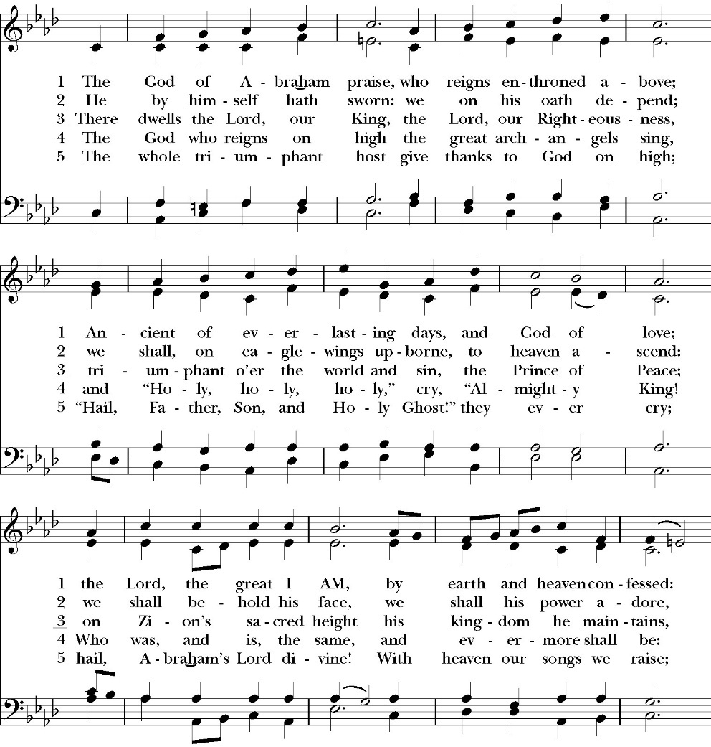
(Verses 1-3 only)

Opening Acclamation

Celebrant Blessed be God: the Father, the Son, and the Holy Spirit. People And blessed be his kingdom, now and for ever.
Amen.
Collect for Purity

Celebrant: Almighty God, to you all hearts are open, all desires
known, and from you no secrets are hid: Cleanse the thoughts
of our hearts by the inspiration of your Holy Spirit, that we
may perfectly love you, and worthily magnify your holy Name;
through Christ our Lord. Amen.

Summary of the law

Celebrant: Hear what our Lord Jesus Christ says: You shall love
the Lord your God with all your heart and with all your soul
and with all your mind. This is the first and great
commandment. And the second is like it: You shall love your
neighbor as yourself. On these two commandments depend all
the Law and the Prophets.

Kyrie

Lord, have mercy upon us
Christ, have mercy upon us
Lord, have mercy upon us

Gloria

Glory to God in the highest,
and peace to his people on earth.
Lord God, heavenly King,
almighty God and Father,
we worship you, we give you thanks,
we praise you for your glory.
Lord Jesus Christ, only Son of the Father,
Lord God, Lamb of God,
you take away the sin of the world:
have mercy on us;
you are seated at the right hand of the Father:
receive our prayer.
For you alone are the Holy One,
you alone are the Lord, you
alone are the Most High,
Jesus Christ,
with the Holy Spirit,
in the glory of God the Father. Amen.

Celebrant The Lord be with you.
People And with your spirit.
Celebrant Let us pray.

The Collect of the Day
O God, you declare your almighty power chiefly in showing mercy and pity: Grant us the fullness of your grace, that we, running to obtain your promises, may become partakers of your heavenly treasure; through Jesus Christ our Lord, who lives and reigns with you and the Holy Spirit, one God, for ever and ever. Amen.

Lesson: Genesis 18:1-14
And the LORD appeared to him by the oaks of Mamre, as he sat at the door of his tent in the heat of the day. 2 He lifted up his eyes and looked, and behold, three men were standing in front of him. When he saw them, he ran from the tent door to meet them and bowed himself to the earth 3 and said, “O LORD, if I have found favor in your sight, do not pass by your servant. 4 Let a little water be brought, and wash your feet, and rest yourselves under the tree,

5 while I bring a morsel of bread, that you may refresh yourselves, and after that you may pass on—since you have come to your servant.” So they said, “Do as you have said.” 6 And Abraham went quickly into the tent to Sarah and said, “Quick! Three seahs of fine f lour! Knead it, and make cakes.” 7 And Abraham ran to the herd and took a calf, tender and good, and gave it to a young man, who prepared it quickly. 8 Then he took curds and milk and the calf that he had prepared, and set it before them. And he stood by themunder the tree while they ate.

9 They said to him, “Where is Sarah your wife?” And he said, “She is in the tent.” 10 The LORD said, “I will surely return to you about this time next year, and Sarah your wife shall have a son.” And Sarah was listening at the tent door behind him. 11 Now Abraham and Sarah were old, advanced in years. The way of women had ceased to be with Sarah. 12 So Sarah laughed to herself, saying, “After I am worn out, and my lord is old, shall I have pleasure?” 13 The LORD said to Abraham, “Why did Sarah laugh and say, ‘Shall I indeed bear a child, now that I am old?’ 14 Is anything too hard for the LORD? At the appointed time I will return to you, about this time next year, and Sarah shall have a son.”

Reader: The Word of the Lord
People: Thanks be to God

Gradual: Psalm 15
1 LORD, who shall dwell in your tabernacle? *
Or who shall rest upon your holy hill?
2 Whoever leads an uncorrupt life, *
and does that which is right, and speaks the truth from his heart.
3 He has not spoken deceitfully with his tongue, nor done evil to his neighbor, *
and has not slandered his neighbor.
4 In his eyes the wicked is rejected, *
and he makes much of those who fear the LORD.
5 He swears to his neighbor and disappoints him not, *
though it were to his own hindrance.
6 He has not given his money for usury, *
nor taken a bribe against the innocent.
7 Whoever does these things *
shall never be overthrown.

Glory be to the Father, and to the Son, and to the Holy Spirit;
as it was in the beginning, is now, and ever shall be, world
without end. Amen

Epistle: Colossians 1:21-29

And you, who once were alienated and hostile in mind, doing evil deeds, 22 he has now reconciled in his body of flesh by his death, in order to present you holy and blameless and above reproach before him, 23 if indeed you continue in the faith, stable and steadfast, not shifting from the hope of the gospel that you heard, which has been proclaimed in all creation under heaven, and of which I, Paul, became a minister.

24 Now I rejoice in my sufferings for your sake, and in my flesh I am filling up what is lacking in Christ's afflictions for the sake of his body, that is, the church, 25 of which I became a minister according to the stewardship from God that was given to me for you, to make the word of God fully known, 26 the mystery hidden for ages and generations but now revealed to his saints. 27 To them God chose to make known how great among the Gentiles are the riches of the glory of this mystery, which is Christ in you, the hope of glory.

28 Him we proclaim, warning everyone and teaching everyone with all wisdom, that we may present everyone mature in Christ. 29 For this I toil, struggling with all his energy that he powerfully works within me.

Reader: The Word of the Lord
People: Thanks be to God

Sequence Hymn: Be Thou My Vision
(verse 1-2 before Gospel and verse 3 after Gospel)

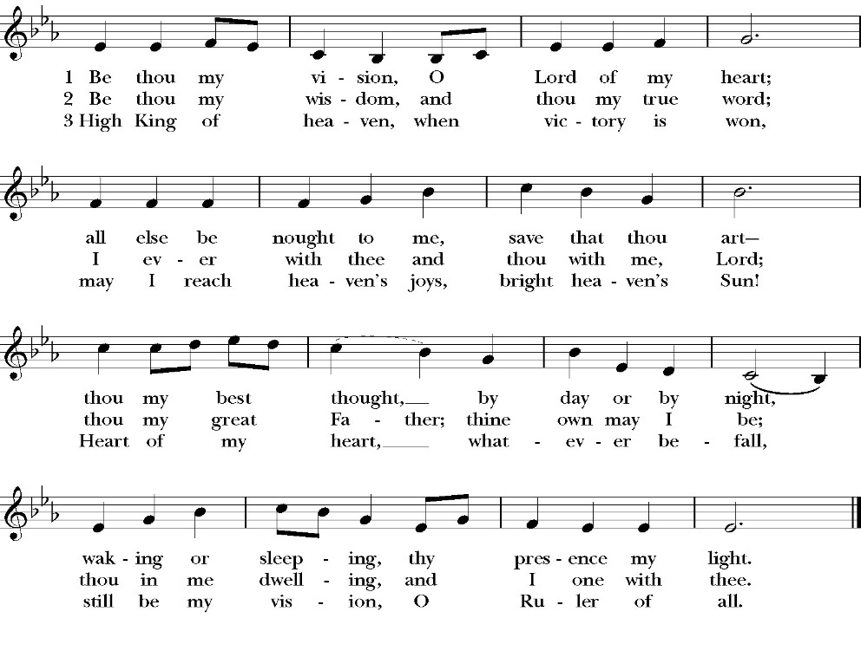

Clergy: The Holy Gospel of Our Lord Jesus Christ,
according to St. Luke
People: Glory to you, Lord God

Gospel: Luke 10:38-42
Now as they went on their way, Jesus entered a village. And a woman named Martha welcomed him into her house. 39 And she had a sister called Mary, who sat at the Lord's feet and listened to his teaching. 40 But Martha was distracted with much serving. And she went up to him and said, “Lord, do you not care that my sister has left me to serve alone? Tell her then to help me.” 41 But the Lord answered her, “Martha, Martha, you are anxious and troubled about many things, 42 but one thing is necessary. Mary has chosen the good portion, which will not be taken away from her.”

Clergy: The Gospel of the Lord
People: Praise to you Lord Christ
Sermon
Rev. John Iseman

The Nicene Creed

We believe in one God,
the Father, the Almighty,
maker of heaven and earth,
of all that is, visible and invisible.

We believe in one Lord, Jesus Christ,
the only-begotten Son of God,
eternally begotten of the Father,
God from God, Light from Light,
true God from true God,
begotten, not made,
of one Being with the Father.
through him all things were made.
For us and for our salvation he came down from heaven:
was incarnate from the Holy Spirit and the Virgin Mary,
and was made man.
For our sake he was crucified under Pontius Pilate;
he suffered death and was buried.
On the third day he rose again in accordance with the
Scriptures;
he ascended into heaven
and is seated at the right hand of the Father.
He will come again in glory to judge the living and the dead,
and his kingdom will have no end.
We believe in the Holy Spirit, the Lord, the giver of life,
who proceeds from the Father and the Son,
who with the Father and the Son is worshiped and glorified.
who has spoken through the Prophets.
We believe in one holy catholic and apostolic Church.
We acknowledge one Baptism for the forgiveness of sins.
We look for the resurrection of the dead,
and the life of the world to come. Amen.

The Prayers of the People
The Deacon or other person appointed says these prayers, or the Prayers of the People in the Anglican Standard Text. The reader pauses after each bidding, and the people may add petitions, either silently or aloud.
Let us pray for the Church and for the world, saying,
“hear our prayer.”

For the peace of the whole world, and for the well-being and unity of the people of God.

Reader Lord, in your mercy:
People Hear our prayer.

For Stephen, our Archbishop, and Eric, our Bishop, and for all the clergy and people of our Diocese and Congregation.

Reader Lord, in your mercy:
People Hear our prayer.

For all those who proclaim the Gospel at home and abroad; and for all who teach and disciple others.

Reader Lord, in your mercy:
People Hear our prayer.

For our brothers and sisters in Christ who are persecuted for their faith.

Reader Lord, in your mercy:
People Hear our prayer.

For our nation, for those in authority, and for all in public service especially Donald our President and Gavin our Governor.

Reader Lord, in your mercy:
People Hear our prayer.

For all those who are in trouble, sorrow, need, sickness, or any other adversity [especially _____________].

Reader Lord, in your mercy:
People Hear our prayer.

For all those who have departed this life in the certain hope of the resurrection, [especially ______,] in thanksgiving let us pray.

Reader Lord, in your mercy:
People Hear our prayer.

In the St. Paul’s cycle of prayer, we pray for our Bishop Eric Menees, the Ministries of the Anglican Diocese of San Joaquin and its churches, for the Anglican Church in North America and it’s dioceses, for the Global Anglican Futures Conference, for the Worldwide Anglican Communion and all their provinces, diocese and churches.
Reader Lord, in your mercy:
People Hear our prayer.

In the ACNA Cycle of Prayer, today we pray for the Diocese of Western Anglicans and Bishop Keith Andrews and his wife, Gail.

Reader Lord, in your mercy:
People Hear our prayer.
Reader Lord, in your mercy:
People Hear our prayer.

The Celebrant concludes with this or some other appropriate Collect.
Heavenly Father, grant these our prayers for the sake of Jesus Christ, our only Mediator and Advocate, who lives and reigns with you in the unity of the Holy Spirit, one God, now and for ever. Amen.

The Confession and Absolution

Deacon Let us humbly confess our sins to Almighty God.

Most merciful God,
we confess that we have sinned against you
in thought, word and deed,
by what we have done, and by what we have left undone.
We have not loved you with our whole heart;
we have not loved our neighbors as ourselves.
We are truly sorry and we humbly repent.
For the sake of your Son Jesus Christ,
have mercy on us and forgive us;
that we may delight in your will, and walk in your ways,
to the glory of your Name. Amen.

Almighty God, our heavenly Father, who in his great mercy has
promised forgiveness of sins to all those who sincerely repent and
with true faith turn to him, have mercy upon you, pardon and deliver
you from all your sins, confirm and strengthen you in all goodness,
and bring you to everlasting life; through Jesus Christ our Lord.
Amen.

Hear the Word of God to all who truly turn to him.

The saying is trustworthy and deserving of full acceptance, that
Jesus came into the world to save sinners. -1 Timothy 1:15

If anyone sins, we have an advocate with the Father, Jesus Christ
the righteous. He is the propitiation for our sins, and not for
ours only, but also for the sins of the whole world. -1 John 2:1-2t

The Peace
Celebrant The Peace of the Lord be always with you.
People And with your spirit.

The Doxology
(Verse 3 only)

Offertory

Celebrant All things come from you, O Lord,
People And of your own have we given you.

The Eucharistic Liturgy
(The Eucharistic liturgy today will be led by Deacon John Iseman and will not include portions of the prayers to bless the bread and the wine to be the body and blood of Jesus Christ. Communion will be distributed from reserve sacraments.)

Celebrant The Lord be with you.
People And with your spirit.
Celebrant Lift up your hearts.
People We lift them up to the Lord.
Celebrant Let us give thanks to the Lord our God.
People It is right to give him thanks and praise.
It is right, our duty and our joy, always and everywhere to give thanks to you, Father Almighty, Creator of heaven and earth.
Who, with your co-eternal Son and Holy Spirit, are one God, one Lord, in Trinity of Persons and in Unity of Substance. For that which we believe of your glory, O Father, we believe the same of your Son, and of the Holy Spirit, without any difference or inequality.

Therefore we praise you, joining our voices with Angels and Archangels and with all the company of heaven, who for ever sing this hymn to proclaim the glory of your Name:

Holy, Holy, Holy, Lord God of power and might, heaven and
earth are full of your glory.
Hosanna in the highest.
Blessed is he who comes in the Name of the Lord.
Hosanna in the highest.

And now, as our Savior Christ has taught us, we are bold to pray,

Our Father, who art in heaven,
hallowed be thy Name,
thy kingdom come,
thy will be done,
on earth as it is in heaven.
Give us this day our daily bread.
And forgive us our trespasses,
as we forgive those
who trespass against us.
And lead us not into temptation,
but deliver us from evil.
For thine is the kingdom,
and the power, and the glory,
for ever and ever. Amen.

The Prayer for Humble Access

We do not presume to come to this your table, O merciful Lord,
trusting in our own righteousness,
but in your abundant and great mercies.
We are not worthy so much as to gather up
the crumbs under your table;
but you are the same Lord
whose character is always to have mercy.
Grant us, therefore, gracious Lord,
so to eat the flesh of your dear Son Jesus Christ,
and to drink his blood,
that our sinful bodies may be made clean by his body,
and our souls washed through his most precious blood,
and that we may evermore dwell in him, and he in us.
Amen.

Agnus Dei
Lamb of God, you take away the sin of the world;
have mercy on us.
Lamb of God, you take away the sin of the world;
have mercy on us.
Lamb of God, you take away the sin of the world;
grant us your peace.

The Ministration of Communion

The gifts of God for the People of God. Take them in remembrance that Christ died for you and feed on him in your hearts by faith, with thanksgiving.

Communion Hymn: Let Us Break Bread Together

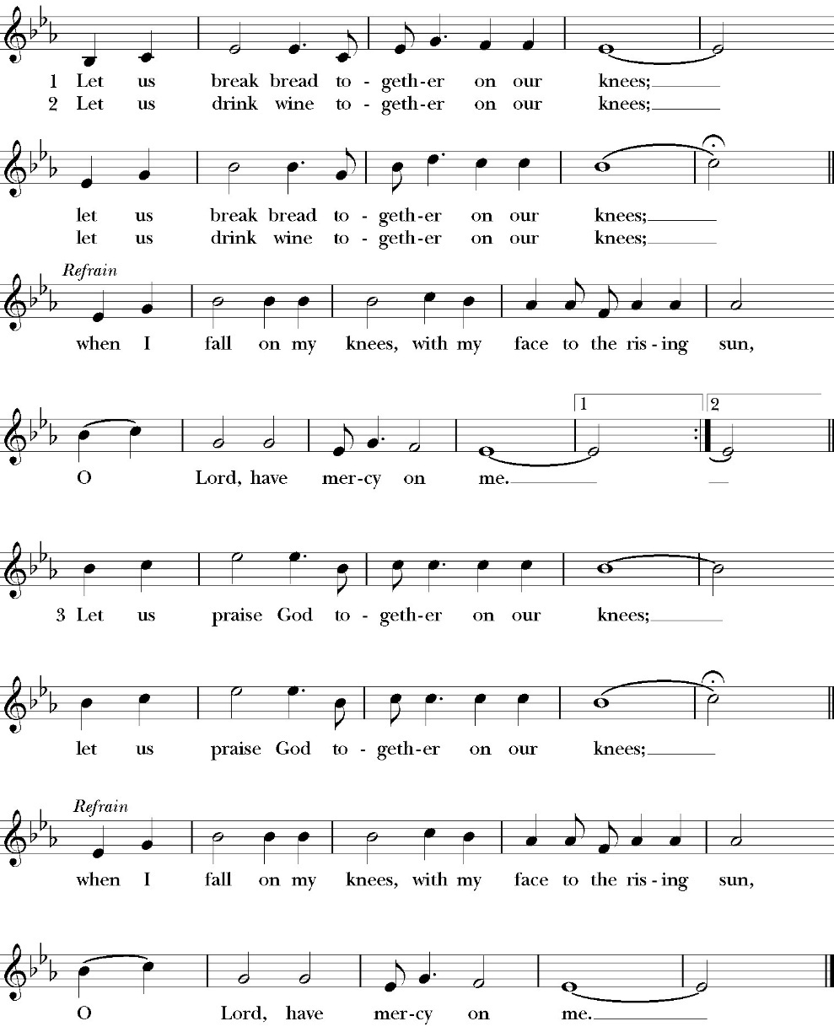

The Post Communion Prayer

Let us pray.

Heavenly Father,
We thank you for feeding us with the spiritual food
of the most precious Body and Blood
of your Son our Savior Jesus Christ;
and for assuring us in these holy mysteries
that we are living members of the body of your Son,
and heirs of your eternal Kingdom.
And now, Father, send us out to do the work you have
given us to do,
to love and serve you as faithful witnesses of Christ our
Lord.
To him, to you, and to the Holy Spirit,
be honor and glory, now and for ever. Amen.

The Blessing

The blessing of God Almighty, the Father, the Son, and the Holy
Spirit, be among you, and remain with you always. Amen.

Closing Hymn: Jerusalem My Happy Home
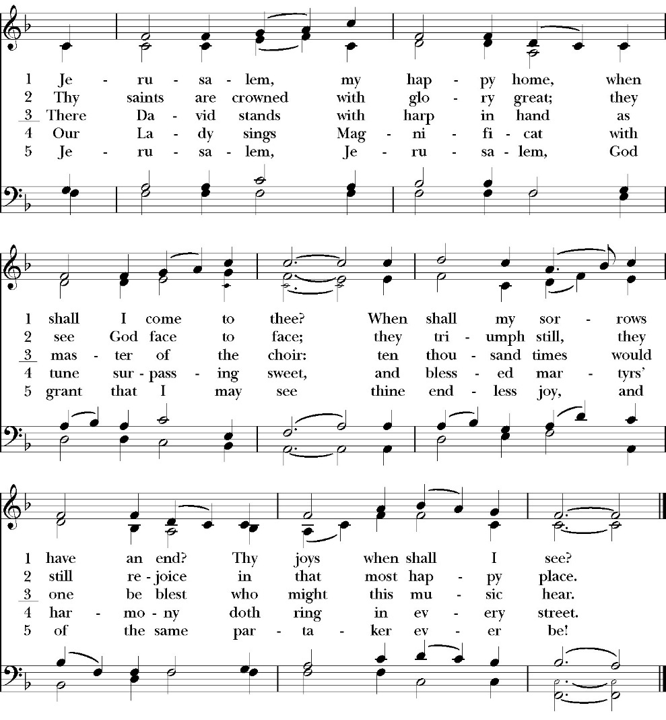

Deacon Alleluia, Alleluia! Let us go forth in the name of Christ.
People Thanks be to God. Alleluia! Alleluia!

St. Paul’s Parish Calendar
Sunday July 20 – Sunday July 27

SUNDAY, July 20 – Sixth Sunday after Pentecost
9:15 AM NO Catechism
10:30 AM Children’s Sunday School, (Pre-K – 6th Grade)
10:30 AM Holy Eucharist, Church
5:30 PM NO Youth Goup

MONDAY, July 21
6:30 PM Women’ s Bible Study, Conference Room

TUESDAY, July 22

WEDNESDAY, July 23
9:30 AM Holy Eucharist, Chapel
10:15 AM Bible Study, Conference Room
6:00 PM Potluck Dinner, James Hall
6:45 PM Practicing the Way, James Hall

THURSDAY, July 24

FRIDAY, July 25
6:30 AM Men’s Bible Study, Valhalla Restaurant

SATURDAY, July 26

SUNDAY, July 27 – Seventh Sunday after Pentecost
9:15 AM NO Catechism
10:30 AM Children’s Sunday School, (Pre-K – 6th Grade)
10:30 AM Holy Eucharist, Church
5:30 PM NO Youth Goup

Church Office Hours
Monday-Thursday 8:00 AM-4:00 PM

Fr. Rob away on retreat July 20-25
Fr. Rob will be away at a spiritual retreat the week of July 20-25. If there is a pastoral emergency, please contact Deacon John Iseman at (518)222-6722, Deacon Kashy Rowland-Smith (559)909-3305 or the church office.
Announcements

July Sunday Sermon Series: Exploring Paul's Epistle the Colossians
From July 13 through August 6, the Epistle reading will walk through Paul's letter to the Colossians. Fr. Rob Longbottom and Deacon John Iseman will be preaching through the readings Colossians and guide us through the purpose, themes, theology and relevance to our lives today.

Pastoral Care and visitation team forming
Pastoral care is the lifeblood of a vibrant church. Pastoral care can take many forms. It can visit the sick and homebound, responding to emergencies, catching up with a church member we have not seen in while, and really so many more opportunities to be present with all the member of the body of Christ. This work is not done just by our clergy, but by the whole church and we are looking for people of the church who feel they may be called to the ministry of pastoral care. If you are interested in learning more about being a pastoral visitor for St. Paul’s please reach out to Deacon Kashy Rowland-Smith who would love to talk with you about our needs and opportunities. Deacon Kashy can be reached at 909-3305.

Wednesday Summer Potluck & Practicing the Way Course
Wednesday, August 6 (Session 7: Crafting a Rule of Life)
6:00PM Potluck Dinner (James Hall)
6:45PM Practicing the Way course (James Hall)
The final two sessions of the Practicing the Way course that were to happen after Easter were postponed due to Fr. Rob’s leave of absence. We have rescheduled these evening sessions along with having two potluck dinners this summer. All church members are invited to join us for the potluck and then stay to walk through our last two sessions with us on this course. Join us for the potluck, the course that follows, or both.

School Supply drive for Hurley Elementary
Now through Sunday, August 10
Did you know that 1/3 of all students at Hurley elementary are from low-income households? Help us serve these students with a school supply drive to help teachers make sure all their students have the supplies they need for a great school year. School supplies can be brought to Church on Sunday or at the church office Monday-Thursday 8am-4pm. List of School Supplies needed, Backpacks, Crayons, Pencils Erasers, Glue Sticks, Scissors, Composition books, 1-inch binders, Expo markers, Lined paper, Pencil pouch.

Sunday Morning Anglican Catechism Class
The Sacraments of the Church
Sundays in August, beginning August 3, 9:15AM, Conference Room
The Anglican Catechism is a summary of our faith and doctrines in the Anglican Church and helps us know what we believe as orthodox Anglican Christians. This session of four classes will focus on the Sacraments of the church. The class will focus on the two primary sacraments of Baptism and Holy Communion. It will then move towards the five lesser sacraments of ordination, holy unction (healing), confirmation, marriage, and confessions.

St. Paul’s Anglican Church
Parish Office
6436 W. Hurley Ave
Visalia, California 93291
559-732-4821
Office Hours: 8:00 – 4:00
Monday – Thursday

Worship: Sundays at 10:30AM
In person: St. Paul’s Anglican Church
Livestream: Link at spvisalia.com
and on our Facebook page
Please be advised that this service is being recorded for broadcast
and/or archival purposes. By attending, you consent
to the inclusion of your likeness in these recordings.

St. Paul’s Clergy and Staff
The Rev. Robert Longbottom, Rector
rector@spvisalia.com
(559)802-2928
The Rev. John Iseman, Pastoral Associate for Family Ministries
family@spvisalia.com
Antoinette Horsting, Parish Administrator
bookkeeper@spvisalia.com
Marguerite Crownover, Organist and Accompanist
Cynthia Culp, Choral Director
Jackie Iseman, Nursery Coordinator
Shane Motl, Sexton

Next Week’s Lessons
Genesis 18:20-33
Psalm 138
Colossians 2:6-15
Luke 11:1-13

The Altar Flowers
The flowers at the altar are given to the Glory of God,
by Scott and Mary Murray, in thanksgiving for Scott David Murray. As he reaches his fifth-year Cancer free.

